Movie Review and Recommendation System
Course: Database Management Systems
Project Title: Movie Review and Recommendation System

1. Project Overview

Project Title:
Movie Review and Recommendation System

Purpose:
This project aims to organize and manage user-generated movie reviews, ratings, watchlists, and preferences using a relational database. It ensures that users can interact with movies meaningfully while administrators can analyze trends.

Scope:
This system allows users to register, maintain watchlists, rate and review movies. It covers the backend structure only and doesn't include a user authentication system or UI.

Stakeholders:
Students, movie enthusiasts, system admins, and academic evaluators.

2. Database Design Requirements

Entities & Descriptions:
- USERS: Stores personal info such as username, email, and preferences.
- MOVIES: Contains movie information like title, director, and genre.
- GENRES: Defines movie genres (e.g., Action, Comedy).
- REVIEWS: Captures textual user reviews on movies.
- RATINGS: Stores numerical ratings (0-10) given by users to movies.
- WATCHLISTS: Keeps track of movies users plan to watch or have watched.

Relationships:
• USERS write REVIEWS and give RATINGS.
• USERS add MOVIES to WATCHLIST.
• MOVIES belong to GENRES.
• USERS watch MOVIES.

ER Diagram:
The ER diagram illustrates the relationships between entities.
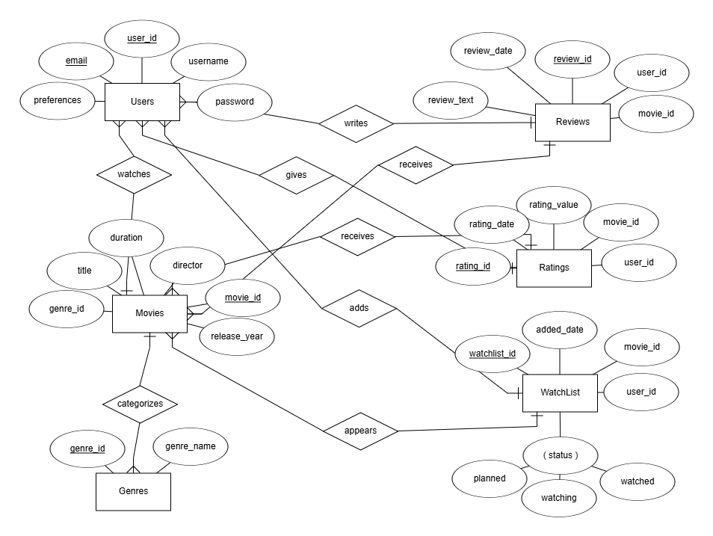

3. Schema Design
Each table has primary keys, data types, and foreign key constraints to maintain referential integrity.
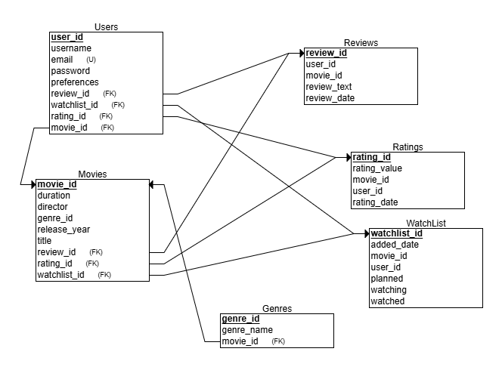

4. Technology Stack and SQL Concepts

DBMS:
MySQL

DDL Concepts Covered:
CREATE, ALTER, and constraints (PRIMARY KEY, FOREIGN KEY, CHECK, ENUM).

DML Concepts Covered:
INSERT, UPDATE, SELECT with conditions.

Querying and Joins:
Queries include:
• SELECT with WHERE, LIKE, IN, BETWEEN, EXISTS
• INNER JOIN, LEFT JOIN, RIGHT JOIN, FULL JOIN (via UNION)
• Aggregations: COUNT, MAX, MIN, AVG, SUM
• GROUP BY and HAVING
• Nested queries and correlated subqueries
• VIEWS and stored PROCEDURES

5. Conclusion
This project demonstrates a comprehensive understanding of database concepts. From data modeling to SQL operations, it covers key features of relational database design and manipulation using MySQL.

