STRUCTURED OUTPUTS
first we will study that llm give text and also give output as a text unstructured output thats why we cannt connect the llm with other models like atabase but with the help of structured output we
are able to connect llm with the database by using structured output

typeddict is like a code editor who tell just that which value have which data type as a hint but if i use wrong datatype than it will not genertae an error or also dont stop you its work is just to give a hint about the data type of the values

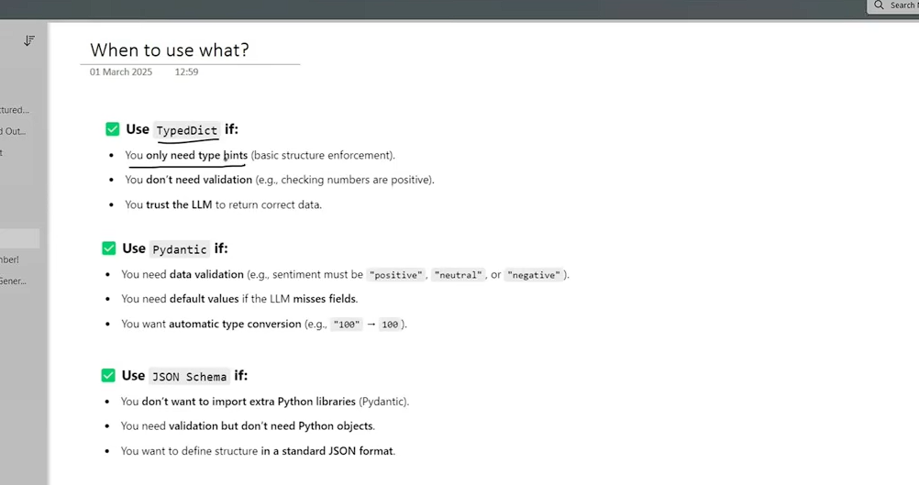

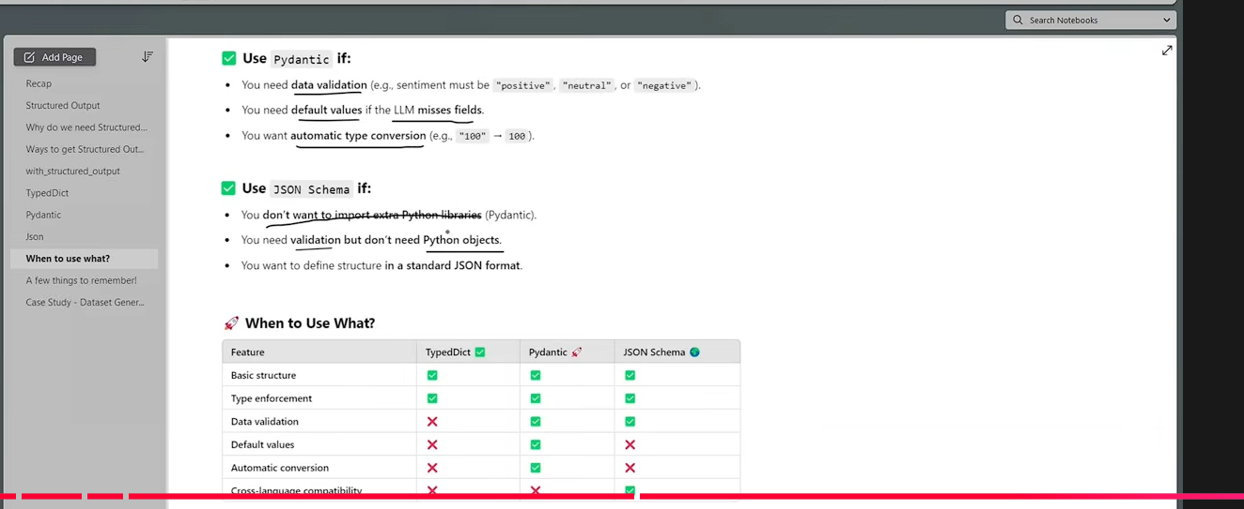

FOCUS ON PYDANTIC:
