L1F24BSCS0675
SIMRAN IFTIKHAR

Window11 cmd

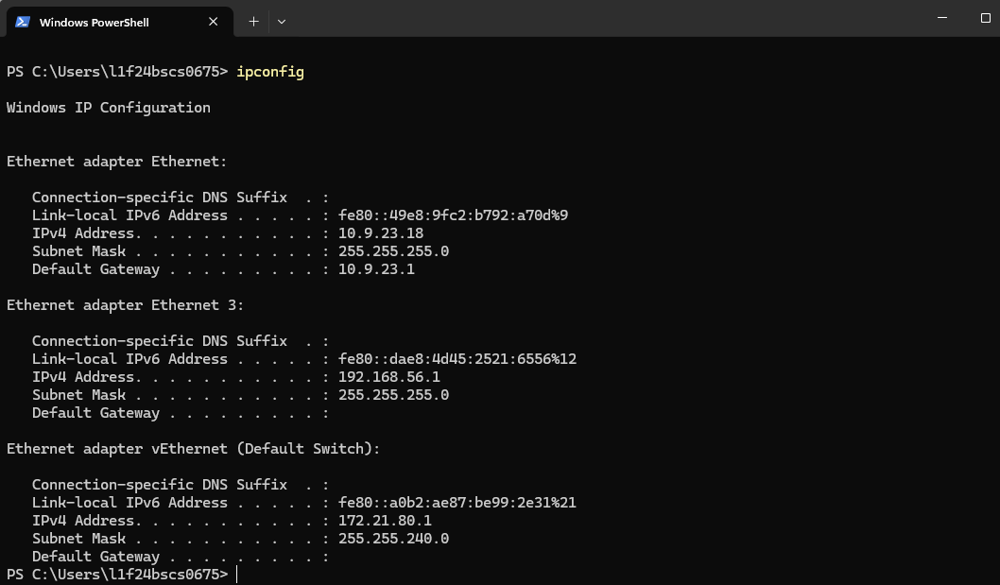

Base Memory
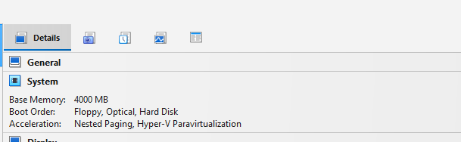

Add adaptor2
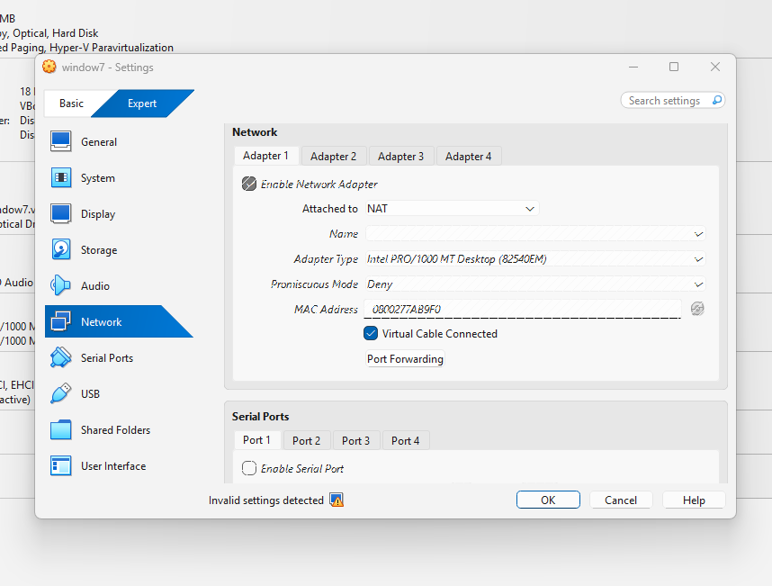

Cmd window7

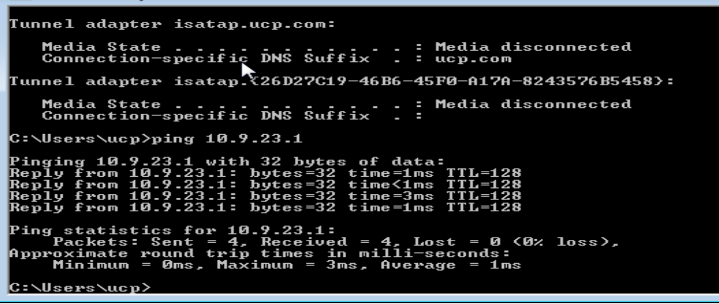

TASK1

ADD ADAPTOR KALI:

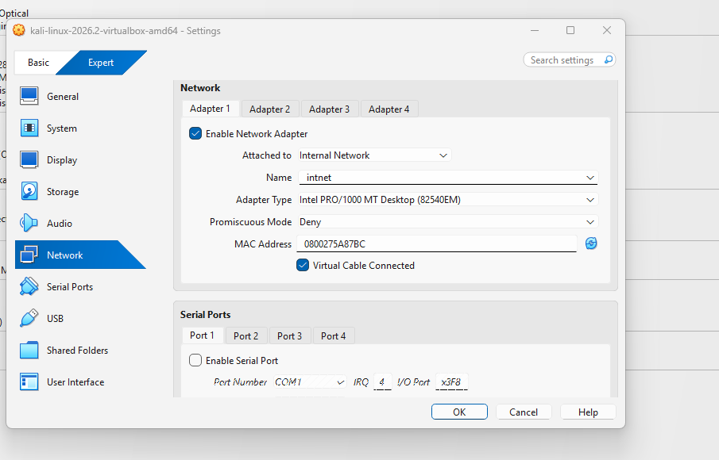

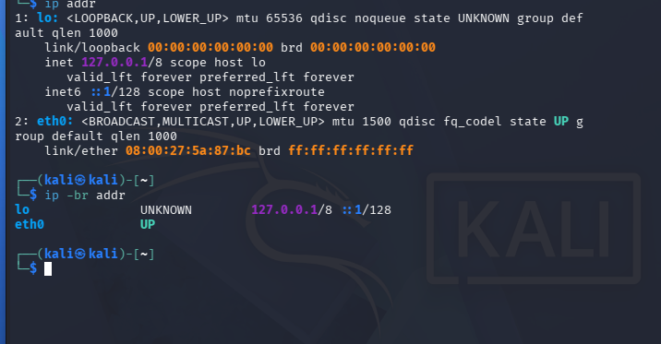

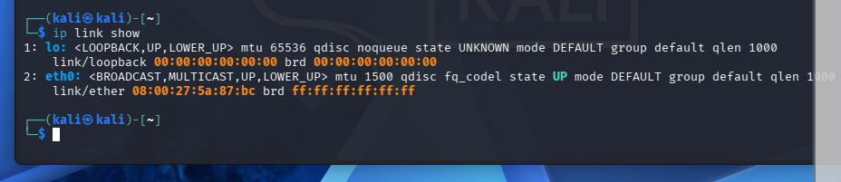

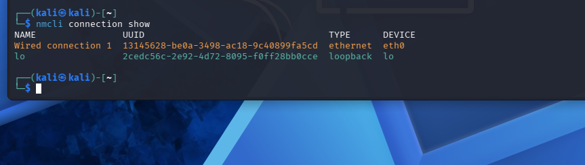

Ip address assigned:

Check 2 adaptor have assigned ip



Ping both kali window7



Ping kali
