INFORMATION SECURITY LAB 1

1- CEASER CYPHER
PLAIN TEXT=PAKISTAN
KEY =4
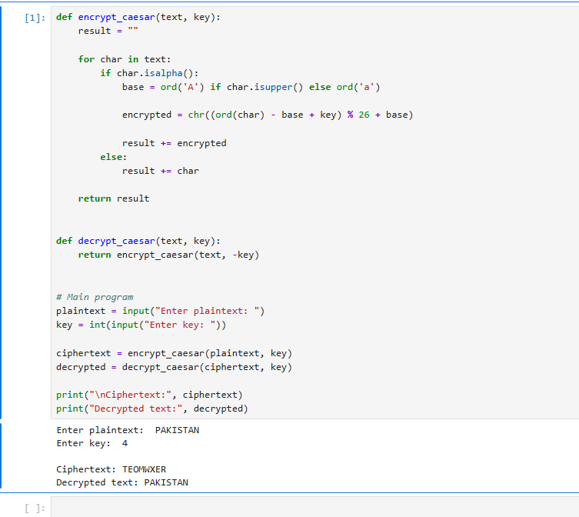

Plain text=TEACHER
KEY =3
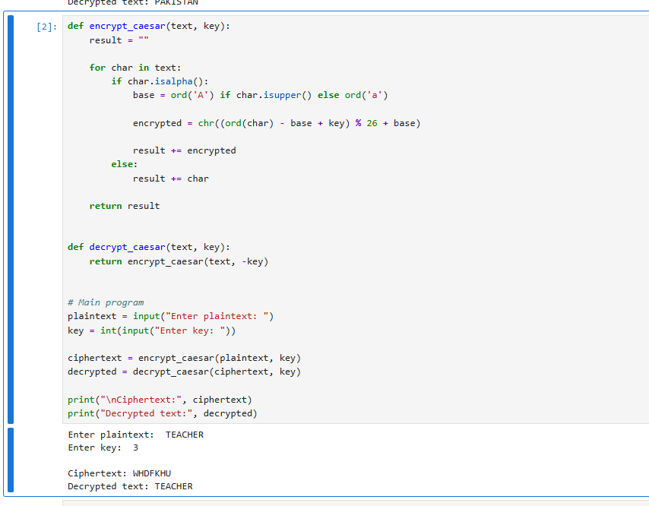

PLAIN TEXT=SIMRAN
KEY=5
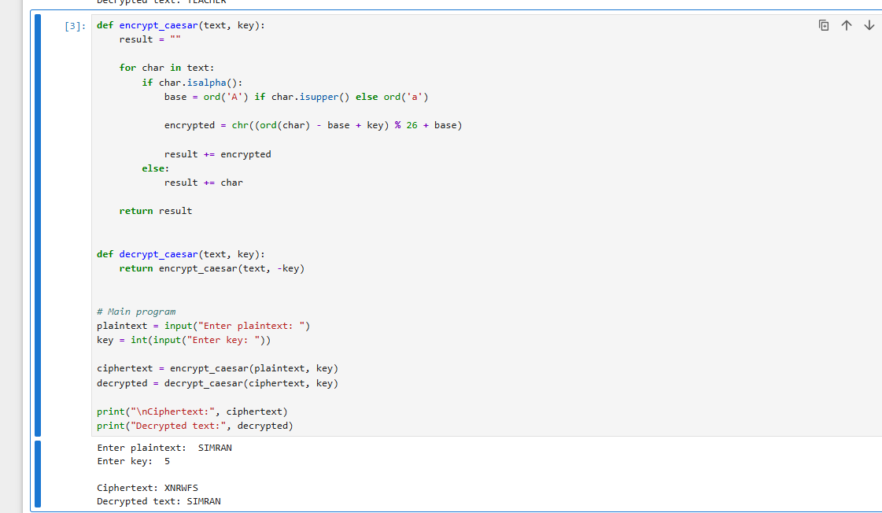
2-VIGENERE CIPHER

PLAIN TEXT=PAKISTAN
KEY WORD=BOX

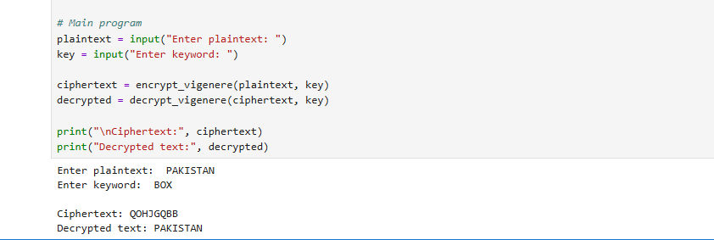
Plain text=TEACHER
KEYWORD=BOX

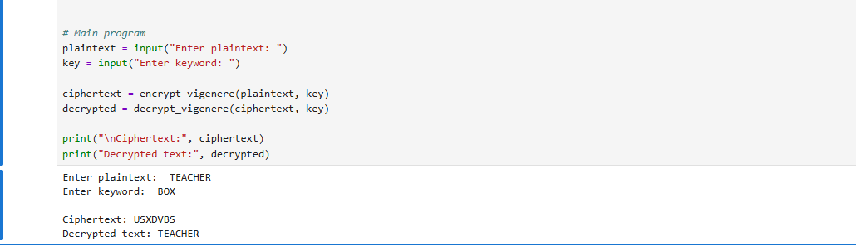

PLAIN TEXT=SIMRAN
KEYWORD=BOX

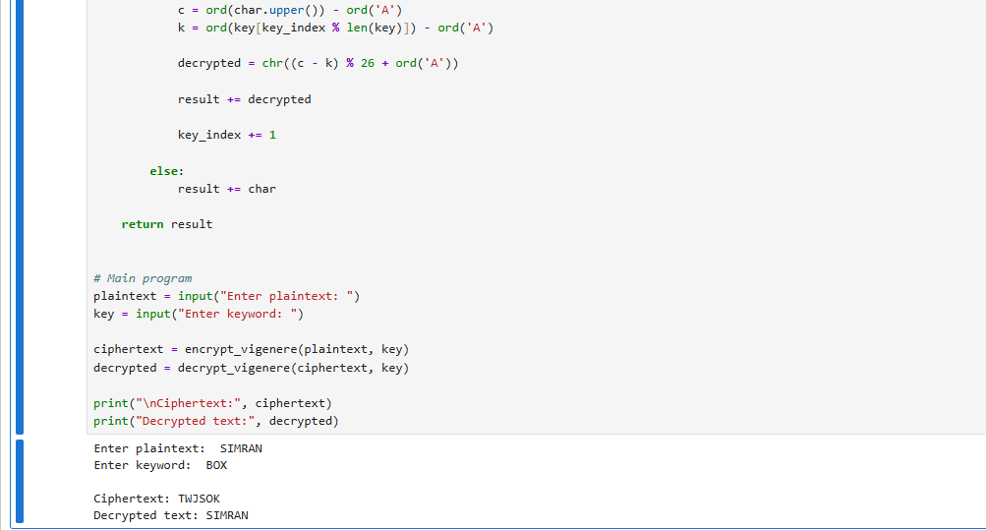

Cp
Code:
def encrypt_caesar(text, key1):
result = ""

for char in text:
if char.isalpha():
base = ord('A') if char.isupper() else ord('a')

encrypted = chr((ord(char) - base + key1) % 26 + base)

result += encrypted
else:
result += char

return result

def decrypt_caesar(text, key1):
return encrypt_caesar(text, -key1)

# Main program
plaintext = input("Enter plaintext: ")
key1 = int(input("Enter key: "))

cciphertext = encrypt_caesar(plaintext, key1)

print("\n Encrypterd by caesar Ciphertext:", cciphertext)

#################################################################################
def encrypt_vigenere(plaintext, key2):
result = ""
key2 = key2.upper()

key2_index = 0

for char in plaintext:
if char.isalpha():

p = ord(char.upper()) - ord('A')
k = ord(key2[key2_index % len(key2)]) - ord('A')

encrypted = chr((p + k) % 26 + ord('A'))

result += encrypted

key2_index += 1

else:
result += char

return result

def decrypt_vigenere(ciphertext, key2):
result = ""
key2 = key2.upper()

key2_index = 0

for char in ciphertext:
if char.isalpha():

c = ord(char.upper()) - ord('A')
k = ord(key2[key2_index % len(key2)]) - ord('A')

decrypted = chr((c - k) % 26 + ord('A'))

result += decrypted

key2_index += 1

else:
result += char

return result

# Main program
plaintext = cciphertext
key2 = input("Enter keyword: ")

vciphertext = encrypt_vigenere(plaintext, key2)

print("\nEncrypt by veigner Ciphertext:", vciphertext)

##########################################################################
def encrypt_autokey(plaintext, key3):
plaintext = ''.join(
char.upper() for char in plaintext if char.isalpha()
)

key3 = ''.join(
char.upper() for char in key3 if char.isalpha()
)

# Generate key stream
keystream = key3

while len(keystream) < len(plaintext):
keystream += plaintext

# Make sure key stream is exactly the plaintext length
keystream = keystream[:len(plaintext)]

ciphertext = ""

for i in range(len(plaintext)):

p = ord(plaintext[i]) - ord('A')
k = ord(keystream[i]) - ord('A')

c = (p + k) % 26

ciphertext += chr(c + ord('A'))

return ciphertext, keystream

def decrypt_autokey(ciphertext, key3):
ciphertext = ''.join(
char.upper() for char in ciphertext if char.isalpha()
)

key3 = ''.join(
char.upper() for char in key3 if char.isalpha()
)

plaintext = ""

for i in range(len(ciphertext)):

# Initial keyword
if i < len(key3):
k = ord(key3[i]) - ord('A')

# Previously recovered plaintext
else:
k = ord(plaintext[i - len(key3)]) - ord('A')

c = ord(ciphertext[i]) - ord('A')

p = (c - k) % 26

plaintext += chr(p + ord('A'))

return plaintext

# Main program
plaintext = vciphertext
key3 = input("Enter initial keyword: ")

aciphertext, keystream = encrypt_autokey(plaintext, key3)

print("\nGenerated Key Stream:", keystream)
print("encrypted by auto Ciphertext:", aciphertext)

adecrypted = decrypt_autokey(aciphertext, key3)

print("Decrypted text by auto :", adecrypted)

vdecripted=decrypt_vigenere(adecrypted,key2)
print("Decrypted text by vigener :", vdecripted)

cdecripted=decrypt_caesar(vdecripted,key1)
print("Decrypted text by ceaser :", cdecripted)

##########################################################################

Ss
