L1F24BSCS0675
SIMRAN IFTIKHAR

TASK5
Write a C program in which the parent creates one child using fork(). The child must print its PID and terminate with exit status
4. The parent must print its PID and the child's PID, then wait 10 seconds before calling waitpid(). During the delay, use a
second terminal to check the child's state using ps. After the delay, collect the child's status with waitpid() and print a
confirmation message. Explain why the child becomes a zombie and why the zombie entry disappears after waitpid().
Code:
#include<stdio.h>
#include<sys/wait.h>
#include<unistd.h>
#include<sys/types.h>
#include<stdlib.h>

int main()
{
pid_t pid = fork();

if(pid < 0)
{
perror("child not created");
return 1;
}
else if(pid == 0)
{
printf("Child process\n");
printf("Child PID = %d\n", getpid());
exit(4);
}
else
{
int exitval;

printf("Parent process\n");
printf("Parent PID = %d\n", getpid());
printf("Child PID in parent = %d\n", pid);

printf("Parent sleeping for 10 seconds...\n");
sleep(10);

waitpid(pid, &exitval, 0);

printf("Child status collected successfully\n");

if(WIFEXITED(exitval))
{
printf("Child exit status = %d\n",
WEXITSTATUS(exitval));
}
}

return 0;
}
Output:

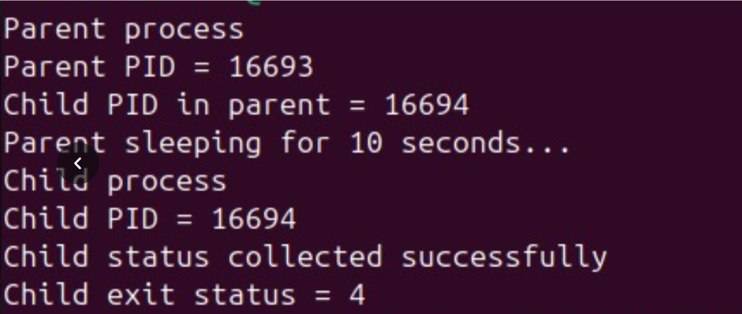

Explanantion:
A child process becomes a zombie when it terminates but its parent has not yet collected its exit status using waitpid().
parent process sleeps for 10 seconds while the child executes and terminates with exit status 4. During this delay the child remains in the process table as a zombie because the parent has not called waitpid() .
After 10 seconds, the parent calls waitpid() to collect the child's exit status. Once the parent collects the status the zombie entry is removed from the process table.

TASK6
Write a C program in which the parent creates a child using fork() and terminates before the child. The parent must print its PID
and the child's PID. The child must print its own PID and initial parent PID, sleep for four seconds, then print its current parent
PID before exiting n

CODE:

#include<stdio.h>
#include<sys/wait.h>
#include<unistd.h>
#include<sys/types.h>
#include<stdlib.h>

int main()
{
pid_t pid = fork();

if(pid < 0)
{
perror("child not created");
return 1;
}
else if(pid == 0)
{
printf("Child process\n");
printf("Child PID = %d\n", getpid());
printf("Child parentid = %d\n", getppid());
sleep(4);
printf("Child parentid after sleep = %d\n", getppid());
}
else
{

printf("Parent process\n");
printf("Parent PID = %d\n", getpid());
printf("Parent child id = %d\n", pid);
exit(0);
}

return 0;
}
OUTPUT:
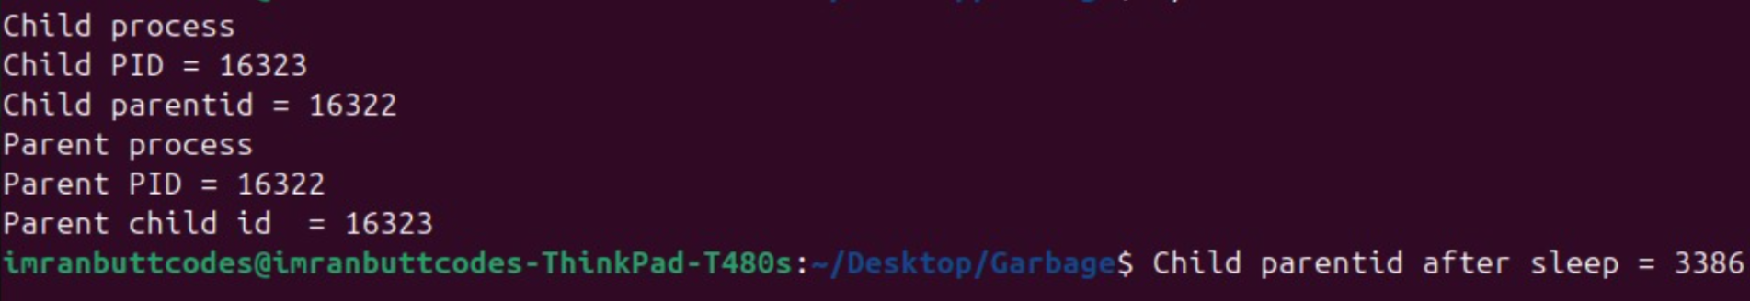

EXPLANATION:
Because parent and child are independent processes after fork().
When the parent terminates the operating system does not automatically terminate the child.
The child continues its execution until it completes its own instructions or is terminated.

TASK7
Write a C program that creates two child processes. Child 1 must print a message and terminate with exit status 2. Child 2 must
print a message and terminate with exit status 5. The parent must use waitpid() for each specific child, check each status using
WIFEXITED(), and print the status using WEXITSTATUS(). The parent must print “All children completed” only after both child
statuses have been collected.
Extension: run a version without waitpid() and describe how output order can vary. Then add waitpid() and explain which
ordering is guaranteed and which is not.

Code:
#include<stdio.h>
#include<sys/wait.h>
#include<unistd.h>
#include<sys/types.h>
#include<stdlib.h>

int main()
{
pid_t pid = fork();

if(pid < 0)
{
perror("1 child not created");
return 1;
}
else if(pid == 0)
{
printf("1 Child process\n");
printf("1 Child PID = %d\n", getpid());
printf("1 Child parentid = %d\n", getppid());
exit(2);
}
//// second child
pid_t pid2 = fork();

if(pid2 < 0)
{
perror("2 child not created");
return 1;
}
else if(pid2 == 0)
{
printf("2 Child process\n");
printf("2 Child PID = %d\n", getpid());
printf("2 Child parentid = %d\n", getppid());
exit(5);
}

else
{
int child1exit,child2exit;
printf("Parent process\n");
printf("Parent PID = %d\n", getpid());
printf("Parent 1child id = %d\n", pid);
waitpid(pid,&child1exit,0);
if(WIFEXITED(child1exit))
{
printf("Child 1 exit status= %d",WEXITSTATUS(child1exit));
printf("\n");
}
//////second child waitpid
waitpid(pid2,&child2exit,0);
if(WIFEXITED(child2exit))
{
printf("Child 2 exit status= %d",WEXITSTATUS(child2exit));
printf("\n");
}
printf("All children completed\n");
}

return 0;
}
Output:

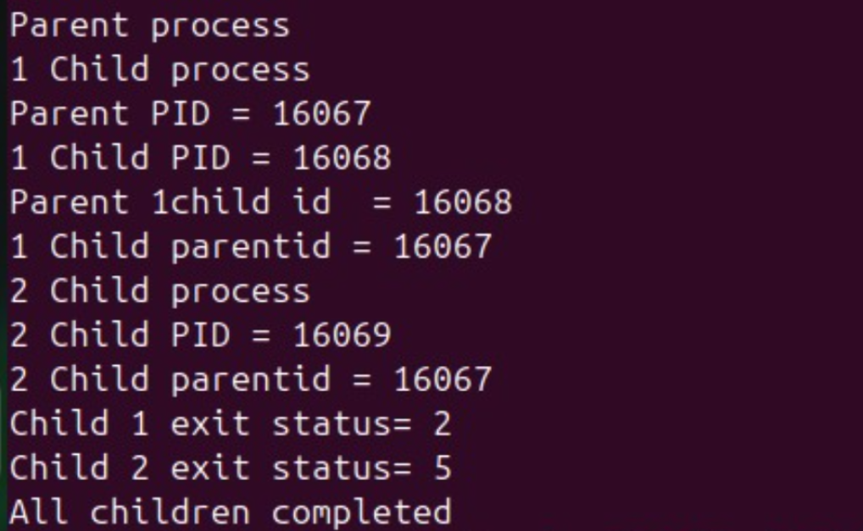

Explanation:
The fork() system call creates two child processes. Child 1 terminates with exit status 2, and Child 2 terminates with exit status 5.
The parent uses waitpid() to collect each child's status. WIFEXITED() checks normal termination, while WEXITSTATUS() retrieves the exit status.
Without waitpid(): Output order can vary, and the parent may terminate before its children.
With waitpid(): The parent collects both child statuses before printing All children completed.The children's execution order is not guaranteed.

