OPERATING SYSTEM

LAB 1

- Ls is used to see all files and directories in the current location

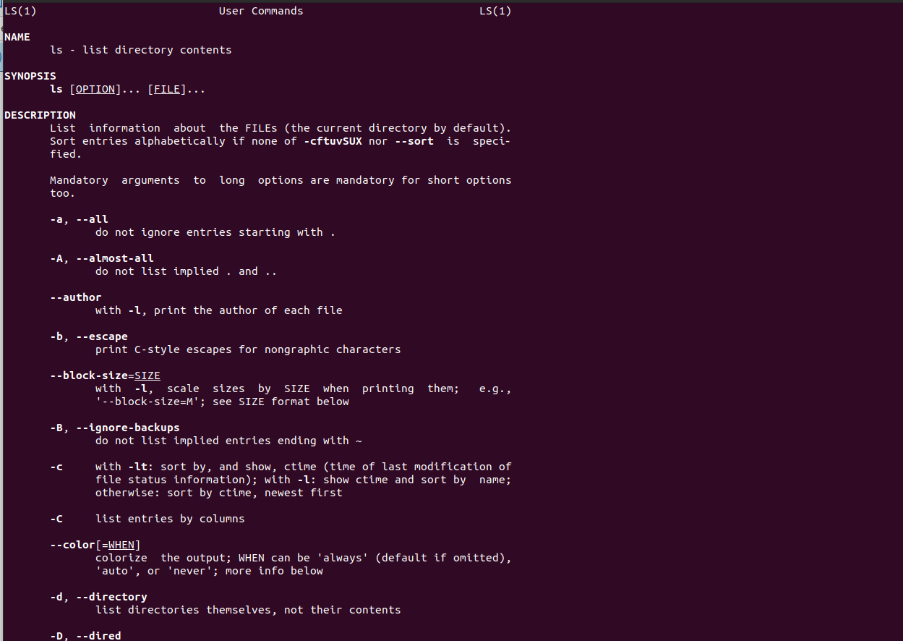
2 ls -A is used to see all files including hidden files

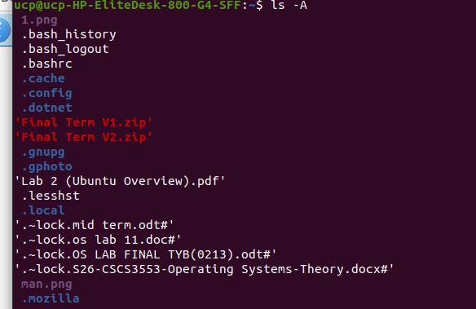

3
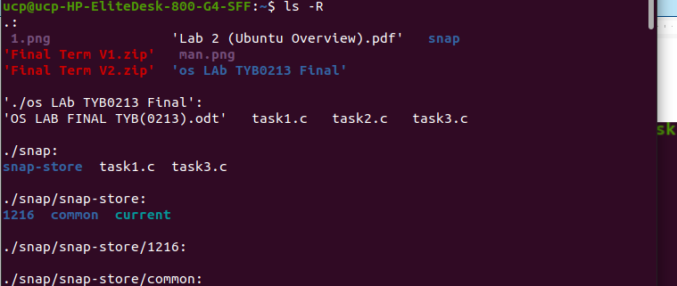

4 gedit is used to create and open the file in a gedit text editor

5 cat>os.txt is used to create a file and write into it through the terminal

6 - touch op.txt is used to create an empty file

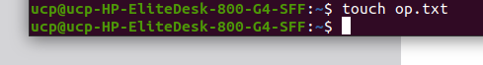

7 - cat os.txt is used to see the content in the file

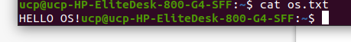

8
Cat os.txt op.txt > simi.txt is used to combine both files content and store in a new file

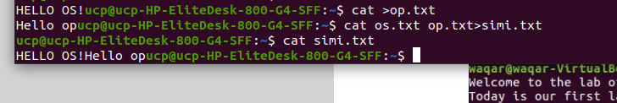

LAB Task 1

CREATE A NAME FILE BY USING THE CAT AND STORE THE RANDOM DATA IN IT
SIMRAN.TXT

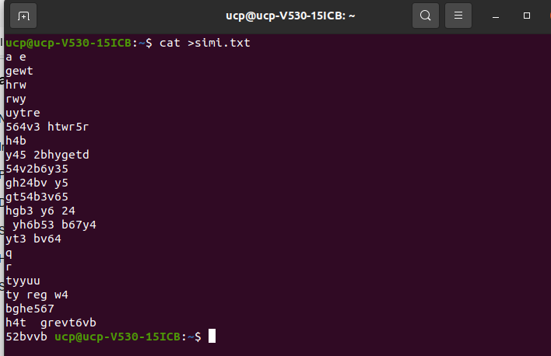

create l1f24bscs0675.txt file
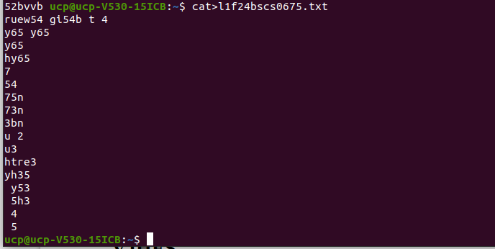

Show data of both files

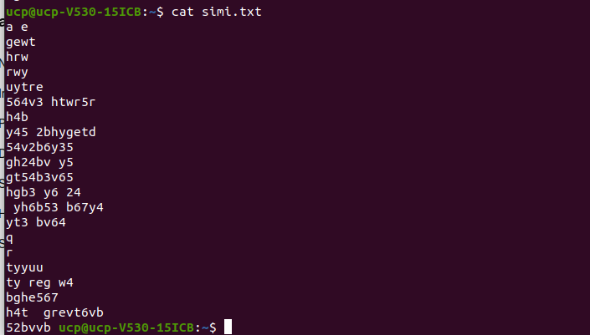

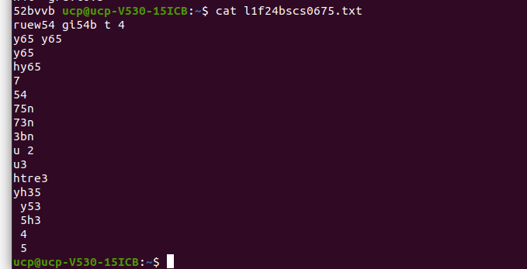
Files by pagewise

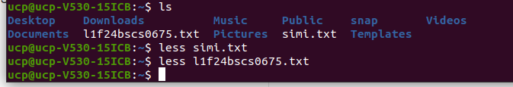

File simi by pagewise

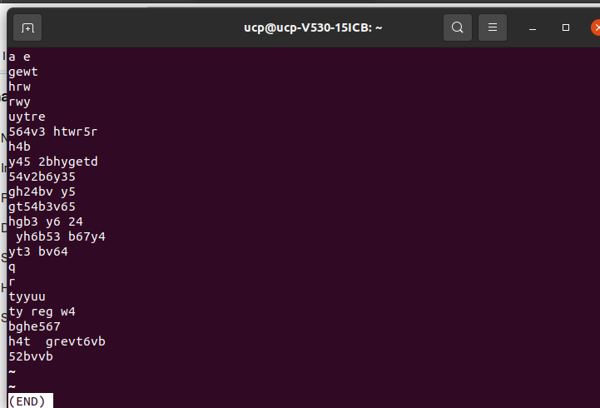

File L1f24bscs0675.txt by pagewise

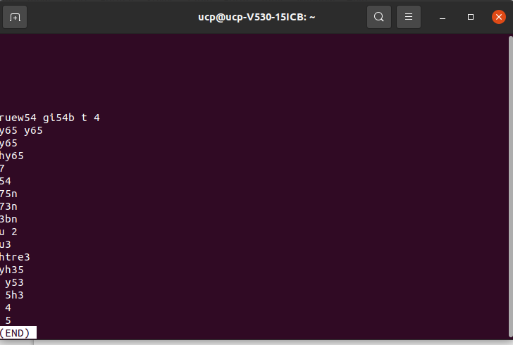

create a new file

Combied data of both files

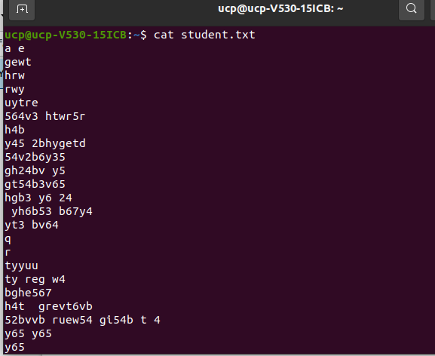

all the files checked by ls

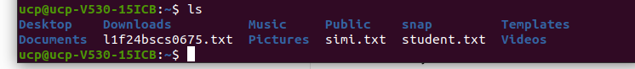

g- rm is used to delete the existing file

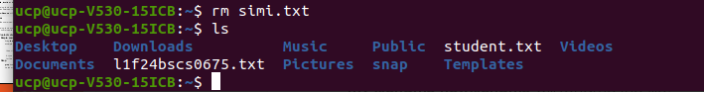

h - mv p.txt n.txt is used to change the file name

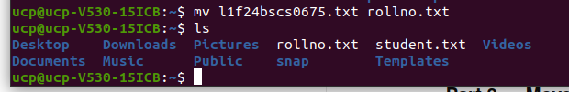
I - cp a.txt c.txt is used to copy the file
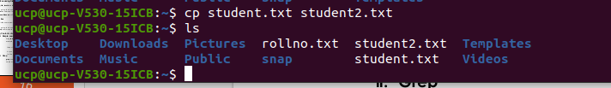

j

1 before enter
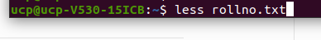

search /yh35

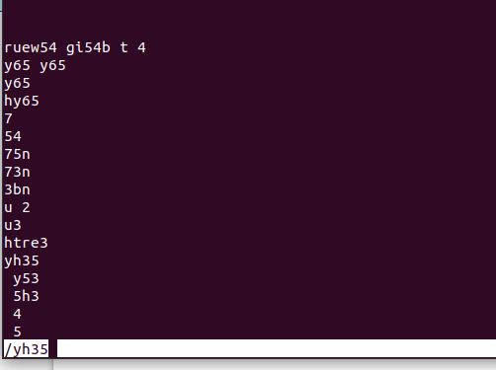
higlighted
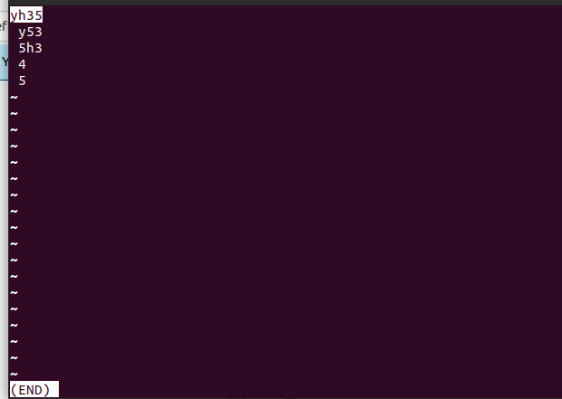

k
word count wc -w a.txt is used to count the words in a file

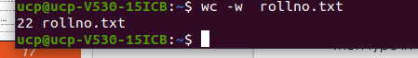

wc -l a.txt is used to count the total lines

l add data at the end of file

Lab task2

check current permissions
Ls -l a.txt is used to see the current permission

Chmod 600 is used to change the permission only owner can read or write in this file

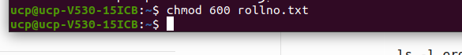

check its changed the permission or not again use the ls -l a.txt

