Cardpeek 0.8 Reference Manual
Alain Pannetrat <L1L1@gmx.com>
June 2014
revision 2

Table of Contents
Chapter 1 Presentation 5
Chapter 2 Installation 7
2.1 Compiling and installing under Linux 7
2.2 Compiling and installing under Mac OS X 8
2.3 Installing under Windows 8
2.4 Related files and initial setup 8
2.4.1 Default installation 8
2.4.2 Changing the default installation directory 9
2.5 Choosing a smart card reader 9
Chapter 3 Using Cardpeek 11
3.1 Quick start 11
3.2 User interface 12
3.2.1 Card view 12
3.2.2 The reader tab 13
3.2.3 The logs tab 14
3.2.4 The one-line command input field 14
3.3 Card-reader selection upon start-up 14
3.4 Command line options 14
Chapter 4 Card analysis tools 16
4.1 Atr 16
4.1.1 Overview 16
4.1.2 General notes 17
4.2 Belgian eID 17
4.2.1 Overview 17
4.2.2 General notes 17
4.3 Calypso 17
4.3.1 Overview 18
4.3.2 Implementation notes 18
4.4 emv 18
4.4.1 Overview 18
4.4.2 Implementation notes 19
4.5 e-passport 19
4.5.1 Overview 19
4.5.2 Implementation notes 19
4.6 GSM/SIM 20
4.6.1 Overview 20
4.6.2 General notes 20
4.7 moneo 20
4.7.1 Overview 20
4.7.2 Implementation notes 20
4.8 OpenPGP 20
4.8.1 Overview 20
4.8.2 Implementation notes 20
4.9 Tachograph driver cards 20
4.9.1 Overview 20
4.9.2 Implementation notes 20
4.10 vitale 2 21
4.10.1 Overview 21
4.10.2 Notes 21
4.11 Adding your own scripts 21
Chapter 5 Programming Cardpeek scripts 23
5.1 5.1 Hello world 23
5.2 Basic communication with a smart card 24
5.3 Representing card data in a tree structure 26
Chapter 6 Development library 28
6.1 The bit library 28
6.1.1 bit.AND 28
6.1.2 bit.OR 28
6.1.3 bit.XOR 28
6.1.4 bit.SHL 29
6.1.5 bit.SHR 29
6.2 The bytes library 29
6.2.1 Operators on bytestrings 30
6.2.2 bytes.clone 30
6.2.3 bytes.concat 30
6.2.4 bytes.convert 31
6.2.5 bytes.format 31
6.2.6 bytes.get 32
6.2.7 bytes.ipairs 33
6.2.8 bytes.is_printable 33
6.2.9 bytes.new 33
6.2.10 bytes.new_from_chars 34
6.2.11 bytes.pad_left 34
6.2.12 bytes.pad_right 35
6.2.13 bytes.reverse 35
6.2.14 bytes.set 35
6.2.15 bytes.sub 36
6.2.16 bytes.tonumber 36
6.2.17 bytes.width 36
6.3 The asn1 library 37
6.3.1 asn1.enable_single_byte_length 37
6.3.2 asn1.join 38
6.3.3 asn1.split 38
6.3.4 asn1.split_length 38
6.3.5 asn1.split_tag 39
6.4 The card library 39
6.4.1 card.connect 40
6.4.2 card.disconnect 40
6.4.3 card.get_data 40
6.4.4 card.info 41
6.4.5 card.last_atr 41
6.4.6 card.make_file_path 41
6.4.7 card.read_binary 43
6.4.8 card.read_record 43
6.4.9 card.select 44
6.4.10 card.send 45
6.4.11 card.warm_reset 45
6.5 The crypto library 45
6.5.1 crypto.create_context 45
6.5.2 crypto.decrypt 47
6.5.3 crypto.digest 47
6.5.4 crypto.encrypt 47
6.5.5 crypto.mac 48
6.6 The iconv library 48
6.6.1 iconv.open 48
6.6.2 iconv.iconv 48
6.7 The nodes library 49
6.7.1 nodes.append 49
6.7.2 nodes.attributes 50
6.7.3 nodes.children 51
6.7.4 nodes.find 51
6.7.5 nodes.find_first 52
6.7.6 nodes.from_xml 52
6.7.7 nodes.get_attribute 52
6.7.8 nodes.parent 53
6.7.9 nodes.remove 53
6.7.10 nodes.root 53
6.7.11 nodes.set_attribute 54
6.7.12 nodes.to_xml 54
6.8 The ui library 55
6.8.1 ui.question 55
6.8.2 ui.readline 55
6.8.3 ui.load_view 56
6.8.4 ui.save_view 56
6.9 The log library 56
6.9.1 log.print 56
6.10 Other libraries 57
6.10.1 The treeflex library 57
6.10.2 The country_codes and currency_codes libraries 57
6.10.3 The en1545 library 57
Chapter 7 File format 58
Chapter 8 License 60

Presentation
Cardpeek is a program that reads the contents of smart cards. This open-source tool has a GTK GUI and can be extended with the LUA programming language. It requires a PCSC card reader to communicate with a smart card, either in contact or contactless mode.
Smart cards are becoming ubiquitous in our everyday life. We use them for payment, transport, in mobile telephones and many other applications. These cards often contain a lot of personal information such as, for example, our last purchases or our last journeys in public transport.
Cardpeek’s goal is to allow you to access all this personal information. As such, you can be better informed about the data that is collected about you.
Cardpeek explores ISO 7816 compliant smart cards and represents their content in an organized tree format that roughly follows the structure it has inside the card, which is also similar to a classical file-system structure.
As of version 0.8.3, this tool is capable of reading the contents of the following types of cards:
- EMV "chip and PIN" bank cards, including:
  - VISA, MasterCard, Amex, CB and UK Post Office Account contact cards;
  - PayWave (VISA) and PayPass (MasterCard) contactless cards;
- Electronic/Biometric passports, which have an embedded contactless chip;
- The Belgian eID card;
- Calypso transport cards including:
  - Navigo transport cards used in Paris;
  - MOBIB cards used in Brussels;
  - RavKav cards used in Israel;
  - VIVA cards used in Lisbon;
- GSM SIM cards (without USIM data used in recent cards);
- Vitale 2, the French health card;
- Moneo, the French electronic purse;
- Driver tachograph cards;
- OpenPGP cards;
It can also read the following cards with limited interpretation of data:
- Some Mifare Classic compatible cards (such as the Thalys card);
Some important card types are missing or need further development, however, this application can be modified and extended easily to your needs with the embedded LUA scripting language. For more information on the LUA project see http://www.lua.org/.
This software has been tested with traditional PCSC card readers (such as the Gemalto™ PC TWIN) as well as contactless or dual-interface PCSC readers (such as the Omnikey™ 5321).

Installation
Cardpeek is designed to work under GNU/Linux with GTK+ and has been successfully ported under Windows.
Cardpeek can be compiled from source using configure and make. It is being developed under Linux Debian and has been reported to work under Ubuntu, Centos, Fedora, Suse and FreeBSD, as well as Raspbian on the Raspberry Pi.
The Windows version is distributed as a self installing binary package. It can also be compiled under MinGW/MSYS with the custom Makefile provided in the source code (Makefile.win32).
Of course, a smart card reader is needed to take full advantage of this software.

Compiling and installing under Linux
Instructions:
- Make sure you have the following development packages installed:
  - libgtk+ 3.0, version 3.5.4 or above (http://www.gtk.org)
  - libglib 2.0, version 2.32 or above.
  - liblua 5.2 (http://www.lua.org)
  - libpcsclite (http://pcsclite.alioth.debian.org/)
  - libssl (http://www.openssl.org/)
  - libcurl (http://libcurl.org)
  - libiconv
- Unpack the source if needed and change directory to the source directory.
- Type ‘./configure’
- Type ‘make’
- Type ‘make install’ (usually as root) to install install Cardpeek in the proper system directories.
Notes:
- On a Debian/Ubuntu system, these necessary packages are all available through package management tools such as apt/aptitude.
- The last step (make install) is optional, as you can run Cardpeek directly from the source directory.

Compiling and installing under Mac OS X
Starting from version 0.8, Cardpeek should compile on Mac OS X following the same steps outlined for Linux. Note however that this requires setting up the correct development environment and an X11 server (Xquartz).
Cardpeek has notably been successfully compiled under Mac OS X Lion (10.7.5) with the following tools/environment:
- Xcode 4.6.2 Command Line Tools.
- Homebrew (http://mxcl.github.io/homebrew/), used to install libgtk+, liblua and libssl.
- XQuartz (http://xquartz.macosforge.org/).

Installing under Windows
Cardpeek works both on windows 32bits and 64bits platforms, in 32 bit compatibility mode.
Instructions:
- Download the self installing binary setup program (cardpeek-x.xx-win32-setup.exe where x.xx is the version number of Cardpeek).
- Follow the instructions.
Cardpeek can also be compiled from source with MinGW/MSYS, but this is a more complicated approach due to some current shortcomings of the windows port. You should use the dedicated Makefile (make -f Makefile.win32) and manually copy the contents of the directory dot_cardpeek_dir/ from the source into the directory %USERPROFILE %/.cardpeek).

Related files and initial setup

Default installation
In the following discussion, the terms “home directory” will refer to the traditional home directory on a Unix system (as indicated by the $HOME environment variable) or the %USERPROFILE% directory on a MS-Windows systems. The first time Cardpeek is run it will attempt to create the .cardpeek/ directory in your home directory. This is normal. For Windows users this directory will be created during installation.
The ./cardpeek directory will contain 5 elements: cardpeekrc.lua, config.lua, the scripts/ and replay/ directories and a version file. The cardpeekrc.lua allows you to run commands automatically when the program starts and the config.lua file is used to store configuration information. The scripts/ directory contains all the scripts needed to explore smart cards. These scripts are LUA files (such as “emv.lua” or “calypso.lua”) and all show up in the ‘analyzer’ menu of Cardpeek (without their extension ‘.lua’). If you add any LUA file to this directory, it will therefore also appear in the menu. The scripts/ directory contains three subdirectories: lib/, etc/ and calypso/. lib/ and etc/ hold a few LUA files containing frequently used commands or data items that are shared among the card processing scripts. The directory calypso/ holds country and region specific scripts for calypso cards. The replay/ directory is used to save data for card emulation purposes.
Each time the program runs, it creates a file .cardpeek.log in your home directory. This file contains a copy of the messages displayed in the “log” tab of the application (see next chapter).

Changing the default installation directory
Under Unix-like systems, if you want to change the directory used by Cardpeek to store and read scripts from $HOME/.cardpeek to something else, you may do so by setting the environment variable CARDPEEK_DIR to point to an existing alternative directory of your choice.

Choosing a smart card reader
There are many smart card readers available on the market, and their compatibility with different contact or contactless cards will depend on many parameters, such as:
- The OS you are using (Linux, Windows, 32bit or 64bit, etc.)
- The smart card driver on the OS.
- The firmware of the smart card reader.
- The smart card itself.
As an example, the OMNIKEY 5321 USB dual-interface reader comes into at least 2 firmware versions. Under MS Windows, a reader with firmware 5.10 fails to connect with some Calypso e-ticketing cards through the contact interface, but works under Linux with default PCSC drivers. However, on Linux, the contactless interface only seems to work with the OMNIKEY drivers and fail to operate with the PCSC standard drivers. Because of all these reasons, to our best knowledge there is no perfect smart card reader.
The following smart card readers have been reported to work with Cardpeek and are provided here as an indication (without any guaranty):
Reader | Type | Notes
BROADCOM BCM5880 | Contact | Only on Windows.
GEMALTO PC Twin USB | Contact | -
OMNIKEY 5321 USB | Contact & contactless | For Navigo cards, the Omnikey proprietary driver doesn't work. However the default PCSC driver seems to work on Linux.
SPRINGCARD Prox'N'Roll PC/SC | Contactless | -
WATCHDATA W1981 | Contact | Offered for 7 euros in subway stations in Paris.
TEO XIRING | Contact | Reported to work on Linux
ASK LoGO | Contactless | Only on Windows.

Using Cardpeek
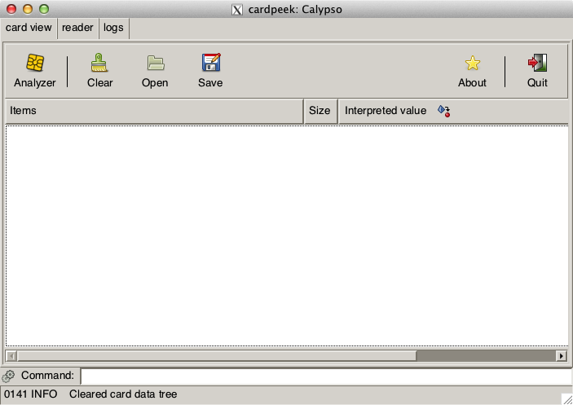Illustration 1: Main Window of Cardpeek

Quick start
To experiment with Cardpeek, you may start with your EMV “PIN and chip” smart card for example, by following these steps:
- Start Cardpeek.
- Select your PCSC card reader in the first dialog box.
- Insert your EMV “PIN and chip” card in the card reader.
- Select emv in the analyzer menu. This will run the default EMV script.
- View the results in the “card data” tab.
On many bank cards, you will discover a surprising amount of transaction log data (scroll down to the “log data” in the card view).

User interface
The user interface is divided in four main parts: 3 tabs and a one-line command input field.
Each one of the 3 tabs proposes a different view of card related information:
- Card view: shows card data extracted from a card in a structured tree form.
- Reader: shows raw binary data exchanged between the host PC and the card reader.
- Logs: displays a journal of application events, mainly useful for debugging purposes.

Card view
The card view tab is the central user interface component of Cardpeek.
It represents the data extracted from a card in a structured tree from. This tree structure is initially blank and is entirely constructed by the LUA scripts that are executed (see Chapter 4). This tree can be saved and loaded in XML format (see Chapter 7) using the buttons in the toolbar.
The card view tab offers the following toolbar buttons:

Analyze | Clicking on this button spawns a menu from which a card analysis script can be chosen (see next chapter).
Clear | This button clears the card view.
Open | This button allows to load a previously saved card view from an XML file.
Save As | This button allows to save the current card view into an XML file.
About | This button displays a very brief message about Cardpeek.
Quit | This button quits the application.

The card view data is represented in 3 columns. The first column displays the nodes of the card tree view in a hierarchical structure similar to a typical file directory tree browser, where each node has a name, composed of a label and an ID. The second column displays the size of the node data, most frequently expressed in bytes. Finally, the third column displays the node data itself. The node data can either be represented in “raw” (hexadecimal) form or in a more user friendly interpreted “alternative” form, such as a text, or a date for example. By default, the card view will display node data in an interpreted “alternative” format if it exists. By clicking on the third column title, it is possible to switch between both “raw” and interpreted “alternative” data representations.
The card view tab has a right-click activated context menu featuring two commands:

expand all | This expands the contents of the tree structure starting from the currently highlighted node.
show raw value  or  show interpreted value | This is equivalent to clicking on on the third column title to switch between both “raw” and interpreted” data representations.

The reader tab
The reader tab displays the raw binary data exchanges between the card reader and the card itself. This data is composed of card command APDUs, card response APDUs and card reset indicators. Command APDUs are represented by a single block of data, while card responses contain two elements: a card status word and card response data.
One interesting feature of the card reader tab is the ability to save the APDU exchanges between the card reader and the smart card in a file that can later be used to emulate the card. Once this data is saved in a file (with the .clf extension) and placed in the .cardpeek/replay/ folder, it will appear as a choice in the smart card reader selection window that appears when Cardpeek is launched. The name of the file will be prefixed by “replay://” in the card selection window. Selecting such a card data file allows to re-run the script on the previously recorded APDU/response data instead of a real smart card inserted in the reader. This is very useful for testing and debugging card scripts without relying on a real smart card inserted in the reader.
The reader tab offers the following toolbar buttons:

Connect | This button establishes a connexion between the card and the card reader.
Reset | This button performs a warm reset of the card.
Disconnect | This button closes the connexion between the card and the card reader.
Clear | This button clears the APDU/response data displayed in the window.
Save as | This button allows to save the displayed APDU/response data, either Save as for future examination or to be replayed as an emulation of a real card.

“Connect”, “Reset” and “Disconnect” operations are usually automatically done by the card scripts. However, it is occasionally useful to manually force the execution of these commands.

The logs tab
The logs tab keeps track of messages emitted by the application or the script being run. These messages are useful for monitoring and for debugging purposes. The last message also appears at the bottom of the screen in the status bar.

The one-line command input field
The one-line command input field at the bottom of the window allows to type LUA commands that will be directly executed by the application. This is useful for testing some ideas quickly or for debugging purposes.

Card-reader selection upon start-up
When the program starts, you’ll be asked to choose a card reader. This will give you 3 main choices :
- Select a PCSC card reader to use: You may have several of PCSC card readers attached to your computer. Card-readers are usually identified by their name, preceded by pcsc://.
- Select a file containing previously recorded smart card APDU/response data: This allows to replay a smart card transaction that was previously recorded by Cardpeek, and is quite convenient for script debugging purposes. Each time an APDU is sent to the card, Cardpeek will answer with the previously recorded response data (or return an error if the query is new). Files containing previously recorded APDU/response data are identified by a file name, preceded by replay://.
- Select “none”: Selecting none is useful if you do not wish to use a card reader at all, for example if you only want to load and examine card data that was previously saved in XML format.

Command line options
Cardpeek accepts a few command line options, when run from the command prompt:

-r reader-name
--reader reader-name

This makes Cardpeek automatically select the reader reader-name upon start-up without prompting the user. The list of available reader names can be obtained with the -v option below.

-e lua-command
--exec lua-command

This makes Cardpeek run the LUA language commands identified by lua-command upon start-up.

-v
--version

This makes Cardpeek print version information to the console as well as the list of available smart card readers.

Examples
To get version information:

$ cardpeek -v
This is Cardpeek 0.8.3 on Darwin 13.2.0 x86_64.
Cardpeek path is /Users/pannetra/.cardpeek/
There are 2 readers detected:
-> pcsc://USB Reader 00
-> pcsc://USB Reader 01

$ _

To execute a script and exit the application automatically

$ cardpeek -r "pcsc://USB Reader 00" -e "dofile('emv.lua'); ui.exit()"

Card analysis tools
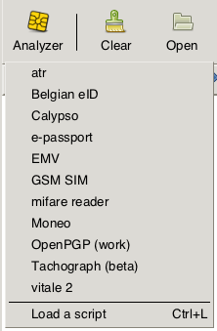Illustration 2: The Analyzer menu
As shown on Illustration 2, Cardpeek provides several card analysis tools, which all appear in the "Analyzer" menu. These tools are actually “scripts” written in the LUA language, and Cardpeek allows you to add your own scripts easily. Though you are unlikely to damage a smart card with these tools, these scripts are provided WITHOUT ANY WARRANTY.

Atr

Overview
This script simply prints the ATR (Answer To Reset) of the card.

General notes
This is a very basic script that should always work. It attempts to identify the card with an internal ATR database (smartcard_list.txt), which is automatically updated online on a regular basis.
In the future this script will be enhanced with a more detailed analysis of the ATR.

Belgian eID

Overview
This script analyses the contents of the Belgian eID card.

General notes
The cardholder's picture is shown if available.

Calypso
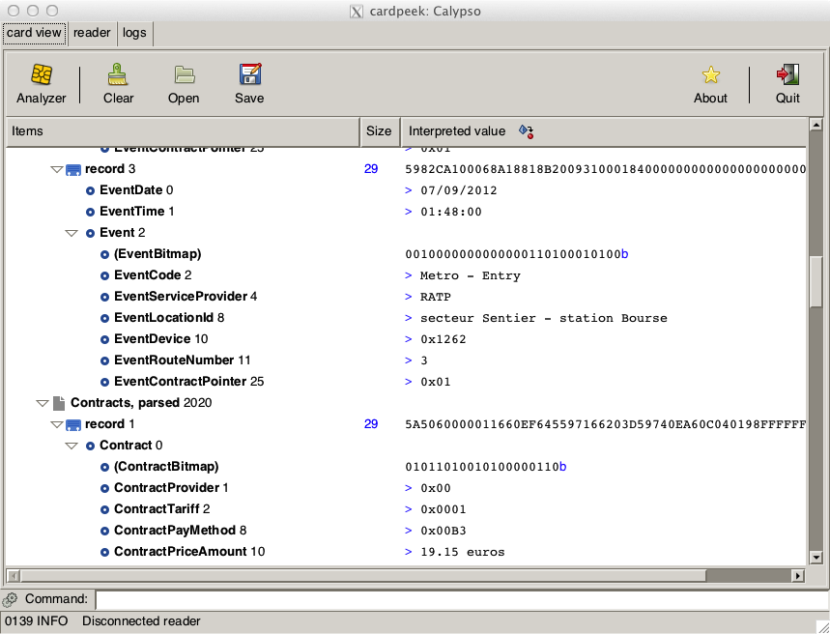Illustration 3: Reading a Navigo card (Paris)

Overview
This script provides an analysis of Calypso public transport cards used in many cities.

Implementation notes
The following calypso cards have been reported to work with this script: Navigo/Paris, MOBIB/Brussels, RavKav/Israel and Korrigo/Rennes (partial support).
You will notice that these transport cards keep an event log describing at least 3 of the last stations/stops you have been through. This event log, which could pose a privacy risk, is not protected by any access control means and is freely readable.
For Navigo cards, this script provides enhanced “event log” analysis notably with subway/train station names, as illustrated in Figure 4. It has been successfully tested on Navigo Découverte, Navigo and Navigo Intégrale cards.
You must use the contact interface to read a Navigo card, because they cannot be read with a normal contactless card reader (these cards use a specific protocol that is not fully compatible with ISO 14443 B).
The script also reads MOBIB cards used in Brussels, with enhanced “event log” analysis. One unusual feature of the MOBIB card is the possibility to access the name and date of birth of the card holder. MOBIB cards are fully compatible with ISO 14443 card readers.
The calypso script reads all the files it can find on the card and extracts the raw binary data it finds. The interpretation of that binary data varies from country to country, and even from region to region.
Once the data is loaded, the script attempts to automatically detect the country and region the card comes from. The country is identified by a number following ISO 3166-1, but without leading zeros. The region code is also a numerical value. The script will then look into the calypso directory for a script called “cXXX.lua” where XXX represents the country code. If found, this extra script will be executed. Next the main script will look again in the calypso directory for a script called “cXXXnYYY.lua” where XXX represents the country code and YYY the region code. If found, this script will also be executed.
Currently country/region detection is based on some simple heuristics and does not work for all calypso cards.
Programmers wishing to tailor the behavior of the calypso script to their own country or region can thus add their own file in the calypso directory.

emv

Overview
This script provides an analysis of EMV banking cards used across the world.

Implementation notes
This script will ask you if you want to issue a “Get Processing Option” (GPO) command for each application on the card. Since some cards have several applications (e.g. a national and an international application), this question may be asked twice or more. This command is needed to allow full access to all freely readable information in the card. As a side effect, issuing this command will increase an internal counter inside the card called ATC (Application Transaction Counter).
You will notice that many of these bank cards keep a “transaction log” of the last transactions you have made with your card. Some banks cards keep way over a hundred transactions that are freely readable, which brings up some privacy issues.

e-passport

Overview
This script provides an analysis of data in an electronic/biometric passport, through a contactless interface.
You will need to enter the second lower line of the MRZ (Machine Readable Zone) data on the passport.
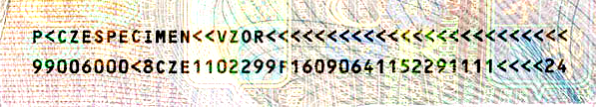Illustration 4: The MRZ of a passport (source: Wikipedia)

Implementation notes
This script implements the BAC (Basic Access Control) secure access algorithm to access data in the passport. It will not be able to access data protected with the EAC (Enhances Access Control) algorithm. When the script starts, you will be required to input a minimum of 28 characters from the beginning of the second lower line of the MRZ (Machine Readable Zone) data on the passport. This data is needed to compute the cryptographic keys used in the BAC algorithm.
This scripts attempts to parse biometric facial and fingerprint image data. Normally however, fingerprint data is not accessible through BAC and requires EAC.
Some versions of GTK do not include support for JPEG 2000 images, which are common in passports. In that case Cardpeek will generate an error and will fail to display the image contained in the passport.

GSM/SIM

Overview
This script analyses the contents of GSM SIM cards, including SMS and phonebook contacts.

General notes
This script is limited to classic GSM/SIM card content. Most additional data contained on newer USIM/3G cards is not analyzed.

moneo

Overview
This scripts provide an analysis of MONEO electronic purse cards used in France.

Implementation notes
The provided output is only partially interpreted.

OpenPGP

Overview
This script reads the contents of OpenPGP cards.

Implementation notes
This script is still in beta.

Tachograph driver cards

Overview
This script provides an analysis of tachograph smart cards used in Europe. The script offers the possibility to export data in a DDD file (also known as ESM or C1B files).

Implementation notes
The script is currently limited to driver cards. The generated DDD file can optionally contain signed data blocks generated by the card.

vitale 2

Overview
This script provides an analysis of the second generation French health card called “Vitale 2”.

Notes
This analysis is based on a lot of guesswork and needs further testing. Some zones, notably the one containing the cardholder’s photography, seem protected: this is a good design choice in terms of privacy protection.

Adding your own scripts
Adding or modifying a script in Cardpeek is easy: simply add or modify a script in:
- the $HOME/.cardpeek/scripts/ directory for Linux/Mac OS X, or
- the %USERPROFILE%/.cardpeek/scripts/ for Windows users.
On Linux systems and Mac OS X, if you want to go further and make a script permanently part of the source code of Cardpeek for further distribution, you should follow these additional steps:
- Go to the directory containing the source code of Cardpeek.
- Execute the update_dot_cardpeek_dir.sh script:
(e.g. type “./update_dot_cardpeek.sh update”)
- Run make to rebuild Cardpeek.
- The new created binary “Cardpeek” will now contain your new scripts and can be distributed.
On MS Windows systems, you will need to manually copy your scripts form %USERPROFILE%/.cardpeek/scripts/ to the dot_cardpeek_dir directory in the source code, before recompiling Cardpeek.

You may provide some additional information in the LUA source code of your script by adding some specific keywords in comments that appear in the first 30 lines of your script. These keywords are identified by being prefixed with the @ character and must be followed by a space. The following keywords are recognized:
- @name → This changes the default name of the script displayed in the menu.
- @description → This provides a human readable description of the script
- @targets → This provide an indication of the version of Cardpeek this script was developed for.
Example:
-- in LUA comments are marked with a double dash '--'
--
-- @name EMV
-- @description Bank cards 'PIN and chip'
-- @targets 0.8
--

Programming Cardpeek scripts
The individual scripts that allow to process different types of smart cards are located in your $HOME/.cardpeek/scripts/ directory or %USERPROFILE%/.cardpeek/scripts/ for MS Windows. These scripts are written in LUA, a programming language that shares some similarities with Pascal and Javascript. To allow LUA scripts to communicate with smart cards and to manipulate card data, the LUA language was extended with custom libraries. This section provides an introduction to the Cardpeek scripting facilities.

5.1 Hello world
The simplest Cardpeek script is probably this one:

nodes.append(nodes.root(), {label="Hello world"})

You can directly type it in the “Command:” input zone at the bottom of the Cardpeek GUI. Alternatively you can create a file called hello_world.lua in the script directory (indicated above), and copy that one line of script in that file. Once the file is saved, if you start Cardpeek, “hello world” should appear in the “Analyzer” menu. One click on “hello world” in the menu will execute the script, providing the result shown in Illustration 5.
The above script is very simple and does not interact with any kind of smart card: it simply creates a node in the tree view area of Cardpeek and assigns the label “Hello world” to it. The first parameter of the append command describes the parent node to which we add a new node. Since we are actually creating the first node in the tree, we use the special function nodes.root() which returns a reference to the default root node of the tree. The second value {label="Hello world"} that is passed to the nodes.append() function describes the attributes of the node. In this example, the node has only one attribute specified: a label, which is set to “Hello world”.
Node attributes can be accessed and modified at any time, with the nodes.set_attribute() and nodes.get_attribute() functions respectively. The above script could have been written in two lines with the same result as follows:

new_node = nodes.append(nodes.root())
nodes.set_attribute(new_node, "label", "Hello world")

Finally, it is worth noting that the function in the nodes library can use the Lua Object Oriented (OO) notation, providing a third and more concise way to write the “Hello world” script as follows:

nodes.root():append({label="Hello world"})

The choice of using the Lua OO notation instead of the traditional one is purely a matter of taste.

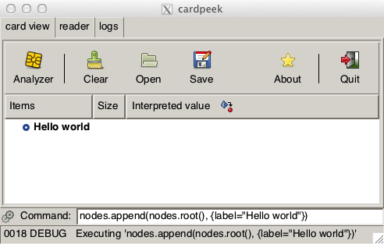Illustration 5: Hello world

Basic communication with a smart card
Here’s a short LUA script that demonstrates how to get and print the ATR (Answer To Reset) of a card in the card view.

card.connect()
atr = card.last_atr()
if atr~=nil then

root = nodes.root()

mycard = root:append({ classname="card",
label="My card" })

mycard:append({ classname="block",
label="Cold ATR",
size=#atr,
val=atr })
end

card.disconnect()

The fist command card.connect() powers-up the card in the card reader and prepares the card for communication. Next card.last_atr() returns the ATR of the card. If the value of the ATR is non-nil, the script creates a node called “ATR”, with a call to nodes.append(). This node will appear at the root of the card data tree-view and is constructed with two attributes:
- A classname: this describes the icon used to display the node (here a “card” icon).
- A label: the text displayed with the node.
A child node called “cold ATR” is then added to the parent “ATR” node, with 4 attributes:
- A classname: the icon used to display the node (here a “block” icon).
- A label: the text displayed with the node (i.e. “Cold ATR”).
- A size: the text displayed in the second column of the tree view.
- A val: the bytestring value displayed in the third column of the tree view (i.e. the hexadecimal value of the ATR).
Finally, the card is powered down with the card.disconnect() function.
The final output of the script should have roughly the following structure (though the value of the ATR will likely be different):
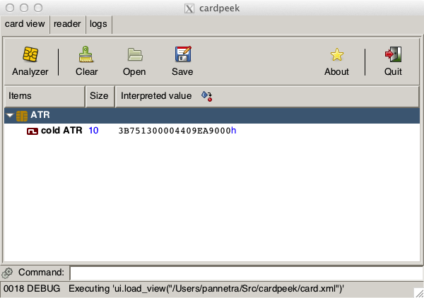Illustration 6: Displaying the ATR
The example above is equivalent to the “atr” script provided with Cardpeek. The LUA language is easy to learn and we refer the reader to http://www.lua.org/ for more information.

Representing card data in a tree structure
The data displayed in the card view of Cardpeek follows a tree structure, as sketched in Illustration 7 below:
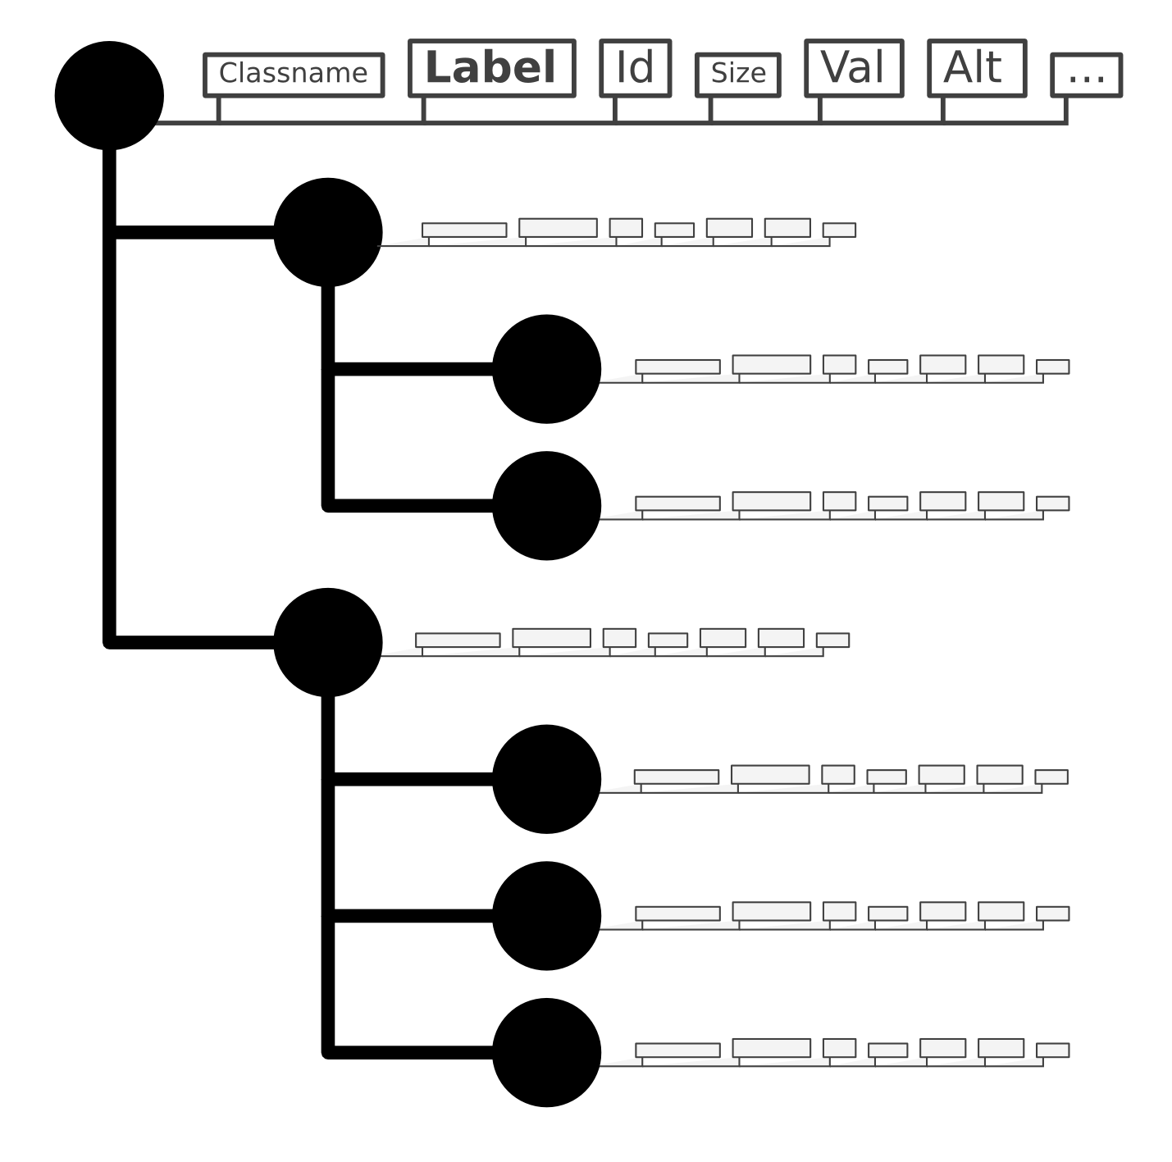Illustration 7: Tree structure

Each node of the tree has the following attributes that influence the display of data in the card view:
- A classname: describes the icon that will be associated with the node in the first column of the card view.
- A label: describes the name of the node, shown in bold in the first column of the card
view.
- An id: describes the Id associated with the node, following the label, in the first
column of the card view.
- A size: the size of the data associated to the node, displayed in the second column
of the card view.
- A value (val): the data associated to the node in raw binary format, displayed in
the third column of the card view.
- An alternative value (alt): the data associated to the node in an interpreted format, displayed in the third column of the card view.
- A mime-type: this gives Cardpeek a hint on how to render the value (val) on the screen, when an alternative value (alt) is not specified. Currently only images are supported.
All these attributes are optional. Moreover, script programmers can create new attributes as they wish for their own use, though only the ones above influence the display of Cardpeek. Attributes are set through functions such as nodes.set_attribute() and nodes.set_value() as described in section 6.6.
The tree itself is built with functions such as nodes.append() already described in the previous examples in this chapter.
Cardpeek provides many other functions to create, remove, alter and find nodes in a tree, all described in section 6.6.

Development library
This chapter describes the LUA libraries of functions that are used in Cardpeek scripts.

The bit library
Since LUA 5.1 does not have native bit manipulation functions, the following functions have been added. They all operate on integer numbers.

bit.AND

Synopsis
bit.AND(A,B)

Description
Compute the binary operation A and B.

bit.OR

Synopsis
bit.OR(A,B)

Description
Compute the binary operation A or B.

bit.XOR

Synopsis
bit.XOR(A,B)

Description
Compute the binary operation A xor B.

bit.SHL

Synopsis
bit.SHL(A,B)

Description
Shift the bits of A by B positions to the left. This is equivalent to computing A*2^{B}.

bit.SHR

Synopsis
bit.SHR(A,B)

Description
Shift the bits of A by B positions to the right. This is equivalent to computing A/2^{B}.

The bytes library
The bytes library provides a new opaque type to LUA: a bytestring, which is used to represent an array of binary elements.
A bytestring is mainly used to represent binary data exchanged with the card reader in the application.
The elements in a bytestring array are most commonly bytes (8 bits), but it is also possible to construct arrays of nibbles (4 bit) or arrays of individual bits. All elements in a bytestring have the same size (8, 4 or 1), which is referred as the “width” of the bytestring. The width of each element is specified when the array is created with the function bytes.new() described in this section. A function to convert between bytestrings of different widths is also provided.
Individual elements in a bytestring array can be accessed or modified with the bytes.get and bytes.set functions respectively. Contrary to the LUA tradition, the first index in a bytestring is 0 instead of 1. The number of elements in a bytestring is indicated by prefixing the bytestring with the “#” operator, just as with an array (e.g. #BS). It is also possible to access elements in bytestring using array notation (e.g. BS[1]=65).
Like LUA arrays, if you create a bytestring A then the assignment B=A does not make B a full copy of A but only an alias of A: any modification of A applies to B and vice-versa. If you want to create a real copy of a bytestring, you should use the bytes.clone() function or the bytes.new() function instead.
The functions of the bytes library are described hereafter.

Operators on bytestrings
The operators that can be used on bytestrings are “..”, “==”, “~=” and “#”

Synopsis
A..B
A==B
A~=B
#A

Description
The “..” operator creates a new bytestring by concatenating two bytestrings together. The concatenation operator also works if one of the operands is a string or a number, by converting it to a bytestring first, following the rules described in the bytes.assign() function. Writing A..B is equivalent to calling the function bytes.concat(A,B).
The “==” and “~=” operators allow to compare two bytestrings for equality or non- equality respectively. To be equal, two bytestrings must have the same width and the same elements in the same order.
Finally the “#” operator returns the number of elements in a bytestring.

bytes.clone

Synopsis
bytes.clone(BS)

BS:clone()

Description
Creates and returns a copy of BS.

Return Value
This function returns a bytestring upon success or nil if it fails.

bytes.concat

Synopsis
bytes.concat(value₀, value₁, ..., value_{N})

Description
Returns the concatenation of value₀, value₁, ..., value_{N} (from left to right).
For the rules governing the processing of value₀, value₁, ..., value_{N}, see the bytes.new() function.

Return Value
This function returns a bytestring upon success and nil otherwise.

bytes.convert

Synopsis
bytes.convert(BS, w)

BS:convert(w)

Description
Converts BS to a new bytestring where each element has a width w. Depending on the value of w, the elements in the converted bytestring are obtained by either splitting elements of BS into several smaller elements in the new bytestring or by grouping several elements of BS into a single element in the new bytestring.
If the conversion requires splitting elements of BS, then the original elements will be split with the most significant bit(s) first: the most significant bits of each original element of BS will have a lower index than the least significant bits.
If the conversion requires grouping elements together, BS is will first be right-padded with zeros to a size that is a multiple of w. Next, new elements are formed by considering elements of BS with a lower index as more significant than elements with a higher index.

Return Value
This function returns a new bytestring upon success and nil otherwise.

bytes.format

Synopsis
bytes.format(BS, format_string)

BS:format(format_string)

Description
Converts the bytestring BS to various printable formats according to the format_string character string. This format_string can be composed of plain characters, which are simply copied to the resulting string, and format specifications which are replaced by the designated representation of BS.
As in printf() functions found in many programming languages, each format specification starts with the character “%” and has the following meaning:
- %I represent BS as an unsigned decimal integer.
- %D represent BS as the concatenation of each of its elements represented in
hexadecimal or binary, starting from BS[0] to BS[N-1].
- %S is equivalent to “%w:%D”.
- %P represent BS where each element is converted to a printable character (in 7 bit
ascii format). Unprintable characters are escaped to octal notation (e.g. ascii 13 or carriage return becomes \015).
- %C represents BS as a LUA string, converting each element into a character of a string. This can notably be used to print a bytestring representing UTF8 data.
- %w represents the width of BS, that is 8, 4 or 1.
- %l represents the number of elements in BS, in decimal form (the length of BS).
- %% represent the “%” character itself.

Return Value
This function returns the resulting character string.

bytes.get

Synopsis
bytes.get(BS,i [,j])

BS:get(i [,j])

Description
Returns the list of values of elements of BS with index i to j inclusive. When j is not specified, this function simply returns the i^{th} element of BS (i.e it is equivalent to bytes.get(BS,i,i) or more simply BS[i]).

Return Value
This function returns a list of integer values upon success or nil otherwise.

bytes.ipairs

Synopsis
for i,v in bytes.ipairs(BS) do
...
end

for i,v in BS:ipairs() do
...
end

Description
The bytes.ipairs(BS) function returns an iterator on the elements of a bytestring BS. This iterator returns both the index and the value of each element, much like the ipairs() iterator used for tables in LUA.

Return Value
This function returns an iterator (a LUA function) upon success or nil otherwise.

bytes.is_printable

Synopsis
bytes.is_printable(BS)

BS:is_printable()

Description
Returns true if all elements in BS can be converted to printable 7 bit ascii characters, and
false otherwise.

Return Value
This function always returns false if the width of BS is not 8 (elements of width 4 or 1 are not printable ascii values).

bytes.new

Synopsis
bytes.new(width [, value₁, ..., value_{N}])

Description
Creates a new bytestring, where each element is width bits. width can be either 8, 4 or 1. A value can optionally be assigned to the bytestring by specifying one or several values value₁, ..., value_{N} that will be concatenated together to form the content of the bytestring.
The optional assigned value is built as the concatenation of value₁, ..., value_{N} (from left to right). Each value_{i} can be either a bytestring, a string or a number. If value_{i} is a bytestring, each element of value_{i} is appended to BS, without any conversion. If value_{i} is a string, it is interpreted as a text representation of the digits of a bytestring (as returned by the tostring() operator). This string representation is interpreted by taking into consideration the width of elements of BS and is appended to BS. If value_{i} is a number, it is converted into a single bytestring element and appended to BS.

Return Value
This function returns a bytestring upon success and nil otherwise.

bytes.new_from_chars

Synopsis
bytes.new_from_chars(string)

Description
Creates a new 8 bit width bytestring from string. Each ascii character in string is converted directly to an element of the resulting bytestring (e.g. “A” is converted to 65).

Return Value
This function returns a bytestring upon success and nil otherwise.

bytes.pad_left

Synopsis
bytes.pad_left(BS, block_length, value)

BS:pad_left(block_length, value)

Description
This function returns a copy of BS padded on the left with the element value until the length of the resulting bytestring reaches a multiple of block_length.
If the size of BS is already a multiple of block_length, no additional padding is applied.

Return Value
This function returns a bytestring upon success and nil otherwise.

bytes.pad_right

Synopsis
bytes.pad_right(BS, length, value)

BS:pad_right(BS, length, value)

Description
This function returns a copy of BS padded on the right with the element value until the length of the resulting bytestring reaches a multiple of block_length.
If the size of BS is already a multiple of block_length, no additional padding is applied.

Return Value
This function returns a bytestring upon success and nil otherwise.

bytes.reverse

Synopsis
bytes.reverse(BS)

BS:reverse()

Description
Returns a bytestring containing the elements of BS in reverse order.

Return Value
This function returns a bytestring upon success and nil otherwise.

bytes.set

Synopsis
bytes.set(BS, i, e0 [, e1, e2, ..., eN])

BS:set(i, e0 [, e1, e2, ..., eN])

Description
This function replaces the i^{th} element of BS with e0. If additional elements e1,e2,...,eN are specified in the call then the (i+1)^{th} element of BS is replaced by e1, the (i+2)^{th} element of BS is replaced by e2, etc.

Return Value
This function modifies its main argument BS and returns it.

bytes.sub

Synopsis
bytes.sub(BS, start [, end])

Description
Returns a copy of a substring from BS containing all elements between start and end. The returned value represents a bytestring containing a copy of all the elements of BS that have an index that verifies index ≥ start and index ≤ end. If end is not specified it will default to the last index of BS. If start (or end) is negative, it will be replaced by #BS+start (or #BS+end respectively).

Return Value
This function returns a bytestring upon success and nil otherwise.

bytes.tonumber

Synopsis
bytes.tonumber(BS)

BS:tonumber()

Description
Converts the bytestring BS to a the unsigned decimal value of BS. This conversion considers BS[0] as the most significant element of BS, and BS[#BS-1] as the least significant.

Return Value
This function returns a number.

bytes.width

Synopsis
bytes.width(BS)

BS:width()

Description
Return the width of the elements in BS.

Return Value
This function may return the number 1, 4 or 8.

The asn1 library
The ASN1 library allows to manipulate bytestrings containing ASN1 TLV data encoded in DER/BER format. These bytestrings must be 8 bit wide.
When Cardpeek reads TLV data from a card, it comes as a bytestring where the tag is encoded, followed by the length, and finally the value itself. For example Cardpeek may receive the following string: 4F07A0000000031010, where 4F is actually the tag, 07 the length, and A0000000031010 is the value. In some cases, the tag or the length follow more complex encodings, and some TLVs may be contained within other TLVs. The asn1 library provides facilities to decode and encode TLV data.
Normally, TLV values are composed of 3 elements: a tag number, a length, and the value itself. In LUA, we only need 2 items to represent a TLV: a tag number and a value represented as a bytestring. The length of the value is implicit and can computed by applying the # operator on the value.
The library provides the following functions.

asn1.enable_single_byte_length

Synopsis
asn1.enable_single_byte_length(enable)

Description
This function is only used in rare cases with erroneous card implementations. If enable=true the behavior of TLV decoding functions (such as bytes.tlv_split()) are modified by forcing the ASN1 length to be 1 byte long. This means that even if the first byte of the encoded length is greater than 0x80 it will be interpreted as the length of the TLV value.

Return Value
None.

asn1.join

Synopsis
asn1.join(tag, val [, extra])

Description
This function performs the opposite of asn1.split() (described in 6.3.3): it creates a bytestring representing the ASN1 DER encoding of the TLV {tag, len, val} where len=#val and appends extra to the result.
tag is positive integer number, val is a bytestring and extra is a bytestring or nil.

Return Value
This function returns a bytestring.

asn1.split

Synopsis
asn1.split(str)

Description
Parses the beginning of the bytestring str according to ASN1 BER TLV encoding rules, and extracts a tag number T and a bytestring value V.

Return Value
The function returns 3 elements {T, V, extra}, where extra is an optional bytestring representing the remaining part of str that was not parsed or nil if no data remains.
If this function fails it returns a triplet of nil values.

asn1.split_length

Synopsis
asn1.split_length(str)

Description
Parses the beginning of the bytestring str according to ASN1 BER and extracts a length L.

Return Value
The function returns {L, extra}, where extra is an optional bytestring representing the remaining part of str that was not parsed or nil if no data remains.
If this function fails it returns a pair of nil values.

asn1.split_tag

Synopsis
asn1.split_tag(str)

Description
Parses the beginning of the bytestring str according to ASN1 BER and extracts a tag T.

Return Value
The function returns {T, extra}, where extra is an optional bytestring representing the remaining part of str that was not parsed or nil if no data remains.
If this function fails it returns a pair of nil values.

The card library
The card library is used to communicate with a smart card in a card reader.
Cardpeek internally defines a minimal set of card functions in the card library. Some additional extensions to the card library are written in LUA and can be found in the file $HOME/.cardpeek/scripts/lib/apdu.lua, which should be loaded automatically when Cardpeek starts.
According to ISO 7816-4, smart card command APDUs are composed as a series of bytes generally organized as follows:

Code | Length | Name
CLA | 1 | Class
INS | 1 | Instruction
P1 | 1 | Parameter 1
P2 | 1 | Parameter 2
Lc | 1 (or 3) | Length of following data
Data | Variable | Data
Le | 1 (or 3) | Maximum expected length of response

The card library defines a global value card.CLA, which is the value that most card commands will use as CLA when they exchange data with the card-reader (unless you use card.send() directly).
This library contains the following functions.

card.connect

Synopsis
card.connect()

Description
Connect to the card currently inserted in the selected smart card reader or in proximity of a contactless smart card reader. This function will block until card is connected.
This command is used at the start of most smart card scripts.

Return Value
This function returns true upon success, and false otherwise.

card.disconnect

Synopsis
card.disconnect()

Description
Disconnect the card currently inserted in the selected smart card reader. This command concludes most smart card scripts.

Return Value
This function returns true upon success, and false otherwise.

card.get_data

Synopsis
card.get_data(id [, length_expected])

Description
Execute the GET_DATA command from ISO 7816-4 where:
- id is the tag number of the value to read from the card.
- length_expected is an optional value specifying the length of the resulting expected result (defaults to 0, which means 256 bytes).
The value of “CLA” in the command sent to the card is defined by the variable card.CLA.
This function is implemented in apdu.lua.

Return Value
The card status word and response data, as described in card.send (section 6.4.10 ).

card.info

Synopsis
card.info()

Description
Return detailed information about the state of the card reader.

Return Value
This function returns an associative array of (name ⇒ value) pairs.

card.last_atr

Synopsis
card.last_atr()

Description
Returns a bytestring representing the last ATR (Answer To Reset) returned by the card.

Return Value
This function returns a bytestring.

card.make_file_path

Synopsis
card.make_file_path(path)

Description
This function is designed to be a helper function for the implementation of card.select. It converts a human readable path string (representing a file location in a smart card) into a format that is compatible with the SELECT_FILE command from ISO 7816-4.
This function parses the string path and returns a pair of values {path_binary, path_type} where:
- path_binary is a bytestring representing the encoded binary value of path, and
- path_type is a number describing the path type (i.e. a relative path, an AID, ...)
The general rules needed to form a path string can be summarized as follows:
- A file ID is represented by 4 hexadecimal digits (however, there is an exception for ADFs that can also be represented by their AID, which requires 10 to 32 hexadecimal digits, or in other words 5 to 16 bytes).
- If path starts with the ‘#’ character, the file is selected directly by its unique ID or AID.
- If path starts with the ‘.’ character, the file is selected relatively to the current DF or EF.
- Files can also be selected by specifying a relative or absolute path, where each element in the path is represented by a 4 digit file ID separated by the ‘/’ character:
  - If path starts with ‘/’ the file is selected by its full path (excluding the MF).
  - If path starts with ‘./’ the file is selected by its relative path (excluding the current DF).
The next table describes the format of the string path and how it is interpreted more precisely. In this table, as a convention, hexadecimal characters are represented with the character ‘h’ and repeated elements are summarized by writing “[...]”.

path format | interpretation | path_type
# | Directly select the MF (equivalent to #3F00) | 0
#hhhh | Directly select the file with ID=hhhh | 0
#hhhhhh[...]hh | Directly select the DF with AID=hhhhhh[...]hh | 4
.hhhh | Under the current DF, select the file with ID=hhhh | 1
.hhhh/ | Under the current DF, select the DF with ID=hhhh | 2
.. | Select the parent of the current EF or DF. | 3
./hhhh/hhhh/hh[...] | Select a file using a relative path from the current DF. All intermediary DF’s are represented by their file ID separated by the ‘/’ character. | 9
/hhhh/hhhh/hh[...] | Select a file with an absolute path from the MF (the MF is omitted) All intermediary DF’s are represented by their file ID separated by the ‘/’ character. | 8

The resulting bytestring path_binary is simply produced from the concatenation of the hexadecimal values in path (represented by ‘h’ in the table above.)

Return Value
Upon success this function returns a pair of values consisting of a bytestring and a number. Upon failure, this functions returns a pair of nil values.

card.read_binary

Synopsis
card.read_binary(sfi [, address [, length_expected]])

Description
Execute the READ_BINARY command from ISO 7816-4 where:
- sfi is a number representing a short file identifier (1 ≤ sfi ≤ 30) or the string ‘.’ to refer to the currently selected file.
- address is an optional start address to read data (defaults to 0).
- length_expected is an optional value specifying the length of the resulting expected result (defaults to 0, which means 256 bytes).
The value of “CLA” in the command sent to the card is defined by the LUA variable card.CLA.
This function is implemented in apdu.lua.

Return Value
The card status word and response data, as described in card.send (section 6.4.10 ).

card.read_record

Synopsis
card.read_record(sfi, r, [, length_expected])

Description
Execute the READ_RECORD command from ISO 7816-4 where:
- sfi is a number representing a short file identifier (1 ≤ sfi ≤ 30) or the string ‘.’ to refer to the currently selected file.
- r is the record number to read.
- length_expected is an optional value specifying the length of the resulting expected result (defaults to 0, which means 256 bytes).
The value of “CLA” in the command sent to the card is defined by the LUA variable card.CLA.
This function is implemented in apdu.lua.

Return Value
The card status word and response data, as described in card.send (section 6.4.10 ).

card.select

Synopsis
card.select(file_path [, return_what [, length]])

Description
- Execute the SELECT_FILE command from ISO 7816-4 where:
file_path is string describing the file to select, according to the format described in card.make_file_path().
- return_what is an optional value describing the expected result, as described in the table below (defaults to 0).
- length is an optional value specifying the length of the resulting expected result (defaults to nil).
The following constants have been defined for return_what (some can be combined together by addition):

Constant | Value
card.SELECT_RETURN_FIRST | 0
card.SELECT_RETURN_LAST | 1
card.SELECT_RETURN_NEXT | 2
card.SELECT_RETURN_PREVIOUS | 3
card.SELECT_RETURN_FCI | 0
card.SELECT_RETURN_FCP | 4
card.SELECT_RETURN_FMD | 8

The value of “CLA” in the command sent to the card is defined by by the variable card.CLA. The value of “P1” in the command sent to the card corresponds to the file type computed by card.make_file_path. The value of “P2” in the command sent to the card corresponds to return_what.
This function is implemented in apdu.lua.

Return Value
The card status word and response data, as described in card.send (section 6.4.10).

card.send

Synopsis
card.send(APDU)

Description
Sends the command APDU to the card.

Return Value
The function returns a pair of values: a number representing the status word returned by the card (ex. 0x9000) and the response data returned by the card.
Both the command APDU and the response data are bytestrings (see the bytes library).

card.warm_reset

Synopsis
card.warm_reset()

Description
Performs a warm reset of the card (reconnects the card currently inserted in the selected smart card reader).

Return Value
None

The crypto library
This library proposes a limited number of cryptographic functions. Currently these
functions offer mainly DES, Triple-DES, and SHA1 based transformations.

crypto.create_context

Synopsis
crypto.create_context(algorithm [,key])

Description
This function creates a cryptographic “context” that holds a description of a cryptographic algorithm, along with a (optional) key. The created context is later used as a parameter to other generic functions in the crypto library, such as crypto.encrypt(), crypto.mac(), crypto.digest(), …
The first parameter algorithm allows to describe the cryptographic algorithm to be used. It can currently take the following values:

Algorithm | Description
crypto.ALG_DES_ECB | Simple DES in ECB mode (so no IV).
crypto.ALG_DES_CBC | Simple DES is CBC mode.
crypto.ALG_DES2_EDE_ECB | Triple DES with a double length 112 bit key in ECB mode (no IV).
crypto.ALG_DES2_EDE_CBC | Triple DES with a double length 112 bit key in CBC mode.
crypto.ALG_ISO9797_M3 | ISO 9797 MAC method 3 with a 112 bit key: a simple DES CBC MAC iteration with triple DES on the final block.
crypto.ALG_SHA1 | The SHA1 digest algorithm.

Some of the previous algorithms only operate on data that has been padded to a reach a proper size, which is usually a multiple of a defined “block size”. The value of algorithm can be used to specify the padding method that is used, by combining (with the ‘+’ operator) one of the following values to the algorithm previously specified:

Padding method | Description
crypto.PAD_ZERO | Add 0’s if needed to reach block size.
crypto.PAD_OPT_80_ZERO | If the size of cleartext is not already a multiple of block size then add one byte 0x80 and then 0’s, if needed, to reach block size.
crypto.PAD_ISO9797_P2 | ISO 9797 padding method 2 (add a mandatory byte 0x80 and pad with optional 0’s to reach block size).

The optional bytestring key must be used to specify the value of the cryptographic key used for encryption or MAC algorithms (but is ignored for hash algorithms).

Return Value
This function returns a bytestring representing the created context. Programmers should consider the result as an opaque value and should not modify its content.

crypto.decrypt

Synopsis
crypto.decrypt(context, data [, iv])

Description
Decrypt the bytestring data, using the key and algorithm provided in context.
When the decryption algorithm requires an initial vector, it must be specified in iv. All parameters and the return value are 8 bit wide bytestrings.

Return Value
This function returns the decrypted data as a bytestring.

crypto.digest

Synopsis
crypto.digest(context, data)

Description
Compute the digest (also often called a hash) of data, using the algorithm provided in context.
All parameters and the return value are 8 bit wide bytestrings.

Return Value
This function returns the digest value as a bytestring.

crypto.encrypt

Synopsis
crypto.encrypt(context, data [, iv])

Description
Encrypt the bytestring data, using the key and algorithm provided in context.
When the encryption algorithm requires an initial vector, it must be specified in iv. All
parameters and the return value are 8 bit wide bytestrings.

Return Value
This function returns the encrypted data as a bytestring.

crypto.mac

Synopsis
crypto.mac(context, data)

Description
Computes the MAC (Message Authentication Code) of data, using the key and algorithm provided in context. All parameters and the return value are 8 bit wide bytestrings.

Return Value
This function returns the MAC as a bytestring. The resulting MAC is not truncated.

The iconv library
The nodes library allows to convert strings from one encoding to another. This is useful for example to convert ISO-8859-1 character strings to UTF-8 for display in Cardpeek, since Cardpeek expects UTF-8 strings in the treeview.
This library is a wrapper around the iconv standard library provided on most unix platforms. See the iconv_open() and iconv() man pages on Linux/Unix for more details.

iconv.open

Synopsis
converter = iconv.open(formcode, tocode)

Description
This function creates a converter object that can be used to convert text encoded in fromcode to text encoded in tocode.
Both fromcode and tocode are strings describing an encoding such as “ISO-8859-1”, “UTF-8”, “ASCII”, “CP437”, etc.

Return Value
Returns a “converter” object that can be used in subsequent calls to iconv.iconv() or nil in case of failure.

iconv.iconv

Synopsis
converted_string = converter:iconv(orginal_string)

converted_string = original_string:iconv()

Description
This function converts a string from one format to another, using a converter object created previously with iconv.open().
The function takes a string as input and returns the converted string.

Return Value
Returns the converted string in case or success or nil otherwise.

The nodes library
The nodes library allows to add, delete, modify and find nodes in the card view representation of the card content.

nodes.append

Synopsis
nodes.append(parent [, attr_array])

parent:append([attr_array])

Description
This function adds a node in the card tree structure.
The new node will be appended to the children of the node identified by the node reference parent. If parent is nodes.root() the new node will be added at the top level (see 6.7.10).
The content of the new node can optionally be specified through attr_array, a LUA associative array of (key,value) pairs describing the content of the new node. For example, to create a node with the label “foo” with a “file” icon, you would pass the value {classname="file", label="foo"} as attr_array. While you may specify any (key,value) pairs, the nodes library gives a specific meaning to the following keys:
- classname: a string that provides additional information describing the type of data represented by the node. This value will affect the choice of the icon that is associated with the node in the displayed card tree structure. The following classname values are associated with a distinct icon: “application”, “block”, “card”, “file”, “record” and “item”. If classname is nil or unrecognized, it will be set to the default value “item”.
- label: a string that describes the data that is represented by the node in human readable form (such as a “file” or a “date of birth” for example).
- id: a string that identifies the node uniquely within a context (such as a number or a unique name).
- size: is a number describing the length of the data element associated to the node. If set, it will be displayed in the second column of the card view in the UI.
- Val: a bytestring that describes the raw data presented in the third column of the card view in the UI.
- alt is an optional string that describes the interpreted data presented in the third column of the card view in the UI.
- mime-type is a string that is used to optionally indicate how to render visually the value specified by the val attribute (described above) when the alt attribute is absent. Currently this is only used to render images by specifying image data in the val attribute and setting mime-type to “image/jpeg” for example.
These attributes can be also added or modified in a node with the node.set_attribute() function (see 6.7.11).

Return Value
Upon success the function returns a node reference to the newly created node. If the function fails, it returns nil.

nodes.attributes

Synopsis
for k,v in nodes.attributes(node_ref) do
...
end

for k,v in node_ref:attributes() do
...
end

Description
This function provides an iterator for the attributes of node_ref, a node reference. The attributes are represented as key/value pairs (in the example here k,v).

Return Value
Returns an iterator for use in a for loop.

nodes.children

Synopsis
for child in nodes.children(parent) do
...
end

for child in parent:children() do
...
end

Description
This function provides an iterator for the child nodes of parent, a node reference. The iterator returns a reference to each child of the parent node (in the example here child).

Return Value
Returns an iterator for use in a for loop.

nodes.find

Synopsis
for node_ref in nodes.find(root, attr_array) do
...
end

for node_ref in root:find(attr_array) do
...
end

Description
This function provides an iterator that will return all nodes in the card tree view rooted at root, which match the attributes defined in attr_array. The attribute array attr_array is a LUA associative array of key/value pairs as defined for the function nodes.append() (see 6.7.1).
A node is considered as matching attr_array if all key value/pairs defined in attr_array exist in the node and have the same value. For example if we use {label="file"} as attr_array, the iterator will go through all nodes that have the label “file”, regardless of other attributes the nodes may have.

Return Value
Returns an iterator for use in a for loop.

nodes.find_first

Synopsis
nodes.find_first(root, attr_array)

root:find_first(attr_array)

Description
This function returns the first node in the card tree view rooted at root, which matches the attributes defined in attr_array. The attribute array attr_array is a LUA associative array of key/value pairs that is used for matching following the same rules used for node.find() (see 6.7.4).

Return Value
A node reference or nil if no node is found.

nodes.from_xml

Synopsis
nodes.from_xml(parent,xml_string)

parent:from_xml(xml_string)

Description
This function appends nodes described in the XML expression xml_string to parent. The expression xml_string describes a subtree of nodes, following the syntax defined in Chapter 7 .

Return Value
This function returns true in case of success and false otherwise.

nodes.get_attribute

Synopsis
nodes.get_attribute(node_ref, attr_name)

node_ref:get_attribute(attr_name)

Description
Gets the value of an attribute in the node identified by node_ref. The name of the attribute to retrieve is identified by the string attr_name.
The attributes named “classname”, “label”, “id”, “alt”, “val”, “mime-type” and “size” refer to the parameters passed to the function nodes.append() as described in section 6.7.1.

Return Value
This function returns a string upon success and nil otherwise.

nodes.parent

Synopsis
nodes.parent(node_ref)

node_ref:parent()

Description
Returns the parent node of the node referenced by node_ref. If the node referenced by node_ref has no parent the function return nil.

Return Value
Return a node reference upon success or nil otherwise.

nodes.remove

Synopsis
nodes.remove(node_ref)

node_ref:remove()

Description
Deletes the node identified by node_ref as well as all its children.

Return Value
The function returns true upon success and false otherwise.

nodes.root

Synopsis
nodes.root()

Description
This function simply return the absolute root of the card view tree, which is invisible. This is typically used to create the first node in the tree in combination with node.append() (e.g. “node.root():append(...)”)

Return Value
A node reference.

nodes.set_attribute

Synopsis
nodes.set_attribute(node, attr_name, attr_value)

node:set_attribute(attr_name, attr_value)

Description
Sets an attribute in the node identified by node_ref. The attribute to set is identified by the string attr_name and takes the value indicated by the string attr_value.
The attributes named “classname”, “label”, “id”, “alt”, “val”, “mime-type” and “size” refer to the parameters passed to the function nodes.append() as described in section 6.7.1.
The programmer can associate any arbitrary attribute with a node.

Return Value
This function returns true upon success and false otherwise.

nodes.to_xml

Synopsis
nodes.to_xml(node)

node:to_xml()

Description
Returns an XML representation of the sub-tree that has node as a root. If node is nodes.root() the representation of the whole tree is returned.

Return Value
This function returns a string upon success. If the function fails, it returns nil.

The ui library
The ui library allows to control some elements of the user interface of Cardpeek, and in particular the tree structure representing the data extracted from the card.
The tree structure representing card data is composed of nodes, each represented on one row in the card tree view. Some function in the ui library are used to manipulate these nodes (or rows), allowing to add, remove or edit them. These functions identify each node by a node reference, which is an internal opaque type. The ui library functions are described in the following paragraphs.

ui.question

Synopsis
ui.question(text, buttons)

Description
Asks the user a question requesting him to answer by selecting a response.
The question is described in the string text, while the set of possible answers described in the LUA array buttons. Each element in the array buttons is string representing a possible answer.

Return Value
Upon success, the function returns the index of the answer selected by the user in the table buttons (LUA table indices are usually numbers greater or equal to 1).
Upon failure the function returns 0.

Example
ui.question("Quit the script?", { "yes", "no" } )

ui.readline

Synopsis
ui.readline(text [,len [,default_value]])

Description
Request the user to enter a text string. The user’s input can optionally be limited to len characters and can also optionally hold a predefined value default_value.

Return Value
The function returns the user’s input upon success and false otherwise.

Example
ui.readline("Enter PIN code:", 4, "0000")

ui.load_view

Synopsis
ui.load_view(file_name)

Description
Loads the tree from the XML file named file_name. See Chapter 7 for a description of the file format.

Return Value
The function returns true upon success and false otherwise.

ui.save_view

Synopsis
ui.save_view(file_name)

Description
Saves the tree in XML format inside the file named file_name. See Chapter 7 for a description of the file format.

Return Value
The function returns true upon success and false otherwise.

The log library
The log library contains just one function described below, which allows to print
messages in the “log” tab of the application.

log.print

Synopsis
log.print(level, text)

Description
Prints a message text in the console window.
level describes the type of message that is printed. level can take the following values: log.INFO, log.DEBUG, log.WARNING, or log.ERROR.
All messages printed on the screen with this function are also saved in the file “$HOME/.cardpeek.log”.

Return Value
None.

Other libraries

The treeflex library
As of version 0.8, the treeflex library is deprecated. All functions previously provided by this library are now available through the nodes library.

The country_codes and currency_codes libraries
These library provide convenience functions to translate currency and country codes in
human readable names.

The en1545 library
This library provides tools to manipulate data used in Calypso cards that follow
CEN/ISO 1545.

6.8.4 The strict library
This library forces LUA variables to be explicitly declared, and thus reduces programming errors.

6.8.5 The tlv library
This library is built upon the asn1 library and provides automated tools to analyze and
display complex ASN1 TLV data objects in Cardpeek.

File format
The card view presented in Cardpeek can be save or imported in XML format. This format is quite straightforward, as shown in the following example, which was created with the atr script:

<?xml version="1.0"?>
<cardpeek>
<version>0.8</version>
<node>
<attr name="classname">card</attr>
<attr name="label">ATR</attr>
<node>
<attr name="classname">block</attr>
<attr name="label">cold ATR</attr>
<attr name="size">10</attr>
<attr name="val" encoding="bytes">8:3B751300004409EA9000</attr>
</node>
</node>
</cardpeek>

The format of the XML card view file is constructed according to the following rules:
- The root element of the XML structure is <cardpeek>, which contains one <version> element followed by one or more <node> elements.
- The <version> element contains the file format version number (currently 0.8).
- A <node> element may contain both <node> and <attr> elements.
- A <attr> element has one mandatory XML attribute “name” which describes the name of a “node attribute” associated with a node in the tree view, while the text inside the <attr> element describes the value associated with that “node attribute”. The <attr> element has one optional XML attributes “encoding” that is used to specify the format of the content data, when it is not a standard string. Currently, the attribute type can only take one value “bytes” to indicate that the content data is an encoded bytestring.
A node can have any number of “node attributes” defined by an <attr> element. However, some “node attributes” have a specific meaning for Cardpeek (see 6.7.1):
- <attr name="classname"> describes the type of node (a file, an application, a data block, a data item, etc.) and its value will determine the icon used to represent the node on the screen in the application.
- <attr name="label"> describes the label given to the node on the screen (first column).
- <attr name="id"> describes the id of the node displayed on the screen (first column).
- <attr name="size”> describes the size that is displayed on the screen (second column).
- <attr name="val" type="bytes"> describes the value of the bytestring associated with a node (and represented in the third column on the screen). This bytestring is represented as a width value followed by “:” and the digits representing the bytestring (this is equivalent to the %S output format of the bytes.format() function).
- <attr name="alt"> describes an alternative representation of the value associated with a node and represented in simple text format.
- <attr name=”mime-type”> is an indicator of how to render the data described by the val attribute in the absence of the alt attribute (see 6.7.1).
Node attribute names stating with a minus sign (example: “-makup-val”) are considered as temporary attributes and are not exported or saved in XML format. They are used internally by Cardpeek or script programs.

Notes:
- The Cardpeek XML format has changed in Cardpeek version 0.8 and is not compatible with previous versions.
- Since version 0.8.3 the attribute “encoding” has replaced “type” in <attr>, but Cardpeek can still read files generated with versions 0.8, 0.8.1 and 0.8.2.

License
Cardpeek is free software: you can redistribute it and/or modify it under the terms of the GNU General Public License as published by the Free Software Foundation, either version 3 of the License, or (at your option) any later version.
As an exemption to the GNU General Public License, compiling, linking, and/or using OpenSSL is allowed.
Cardpeek is distributed in the hope that it will be useful, but WITHOUT ANY WARRANTY; without even the implied warranty of MERCHANTABILITY or FITNESS FOR A PARTICULAR PURPOSE. See the GNU General Public License for more details.
You should have received a copy of the GNU General Public License along with this program. If not, see http://www.gnu.org/licenses/.

APDU: Application Protocol Data Unit, a sequence of bytes describing a message exchanged between the smart card and the reader.
For a quick tutorial on ASN1 see “A Layman's Guide to a Subset of ASN.1, BER, and DER” by B. S. Kaliski Jr.
TLV = Tag,Length,Value
DER/BER = Distinguished/Basic Encoding Rules

