Introduction

1.1 Literature Review

Natural language processing (NLP) has become invaluable for many clinical tasks, from Electronic Health Records (EHR) phenotyping to patient communication systems. Patient question classification supports medical information retrieval, automated patient triage and clinical decision support.

Historically, healthcare NLP relied on rule-based methods or classical machine learning (ML), with TF-IDF vectorisation a traditional baseline, paired with distance-based retrieval: questions are represented as sparse TF-IDF vectors and classified by most similar labels. TF-IDF baselines remain robust and computationally efficient despite struggling with semantic variation, synonyms and novel vocabulary.

Deep learning captures context-aware embeddings, representing specialised terminology better than lexical methods: BERT (Devlin et al., 2019) models fine-tuned on clinical corpora, like BioBERT (Lee et al., 2020) and Bio_ClinicalBERT (Alsentzer et al., 2019), achieve state-of-the-art clinical text classification. Large language models (LLMs) have enabled in-context learning, classifying purely through prompting, with zero-shot, few-shot and chain-of-thought strategies for supplying context without any parameter update (Schulhoff et al., 2024). Fine-tuned encoders nonetheless beat zero-shot LLMs on biomedical classification (Chen et al., 2025), motivating retrieval-augmented generation (RAG), which adds clinical text as context to improve accuracy and reduce hallucination.

1.2 Motivation and Rationale

The primary aim is to evaluate traditional lexical retrieval against deep neural approaches on a 906-class medical condition classification task, using accuracy and F1, and considering implications for digital health safety, transparency and compute cost.

Three arms implement this comparison:

- Arm 1, TF-IDF vectorisation with cosine k-nearest-neighbour retrieval over a class-level index;
- Arm 2, Bio_ClinicalBERT fine-tuned as a 906-way classifier;
- Arm 3, TF-IDF retrieval shortlisting candidates for an LLM to re-rank by prompting. Retrieval is expected to be a strong baseline because class distribution is uniform at 10 examples for most classes, limiting the encoder's advantage over it by the same sparsity.

Methodology

2.1 Dataset Description

The dataset was synthetically generated using ChatGPT from the NHS UK website's patient-information section, released as part of the OpenGPT dataset (CogStack, 2023) after manual human validation.

It covers 906 conditions with multiple Q&A pairs each, across 8,891 questions. The provided test set covers 200 questions over 102 of those conditions, all present in training. It is distinct from the internally constructed validation split, taken from training and matching the test set's size and class count. Neither contains null values, exact duplicate rows or repeated question-disease pairs, and both are almost uniformly distributed, with 87.9% of classes having exactly 10 pairs, requiring no resampling. Questions are short, averaging 8.4 words in training, 7.4 in test.

2.2 Data Preprocessing

Text was converted using TfidfVectorizer for retrieval and Bio_ClinicalBERT WordPiece tokeniser for the neural arm. Only the question field is inputted and reference_url was dropped since it maps directly to the disease label. Case sensitive labels were preserved since NHS filenames match label casing. Setting min_df=1 avoids discarding rare class-identifying terms (Table 1).

Stop-word removal and lemmatisation were tested as ablations and rejected. Removal isn't safe due to the short question length (8.4), and because the text is lowercased, two of the 155 clinical acronyms in the training questions - AS (ankylosing spondylitis) and ME (myalgic encephalomyelitis) appear in scikit-learn's stop-word list and would be discarded, IDF already down-weights frequent terms.

Questions were capped at max_length=48 rather than BERT's default 512 because the longest is 44 tokens including special tokens, and truncation at 48 measures 0%, allowing to safely reduce the computational costs.

NHS documents were cleaned before indexing, since for QLAD they are scored at retrieval time. Navigation text, image-credit links and "page last reviewed" footers made up 4.96% of characters and removing them reduced the terms present in over 95% of documents from 22 to 13.

Table 1: Preprocessing and index-construction ablations.

Stage

Parameter

Value used

Library default

Changed

Source

Case folding

lowercase

True

True

No

default

Tokenisation

token_pattern

(?u)\b\w\w+\b

(?u)\b\w\w+\b

No

default

N-grams

ngram_range

(1, 2)

(1, 1)

Yes

grid

Stop words

stop_words

None

None

No

grid

DF floor

min_df

1

1

No

grid

DF ceiling

max_df

1.0

1.0

No

fixed

Term weighting

sublinear_tf

False

False

No

grid

IDF

use_idf

True

True

No

default

IDF smoothing

smooth_idf

True

True

No

default

Normalisation

norm

l2

l2

No

default

Lemmatisation

spaCy model / enabled

en_core_web_sm / disabled

n/a (not a TfidfVectorizer parameter)

No

ablation

BERT tokenisation

WordPiece: model / max_length/padding

Bio_ClinicalBERT / 48, pad to max_length

model_max_length=512 (default)

Yes

grid

Source indicates how each value was chosen: grid search, kept default, or by ablation (Table 5).

2.3 Traditional NLP Approach

TF-IDF vectorisation is followed by a cosine k-nearest-neighbour classifier, where the predicted label is voted for by top-k (k=1) neighbours and weighed by similarity (Figure 1). The same weighted ranking informs Arm 3's depth-20 shortlist, letting one very close neighbour outrank several weak ones.

Figure 1: Arm 1 - TF-IDF retrieval over a QLAD class-blob index.

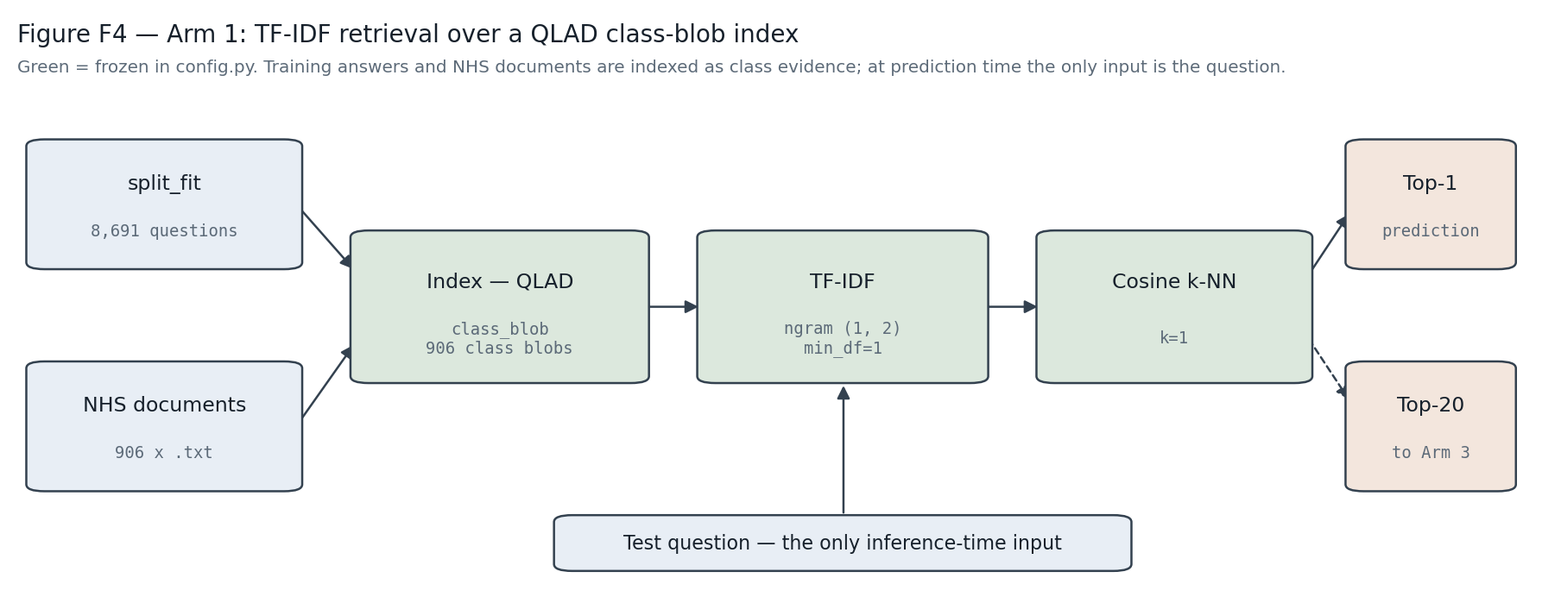

Pipeline diagram: split_fit questions and the 906 NHS documents were indexed under the frozen QLAD/class_blob/ngram(1,2) configuration. The test question is the only inference-time input, producing a top-1 prediction and a top-20 shortlist for Arm 3. Green blocks mark settings frozen in config.py.

Four index variants were tested:

- question text only (Q);
- +label text (QL);
- +training answers (QLA);
- +NHS documents (QLAD). Training-side answers and documents are indexed only as class evidence and prediction-time input remains the test question alone, so this is knowledge-base construction, not leakage.

LinearSVC, Random Forest and Logistic Regression were fit directly on TF-IDF vectors as supervised baselines, scoring 0.815, 0.765 and 0.635. They did not beat retrieval's 0.850, therefore neighbour matching was preferred.

NHS-prose index text forced a vectoriser re-tune, selecting ngram_range=(1,2), min_df=1 and no stop-word removal. Shortlist depth was fixed at 20. The ceiling this places on Arm 3 is the more conservative 0.975 on test, rather than the 0.995 measured on validation.

2.4 Neural Approaches

Arm 2: fine-tuned BERT classifier

Bio_ClinicalBERT was fine-tuned with a 906-way head (AdamW, learning_rate=2e-5, batch_size=16, max_length=48). Learning rate and batch size were left at standard fine-tuning values across both encoders, since at 3.5pp standard error (SE) a 200-item hold-out could not resolve the difference. Epoch selection takes the fewest epochs whose validation accuracy is within 1 SE of the best (Figure 2; epochs are numbered from zero throughout, as on the figure's axis). The best accuracy was 0.870 at epoch 22 but epoch 14 already reached 0.850, inside that margin, so the earlier and cheaper checkpoint was kept at 15 epochs of training in total.

Figure 2: Arm 2 training/validation loss.

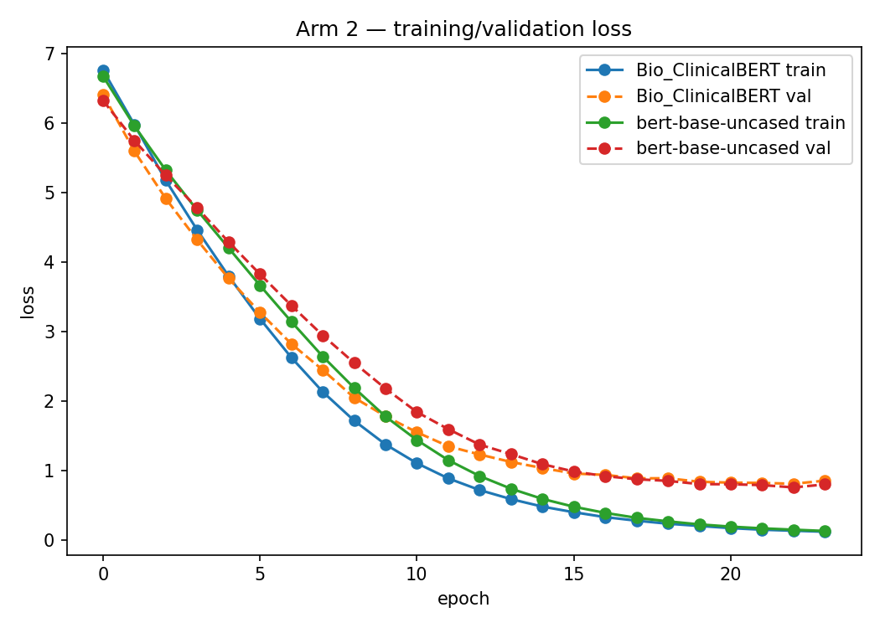

Cross-entropy loss by epoch for Bio_ClinicalBERT and bert-base-uncased. The checkpoint was chosen on validation accuracy, not on loss convergence: validation loss was still falling at the selected epoch 14 but choice comes from accepting an accuracy within 1 SE of the best.

Bio_ClinicalBERT (0.850) was compared against bert-base-uncased (0.875) by McNemar: 6 items only the first got right, 11 only the latter, p=0.332. The comparison failed to resolve the selection, so Bio_ClinicalBERT was kept as the domain-specific model.

Arm 3: LLM shortlist re-ranking

Arm 3 reuses the frozen Arm 1 index to select 20 candidate labels per question and prompts an LLM to pick one, under three conditions:

- zero-shot (candidates only);
- few-shot (with two worked examples);
- and chain-of-thought (COT) (with a reasoning instruction).

The reply was matched with a candidate by name and Arm 1's top-1 was used as a safe fallback if no match was found.

Two generators were compared at temperature 0: primary microsoft/MediPhi-Guidelines and secondary google/flan-t5-large. Rather than testing all six prompt-by-model combinations at once, selection ran in two stages fixed in advance: the three prompt conditions were first compared on the primary generator alone by McNemar's test, then the two generators were compared at that fixed condition. Splitting the choice this way improves clarity and avoids the extra false-positive risk of six simultaneous pairwise comparisons on a 200-item hold-out.

2.5 Experimental Protocol

Stratified splitting by train_test_split is infeasible, because it requires one held-out example per class, but the 906-class label space exceeds the 200-item validation size, and an unstratified split can result in non-uniform class representation (177 classes under seed 42). Therefore quota-based sampling was used, mirroring the test set's size while keeping at least two training examples per class.

At n=200 the single-proportion SE is ≈3.5pp, so differences below 7pp are considered as noise. Every comparison was instead checked with McNemar's test, which only uses the questions where the systems disagreed, since paired predictions on the same items are more informative than two independent ones. Accuracy is reported with bootstrap 95% CIs (Table 2).

A shift-aware protocol was used to resolve ties which the standard hold-out failed. A hold-out was drawn only from training questions sharing no words with their own label (1,423 of 8,891), because the test distribution more closely resembles this sample, in which the question never names its own label. The standard hold-out decided between candidates if the gap between them exceeded one SE, otherwise the shift-aware hold-out's ranking was used to break the tie. This was used for Arm 1 index selection only, as discussed in 4.2.

Validation informed every model, hyperparameter, and prompt decision, and test predictions were generated only once after freezing.

Results

3.1 Exploratory Data Analysis

Class support, question length and label-family structure are summarised in Figure 3. Near-duplication and sibling homogeneity use different representations, with bigrams detecting duplicate phrasing, unigrams the within-class comparison. Median per-test-question maximum similarity to any training question is 0.485, with only 0.5% above the 0.9 near-duplicate threshold, rejecting near-duplication as an explanation for the results.

Figure 3: Dataset composition and length/duplication diagnostics.

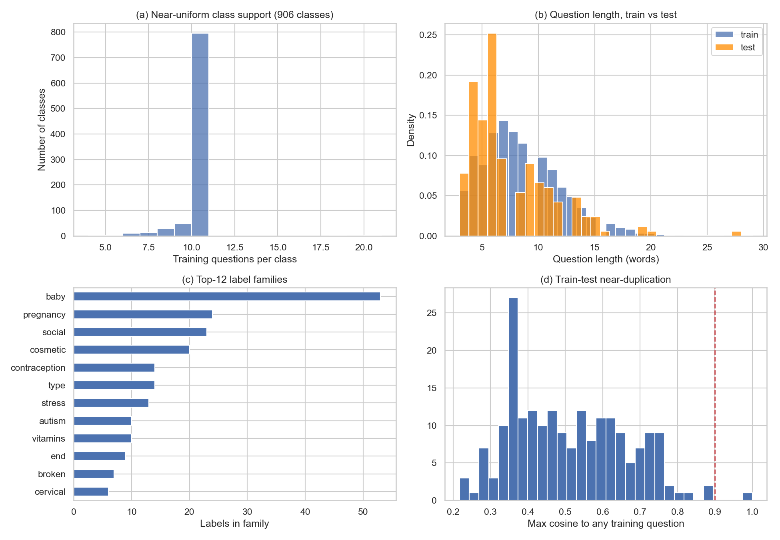

(a) Training questions per class are near uniform (min 4, median 10, max 20) except a small left tail.

(b) Train vs. test question-length distributions in words.

(c) The twelve largest label-prefix families.

(d) Maximum cosine similarity from each test question to any training question, with the 0.9 near-duplicate threshold marked with the dashed line.

Training questions are lexical siblings (Figure 4), where the nearest same-class sibling scores 0.572. The test question's nearest own-class training question scores only 0.391 and its nearest other-class question scores 0.510 (0.119 difference). 84.0% of training questions, but only 5.5% of test questions, contain a word from their own disease label.

Figure 4: Sibling phrasing homogeneity chart to explain the val-test gap.

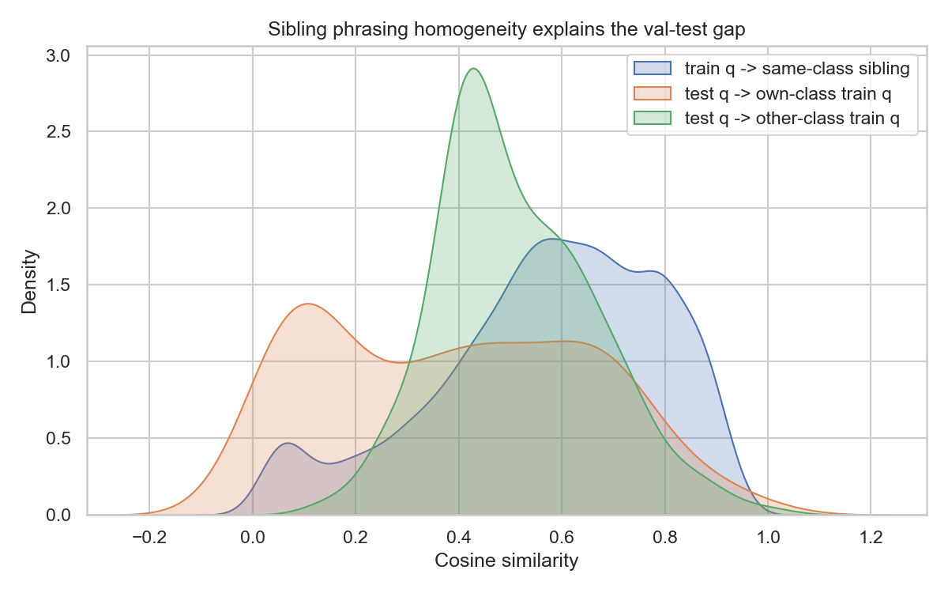

Cosine-similarity distributions: each training question to its nearest same-class sibling, each test question to its nearest own-class training question, and each test question to its nearest other-class training question — the basis for the shift-aware validation protocol.

Consequently, for 59.5% of test questions a wrong-class training question is closer than any own-class one. Therefore, nearest-neighbour rule is ineffective for the test distribution, and any validation estimate drawn from siblings will be optimistic, supporting the shift-aware protocol.

3.2 Performance Comparison

Table 2 gives each arm's validation and test accuracy with bootstrap confidence intervals, and Figure 5 plots the test figures side by side.

Table 2: Validation and test accuracy by arm, with bootstrap 95% confidence intervals, optimism, and macro-F1.

System

Validation

Test

95% CI (test)

Optimism

Macro-F1 (test)

Arm 1 (TF–IDF k-NN)

0.850

0.765

$0.705,0.820$

8.5pp

0.563

Arm 2 (Bio_ClinicalBERT)

0.850

0.615

$0.545,0.680$

23.5pp

0.354

Arm 3 (shortlist + LLM)

0.720

0.720

$0.660,0.780$

0.0pp

0.494

All four index variants scored 0.820 on the standard hold-out, so the shift-aware split was the tiebreaker, ranking QLAD (0.328) over QLA (0.263). Those two figures come from the grid run before the vectoriser was re-tuned, so they are not comparable with the frozen-configuration ablations in Table 5. Arm 3's prompt conditions were indistinguishable (smallest p=0.511), so zero-shot was chosen for simplicity. In the generator comparison via McNemar's test MediPhi (0.720 validation accuracy) beat flan-t5-large (0.635) (p=0.033).

Figure 5: Test accuracy by arm.

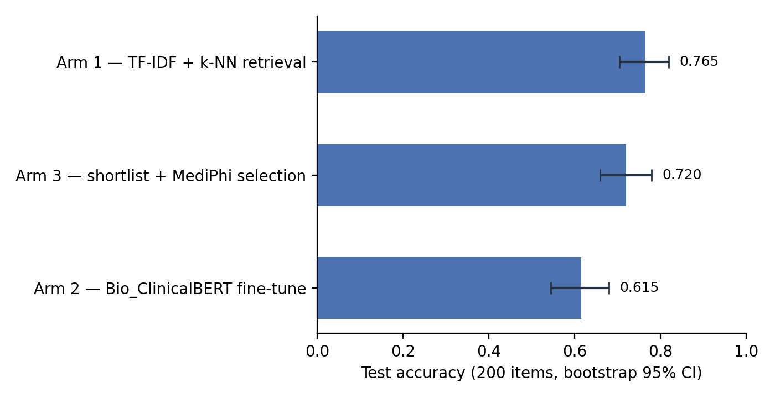

Test-set accuracy (200 items) with bootstrap 95% confidence intervals for each arm.

Table 3: Pairwise McNemar comparisons between arms, validation vs. test.

Pair

Validation

Test

Arm 1 vs Arm 2

15/15, p=1.000, unresolved

37/7, p=5.3e-06, Arm 1 wins

Arm 1 vs Arm 3

32/6, p=2.4e-05, Arm 1 wins

20/11, p=0.150, unresolved

Arm 2 vs Arm 3

33/7, p=4.2e-05, Arm 2 wins

11/32, p=0.0019, Arm 3 wins

Every ranking that seemed reliable on the hold-out was reversed on the test set (Table 3). Arm 2 learned to recognise the phrasing of training questions rather than the disease, so it performed well on questions with similar phrasing and struggled when test questions used different wording. Arm 1's TF-IDF index was less influenced because it's built from NHS description text, not paraphrases. This is also why Arm 3 closely tracks Arm 1, since the LLM returns Arm 1's top candidate on 81% of test items.

Arm 1 and Arm 2 reached identical validation accuracy but disagreed on 22% of test items (44 of 200), suggesting they make mistakes on different questions. However, combining them would likely underperform Arm 1 alone, because Arm 2 is only uniquely correct on 2 of the 200 test items. Since Arm 1 is correct on almost every item where the two disagree, merging Arm 2's answers would add more mistakes than corrections.

3.3 Error Analysis

Macro-F1, the unweighted average of each class's F1-score, is lower than accuracy for every arm on test (Arm 1 scores 0.563 against its accuracy of 0.765), suggesting errors are not spread evenly.

Many of the 906 disease labels share a text prefix (siblings), and 88 of the 200 validation questions have a true label with at least one sibling. Both arms made 30 validation errors. For Arm 1, 25 of those errors were on questions where a sibling confusion was possible, and 18 of the 25 (72%) were due to that. For Arm 2 these figures are 21 and 10 (48%).
This cannot be reported for the test set, where too few (18 of the 200) test questions have a sibling for the rate to be meaningful. Figure 6 shows each arm's most frequent test confusions.

Figure 6: Most frequent confusions.

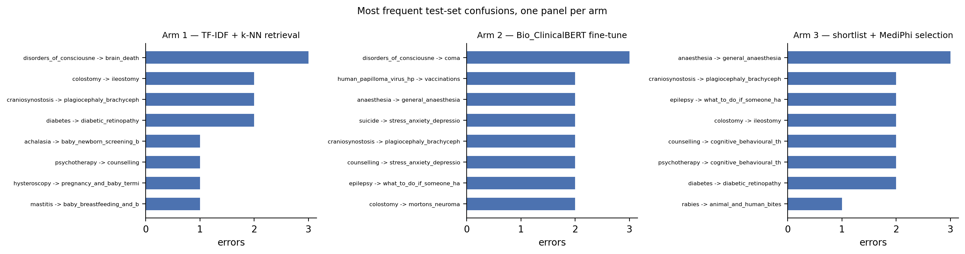

The most frequent test-set misclassifications by count, one panel per arm. None of these top confusions is a within-family pair: in every case the true label had no sibling in the 906-label space to be confused with, consistent with the test set's sparse sibling coverage described above.

Arm 3 uses the same 20-candidate shortlist as Arm 1 (built by TF-IDF retrieval of candidates, adding them to the prompt, then generating an answer). Out of 200 test questions the LLM kept Arm 1's top choice for 120 (accuracy 0.958, unchanged), returned Arm 1's top choice for 42, because its own output was not a valid candidate (accuracy 0.429, also unchanged), and chose a different candidate to Arm 1's on 38 (an override), where accuracy fell from 0.526 (Arm 1) to 0.289 (Arm 3).

On those 38 override questions, Arm 1 was originally correct on 20 and wrong on 18, so overriding fixed 11 previously wrong answers but broke 20 previously correct ones.

The true label appeared in the LLM's 20-candidate list on 97.5% of test questions, so the LLM was rarely missing the right answer. Its weaker accuracy on override questions suggests misplaced confidence when it does intervene.

Discussion

4.1 Comparison of Approaches

Traditional retrieval beats both neural arms on test at a fraction of the compute (Table 4): Arm 1 needs no GPU and no training step, while Arm 3's inference cost is in addition to Arm 1, since it builds up on it.

Table 4: Computational resources per arm (hardware, time, what was measured).

Arm

Hardware

Time

What was measured

Arm 1: TF-IDF + k-NN

CPU (local)

8.2 s

index build, then vectorise and rank 200 test questions.

Arm 2: Bio_ClinicalBERT

Colab T4 GPU

32.9 min

full 24-epoch sweep behind the checkpoint choice. The frozen checkpoint is epoch 14, so training only to that point costs less.

Arm 3: shortlist + LLM

Colab T4 GPU

78 s

generation over 200 items at the selected zero_shot condition, on top of Arm 1.

Computational resources per arm. Arm 1 is timed in this run on local CPU, while Arms 2 and 3 are read from the artefacts their Colab runs persisted, since neither can be re-run on the laptop. Arm 2 is training, Arm 3 is inference, orders of magnitude instead of durations are compared in the report.

Near-uniform distribution at around 10 examples per class is too little per-class data for fine-tuning to learn separate decision boundaries across 906 classes. Retrieval exploits a direct lexical queue where 84.0% of training questions contain a word from their own disease label, so TF-IDF retrieval uses that overlap instead of learning it implicitly from class examples. The encoder seemed to compensate by memorising phrasing shared among sibling questions; hence it underperformed when the shared phrasing disappeared and validation didn’t hint at it.

4.2 Impact of Design Choices

The index variant was Arm 1's largest lever, and the shift-aware protocol is what identified it: the standard hold-out could not separate the four variants at all. The test results confirm that when a hold-out is drawn from paraphrase siblings, a shift-aware split is the better guide to generalisation. No isolating ablation was re-run at the frozen vectoriser, so this remains consistent with the evidence.

The ablations (Table 5) show sublinear_tf=True at 0.530 on the shift-aware split against the frozen 0.398 (over five standard errors) while the standard hold-out separates them by 2pp, inside its own SE. The tie-break was scoped to index selection, so it never reached the vectoriser grid; scoped wider it would have chosen True. Because this surfaced only after the test set had been read, it is left unchanged by choice rather than oversight: acting on it would be exactly the test-informed selection that pre-registering a rule exists to prevent. It is the first thing to change in a repeat.

Table 5: Vectoriser and index ablations: standard vs. shift-aware hold-out accuracy.

Variant

Hold-out accuracy

Shift-aware accuracy

Δ vs frozen (shift-aware)

Vocab size

Frozen configuration (baseline)

0.850

0.398

0.000 (baseline)

237037

ngram_range=(1,1) (unigrams only)

0.820

0.328

-0.070

16671

min_df=2

0.755

0.305

-0.093

78757

sublinear_tf=True

0.870

0.530

+0.133

237037

stop_words='english'

0.850

0.400

+0.003

247743

Lemmatisation enabled (en_core_web_sm, stop words kept as frozen)

0.840

0.352

-0.045

239335

NHS documents uncleaned (boilerplate retained)

0.850

0.400

+0.003

242212

index_variant=QL

0.815

0.203

-0.195

30700

index_variant=QLA

0.840

0.305

-0.093

141423

Both protocols use the frozen Arm 1 vectoriser/index settings except the single varied factor per row, seed=44, and the same std-val split (n=200, 102 classes) / hard-val split (n=400, 400 classes) across all rows. Standard-error reference at the frozen row's accuracy: std-val SE ≈ 2.52pp (n=200), and shift-aware SE ≈ 2.45pp (n=400).

The rules differ in provenance: Arm 1's and Arm 3's were pre-registered before the numbers were seen, Arm 2's only after - disclosed rather than smoothed over. Both the Arm 2 and Arm 3 priors deliberately retained the lower-scoring option as previously declared.

4.3 Implications for Healthcare

85 identical question strings map to more than one disease, an irreducible error floor. A triage system here should abstain rather than guess: validation accuracy climbs from 0.850 to 0.945 once only the most confident 36.5% of items are answered (Figure 7). Arm 3 shows the same principle accidentally, its only component that never hurt accuracy was the fallback that declined to re-rank. With the sharp degradation once phrasing shifts, patient-facing classifiers must be validated on genuinely independent data and deployed with a route to human review.

Figure 7: Arm 1 accuracy-coverage curve (validation).

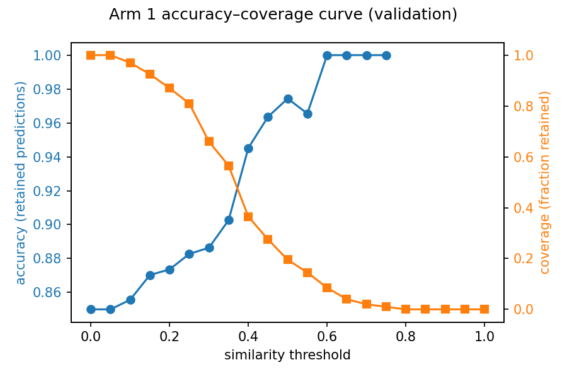

Accuracy of retained predictions and fraction of items retained (coverage) as the nearest-neighbour similarity abstention threshold varies; the source for this 0.850 to 0.945 accuracy at 36.5% coverage figure above.

References

Alsentzer, E., Murphy, J., Boag, W., Weng, W.-H., Jindi, D., Naumann, T. and McDermott, M. (2019)
'Publicly available clinical BERT embeddings', Proceedings of the 2nd Clinical Natural Language
Processing Workshop, NAACL, pp. 72-78. Available at: https://aclanthology.org/W19-1909/

Chen, Q., Hu, Y., Peng, X., Xie, Q., Jin, Q., Gilson, A., Singer, M.B., Ai, X., Lai, P.-T., Wang, Z.,
Keloth, V.K., Raja, K., Huang, J., He, H., Lin, F., Du, J., Zhang, R., Zheng, W.J., Adelman, R.A.,
Lu, Z. and Xu, H. (2025) 'Benchmarking large language models for biomedical natural language
processing applications and recommendations', Nature Communications, 16(1), 3280.
doi: 10.1038/s41467-025-56989-2

CogStack (2023) OpenGPT: a framework for creating grounded instruction-based datasets and training
conversational domain expert LLMs. Available at: https://github.com/CogStack/OpenGPT
(Accessed: 3 September 2026).

Devlin, J., Chang, M.-W., Lee, K. and Toutanova, K. (2019) 'BERT: pre-training of deep bidirectional
transformers for language understanding', Proceedings of NAACL-HLT 2019, pp. 4171-4186.
Available at: https://aclanthology.org/N19-1423/

Lee, J., Yoon, W., Kim, S., Kim, D., Kim, S., So, C.H. and Kang, J. (2020) 'BioBERT: a pre-trained
biomedical language representation model for biomedical text mining', Bioinformatics, 36(4),
pp. 1234-1240. doi: 10.1093/bioinformatics/btz682

Schulhoff, S. et al. (2024) The prompt report: a systematic survey of prompting techniques.
arXiv:2406.06608.
Available at: https://arxiv.org/abs/2406.06608

Appendix

submission/AMLH_patient_question_classification.ipynb is the reproducible notebook required
by §5 (Coding) and §6 (Appendix) of the brief. It is a single, self-contained notebook: the
twelve src/amlh modules are inlined verbatim (via %%writefile cells generated directly from
the files on disk, byte-for-byte) and imported normally, so nothing in it can drift from the
package the rest of this report describes. SEED = 44 throughout, read from config.py rather
than restated (42 appears once in the whole project, as one of three robustness-check seeds in
§2's split-robustness cell — it is not the project seed).

Section headers mirror this report's sections:

Notebook section | Report section(s)
§0 Setup, environment and provenance | —
§1 Dataset and preprocessing | 2.1, 2.2, 3.1
§2 Arm 1 — TF-IDF + k-NN retrieval | 2.3
§3 Arm 2 — Bio_ClinicalBERT | 2.4
§4 Arm 3 — shortlist + MediPhi | 2.4
§5 Frozen test run | 3.2, 3.3
§6 Workflow diagrams and download | Figure 1, Figure 2

RUN_FULL_SELECTION. Two sweeps in the notebook are expensive enough that re-running them
does not fit inside one free Colab session: Arm 2's 24-epoch x 2-encoder comparison (§3.4) and
Arm 3's 6-cell prompt x model grid (§4.4). With RUN_FULL_SELECTION = False (the notebook's
default), these two cells load the CSVs the original sweeps produced, shipped in the input
archive under artefacts/precomputed/. Every selection rule and pre-registered tie-break —
epoch selection, the Arm 2 encoder McNemar test, the Arm 3 prompt-condition and model McNemar
tests — still executes live on whichever data is in memory, printing its own margin, standard
error and p-value. Setting RUN_FULL_SELECTION = True reproduces both sweeps from scratch
(order of 5-7 hours combined) instead of loading them.

Data access. The notebook prompts for one archive, submission/amlh_submission_inputs.zip
(built by scripts/make_submission_inputs.py): the training CSV, the test CSV with answer
already stripped before it left the workstation, all 906 NHS documents, the twelve precomputed
sweep CSVs above, and the canonical split_fit.csv/split_val.csv. §1 regenerates a split
itself (matching notebooks/01_eda.ipynb exactly, for transparency), but that regeneration —
while deterministic within one fixed code/data state — does not reproduce the exact 200-item
partition the frozen hyperparameters were originally selected against, so the notebook loads
the canonical split from the archive immediately afterward and every later section reads that
one. data.load_test() is called exactly once in the whole notebook, in §5, after every
hyperparameter in config.py is frozen; the only earlier use of test data is §1's declared EDA
exception (sibling-homogeneity measurement, near-duplication audit, novelty calibration), which
selects nothing.

Runtime. [To be completed from the executed run's own §6.2 output — CLAUDE.md hard rule #3
forbids stating a runtime figure no code has printed. Fill in the total wall clock and the GPU
name reported by §0.1 once the notebook has been run end-to-end on a Colab T4.]

