Below I will indentify the characteristics of this situation include reliability, types and number of requirements, how often the requirements can change, can the requirements be defined at an early stage, team size, level of understanding of user requirements by the developers, user involvement in the project.

• Reliability: The requirements of Babysitter app are not exactly clear, those requirements are based on basic demand that for parent to find part time babysitters.

• Types and number of requirements: They defined both functional for managers, customers and employees, and also non-functional for the system. The number of functional requirements of this application are quite a lot. They list more than 6 functional reqiremenents for customers supporting, more than 2 functional reqiremenents for managers and more than 4 functional reqiremenents for employees. They also list more than 2 non-functional requiremenents for the system.

• How often the requirements can change: I think that they list quite clearly requirements for IT to develop, they define the requirements very well so that the requirements can be describe as predictive and requirements may not be changed regularly.

• Can the requirements be defined at an early stage: Yes, the requirements can be defined as an early stage because they mentioned in the essay that: “The IT support of MaMaSpa could assist you to elicitate missing requirements in the early stage.

• Team size: They do not mention about the team development.

• Level of understanding of user requirements by the developers: Because they define the features of the system very well, so that I think the developers understand enough to run this project.

• User involvement in the project: They do not mention about the user will or won’t involve in the project to test the system or not. But I think user should involve in the project to give their ideas for a better system.

To conclude, because the features of the system are defined quite clear, so that we can build in parts. The system must be delivered earlier for the uses to learn to use quickly, we should deliver part of project earlier to get feedback from user, then apply necessary change for anther parts. We can overlap and use different model for each increment to adapt changes. Therefore, I think the most suitable software development model to build this system is Incremental Model

2.

- Create account for babysitter

- Update profile of babysitter

- View income by month, week, day,…

- Search and filter the jobs based on the post’s information which babysitter want

3.

2 user stories of babysitter:

As a babysitter, I want to search and filter the jobs so that I can find suitable job for me.

As a babysitter, I want to create an account so that I can apply the jobs in this app.

4.

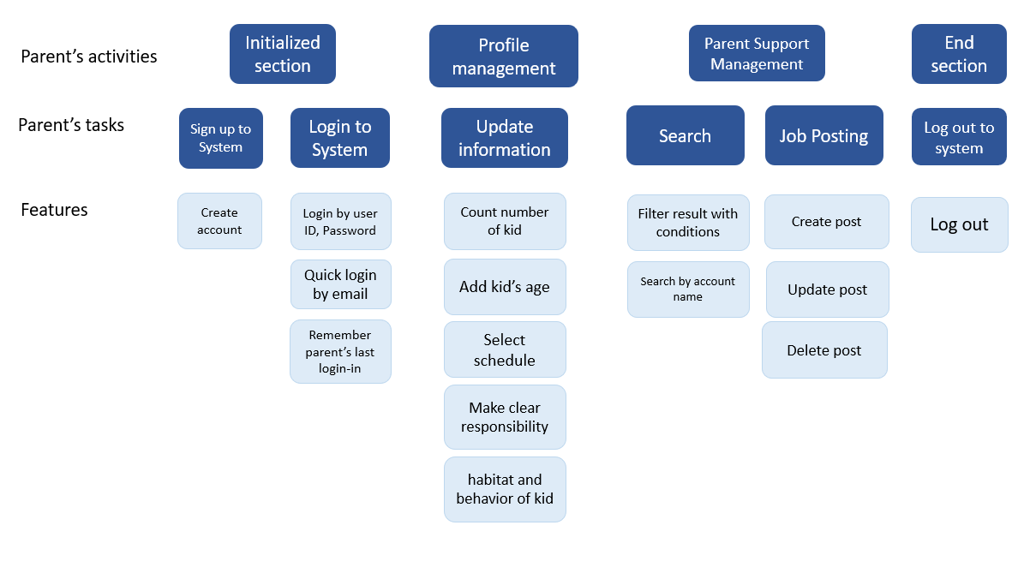

2 loại test:

Function and non-function