

**<<Online-Shop>>**

**Software Requirement Specification**

– Hanoi, August 2022 –

Record of changeS

|  |  |  |  |
| --- | --- | --- | --- |
| Date | A* M, D | In charge | Change Description |
| 13/Apr | A | KienNT | Thêm mô tả chức năng Setting Details (II.1.a) |
| 2/2 | A | Linhtq | Function Requirement(II) |
| 15/2 | A | Linhtq | Thêm ERD(I.3) |
| 19/2 | U | Linhtq | Update context diagram |
| 20/2 | A | Linhtq | Thêm screen flow(I.2.a) |
| 20/2 | A | Linhtq | Theem screen Detail(I.2.b) |
|  |  |  |  |
|  |  |  |  |
|  |  |  |  |
|  |  |  |  |
|  |  |  |  |

*A - Added

*M - Modified

*D - Deleted

**Table of Contents**

I. Overview 4

1. Introduction 4

2. System Functions 5

3. Entity Relationship Diagram 6

II. Functional Requirements 7

1. <<Feature Name 1>> 7

a. <<Function Name 1>> 7

b. <<Function Name 2>> 7

2. <<Feature Name 2>> 7

# I. Overview

## 1. Introduction

Sell phone website can replace the current manual and help users buy easier instead of going showroom. The system is expected to be developed after several releases and updates. Besides, the website will link with phone brands to release the latest products.

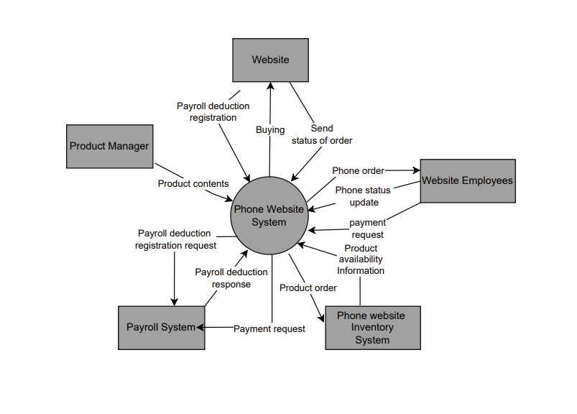

## 2. System Functions

#### a. Screen Flow

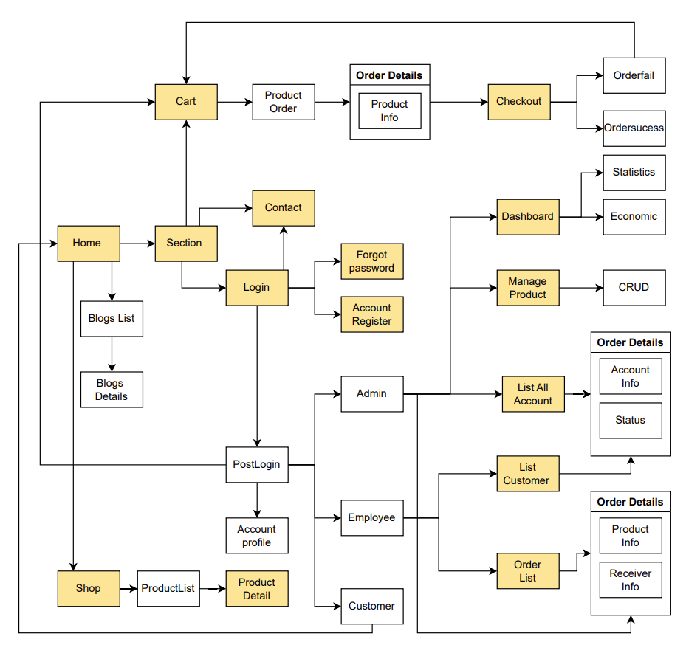

#### b. Screen Details

|  |  |  |  |
| --- | --- | --- | --- |
| **#** | **Feature** | **Screen** | **Description** |
| 1 | Show Product | Shop | Show all products. |
| 2 | Storage Product | Cart | Store the product which user add in order. |
| 3 | User authentication | Login | User can sign in by their account. |
| 4 | User authentication | Forgot password | User can change password when they don’t remember the password. |
| 5 | User authentication | Register | Users create an account. |
| 6 | Contact | Contact | User can send feed back to help improving quality of service. |
| 7 | Payment | Checkout | User can complete order in checkout screen by using credit card, E-wallet or Cash, v.v. |
| 8 | Show Infor | Product Detail | Show the information of the product. |
| 9 | Show Infor | Account Profile | Show the information of the account and they can UR the information. |
| 10 | Order Product | Order Detail | User can CRUD the product in order |
| 11 | Admin | List All Account | Admin can CRUD account status ( exam: ban account). |
| 12 | Admin | Dashboard | Admin can see the view order statistics and economic on that time. |
| 13 | Employee | List Customers | Employee can view all Customer mail |
| 14 | Employee | Order List | Employee can CRUD order. |

#### c. User Authorization

|  |  |  |  |  |
| --- | --- | --- | --- | --- |
| **Screen** | **Guest** | **Customer** | **Employee** | **Admin** |
| Home | X | X | X | X |
| Sign In |  | X | X | X |
| Sign Up | X | X | X |  |
| Checkout | X | X | X |  |
| Shopping cart | X | X | X |  |
| Contact | X | X |  |  |
| Product Detail | X | X | X | X |
| Forgot password |  | X | X | X |
| Account Profile | X | X | X |  |
| Order Detail | X | X | X |  |
| List All Account |  |  |  | X |
| Dashboard |  |  |  | X |
| List Customers |  |  | X |  |
| Order List |  |  | X | X |

In which:

* Guest: User who does not have the account
* Customer: User have account
* Employee: Who can manage the products store
* Admin: The owner

#### d. Non-Screen Functions

|  |  |  |  |
| --- | --- | --- | --- |
| **#** | **Feature** | **System Function** | **Description** |
| 1 | **External Interfaces** | **User interface** | -UI-1: The GUI is suitable for display on the PC and laptop.  -UI-2: The layout of the screen is streamlined, easy to  operate, and implement for the user.  -UI-3: For the creator screen, the system must show the confirmation modal (Y / N) for operations add, edit, delete, clone survey.  -UI-4: Use icons to provide visual insights to users.  -UI-5: Encourage vertical scrolling, minimize horizontal scrolling.  -UI-6: All error messages must provide troubleshooting instructions to the user.  -UI-7: Important commands and messages are displayed as buttons and labels with distinct background colors.  -UI-8: For student screen, the system must show confirmation modal (Y / N) for survey submission activity. |
| 2 | … |  |  |

## 3. Entity Relationship Diagram

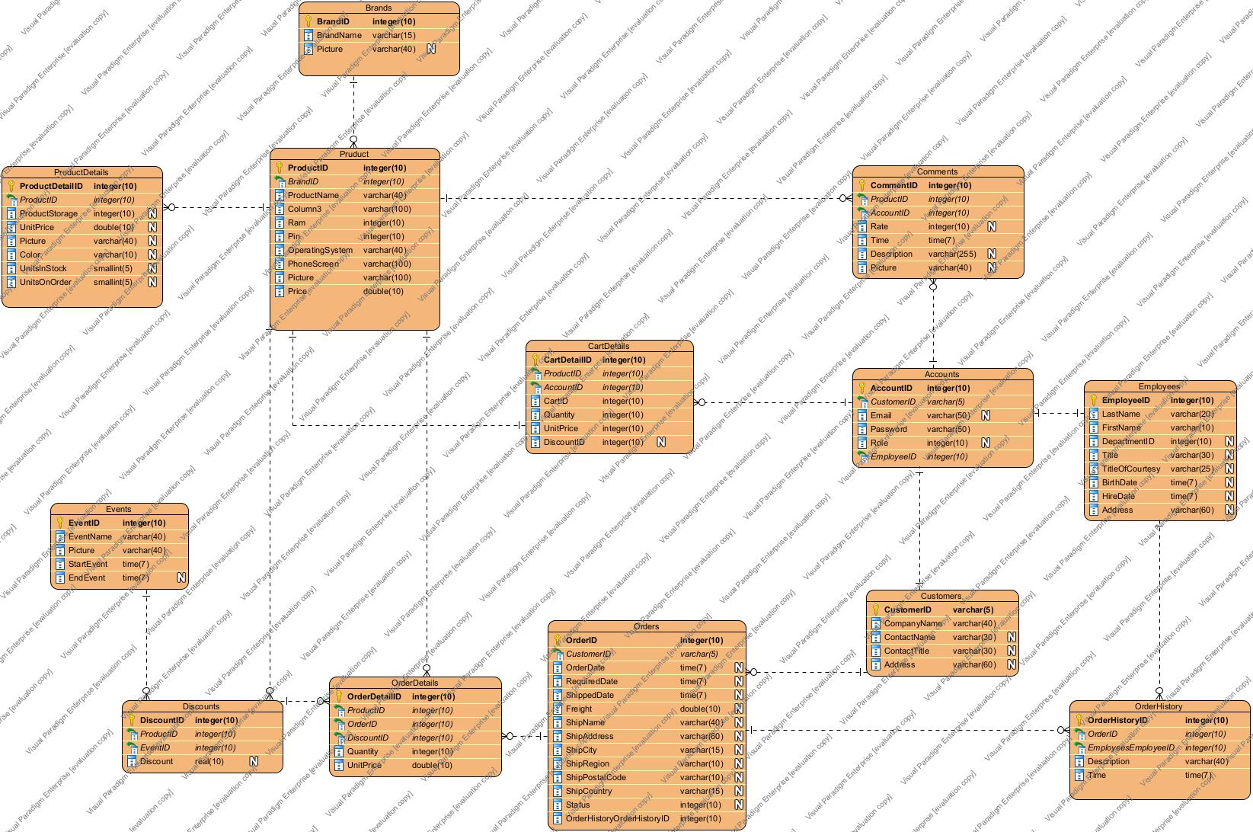

**Entities Description**

|  |  |  |
| --- | --- | --- |
| **#** | **Entity** | **Description** |
| 1 | User |  |
| 2 | Meal |  |
| 3 | Meal Subscription |  |
| 4 | … |  |

# II. Functional Requirements

## 1. Authenticate & Authorise

### a. Login

Function Trigger:

* Navigation Path: Login Screen
* Frequency of Use: High

Function Description:

* Actors: All
* Purpose: User login into the system
* Data processing: Data wrapped as a request through a secure connection

Screen Layout:

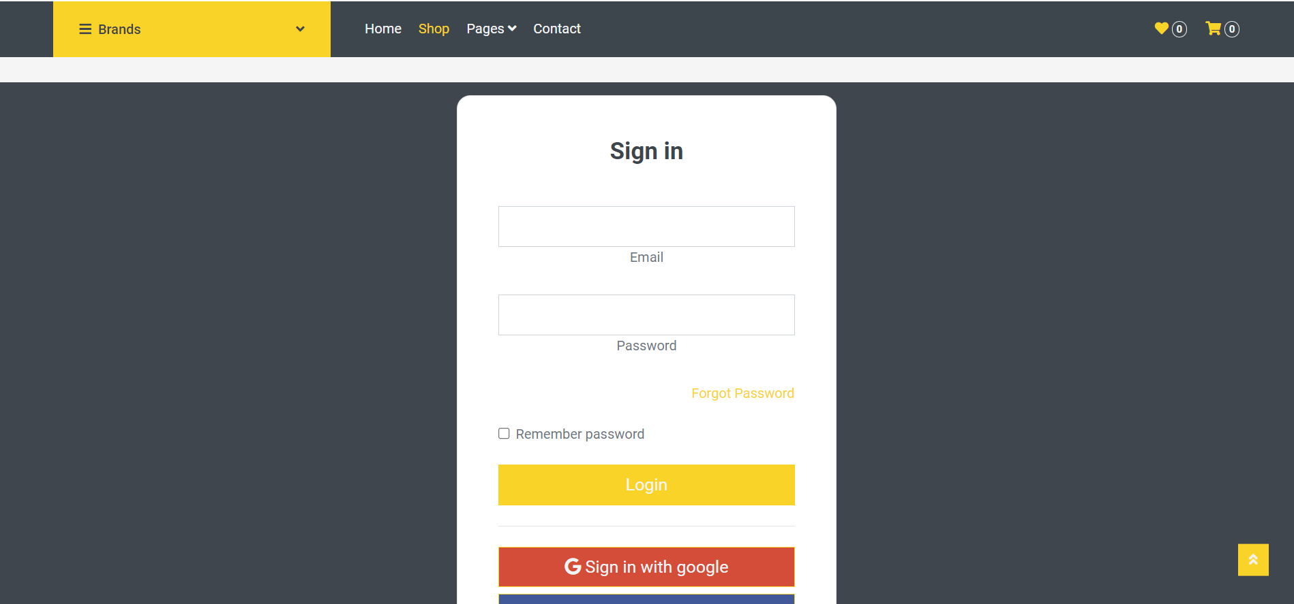

Function details:

* Normal case: User logins successfully
* Abnormal case: Wrong email or password, …

### b. Logout

Function Trigger:

* Navigation Path: Click “My Account” icon → click on “Sign out”
* Frequency of Use: High

Function Description:

* Actors: All
* Purpose: User logout to the website
* Data processing: Data wrapped as a request through a secure connection
* Screen Layout:
* 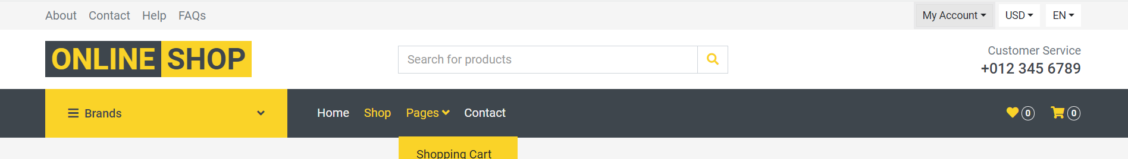

 Function details:

* Normal case: User logout successfully
* Abnormal case

### c. Sign Up

Function Trigger:

* Navigation Path: Click “My Account” icon → click on “Sign up”
* Frequency of Use: High

Function Description:

* Actors: User don’t have account or google account
* Purpose: Create user account
* Data processing: Data wrapped as a request through a secure connection
* Screen Layout:
* 

 Function details:

* Normal case: Create account successfully
* Abnormal case: Invalid data, email exist, not fill, …

### c. Forgot password

Function Trigger:

* Navigation Path: Click “Forgot password” icon
* Frequency of Use: Normal

Function Description:

* Actors: User don’t remember the password
* Purpose: Help user can change password by email address
* Data processing: Data wrapped as a request through a secure connection
* Screen Layout:



 Function details:

* Normal case: Create account successfully
* Abnormal case: Invalid data, email exist, not fill, …

### 2. Paying and Contacting

### a. Checkout

Function Trigger:

* Navigation Path: Click “Pages” icon → click on “Checkout”
* Frequency of Use: Normal

Function Description:

* Actors: All
* Purpose: Payment
* Data processing: Data wrapped as a request through a secure connection
* Screen Layout:

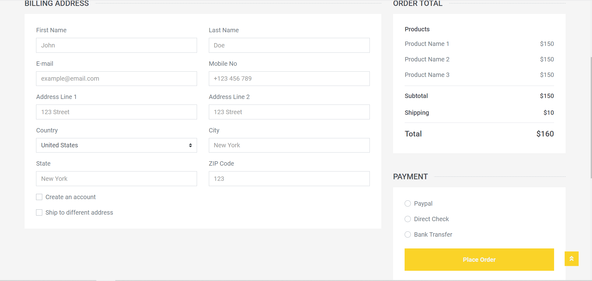

 Function details:

* Normal case: Paying successfully
* Abnormal case: Invalid data, missing checkbox,…

### b. Contact

Function Trigger:

* Navigation Path: Click “Contact” icon in bar
* Frequency of Use: Normal

Function Description:

* Actors: All
* Purpose: Help user feedback
* Data processing: Data wrapped as a request through a secure connection
* Screen Layout:

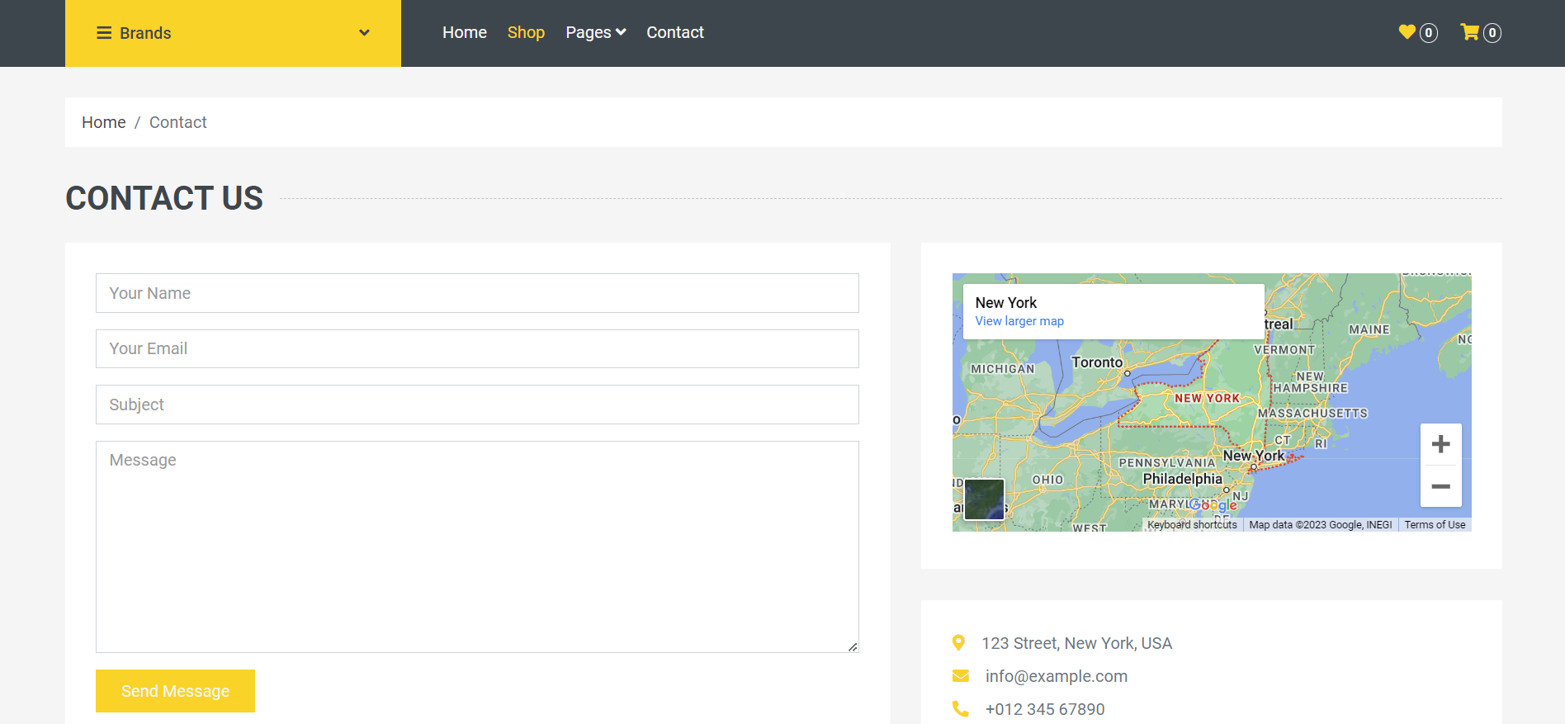

 Function details:

* Normal case: Send message successfully
* Abnormal case: Invalid data, not fill, …

### 3. Manage shopping

### a. Shopping cart

Function Trigger:

* Navigation Path: Click “Pages” icon in bar -> click “ shopping cart”
* Frequency of Use: High

Function Description:

* Actors: All
* Purpose: Help user store products
* Data processing: Data wrapped as a request through a secure connection
* Screen Layout:

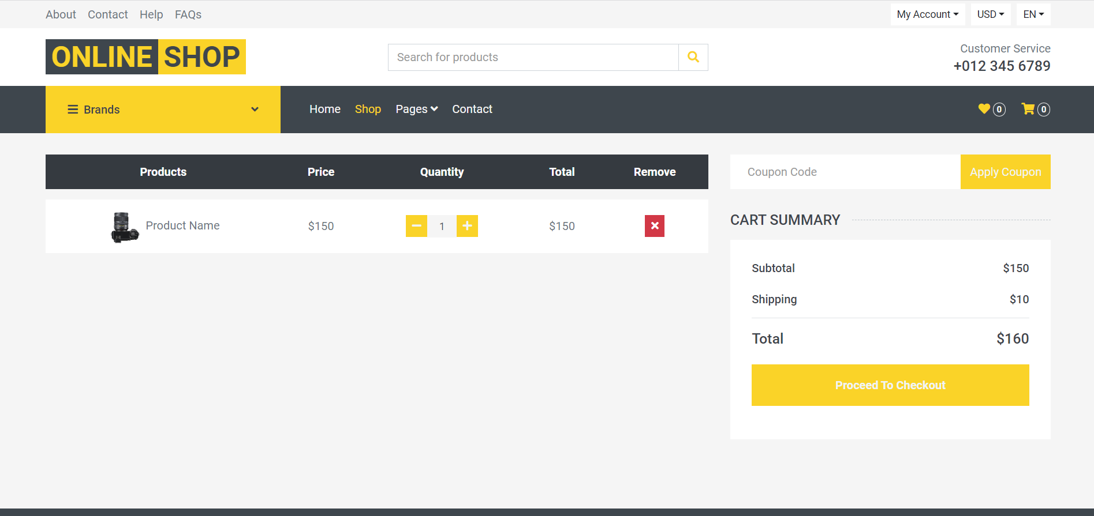

 Function details:

* Normal case: Show products successfully
* Abnormal case