Loan Prediction Data Preparation Report
GitHub repository: https://github.com/L1S23BSCS0119/Loan-Prediction

Dataset and objective
The Loan Prediction Problem Dataset contains 614 applications and 13 original columns. Source: Kaggle Loan Prediction Problem Dataset
This supervised binary classification task uses Loan_Status as its target: N = 0 (not approved), Y = 1 (approved). The aim was to clean, encode and scale the inputs. The displayed final outputs contain 491 training rows and 123 test rows, with no missing values.

Exploratory data analysis
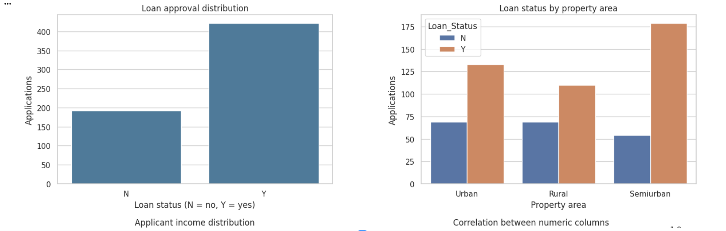
Figure 1. Approval distribution and loan status by property area.
Approvals account for 422 applications (68.73%), compared with 192 non-approvals (31.27%). Semiurban applications show the highest approval count. These counts describe associations rather than causes.
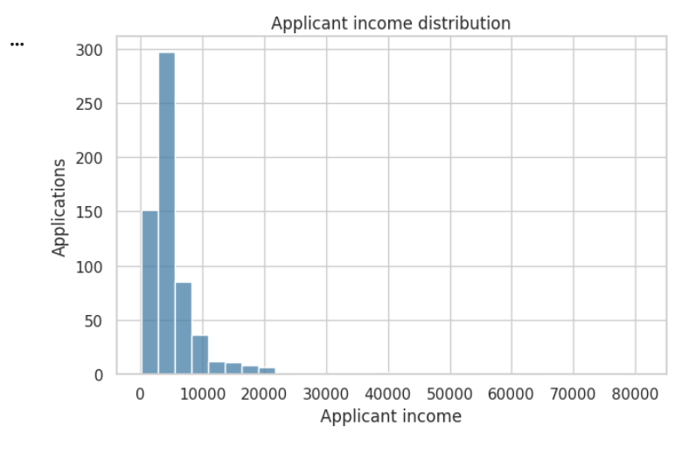  Figure 2. Applicant income distribution. | 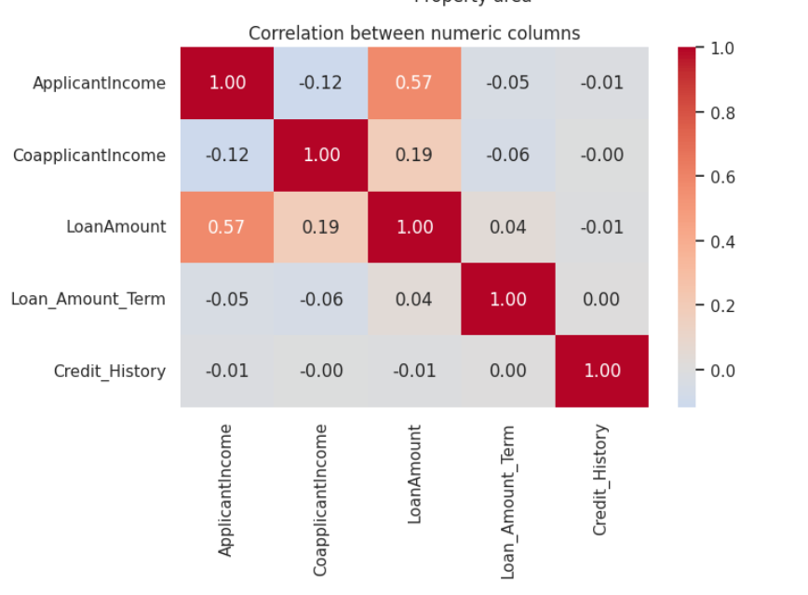  Figure 3. Numeric correlation heatmap.
Income is strongly right-skewed, with most applicants at lower income levels. ApplicantIncome and LoanAmount have a moderate positive correlation of 0.57; most other displayed numeric relationships are weak.

Cleaning decisions
No exact duplicate rows were found, so all 614 applications remained. Loan_ID was dropped. Missing feature values were retained for imputation after splitting, with statistics learned from training data only.
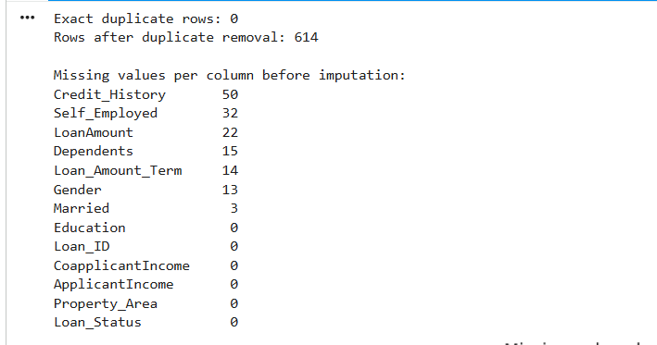
Figure 4. Duplicate check and missing values before imputation.

New features and input selection
TotalIncome adds applicant and coapplicant income to represent combined financial resources. LogTotalIncome = log(1 + TotalIncome) reduces the influence of very large incomes. Both formulas use only each row’s inputs.
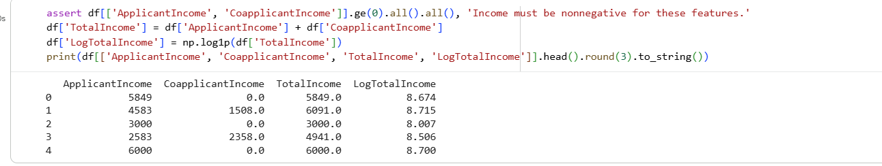  Figure 5. Two income features. | 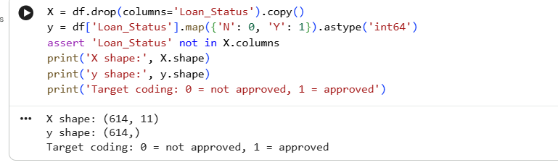  Figure 6. Inputs and target selection.
Execution issue: the later outputs show 11 inputs and omit both new features. They were created in Figure 5 but were not carried into the displayed split. Rerun the notebook in order and confirm 13 inputs before preprocessing to include them.

Train and test split
An 80/20 split used random_state = 42 and stratify = y. Training contains 491 applications (337 approved, 154 not approved); testing contains 123 (85 approved, 38 not approved). Approval proportions are similar: 68.64% in training and 69.11% in testing.
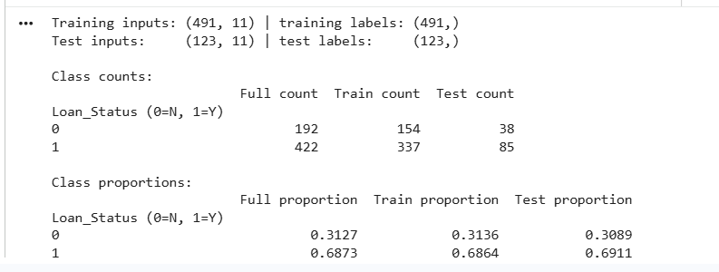
Figure 7. Split sizes, class counts and class proportions.

Preprocessing and data leakage prevention
A ColumnTransformer combined numeric and categorical pipelines. Numeric gaps used the training median, followed by StandardScaler to give numeric inputs comparable scales. Category gaps used the training mode, followed by OneHotEncoder to avoid artificial rankings. Credit_History was treated as categorical.
Only training inputs used fit_transform. Test inputs used transform with the same fitted processor. Imputation values, scaling statistics and encoding categories therefore came from training rows. The displayed pipeline used four numeric and seven categorical inputs.
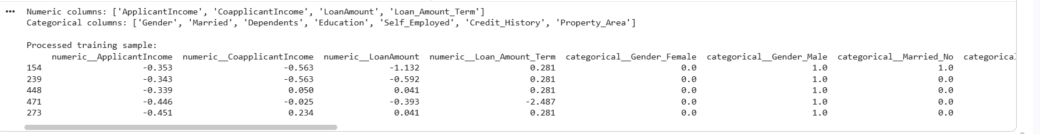
Figure 8. Selected columns and a sample of the scaled and encoded training inputs.

Final results
The displayed processed outputs are X_train = (491, 21), X_test = (123, 21), y_train = (491,) and y_test = (123,). All four contain zero missing values. These shapes describe the displayed run; they will change when both engineered features are included.
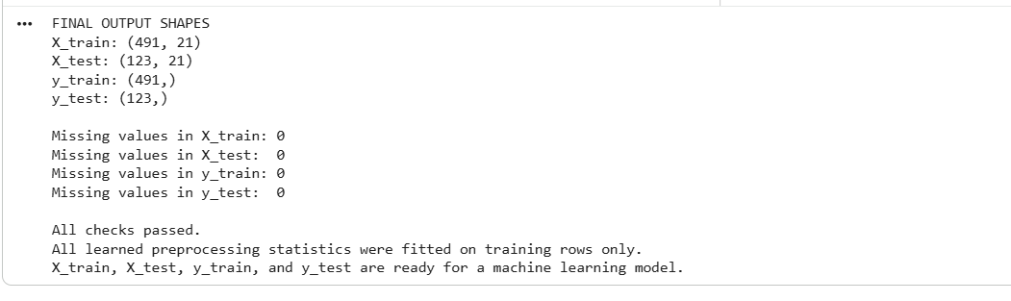
Figure 9. Final shapes, missing-value checks and training-only fitting confirmation.

Problems and learning
The main challenges were missing entries, skewed income values and mixed column types. The outputs also reveal why notebook execution order matters: features must remain present through selection and splitting. Pipelines make preprocessing repeatable and help prevent data leakage. Model training and performance evaluation are the next stage.

