Fashion Dataset Exploration Report
Dataset: Fashion Product Images (Small. This report uses its tabular metadata file, styles.csv, rather than the product images.

Purpose of the assignment
Explore clothing colours and product attributes, assess data quality, and propose a supervised model to predict a product's labelled occasion or usage. The work completed so far is exploratory data analysis; no model has been trained or evaluated.

Dataset overview
The submitted notebook output contains 44,424 rows and 10 columns after malformed CSV lines were skipped. Each row represents a catalog product. The full catalog includes apparel, accessories, footwear, personal care and other categories, so it is not exclusively clothing.

Learning Type and Proposed Model

Is this supervised or unsupervised
The proposed task is supervised learning. The dataset includes an existing target label, usage, which the model will learn to predict from product attributes. Since usage has multiple categorical values, this is multiclass classification.
Recommended models
Main model: Random Forest Classifier. This can learn combinations of categorical product attributes after encoding and capture nonlinear relationships. Control tree depth and tree count to keep memory use manageable.
Baseline: Logistic Regression. Compare it with Random Forest using the same train/test split and preprocessing. Also include a majority-class baseline to judge whether the model improve on always predicting the most common label.

Queries First Rows Last Rows and Shape
df.head()
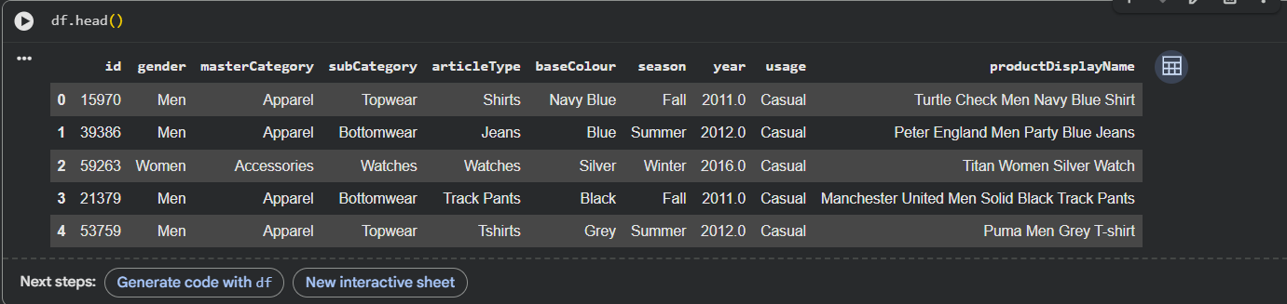
Figure 1. First five records. Shows the column structure and examples of product attributes.
df.tail()
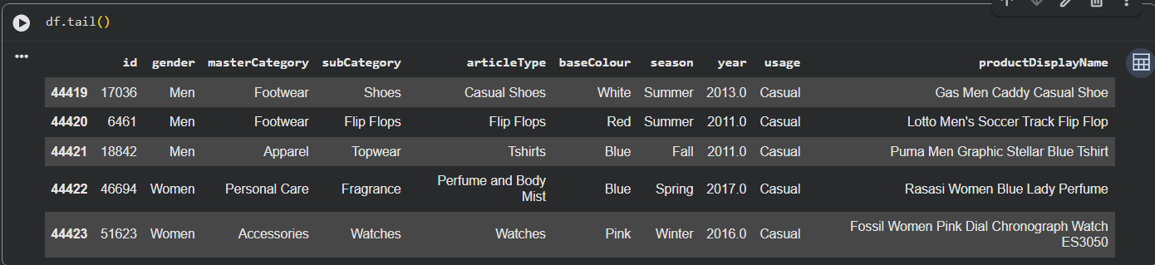
Figure 2. Last five records. Confirms that the catalog also contains non-apparel products.
df.shape
Figure 3. Dataset dimensions: 44,424 rows and 10 columns.

Queries Missing Values and Duplicates
df.isnull().sum()
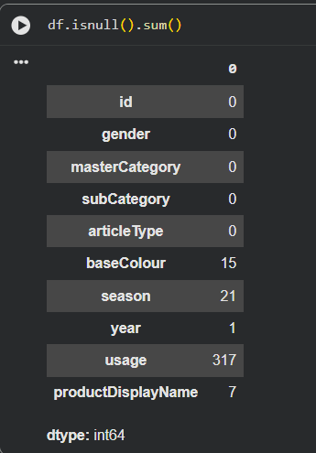
Figure 4. Missing-value counts: baseColour 15, season 21, year 1, usage 317, and productDisplayName 7. All remaining columns have zero missing values. Counts are per column; missing values can occur in the same row.
df.duplicated().sum()
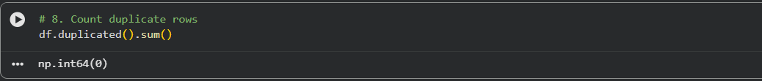
Figure 5. Zero fully duplicated rows. This query checks complete-row duplicates; it does not establish whether product IDs or similar product descriptions repeat.

Conclusion
The metadata is suitable for a clothing-focused supervised classification assignment. Random Forest is the proposed main model, with Logistic Regression and a majority-class baseline for comparison. Cleaning, encoding, training and evaluation remain to be completed.

