ALIYA
CONSTRUCTION PLC
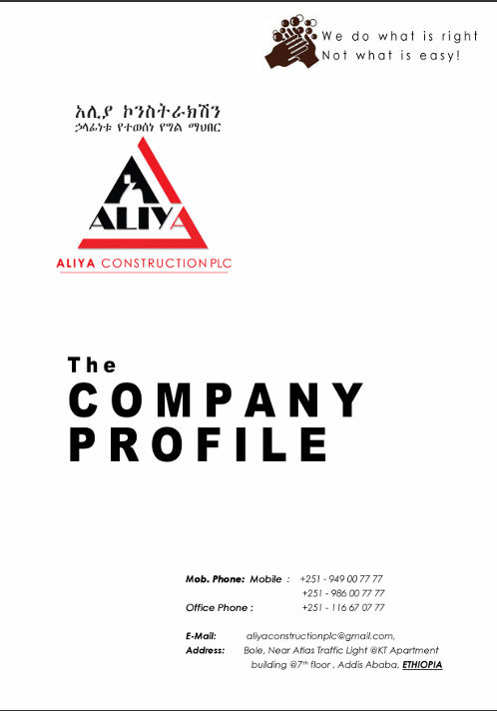

“We do what is right, Not what is easy!”

01 EXECUTIVE SUMMARY & BRAND MANIFESTO

WHO WE ARE
ALIYA CONSTRUCTION PLC was established in 2014 G.C. by Belay Taye with a clear ambition: to play a defining role in Ethiopia's rapidly urbanizing construction industry. Ethiopia's breakneck economic growth and accelerating rate of urbanization have made construction a direct driver of national development, expansion, and modernization — and Aliya Construction PLC positions itself at the center of that transformation.
The company's capital was fully paid at the time of establishment and has continued to grow significantly since. Over the years, Aliya Construction PLC has successfully delivered building construction projects to the required professional standard, building a track record defined by discipline, precision, and integrity.
CORPORATE BACKGROUND
The company holds a Business License from the Addis Ababa Trade, Industry & Urban Development Bureau as a Grade-5 General Contractor and/or Grade-4 Building Contractor. It is further certified with a TIN from the Federal Democratic Republic of Ethiopia Bureau of Revenue and is fully registered for VAT, with certification issued by the same office.
The company is presently led by General Manager Belay Taye, whose legal and professional credentials are documented in full within Section 07 of this profile.
OUR MANIFESTO
“We do what is right, Not what is easy!”

02 CORPORATE VISION, MISSION & CORE OBJECTIVES

Vision
- To be a respectable building contractor, delivering beyond expectation.
- To be a leading member of the local construction industry, defined by excellence and integrity.
Mission
To procure projects at competitive pricing, provide a safe working environment, and deliver quality work within a reasonable time frame.
Objective
Our objective is to give every client an assured experience whenever Aliya Construction PLC is entrusted with executing their project. Clear communication and disciplined follow-through keep client objectives at the center of every planning and execution decision we make.
Project Management & Execution Philosophy
- Create a detailed schedule and resource plan aligned to each client's project objectives.
- Communicate clearly and continuously with all project stakeholders.
- Track project progress and proactively fine-tune deviations.
- Supervise quality of work closely at every stage.
- Complete and commission each project on time.
We take pride in our delivery — our clients are always served by the most experienced and qualified professionals, at every stage of the project.

03 LEGAL STANDING & QUALIFICATION MATRIX

ALIYA CONSTRUCTION PLC is registered and licensed under Ethiopian law to carry out the full spectrum of civil works and building construction — including residential buildings, office building complexes, hospitals, colleges and schools, training centers, factories, warehouses, and multipurpose buildings. The company is registered with the Ethiopian Ministry of Construction and Works and the Addis Ababa City Administration Trade and Industry Development Bureau.
Legal Qualification Matrix
Qualification Criterion | Status / Description
Nationality | Ethiopian
Conflict of Interest | No conflict of interest
Registration in FPPA's Suppliers List | Registered in FPPA's Suppliers List
Debarred by Decision of the FPPA | Not having been debarred by the FPPA
Valid Trade License / Business Registration Certificate | Valid for the year 2018 E.C.
VAT Registration Certificate | Registered for VAT
Valid Tax Clearance Certificate | Tax cleared
Government-Owned Entity | Private Limited Company
History of Non-Performing Contracts | No contract of non-performance during the stipulated period
Pending Litigation | No pending litigation in the history of the company

Current Litigation
Since its establishment, the company has not been involved in any kind of dispute.

04 STRATEGIC ASSET INVENTORY

ALIYA CONSTRUCTION PLC is equipped with the full complement of construction equipment, machinery, and vehicles required to execute projects independently and on schedule. All major assets listed below are company-owned.
No. | Equipment Type | Units | Capacity | Ownership
1 | Dump Truck | 1 | 16 m³ | Owned
2 | Dump Truck | 1 | 16.5 m³ | Owned
3 | Pickup Car | 1 | 4 person / 6 qt | Owned
4 | 1HZ Car | 1 | 9 person | Owned
5 | Good Quality HCB Production Machine | 1 | 2,000 pcs/day and above | Owned
6 | Lift | 1 | 42 m | Owned
7 | Concrete Mixer (Normal) | 2 | 360 lt | Owned
8 | Concrete Vibrator | 8 | EY 20 | Owned
9 | Water Pump | 2 | 5 Hp | Owned
10 | Plate Compacter | 3 | — | Owned
11 | Diesel Generator | 1 | 5 KW | Owned
12 | Jack Hammer | 1 | — | Owned
13 | Automatic Level | 3 | — | Owned
14 | Scaffolding | — | 5,000 m² | Owned
15 | Metal Grinder | 2 | — | Owned
16 | Welding Machine | 2 | — | Owned

The company additionally maintains fully equipped offices in Addis Ababa, staffed with the necessary office equipment and manpower to support ongoing operations.

05 HUMAN CAPITAL & ORGANIZATIONAL STRUCTURE

A systematic organizational and administrative framework underpins every duty and responsibility carried out by ALIYA CONSTRUCTION PLC. The company maintains a core workforce of more than 34 basic employees, spanning the full range of technical disciplines required for complex building construction.
Core Technical Disciplines
- Civil Engineers
- Construction Managers
- Building Engineers
- Mechanical Engineers
- Surveyors
- Experienced Construction Foremen
- Sanitary & Electrical Foremen
- Skilled Labor Crews across all civil disciplines
Sub-Professional & Specialist Support
Sub-professional support staff undertake supplementary duties across the organization; whenever workload becomes excessive or a specialist discipline is required, additional staff are engaged for the required duration of specific projects.
Professional Staff
The company's full-time and part-time professional staff carry qualifications and extensive experience across structural construction and design, civil construction, water supply, drainage systems and irrigation, and road and bridge construction. CVs of key personnel are maintained on file and available upon request.

06 TRACK RECORD & PROJECT PORTFOLIO

ALIYA CONSTRUCTION PLC's project history spans 19 contracted engagements across residential, mixed-use, institutional, and industrial-maintenance developments — 15 fully completed and 4 currently under construction.
No. | Project Name | Owner / Client | Region | Status
1 | Proposed Ariyo Catholic Learning Institute — 2nd Phase | Ethiopia Catholic Church Society of Jesus | Bonga, Keffa | Under Construction
2 | Proposed Ariyo Catholic Learning Institute — 3rd Phase / Lot 1 | Ethiopia Catholic Church Society of Jesus | Bonga, Keffa | Under Construction
3 | Ariyo Catholic Learning Institute — Supplementary Agreement: Landscape & Site Work | Ethiopia Catholic Church Society of Jesus | Bonga, Keffa | Under Construction
4 | Ariyo Catholic Learning Institute — Supplementary Agreement: Sport Field & Power House | Ethiopia Catholic Church Society of Jesus | Bonga, Keffa | Under Construction
5 | Ariyo Catholic Learning Institute — G+1 Residence Building | Ethiopia Catholic Church Society of Jesus | Bonga, Keffa | Completed
6 | Mixed-Use Building (B+G+6) — Finishing Work | Ato Girma Amare & W/ro Martha Negash | Addis Ababa | Completed
7 | Residence Building (2+B+G+3) | W/Ro Senait G/Gziabher | Addis Ababa | Completed
8 | Mixed-Use Building (B+G+6) — Structural Work | Ene Wro Belay Tesfaye | Addis Ababa | Completed
9 | Residence Building (2+B+G+3) | Art. Ephrem Tamiru | Addis Ababa | Completed
10 | Mixed-Use Building (B+G+5) | Wro Etenesh Haile | Addis Ababa | Completed
11 | Mixed-Use Building (B+G+6) — Structural Work | Ato Girma Amare & W/ro Martha Negash | Addis Ababa | Completed
12 | Mixed-Use Building (B+G+6) — Finishing Work | Ene Belay Tesfaye | Addis Ababa | Completed
13 | Residence Building (B+G+2) | Dr. Atnafu Tola | Addis Ababa | Completed
14 | Mixed-Use Building (B+G+5) | Wro Misrak Elias | Addis Ababa | Completed
15 | Apartment Building Construction (G+5) | Tigist Asefa | Addis Ababa | Completed
16 | BGI Ethiopia — Kera Store Maintenance Work | BGI Ethiopia PLC | Addis Ababa | Completed
17 | Mixed-Use Building (B+G+5) | Wro Misrak Elias | Addis Ababa | Completed
18 | Apartment Building Construction (G+5) | Tigist Asefa | Addis Ababa | Completed
19 | BGI Ethiopia — Kera Store Maintenance Work | BGI Ethiopia PLC | Addis Ababa | Completed

Featured Projects
- Ariyo Catholic Learning Institute — G+1 Residence Building | Client: Ethiopia Catholic Church Society of Jesus | Location: Bonga, Ethiopia | Status: Completed
- Mixed-Use Building (B+G+6) | Client: Ato Girma Amare & W/ro Martha Negash | Location: Addis Ababa | Status: Completed
- Residence Building (2+B+G+3) | Client: W/Ro Senait G/Gziabher | Location: Addis Ababa | Status: Completed
- Mixed-Use Building (B+G+6) — Structural & Finishing Work | Client: Ene Wro Belay Tesfaye | Location: Addis Ababa | Status: Completed
- Residence Building (2+B+G+3) | Client: Art. Ephrem Tamiru | Location: Addis Ababa | Status: Completed
- Mixed-Use Building (B+G+5) | Client: Wro Etenesh Haile | Location: Addis Ababa | Status: Completed
- Residence Building (B+G+2) | Client: Dr. Atnafu Tola | Location: Addis Ababa | Status: Completed
- Mixed-Use Building (B+G+5) | Client: Wro Misrak Elias | Location: Addis Ababa | Status: Completed
- Apartment Building Construction (G+5) | Client: Tigist Asefa | Location: Addis Ababa | Status: Completed
- BGI Ethiopia — Kera Store Maintenance Work | Client: BGI Ethiopia PLC | Location: Addis Ababa | Status: Completed

Project Gallery
Photographic and rendered documentation of completed and in-progress works, reproduced as provided.
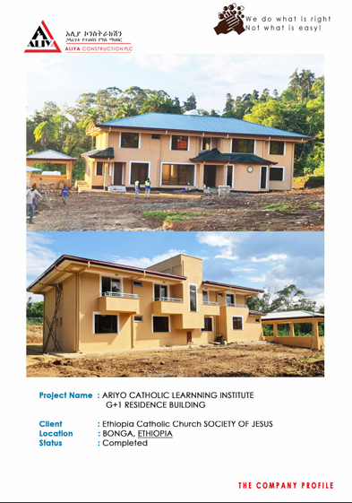
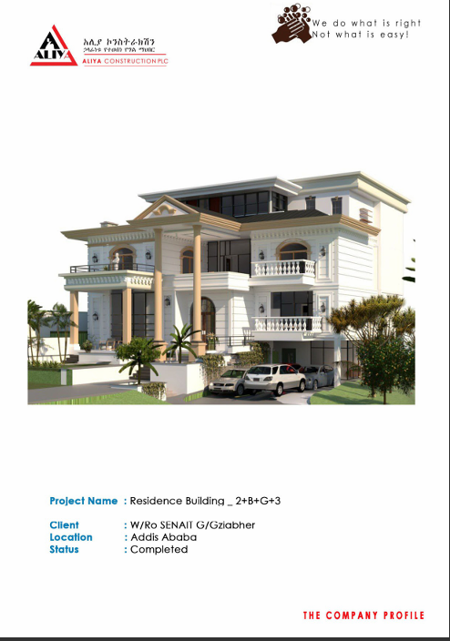  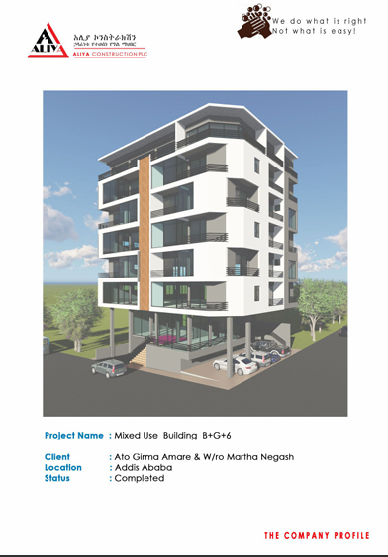 | 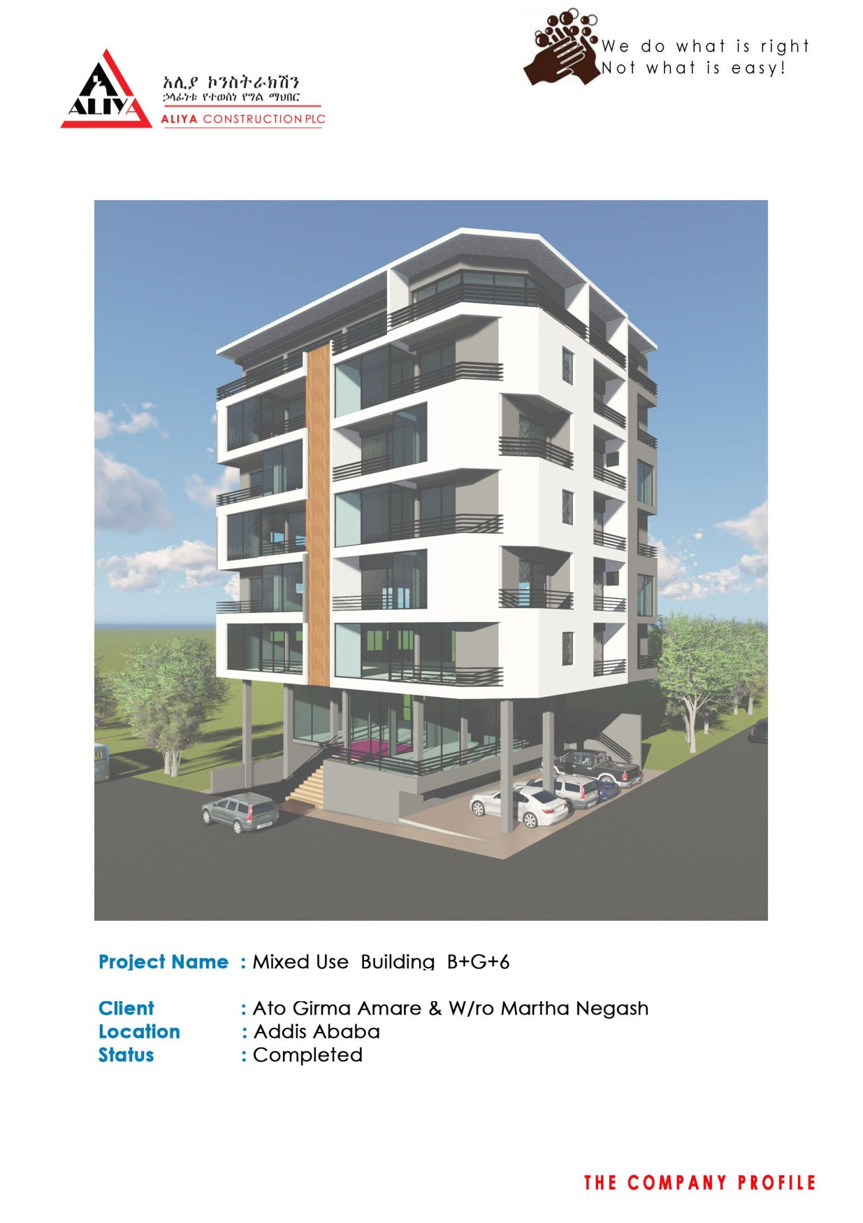  Mixed-Use Building (B+G+6) · Ato Girma Amare & W/ro Martha Negash · Addis Ababa · Completed
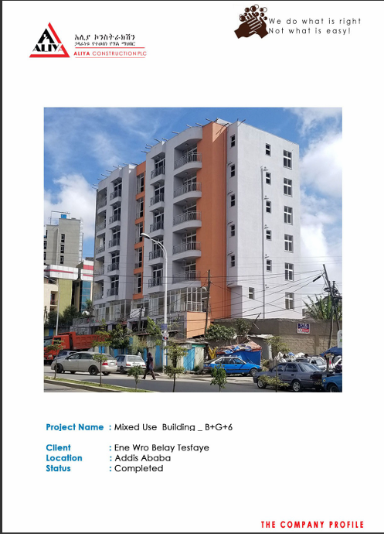 | 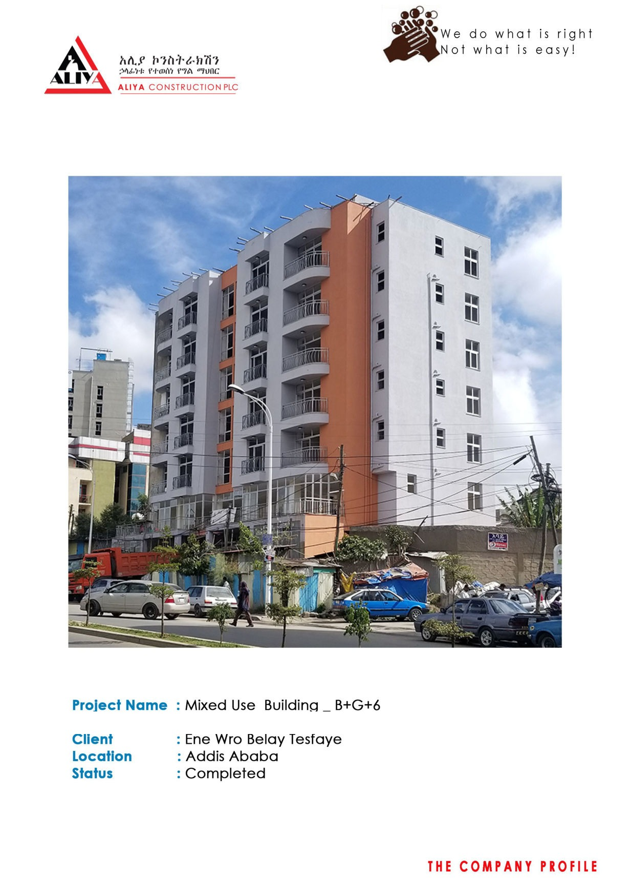  Mixed-Use Building (B+G+6) · Ene Wro Belay Tesfaye · Addis Ababa · Completed
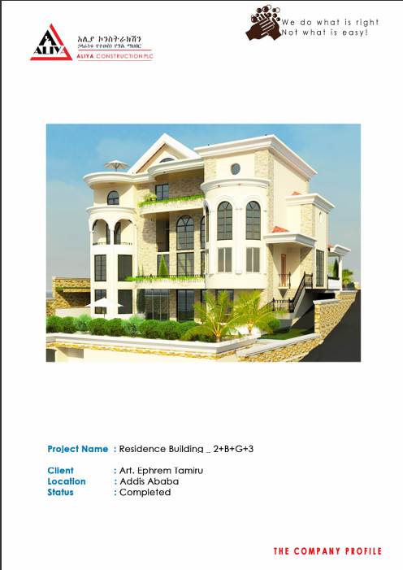 | 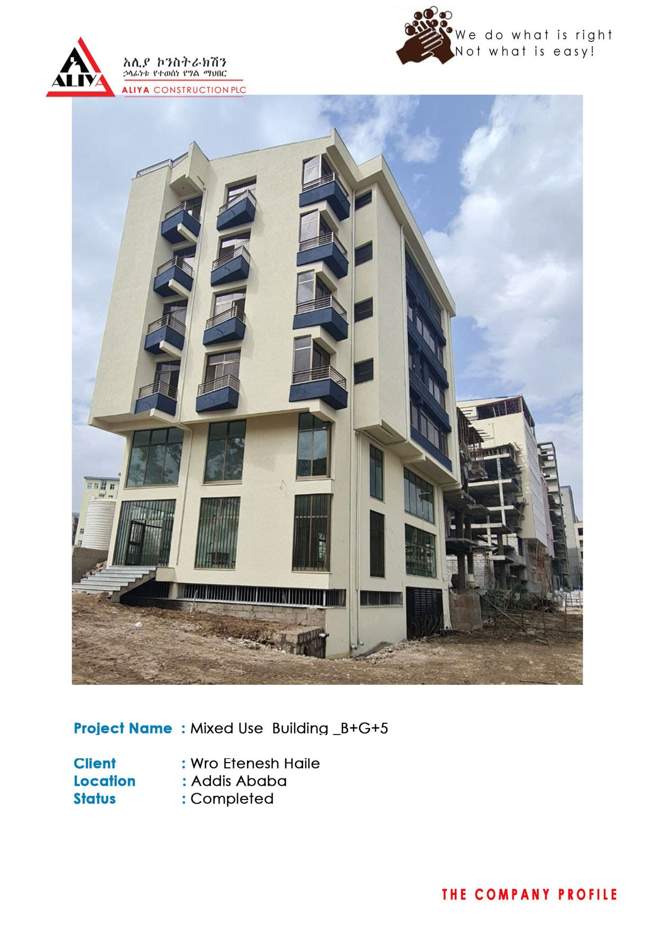  Mixed-Use Building (B+G+5) · Wro Etenesh Haile · Addis Ababa · Completed
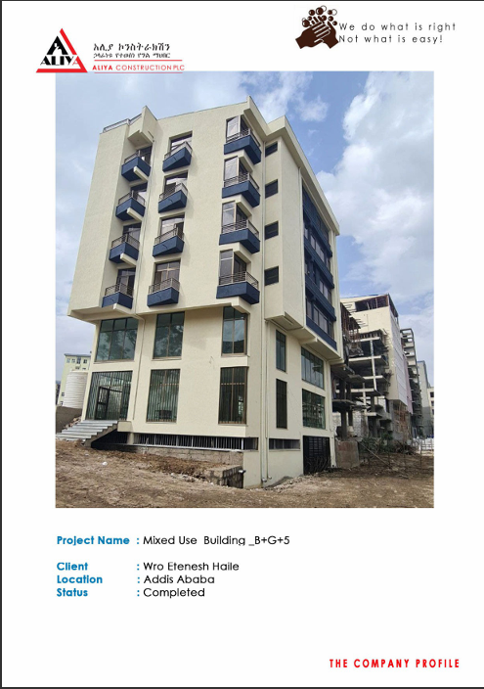 | 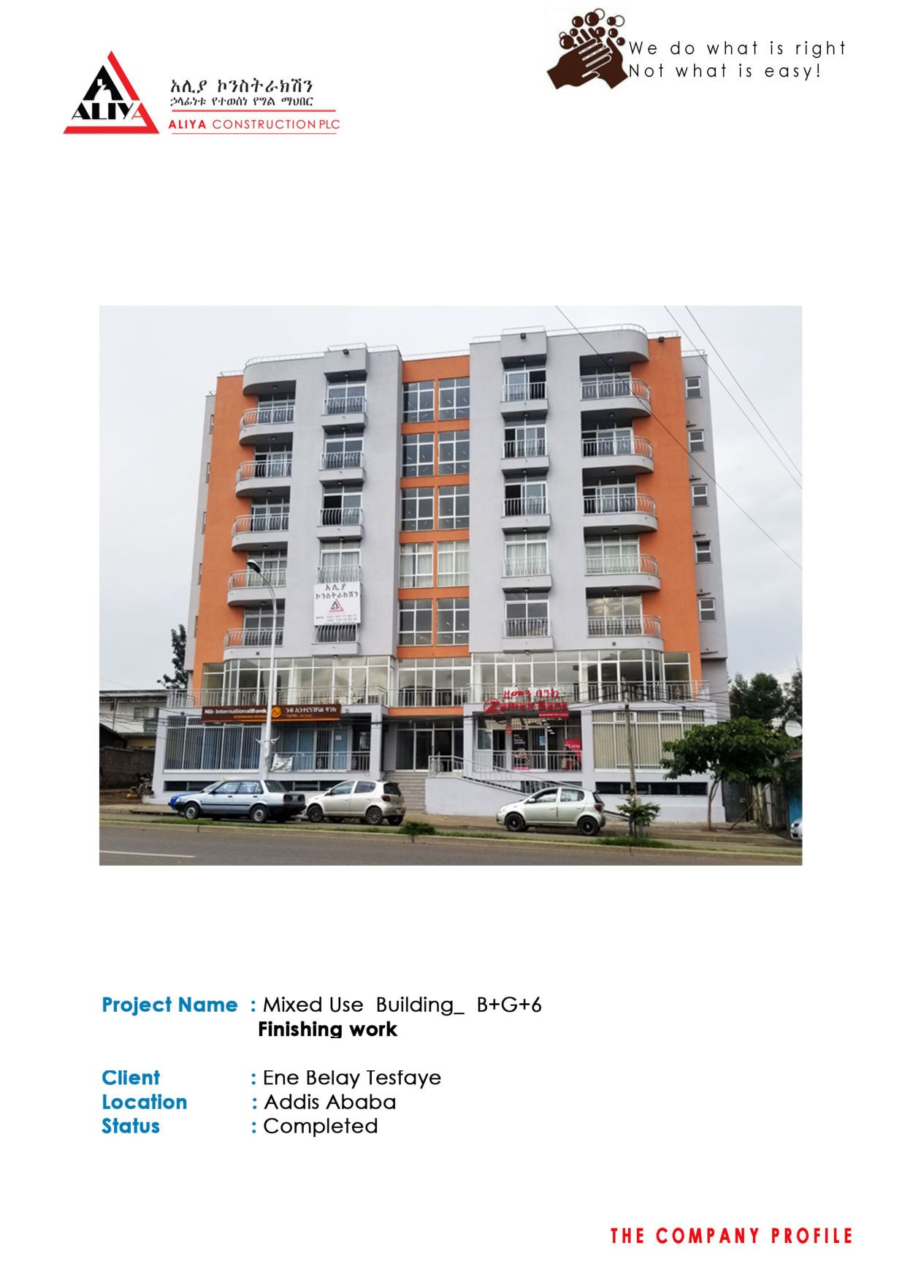  Mixed-Use Building (B+G+6) — Finishing Work · Ene Belay Tesfaye · Addis Ababa · Completed
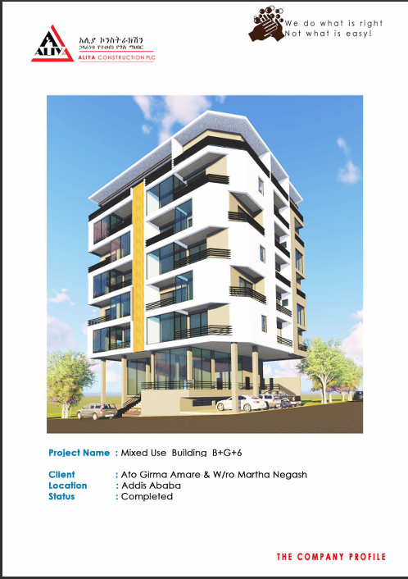 | 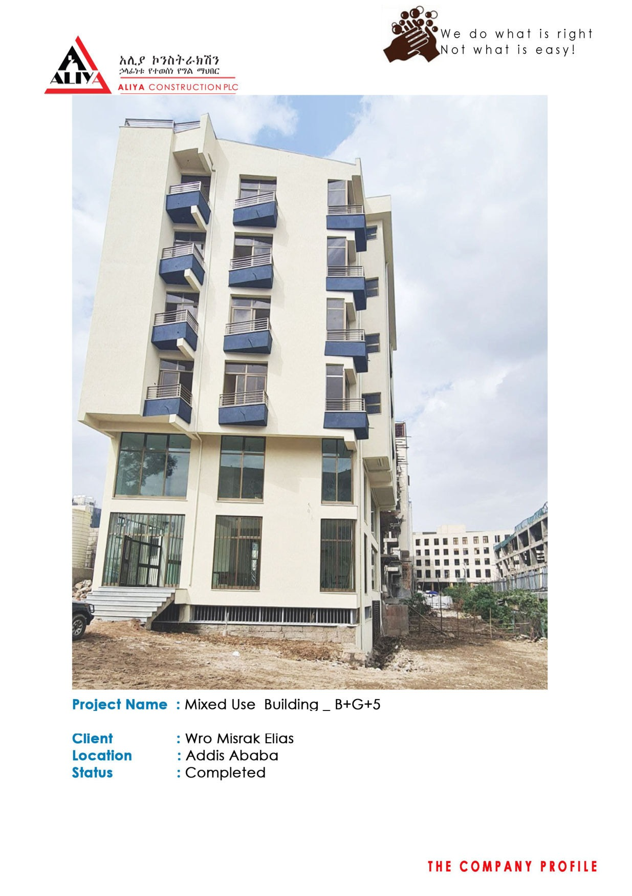  Mixed-Use Building (B+G+5) · Wro Misrak Elias · Addis Ababa · Completed
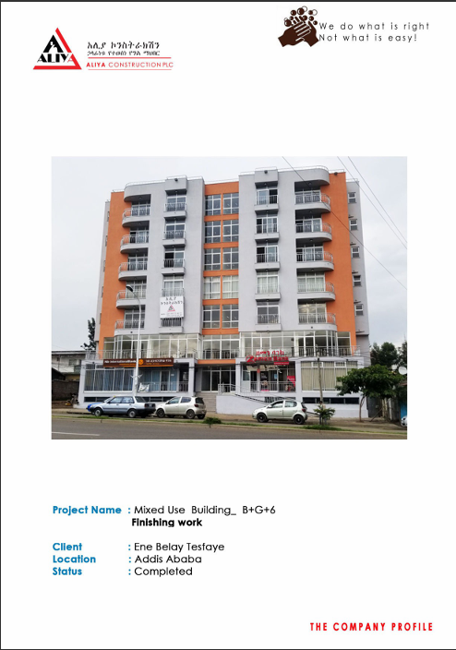 | BGI Ethiopia — Kera Store Maintenance Work (Before / After) · Addis Ababa · Completed

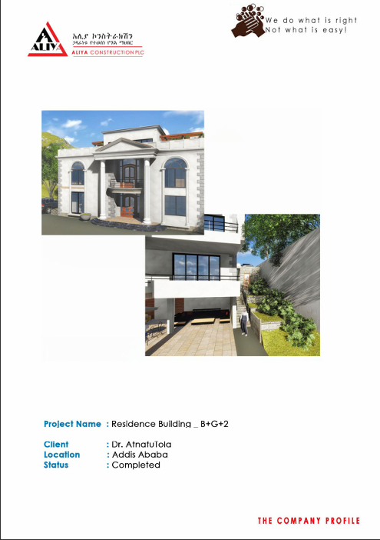

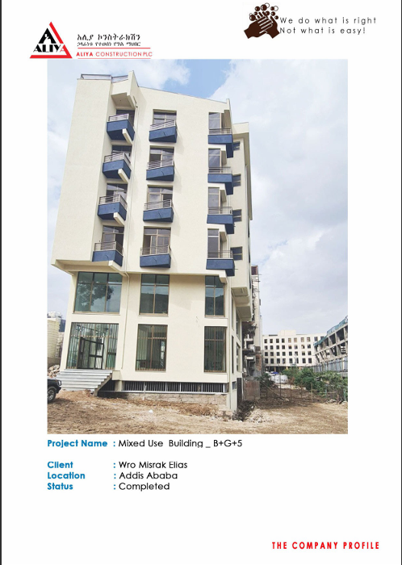

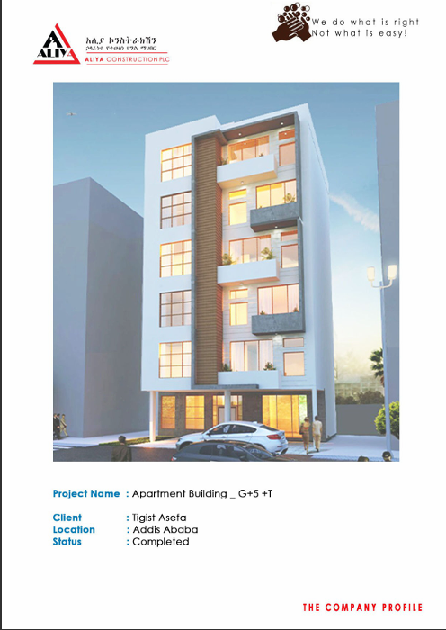

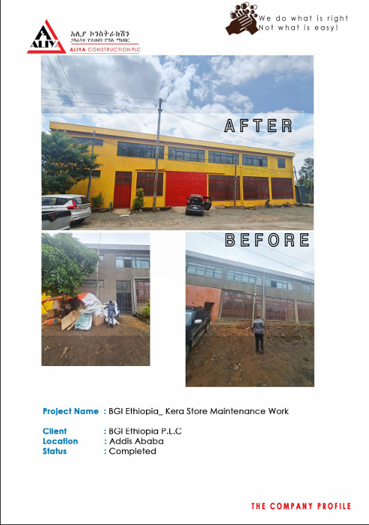

07 STATUTORY CERTIFICATES & PROFESSIONAL CREDENTIALS
The company's legal, technical, and professional standing is substantiated by the following statutory certificates, university diplomas, and competence credentials, held either by ALIYA CONSTRUCTION PLC or by its General Manager and Technical Manager, Belay Taye Gurmu. Certified copies of all listed documents are appended to this profile.
No. | Certificate / Credential | Issuing Authority | Validity / Date
1 | Certificate of Competence for Contractor — General Contractor Grade 5 | City Government of Addis Ababa, Construction Permit & Control Authority | Valid: 2017–2018 Budget Year
2 | Practicing Professional Engineer in Construction Management (Belay Taye Gurmu) — Reg. No. PPECM/4469 | Construction Works Regulatory Authority, Ministry of Urban Development and Construction | Valid until Dec. 28, 2027 G.C.
3 | Practicing Professional Engineer in Construction Management (Belay Taye Gurmu) — Reg. No. PPECM/563 | City Government of Addis Ababa, Construction Permit & Control Authority | Issued Jan. 2, 2023 · Valid 2022–2026 G.C.
4 | Certificate of Competence — Aliya Construction, Building Contractor, Grade Four (Serial No. 03884 / CON/8154) | Ethiopian Construction Authority | Issued 17/07/2024
5 | Bachelor of Science in Civil Engineering (Belay Taye Gurmu) | Addis Ababa University | Issued July 9, 2015 E.C.
6 | Advanced Diploma in Building Engineering (Belay Taye Gurmu) | Addis Ababa University | Issued July 23, 2005 E.C.
7 | Acceptance-Testing Training Certificate — University Capacity Building Program (Ato Belay Taye, MH Engineering) | GTZ IS, funded by the Ministry of Education | Workshop: Aug. 7–10, 2007
8 | Human Resource Management Training Certificate (Belay Taye) | Addis Ababa Chamber of Commerce and Sectoral Associations — Addis Chamber Training Institute | Training: Aug. 23–27, 2021
9 | Health and Safety in Construction Training — Certificate of Completion (Feven Zewde, Aliya Construction trainee) | Construction Management Institute (CMI) & Construction Contractors Association of Ethiopia (CCAE) | March 21–22, 2024 · Cert. ID A10094
10 | Participation Certificate — Best Sponsor Award | Tesfa Art Enterprise | 2014 E.C.

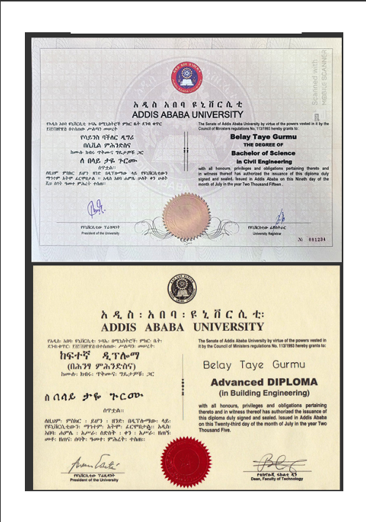 | 2 — Practicing Professional Engineer in Construction Management, Reg. No. PPECM/4469 · Construction Works Regulatory Authority
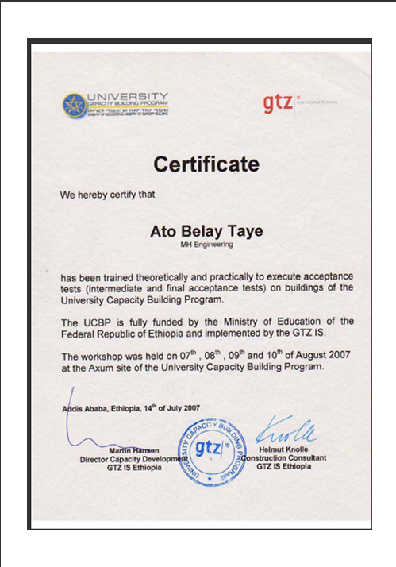 | 4 — Certificate of Competence, Building Contractor Grade Four · Ethiopian Construction Authority
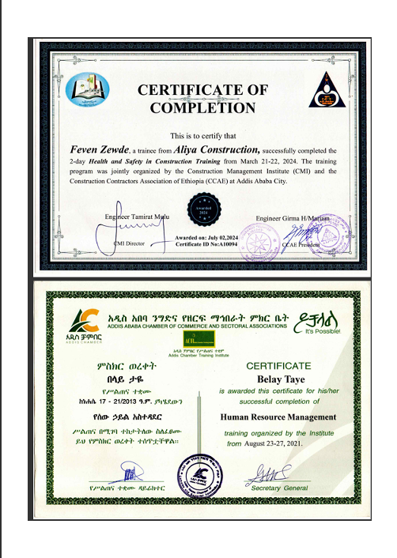 | 3 — Practicing Professional Engineer in Construction Management, Reg. No. PPECM/563 · City Government of Addis Ababa
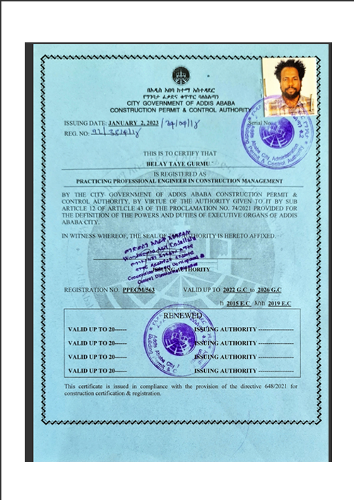 | 7 — Acceptance-Testing Training Certificate · GTZ IS / University Capacity Building Program
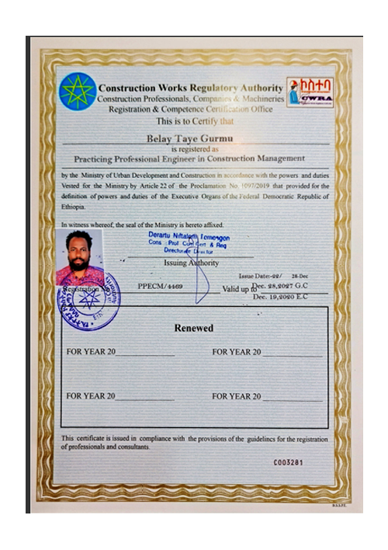

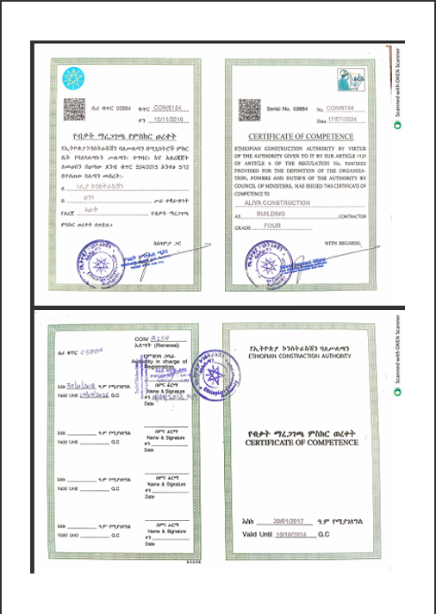

08 INTERNATIONAL CORPORATE CONTACT DIRECTORY

ALIYA CONSTRUCTION PLC
Contact Person: Belay Taye — General Manager
Mobile: +251 949 00 77 77 / +251 986 00 77 77
Office Phone: +251 116 67 07 77
P.O. Box: 8566
Email: aliyaconstructionplc@gmail.com
Location: Bole, Near Atlas Traffic Light, KT Apartment Building, 7th Floor, Addis Ababa, Ethiopia

“We do what is right, Not what is easy!”

