SMART PARKING SYSTEM



**Business Requirements Specification**

**SMART PARKING SYSTEM**

Author: Thejasri Dowluri

Shruti Mishra

Javier Olaya

Manjyoti Manchanda

Creation Date: 2/26/2014

Last Revised: 2/26/2014

Version: 1.0

TABLE OF CONTENTS

INTRODUCTION 3

Purpose of requirement specification document 3

Project Overview 3

Project Purpose 3

Project Scope 3

Requirement ID Nomenclature 4

PRODUCT/SERVICE DESCRIPTION 5

Product Context 5

User Characteristics 5

Assumptions 5

Constraints 5

Dependencies 6

REQUIREMENTS 7

Functional Requirements 7

Hardware Requirements 9

Software Requirements 9

User Interface Requirements 10

Performance 10

Manageability/Maintainability 10

System Interface/Integration 11

Standards Compliance 11

Portability 11

USER SCENARIOS/USE CASES 12

UML Diagram 12

APPENDIX A 13

Citations: 13

APPENDIX B 14

List of requirement Id’s 14

APPROVALS 16

Sign-off Sheet 16

INTRODUCTION

Purpose of requirement specification document

This document details the functionalities required for smart parking system. Although this document is intended as a set of Requirements, not a design, some technical information has been included with the requirements description.

Project Overview

This project named as “smart parking system”, is a combination of hardware and software implementation to generate real time information about parking slots available and display this information on a web/mobile application for users.

Project Purpose

The smart parking system will be deployed in Kean University to help better management of the parking lots available. It will facilitate faculty, students, workers, visitors and others to find open parking space in real time using smart phone App or a device connected over internet. It aims at saving time of the users and better traffic management inside the campus.

The system will be recording visuals and stills from the parking lots from over the campus.  Hence the security department of the campus can also access the same for surveillance

Project Scope

By the end of the timeline, there should be successful development of the following:

* Webcam - Raspberry Pi - Wireless network over all the parking lots on campus.
* Image Processing unit
* Web Application
* Mobile Application

There should be also successfully tested the complete system by either deploying it on a small number of parking spots or creating a small scale model of a parking lot.

Requirement ID Nomenclature

All the requirements in this document are given an Id in the format of “Reqxxxx” where xxxx are decimal digits starting from Req0100 to Req0900 and the subparts are identified as Req01** so on and so forth.

PRODUCT/SERVICE DESCRIPTION

This product is intended to be used as an ios, android and web application. User using iphone, android or a laptop can be benefitted by this product. Once the user gains access to the application it will guide him about the available parking spots. So without wasting any time user can head to that particular spot.

Product Context

The main technology adopted here is Image Processing. So it will work in conjunction with several technical and database aspects.

User Characteristics

No technical training or education is required to use this product. Our main user is the student and the staff members at Kean University.

Assumptions

Availability of the high resolution cameras is assumed. Team’s Knowledge of objective c and java to develop ios and android app is assumed. Further database and web development expertise is assumed.

In addition, we also assume campus police at kean university shall give us permission to allow smart parking system’s devices to be placed at the kean university parking lot

Constraints

* Technical Constraints:

Strength and availability of Wi-Fi network will govern the efficiency of process.

Raspberry Pi works with electricity, hence power outage on poles will result in failure of system to work

* Budgetary Constraints:

Due to insufficient budget we are not able to provide the cameras and raspberry pi to all the parking lots available.

* Environmental Constraints:

Weather is also a major constraint. If the parking lots are covered with snow, cameras will not be able to scan the number assigned to the parking spots.

Dependencies

This new product will require a timely download of data from the camera scanners and is also dependent on internet connection.

REQUIREMENTS

Functional Requirements

The smart parking system has two distinct modules

1. Image processing

2. Information display

The information display is further subdivided into Website, IOS App, and Android App.

The “smart parking system” as implemented in the present project should have following functions.

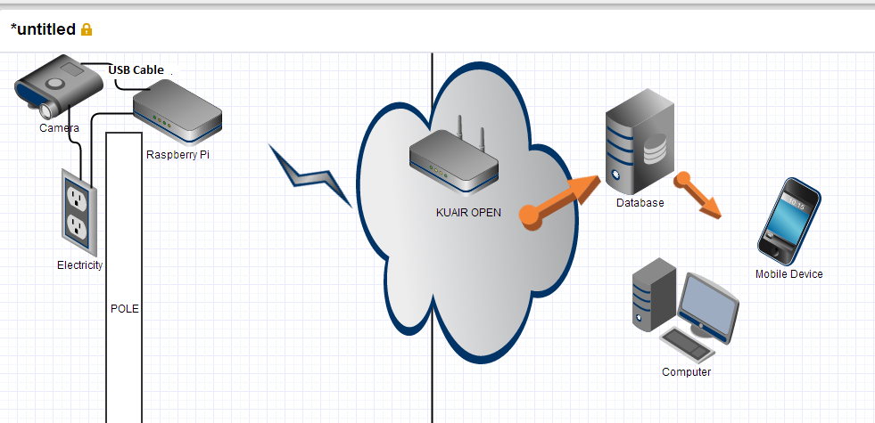

Fig1: System Design Architecture overview

* The camera will be connected to Raspberry pi through which it is connected to the Wi-Fi network (KUAIR).
* We use a computer/server to do the image processing since it has good processing capability.
* A static IP address is assigned to the camera or raspberry so that the devices are easily identified.
* The database should be real time database.

**Req0101: Image from each camera should be captured within 30 secs.**

**Req0102: Image from all 200 nodes should be updated within 30 secs.**

**Req0103: All the updated images captured should be processed every 30 secs.**

**Req0104: The real time database should be updated for parking spot status every 30 secs.**

Once the image is received every 30 secs or 1 min (For the sake of simplicity of project we do not receive the image automatically from the parking spot in real time).

The image should be scanned for number of empty spots. The information extracted should update the status of parking lots in the central database holding the information about parking spots.

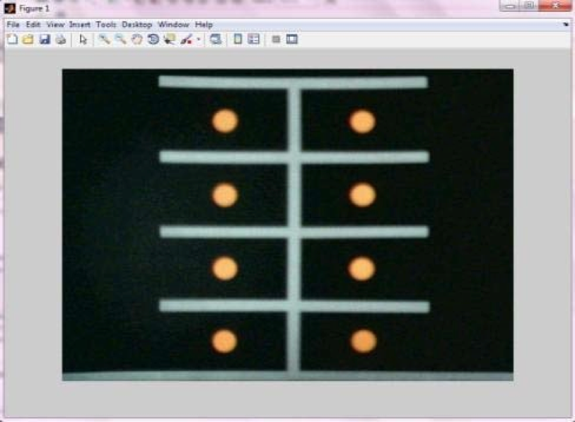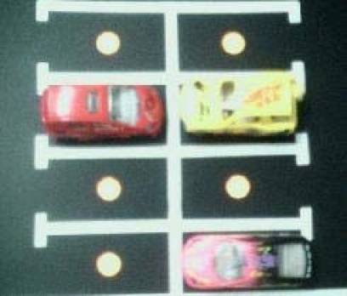

Fig2: Images showing an example of image prototypes.

**Req0105: the entire process (capturing of images + updating of image from 200 nodes + processing of all images+ updating od real time database ) should not take more than 30 secs.**

Timely: The system should be checked for timely execution of the entire process and should not take more than 30 secs.

**Req0106: The system should be scalable.**

Scalability: The system should be easily scalable if the user decides to add more parking lots.

**Req0107: The system should be centralized for all parking lots.**

Centralized: The system should be centralized, for more than one parking lot, the same application should be able to handle the image processing

**Information Display Requirements**

**Req0108: The Information should be displayed over web/mobile applications.**

Display the information over website as the number of parking spots available and the location of the spot for each parking lot at Kean University.

**Req0109: Data displayed on the web/mobile application should be same as the information stored in database at any given instance.**

The data from the database should also be updated to website and Apps every 30 sec, so that the user gets accurate information.

**Req0110: Administrator should have access to put announcements in applications.**

Administration Access: Website and Apps should have administrator access. Administrator should be allowed to activate or deactivate parking lots or add any announcement about the parking lots for the users.

Hardware Requirements

**Req0201: Establish network of cameras.**

**Installation of camera and raspberry Pi nodes should be done for coverage of all parking slots in the campus.**

Camera, position and angle: The camera will be installed on the available light poles and the angle of the camera should be such that it can capture maximum number of parking spots. The empty parking spots should not be obstructed by incoming cars that park. Each node should be placed in weather resistant box.

**Req0202: Establish application and database server.**

A network of webcam-raspberry pi-wireless has to be established in the parking lots.

Given that the numbers of parking spots are 4000. And one node (webcam-raspberry pi combination) is expected to cover at least 20 parking spots.

Following are the hardware requirements: -

200 nodes will be required

200 cameras

200 raspberry pi boards

Application Server

Database server

Software Requirements

**Req0300: Use the following technologies.**

To develop the image processing applications ‘OpenCV’ will be used.

The languages used to develop the application are, C++,PhP, MySQL database, HTML, CSS, Java, Objective C.

User Interface Requirements

The user interface section of the application has website, IOS App and Android App.

It should be

**Req0401 Concise information display checklist**

**Name of parking lot**

**Number of spots available at a current time**

**Location of the available spot**

**Req0402 GUI should avoid typing of input from users (typing information should not be required)**

**Req0403 The interface/GUI of the website/mobile applications should have same color theme and logo to keep consistency between the applications.**

Performance

To evaluate the performance of the smart parking system, we introduce the following metrics, which reflects the needs of the users and our concerns on the parking system.

**Capacity** **Req0501:** The size of audience being addressed is 20,000.The system should be able to support at least 300 hits per sec. This communication plan is for the following audiences.

**Availability Req0502:** The information about the empty parking spots is available to the students on the website throughout the day. The system should be available round the clock but can be programmed for delayed updates during off peak hours or holidays.

**Latency Req0503:** Latency should not be more than 60 seconds at any time. Latency: The time interval between the time parking spot gets empty and the time the apps and the website get updated. This latency will be in seconds, because the camera clicks at the parking lot for every 30 seconds.

Manageability/Maintainability

Maintenance of the smart parking system is not difficult as most of the process in this system is automated. The nodes may have to repaired and maintained time to time.

System Interface/Integration

**Req0701: Camera-Raspberry Pi interface.**

* The hardware network of this system consists of a camera, which will be connected to raspberry Pi by a usb cable.

**Req0702: Node (camera + raspberry Pi) and Software application interface.**

* The raspberry pi will be connected to application server via Kean wi-fi network.

**Req0703: Software Application and Database server interface.**

* Application server will communicate to database using a scripting language.

Standards Compliance

**Req0801: The smart parking system should comply to the school safety and privacy policies.**

**Req0802:**

Software programs being used by the system should not be illegal, unauthorized, or unlicensed.

Portability

**Req0910:**

This system should be accessible by users on PC, Mobile, Laptop or tablets.

**Req0920:**

The information should be available and accessible on both Windows and Mac OS X

**Req0930:**

The information (mobile application) should be available for both android and ios environment.

USER SCENARIOS/USE CASES

UML Diagram

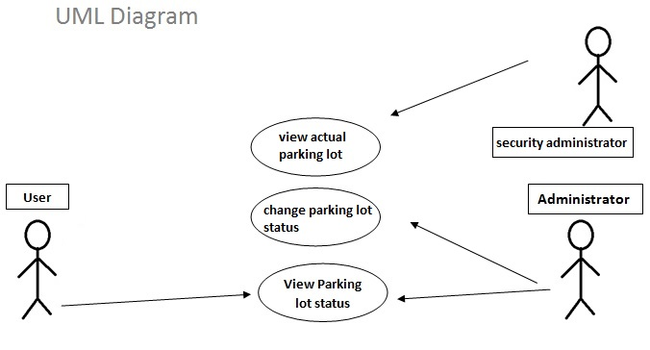

**Use case 1**: view parking lot status

The user or the administrator has the ability to view if a parking spot is available or not in the parking lot region.

**Use case 2**: change parking lot status

The administrator is able to change the status of the parking spot availability. This is used to notify the uses that the parking lot is closed due to university activities or climate reasons.

**Use case 3**: view actual parking lot

This case is used only for the security administrator to view. This is an actual video view of what the camera is capturing from the parking lot region.

APPENDIX A

Citations:

Intelligent Parking Space Detection System Based on

Image Processing

<http://www.ijimt.org/papers/228-G0038.pdf>

APPENDIX B

List of requirement Id’s

**Req0100 series:** **Image processing requirements**

**Req0101:** Image from each camera should be captured within 30 secs.

**Req0102:** Image from all 200 nodes should be updated within 30 secs.

**Req0103:** All the updated images should be processed every 30 secs.

**Req0104:** The real time database should be updated for parking spot status every 30 secs.

**Req0105:** the entire process (capturing of images + updating of image from 200 nodes + processing of all images+ updating od real time database ) should not take more than 30 secs**.**

**Req0106:** The system should be scalable.

**Req0107:** The system should be centralized for all parking lots.

**Req0108:** The Information should be displayed over web/mobile applications.

**Req0109:** Data displayed on the web/mobile application should be same as the information stored in database at any given instance.

**Req0110:** Administrator should have access to put announcements in applications.

**Req0200 series: Hardware Requirement**

**Req0201:** Establish network of cameras.

**Req0202:** Establish application and database server.

**Req0300: Use the following technologies.**

**Req0400 series: User Interface Requirements**

**Req0401** Concise information display checklist

Name of parking lot

Number of spots available at a current time

Location of the available spot

**Req0402** GUI should avoid any kind of input from users (typing information should not be required)

**Req0403** The interface/GUI of the website/mobile applications should have same color theme and logo to keep consistency

**Req0500 series: Performance**

**Req0501:** Capacity

**Req0502:** Availability

**Req0503:** Latency

**Req0700 series: System Interface/Integration**

**Req0701:** Camera-Raspberry Pi interface.

**Req0702:** Node (camera + raspberry Pi) and Software application interface.

**Req0703:** Software Application and Database server interface.

**Req0800 series: Standard Compliance**

**Req0801:** Compliance with school safety and policies

**Req0802:** All the software used should be licensed.

**Req0900 series: Portability**

**Req0910:**

This system should be accessible by users on PC, Mobile, Laptop or tablets.

**Req0920:**The information should be available and accessible on different    OS (Mac and windows).

**Req0930:** The information (mobile application) should be available for both android and ios environment

APPROVALS

Sign-off Sheet

***I have read the above Project Plan and will abide by its terms and conditions and pledge my full commitment and support for the Project Plan.***

**Project Sponsor: Dr. Jing-Chiou Liou**

Date

**Project Manager: Nayan Bhavsar**

Date

**Project Manager: Carlos Silva**

Date