# **Functional Requirements**

## Administrators

Req0100: Administrators can login into the application with their user ID and password.

Req0101: Successful login of the administrator should default their view to the administrator dashboard.

Req0102: Administrators can create, modify or delete any user account or account information.

Req0103: Administrators can create, modify or delete supervisor accounts.

Req0104: Administrators can generate all system reports (user account management, logins, supervisor, tutor and student analytic reports).

## Supervisors

Req0200: Supervisors can login into the application with their user ID and password.

Req0201: Successful login of the supervisor should default their view to the supervisor dashboard.

Req0202: Supervisors can create and delete tutor groups.

Req0203: Supervisors can assign and activate accounts as tutors.

Req0204: Supervisors can set account expirations dates for tutor accounts.

Req0205: Supervisors can view tutor ratings.

Req0206: Supervisors can view tutor notes of students.

Req0207: Supervisors can generate account activity reports (user logins, workday logins, check-in\out, tutor and student analytic reports).

## Tutors

Req0300: Tutors can login into the application with their user ID and password.

Req0301: Successful login of the tutor should default their view to the tutor dashboard.

Req0302: Tutors can choose from list of departments they are an associated tutor of.

Req0303: Tutors can clock-in\out of their tutoring workday.

Req0304: Tutor session QR codes are generated during clock-in to use for check-in purposes for tutoring sessions.

Req0305: Tutors can check-in a student into a tutoring session using a QR code.

Req0306: Tutors can check-in a student into a tutoring session by the student’s login ID.

Req0307: Tutors can check-out a student manually.

Req0308: Tutors can view and change their account information.

Req0309: Tutors can view statistics on their tutoring of specific courses.

Req0310: Tutors can view statistics on their tutoring to specific students.

Req0311: Tutors can view statistics on their tutoring of courses within a specific course year (Freshman, Sophomore, Junior, Senior).

Req0312: Tutors can send students messages regarding their tutoring session.

Req0313: Tutors can make notes about specific students which are viewable only to other tutors and supervisors.

Req0314: Tutors can generate account activity reports (logins, workday logins, check-in\out, student analytic reports).

## Students

Req0400: Students can login into the application with their user ID and password

Req0401: Successful login of the student should default their view to the student home page.

Req0402: Students must choose the tutor group they want to use

Req0403: Students can check-in to tutoring session by scanning the tutor’s QR code.

Req0404: Students can check-in to tutoring sessions by lookup of tutor and entering the course. Tutor receives confirmation message to approve

Req0405: Students can check-in to tutoring sessions by entering their login ID on the tutor’s interface.

Req0406: Students can view and change their account information.

Req0407: Students can view statistics on the tutors they had tutoring sessions with.

Req0408: Students can view statistics on how often they go to tutors for each course.

Req0409: Students can view statistics on the courses they needed tutoring for.

Req0410: Students can send tutors messages and can view tutor’s hours.

Req0411: Students can view tutor ratings and reviews.

Req0412: Students can rate tutor performance and leave review.

Req0413: Students can generate account activity reports on their activity logs (logins, check-in\out, tutoring session analytics)

# **Non-Functional Requirements**

## Hardware Requirements

Req0500: The system requires the mobile application and web application is utilized from a device connected to the Internet.

Req0501: The system requires a web server to process the web application.

Req0502: The system requires a database server to allow users and applications to centrally access the data.

Req0503: The system should be operational on different screen sizes and internet connection speed.

Req0504: The system should make use of the camera on the android device. The camera should be used for QR code scanning.

## Software Requirements

Req0600: The Android application must support Android devices running on OS versions 4.0.3 or higher.

Req0601: The Android application will run quarterly maintenance cycles to provide updates for the end users.

Req0602: The web application should support all commonly used web browsers (Google Chrome, Mozilla FireFox, Microsoft Internet Explorer)

## Security Requirements

Req0700: Students can only view his/her own account and activity information and not that of any other student, tutor or administrator.

Req0701: Tutors can only view his/her own account and activity information and not that of other tutors or administrators.

Req0702: Administrators can only view his/her own account and not that of other administrators.

Req0703: The system must store passwords in bcrypt hashes and not reveal passwords to any users.

## Availability Requirements

Req0800: The system should always be available during business hours EST. Maintenance times where the application needs to be offline should be done outside of these times.

# **UML Diagrams**

## UML – Administrator

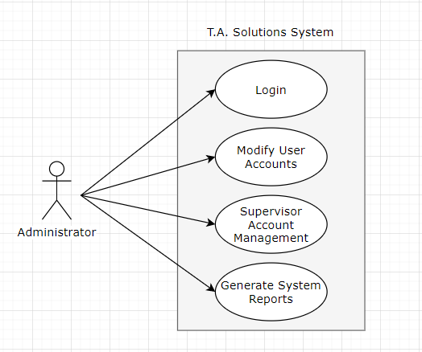

## **UML – Supervisor**

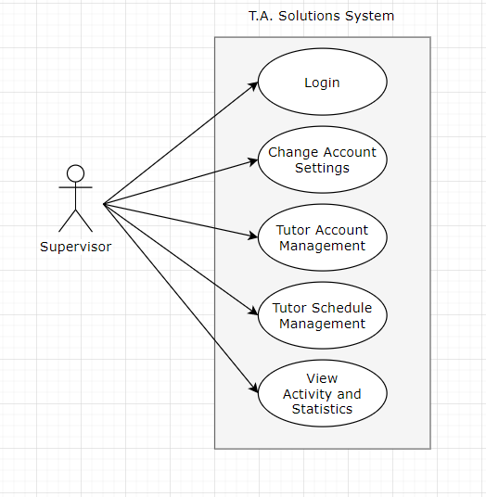

## UML – Tutor

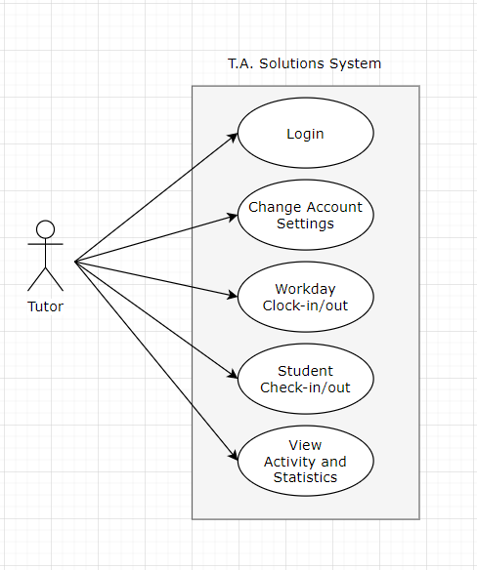

## UML – Student

