# **Functional Requirements**

## Common

Req0001: Users that want to access the application from a mobile device will be required to download and install the application from the Google Play Store.

Req0002: All new users created are defaulted to a student account type.

Req0003All users can login to the application with the supplied user ID and password.

Req0004: Successful login to the application will display dashboard appropriate to the user account type that logged in.

## Administrators

Req0100: Administrator access is limited to the web application and will not be able to log onto mobile.

Req0101: Administrators can create, modify or delete any user account or account information.

Req0102: Administrators can create, modify or delete supervisor accounts.

## Supervisors

Req0201: Supervisors can create and delete classes must require class name, class ID, and brief description.

Req0202: Supervisors can promote and demote one to many student accounts to tutors.

Req0203: Supervisors can set specific account expirations dates when promoting tutor accounts.

Req0204: Supervisors can view tutor ratings and can view tutor notes of students.

Req0207: Supervisors can generate account activity reports (user logins, workday logins, check-in\out, tutor and student analytic reports).

## Tutors

Req0301: Tutors can choose from list of departments with when clocking in.

Req0302: Tutors can clock-in\out of their tutoring workday.

Req0303: Tutor session QR codes are generated during clock-in to use for check-in purposes for tutoring sessions.

Req0304: Tutors can check-in a student into a tutoring session using a QR code.

Req0305: Tutors can check-in a student into a tutoring session with user email.

Req0306: Tutors can check-out a student manually.

Req0307: Tutors can view and change their account information.

Req0308: Tutors can view their tutoring history and organize view by specific courses.

Req0309: Tutors can share session history page to email app

Req0310: Tutors can make notes about specific students which are viewable to supervisors.

## Students

Req0400: Students can login into the application with their user ID and password

Req0401: Successful login of the student should default their view to the student dashboard.

Req0402: Students must choose the departments they want to use/see.

Req0403: Students can check-in to tutoring session by scanning the tutor’s QR code.

Req0404: Students can “check for existing session” to activate session once a tutor has clocked them in

Req0405: Students can view and change their account information.

Req0406: Students can view their tutoring history and specify the subject or view all.

Req0407: Students can view a tutors profile, which contains contact the tutor has input such as email.

Req0408: Students are given the option to rate their tutor’s performance and leave review after checking out of a tutor session.

Req0409: new users are student users by default

# **Non-Functional Requirements**

## Hardware Requirements

Req0500: Accessing the application on a mobile platform will require an Android OS device.

Req0500: The system requires the mobile application and web application is utilized from a device connected to the Internet.

Req0501: The system requires a web server to process the web application.

Req0502: The system requires a database server to allow users and applications to centrally access the data.

Req0503: The system should be operational on different screen sizes and internet connection speed.

Req0504: The system should make use of the camera on the android device. The camera should be used for QR code scanning.

## Software Requirements

Req0600: The Android application must support Android devices running on OS versions 4.0.3 or higher.

Req0601: The Android application will run quarterly maintenance cycles to provide updates for the end users.

Req0602: The web application should support all commonly used web browsers (Google Chrome, Mozilla FireFox, Microsoft Internet Explorer)

## Security Requirements

Req0700: Students can only view his/her own account and activity information and not that of any other student, tutor or administrator.

Req0701: Tutors can only view his/her own account and activity information and not that of other tutors or administrators.

Req0702: Administrators can only view his/her own account and not that of other administrators.

Req0703: The system must store passwords in bcrypt hashes and not reveal passwords to any users.

## Availability Requirements

Req0800: The system should always be available. Maintenance should be scheduled and communicated in advance and limit downtime to 3 hours.

# **UML Diagrams**

## UML – Administrator

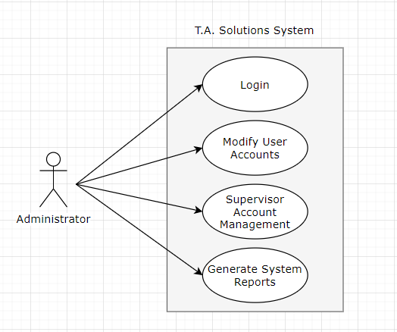

## **UML – Supervisor**

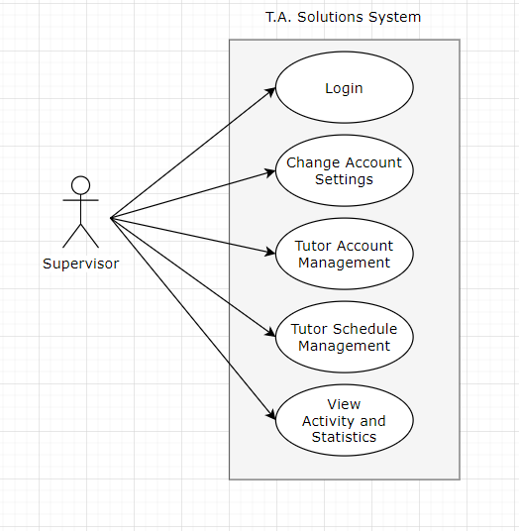

## UML – Tutor

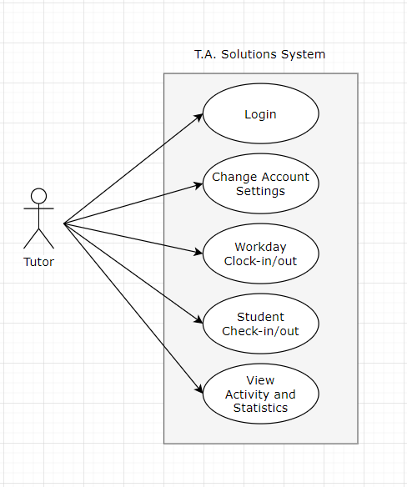

## UML – Student

