Microsoft N-tier
08 Maret 2015
15:18

N-tier and 3-tier are architectural deployment styles that describe the separation of functionality into segments in much the same way as the layered style, but with each segment being a tier that can be located on a physically separate computer. They evolved through the component-oriented approach, generally using platform specific methods for communication instead of a message-based approach.

N-tier application architecture is characterized by the functional decomposition of applications, service components, and their distributed deployment, providing improved scalability, availability, manageability, and resource utilization. Each tier is completely independent from all other tiers, except for those immediately above and below it. The nth tier only has to know how to handle a request from the n+1th tier, how to forward that request on to the n-1th tier (if there is one), and how to handle the results of the request. Communication between tiers is typically asynchronous in order to support better scalability.

N-tier architectures usually have at least three separate logical parts, each located on a separate physical server. Each part is responsible for specific functionality. When using a layered design approach, a layer is deployed on a tier if more than one service or application is dependent on the functionality exposed by the layer.

An example of the N-tier/3-tier architectural style is a typical financial Web application where security is important. The business layer must be deployed behind a firewall, which forces the deployment of the presentation layer on a separate tier in the perimeter network. Another example is a typical rich client connected application, where the presentation layer is deployed on client machines and the business layer and data access layer are deployed on one or more server tiers.

The main benefits of the N-tier/3-tier architectural style are:

Maintainability.
Because each tier is independent of the other tiers, updates or
changes can be carried out without affecting the application as a whole.

Scalability.
Because tiers are based on the deployment of layers, scaling out an application is reasonably straightforward.

Flexibility.
Because each tier can be managed or scaled independently, flexibility is increased.

Availability.
Applications can exploit the modular architecture of enabling systems using easily scalable components, which increases availability.

Consider either the N-tier or the 3-tier architectural style if the processing requirements of the layers in the application differ such that processing in one layer could absorb sufficient resources to slow the processing in other layers, or if the security requirements of the layers in the application differ. For example, the presentation layer should not store sensitive data, while this may be stored in the business and data layers. The N-tier or the 3-tier architectural style is also appropriate if you want to be able to share business logic between applications, and you have sufficient hardware to allocate the required number of servers to each tier.

Consider using just three tiers if you are developing an intranet application where all servers are located within the private network; or an Internet application where security requirements do not restrict the deployment of business logic
on the public facing Web or application server. Consider using more than three tiers if security requirements dictate that business logic cannot be deployed to the perimeter network, or the application makes heavy use of resources and you want
to offload that functionality to another server.

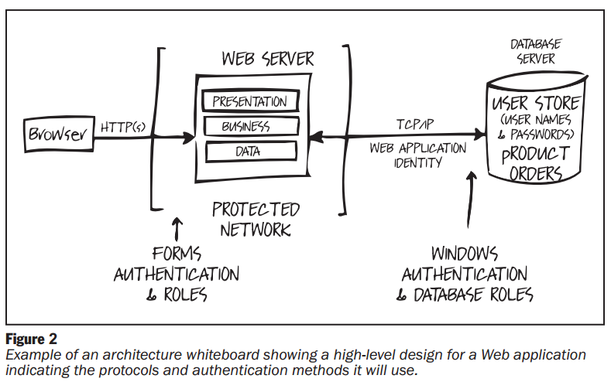

Design:

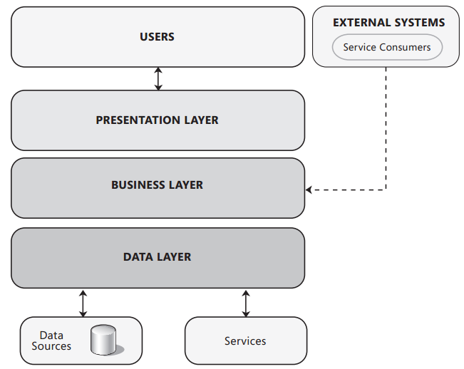

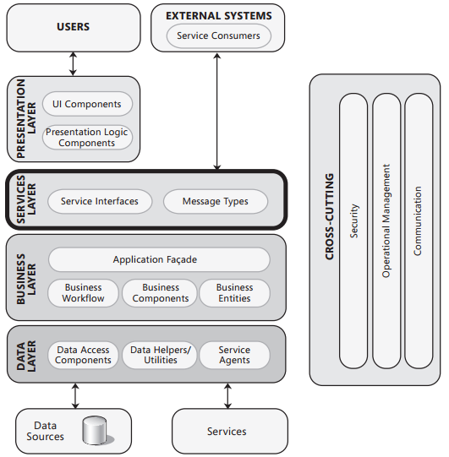

'
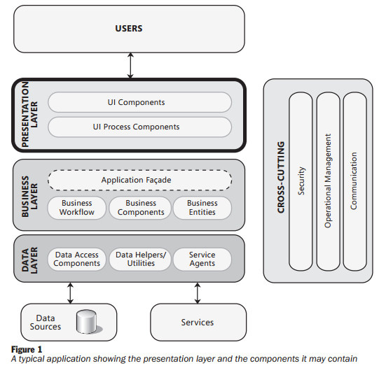

Security Issue:

