Pendahuluan
10 Maret 2016
18:31

Sistem Informasi Terdistribusi:

RSS
WebServices

Referensi:
http://it-ebooks.info/book/6799/
PHP web service

http://www.turorialspoint.com
(tentang XML, JSON, & PHP, web service)

http://www.w3schools.com
(tentang XML, JSON, & PHP)

Data XML:
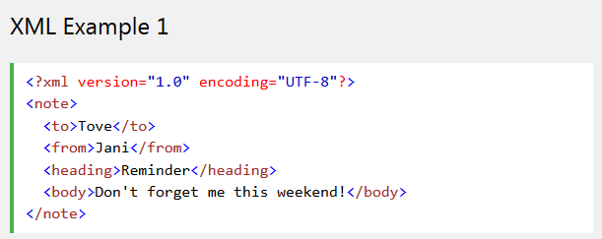

Dalam format JSON

{"note":
{"to":"Tove"},
{"from":"Jani"},
{"heading":"Reminder"},
{"body":"Don't forget me this weekend!"}
}

