|  |  |  |  |  |
| --- | --- | --- | --- | --- |
| Course | Software Engineering |  | Student ID | L200134005 |
| Lecturer | Ir. Bana Handaga |  | Name | Tifany Avika Rahmah |
| DEPARTMENT OF INFORMATICS  X (INTERNATIONAL) CLASS | | | | |

**CLIENT’S PROBLEM STATEMENT**

I need to have you develop a website system which enables me to create, edit, delete as many web pages as possible with easy to administrate dashboard. Website system should also have ability to protect some of web pages to show to only accessible users. Additionally, I will also need ability to manage widgets that appears on sidebar areas of website. Ability to change the theme of website at anytime.

**From passage above:**

1. **Create a document requirement specification.**
2. Website
3. Using dashboard easily (may create, edit, and delete web pages)
4. Access control to all pages (website protection)
5. Show widgets in the sidebar of page
6. Change theme of page anytime
7. **Create a DFD level-0 and the description for the diagram.**

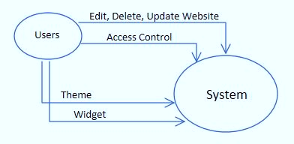

1. **Create a use-case diagram and the description for the diagram.**

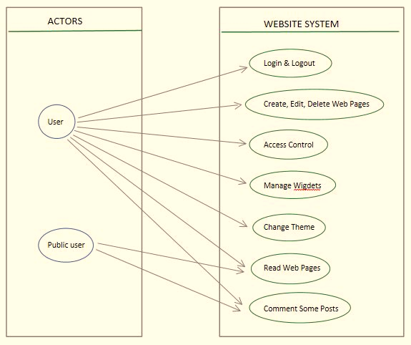

1. **Create an architecture of system and descript how the system work.**

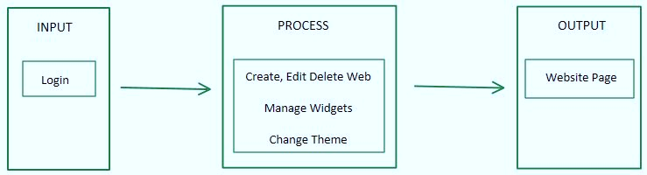

1. **Take one item from use-case and then create an activity diagram for that item.**

- Login Activity -

