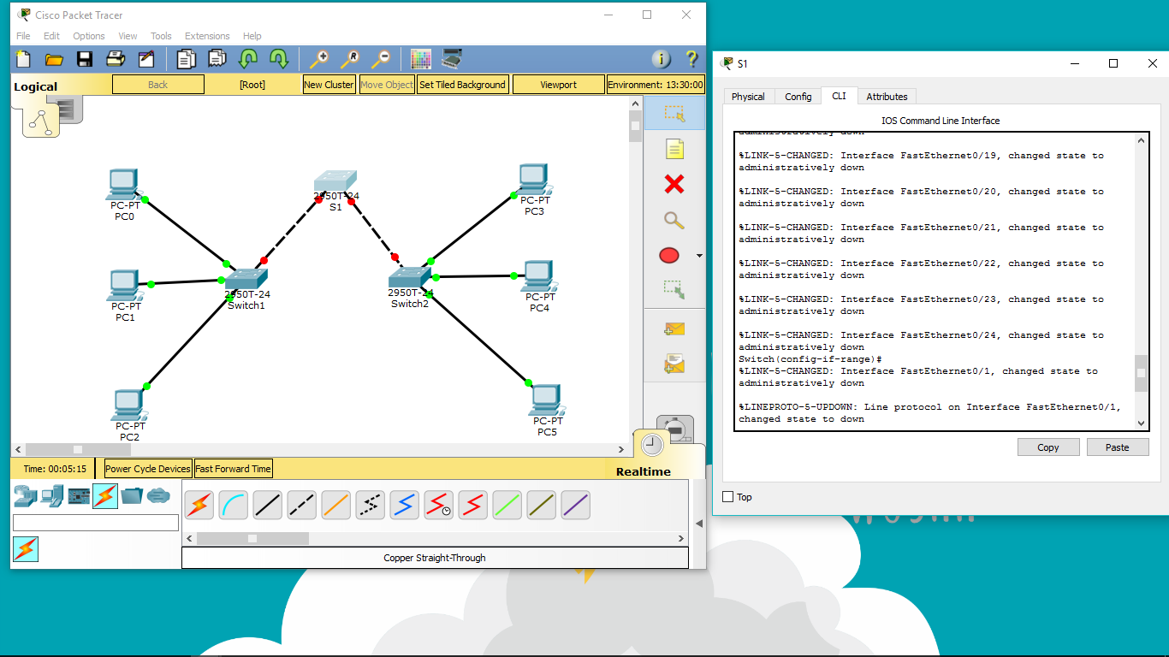

Switch#config term

Switch(config)#interface range fa0/1-24

Switch(config-if-range)#shutdown

Switch(config-if-range)#

interface range gi0/1-2

Switch(config-if-range)#

shutdown

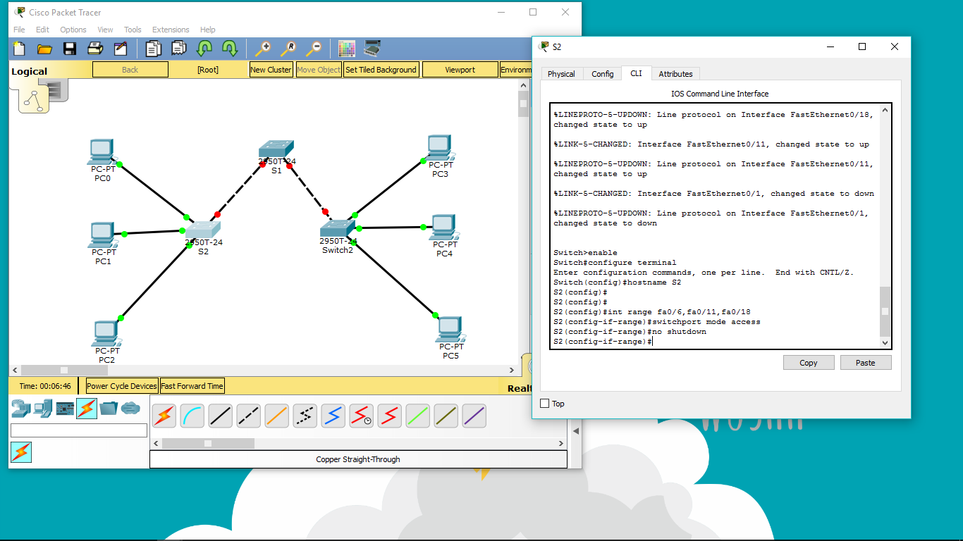

S2(config)#interface range fa0/6, fa0/11, fa0/18

S2(config-if-range)#switchport mode access

S2(config-if-range)#no shutdown

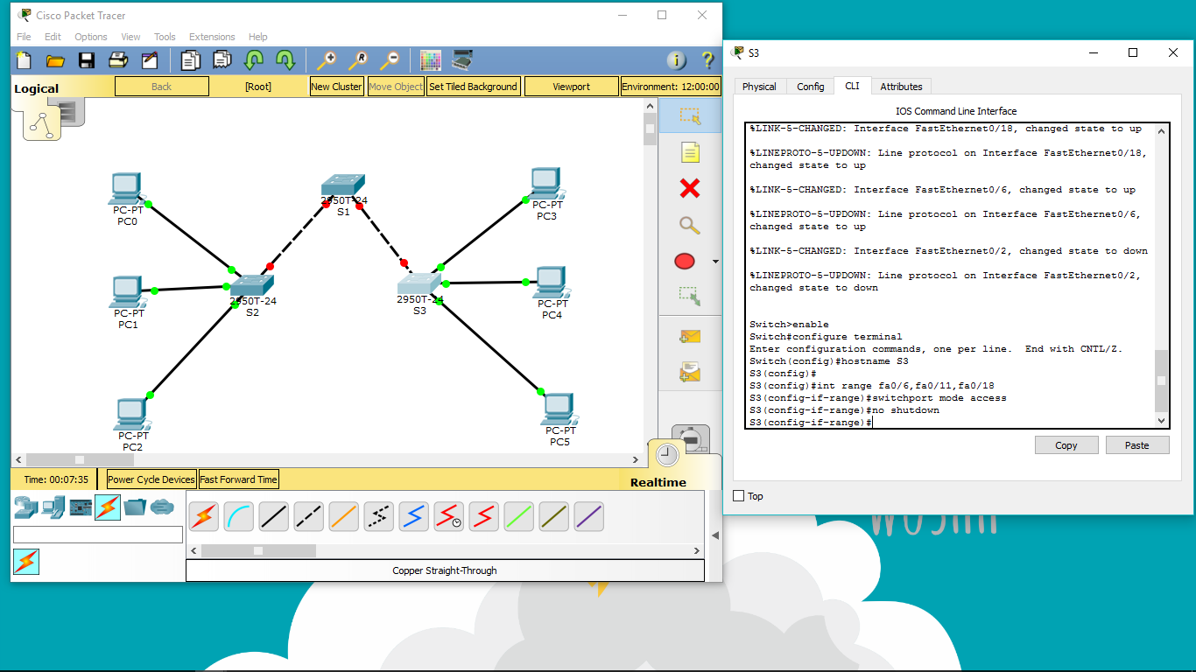

S3(config)#interface range fa0/6, fa0/11, fa0/18

S3(config-if-range)#switchport mode access

S3(config-if-range)#no shutdown

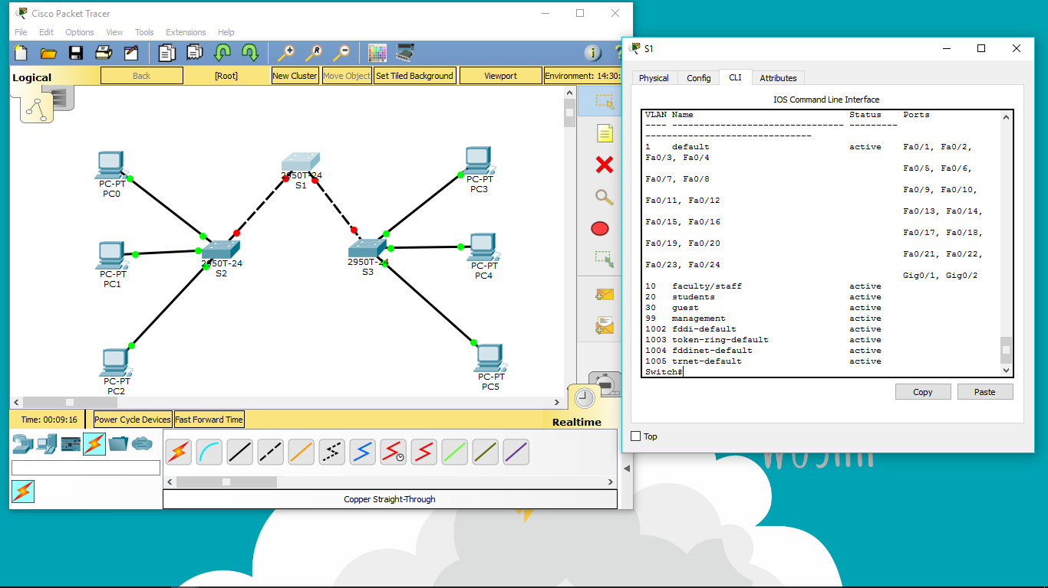

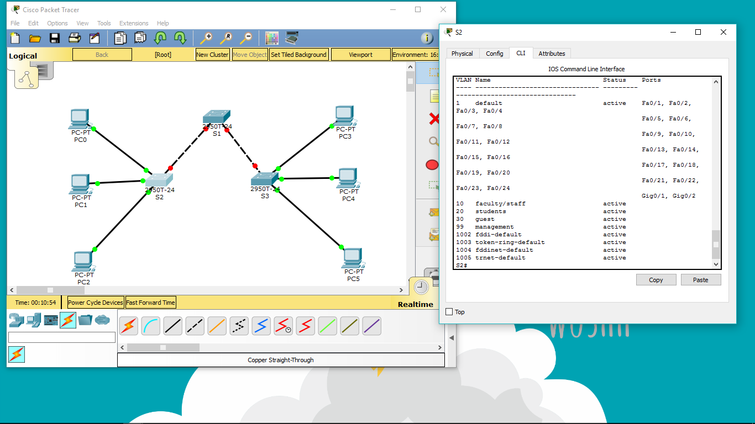

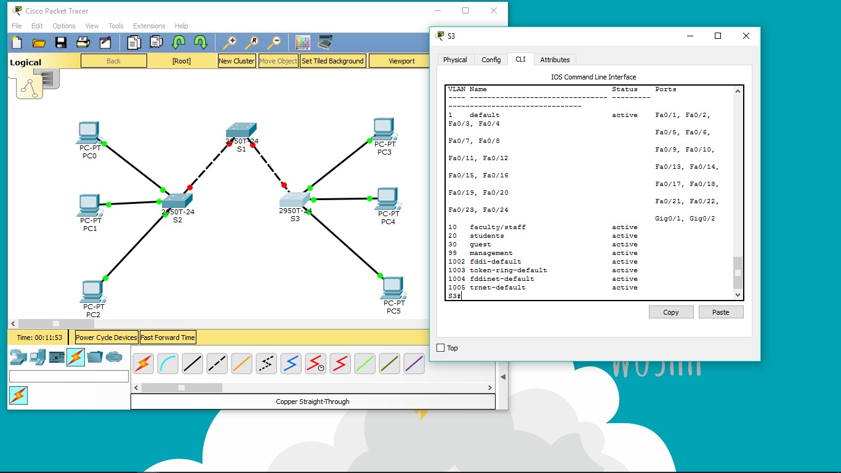

S1(config)#vlan 10

S1(config-vlan)#name faculty/staff

S1(config-vlan)#vlan 20

S1(config-vlan)#name students

S1(config-vlan)#vlan 30

S1(config-vlan)#name guest

S1(config-vlan)#vlan 99

S1(config-vlan)#name management

S1(config-vlan)#end

S1#show vlan brief

VLAN Name Status Ports

---- ------------------------------- --------- ----

-------------------------

1 default active Fa0/

1, Fa0/2, Fa0/4, Fa0/5

Fa0/

6, Fa0/7, Fa0/8, Fa0/9

Fa0/

10, Fa0/11, Fa0/12, Fa0/13

Fa0/

14, Fa0/15, Fa0/16, Fa0/17

Fa0/

18, Fa0/19, Fa0/20, Fa0/21

Fa0/

22, Fa0/23, Fa0/24, Gi0/1

Gi0/2

10 faculty/staff active

20 students active

30 guest active

99 management active

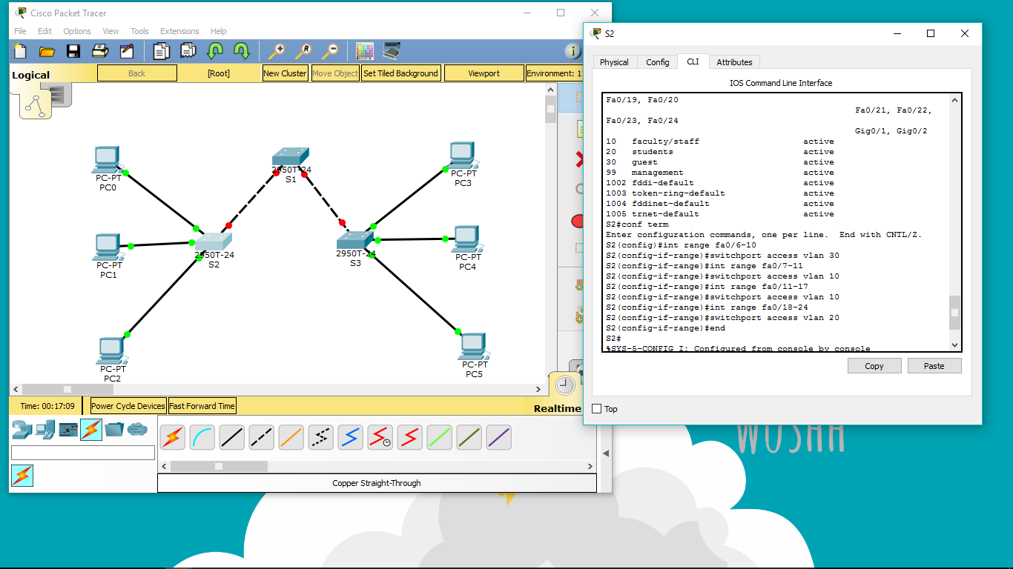

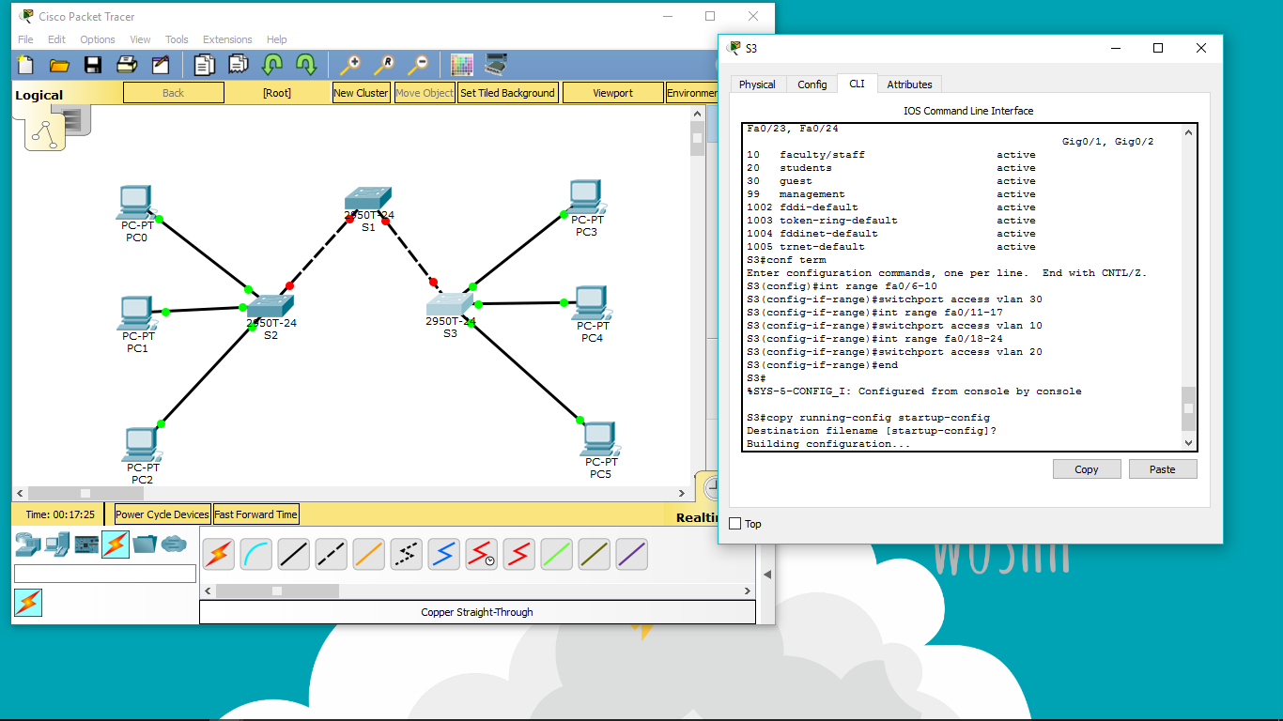

S3(config)#interface range fa0/6-10

S3(config-if-range)#switchport access vlan 30

S3(config-if-range)#interface range fa0/11-17

S3(config-if-range)#switchport access vlan 10

S3(config-if-range)#interface range fa0/18-24

S3(config-if-range)#switchport access vlan 20

S3(config-if-range)#end

S3#copy running-config startup-config

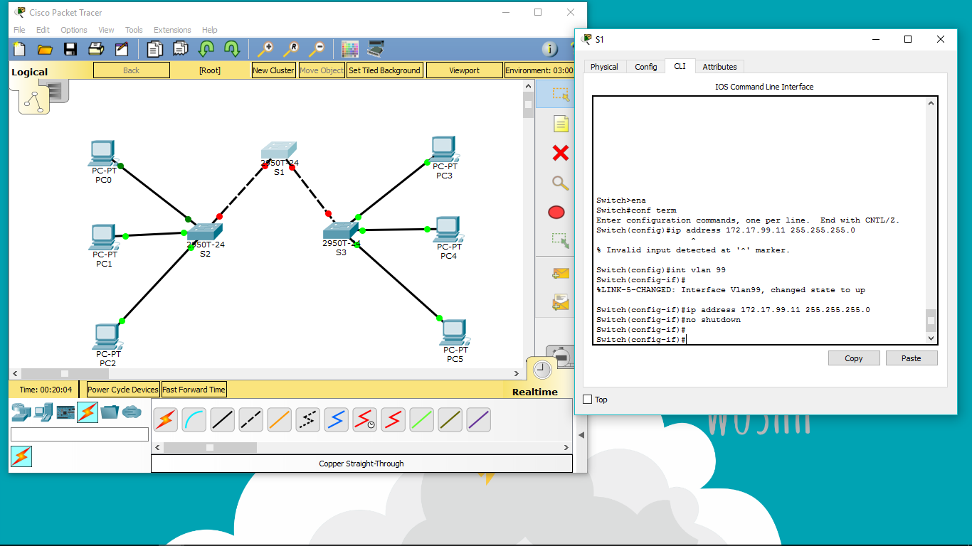

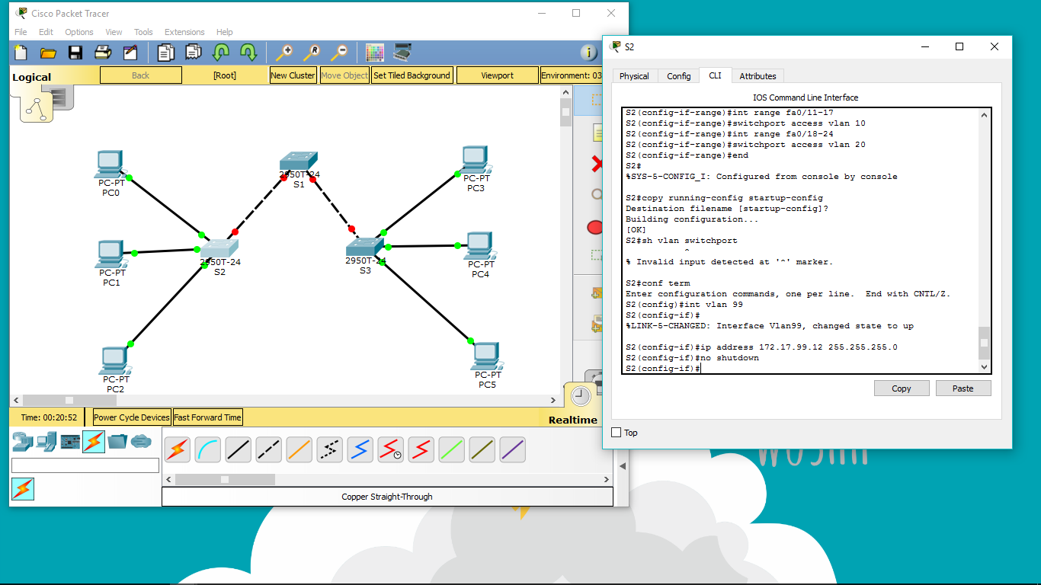

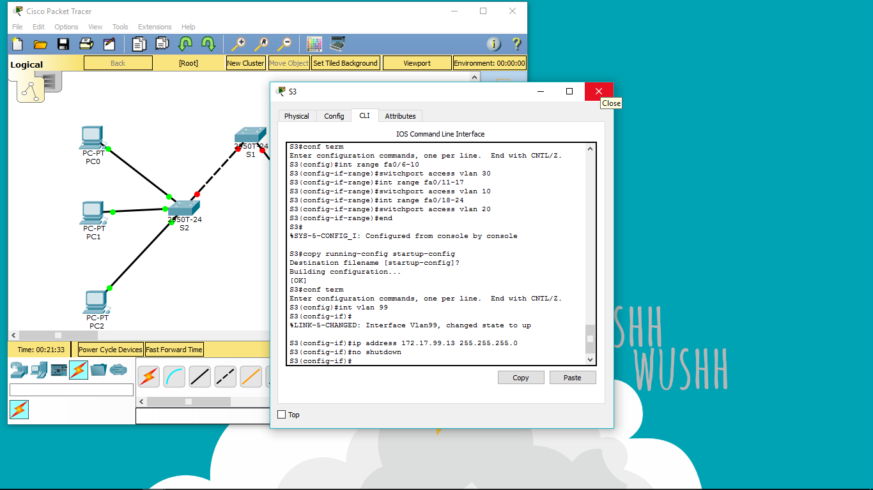

S1(config)#interface vlan 99

S1(config-if)#ip address 172.17.99.11 255.255.255.0

S1(config-if)#no shutdown

S2(config)#interface vlan 99

S2(config-if)#ip address 172.17.99.12 255.255.255.0

S2(config-if)#no shutdown

S3(config)#interface vlan 99

S3(config-if)#ip address 172.17.99.13 255.255.255.0

S3(config-if)#no shutdown

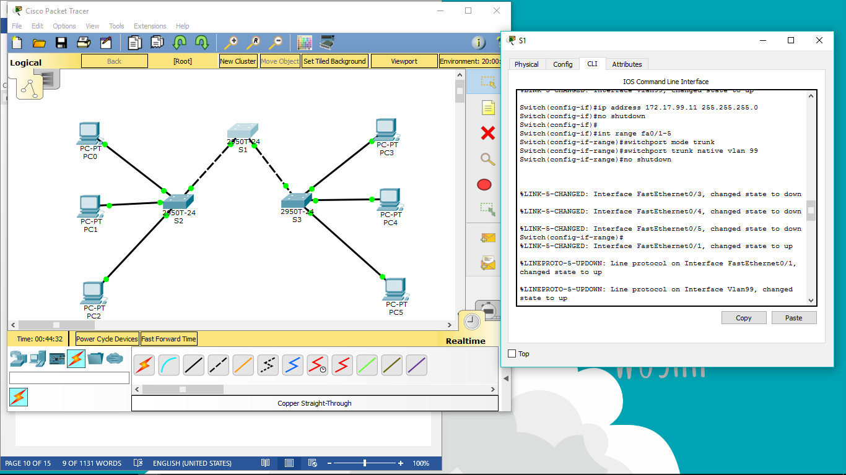

Switch(config-if)#ip address 172.17.99.11 255.255.255.0

Switch(config-if)#no shutdown

Switch(config-if)#

Switch(config-if)#int range fa0/1-5

Switch(config-if-range)#switchport mode trunk

Switch(config-if-range)#switchport trunk native vlan 99

Switch(config-if-range)#no shutdown

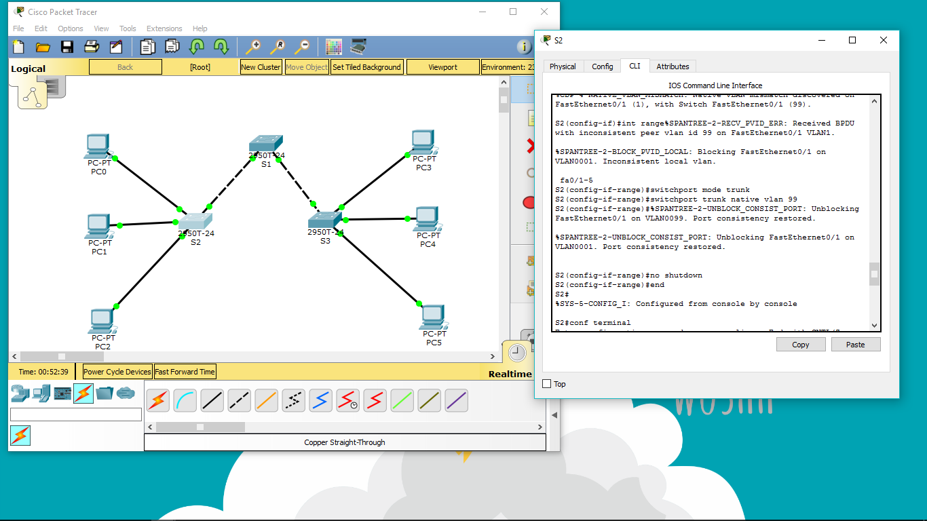

S2(config)# interface range fa0/1-5

S2(config-if-range)#switchport mode trunk

S2(config-if-range)#switchport trunk native vlan 99

S2(config-if-range)#no shutdown

S2(config-if-range)#end

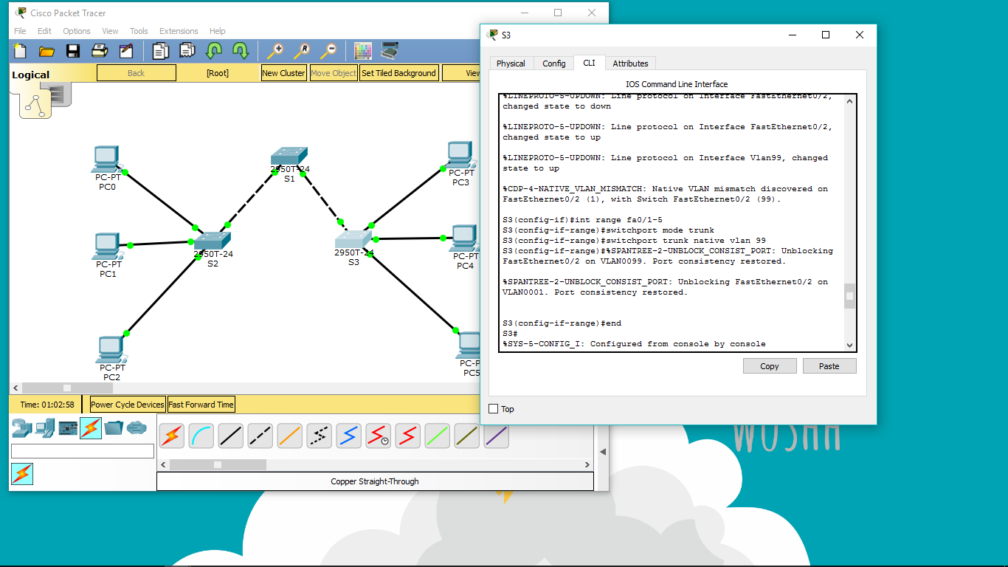

S3(config)# interface range fa0/1-5

S3(config-if-range)#switchport mode trunk

S3(config-if-range)#switchport trunk native vlan 99

S3(config-if-range)#no shutdown

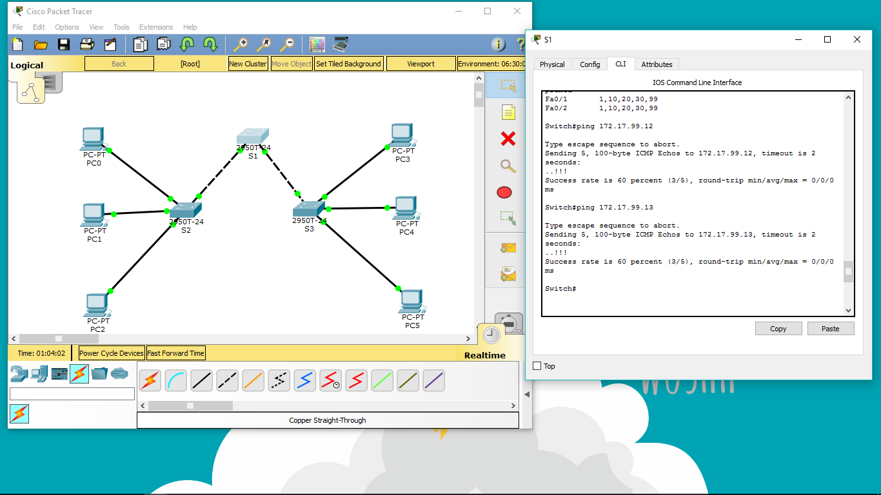

PING 172.17.99.12 dan PING 172.17.99.13