Nama : Ghani Kurniasaid

NIM : L200140108

Kelas : A

LATIHAN MODUL

ADIMINISTRASI JARINGAN KOMPUTER

**Task 1: Prepare the Network**

**Step 1: Cable a network that is similar to the one in the topology diagram.**

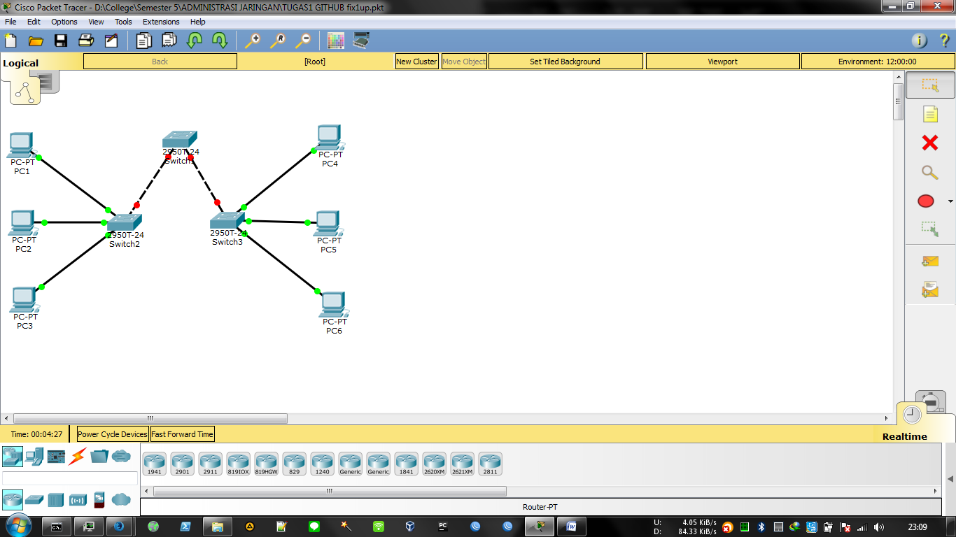

**Step 2: Clear any existing configurations on the switches, and initialize all ports in the shutdown state**

If necessary, refer to Lab 2.5.1, Appendix 1, for the procedure to clear switch configurations. It is a good practice to disable any unused ports on the switches by putting them in shutdown. Disable all ports on the switches:

Switch#config term

Switch(config)#interface range fa0/1-24

Switch(config-if-range)#shutdown

Switch(config-if-range)#

interface range gi0/1-2

Switch(config-if-range)#

shutdown

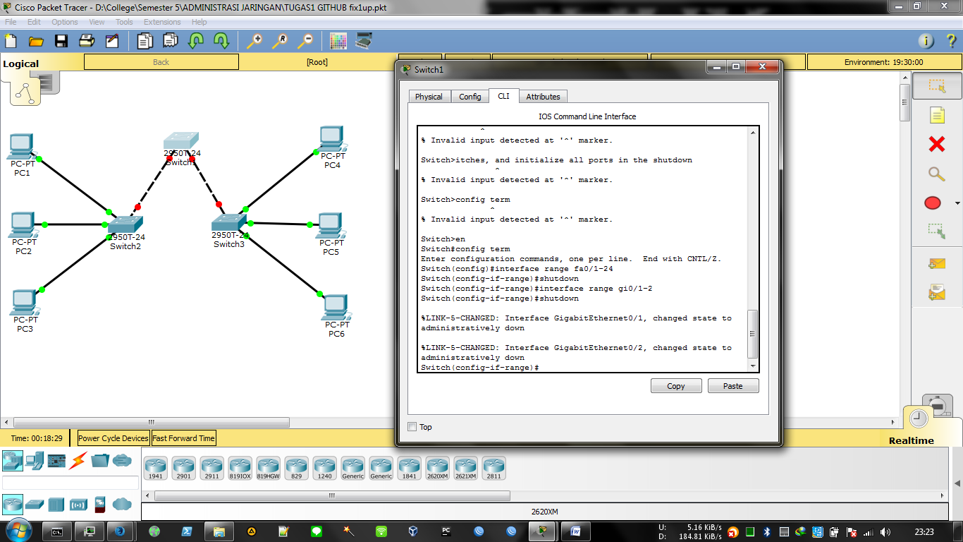

**Task 2: Perform Basic Switch Configurations**

**Step 1: Configure the switches according to the following guidelines**.

•Configure the switch hostname.

•Disable DNS lookup.

•Configure an EXEC mode password of class

•Configure a password of cisco for console connections.

•Configure a password of cisco for vty connections.

**Step 2: Re-enable the user ports on S2 and S3.**

S2(config)#interface range fa0/6, fa0/11, fa0/18

S2(config-if-range)#switchport mode access

S2(config-if-range)#no shutdown

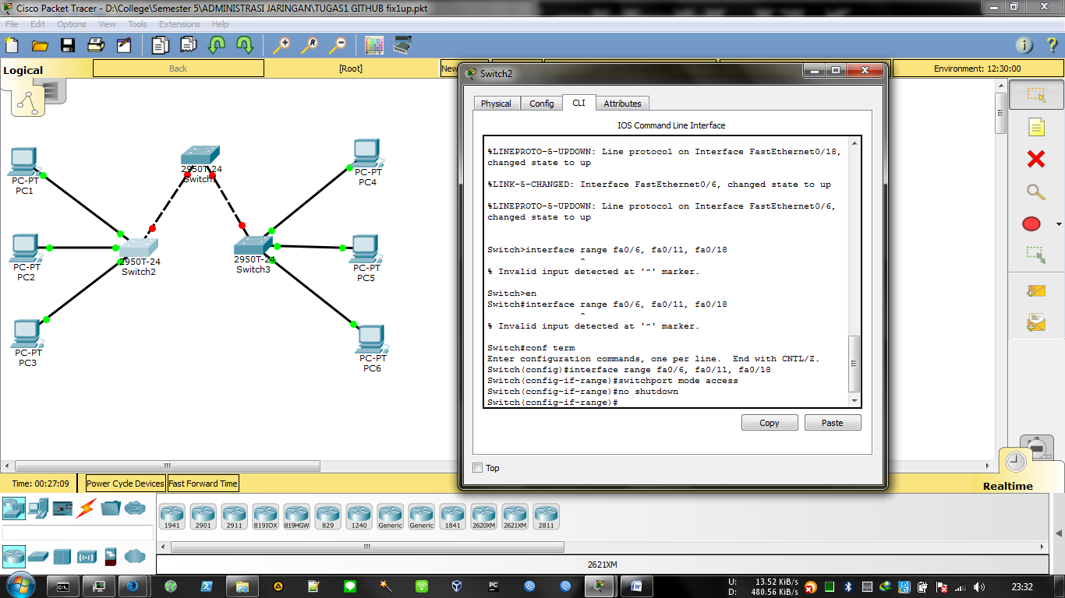

S3(config)#interface range fa0/6, fa0/11, fa0/18

S3(config-if-range)#switchport mode access

S3(config-if-range)#no shutdown

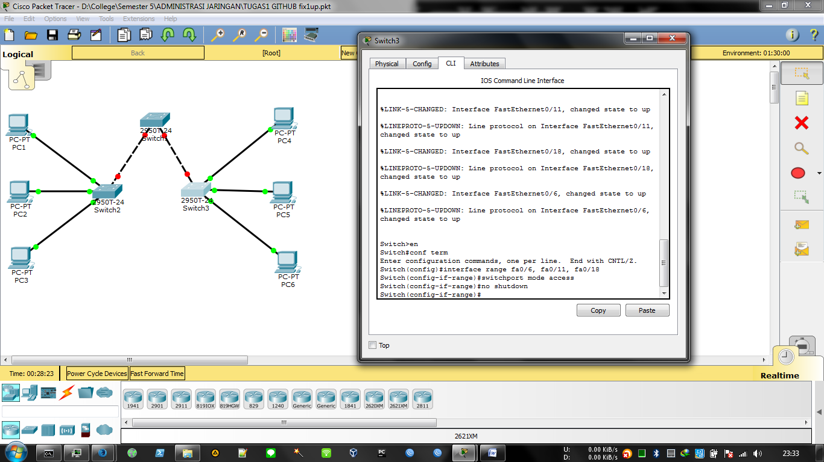

**Task 3: Configure and Activate Ethernet Interfaces**

**Step 1: Configure the PCs.**

You can complete this lab using only two PCs by simply changing the IP addressing for the two PCs specific to a test you want to conduct. For example, if you want to test connectivity between PC1 and PC2, then configure the IP addresses for those PCs

by referring to the addressing table at the beginning of the lab. Alternatively, you can configure all six PCs with the IP addresses and default gateways.

**Task 4: Configure VLANs on the Switch**

**Step 1: Create VLANs on switch S1.**

Use the vlan vlan-id command in global configuration mode to add a VLAN to switch S1. There are four VLANS configured for this lab: VLAN 10 (faculty/staff); VLAN 20 (students); VLAN 30 (guest); and VLAN 99 (management). After you create the VLAN, you will be in vlan configuration mode, where you can assign a name to the VLAN with the name vlan name command.

S1(config)#vlan 10

S1(config-vlan)#name faculty/staff

S1(config-vlan)#vlan 20

S1(config-vlan)#name students

S1(config-vlan)#vlan 30

S1(config-vlan)#name guest

S1(config-vlan)#vlan 99

S1(config-vlan)#name management

S1(config-vlan)#end

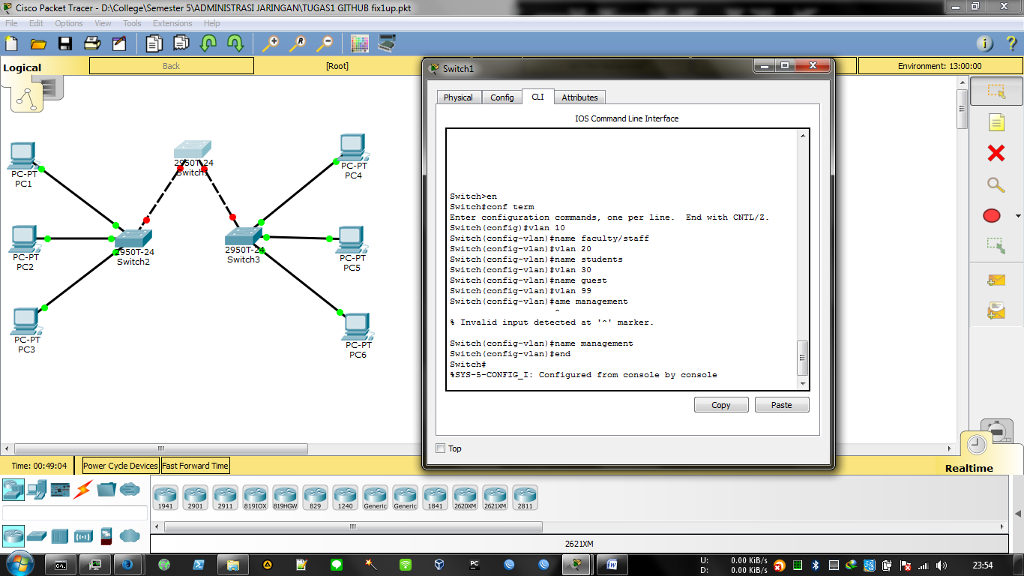

**Step 2: Verify that the VLANs have been created on S1.**

Use the show vlan brief command to verify that the VLANs have been created

S1#show vlan brief

VLAN Name Status Ports

---- ------------------------------- --------- ----

-------------------------

1 default active Fa0/

1, Fa0/2, Fa0/4, Fa0/5

Fa0/

6, Fa0/7, Fa0/8, Fa0/9

Fa0/

10, Fa0/11, Fa0/12, Fa0/13

Fa0/

14, Fa0/15, Fa0/16, Fa0/17

Fa0/

18, Fa0/19, Fa0/20, Fa0/21

Fa0/

22, Fa0/23, Fa0/24, Gi0/1

Gi0/2

10 faculty/staff active

20 students active

30 guest active

99 management active

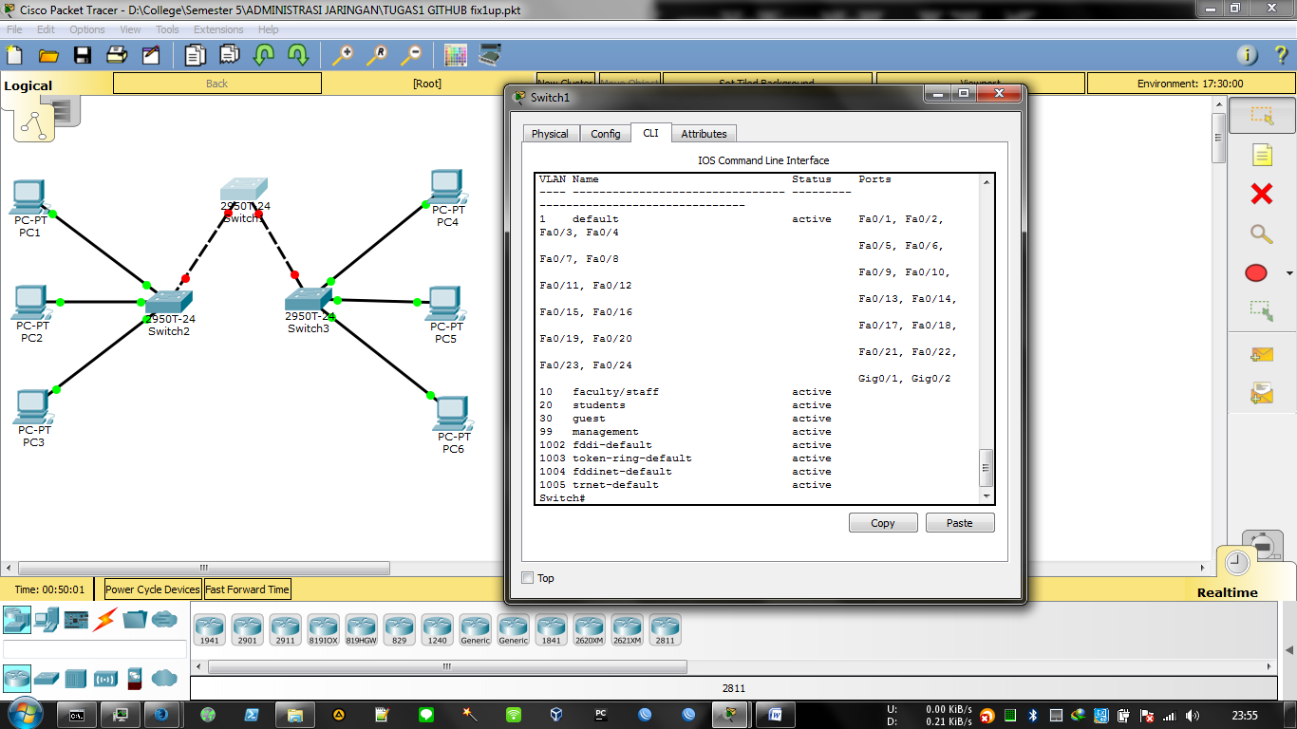

**Step 3: Configure and name VLANs on switches S2 and S3.**

Create and name VLANs 10, 20, 30, and 99 on S2 and S3 using the commands from Step 1. Verify the correct configuration with the show vlan briefcommand. What ports are currently assigned to the four VLANs

you have created?

**Step 4: Assign switch ports to VLANs on S2 and S3.**

Refer to the port assignment table on page 1. Ports are assigned to VLANs in interface configuration mode, using the switchport access vlan vlan-id command. You can assign each port individually or you can use the interface range command to simplify this task, as shown here. The commands are shown for S3 only, but you should configure both S2 and S3 similarly. Save your configuration when done. \

S3(config)#interface range fa0/6-10

S3(config-if-range)#switchport access vlan 30

S3(config-if-range)#interface range fa0/11-17

S3(config-if-range)#switchport access vlan 10

S3(config-if-range)#interface range fa0/18-24

S3(config-if-range)#switchport access vlan 20

S3(config-if-range)#end

S3#copy running-config startup-config

Switch 2

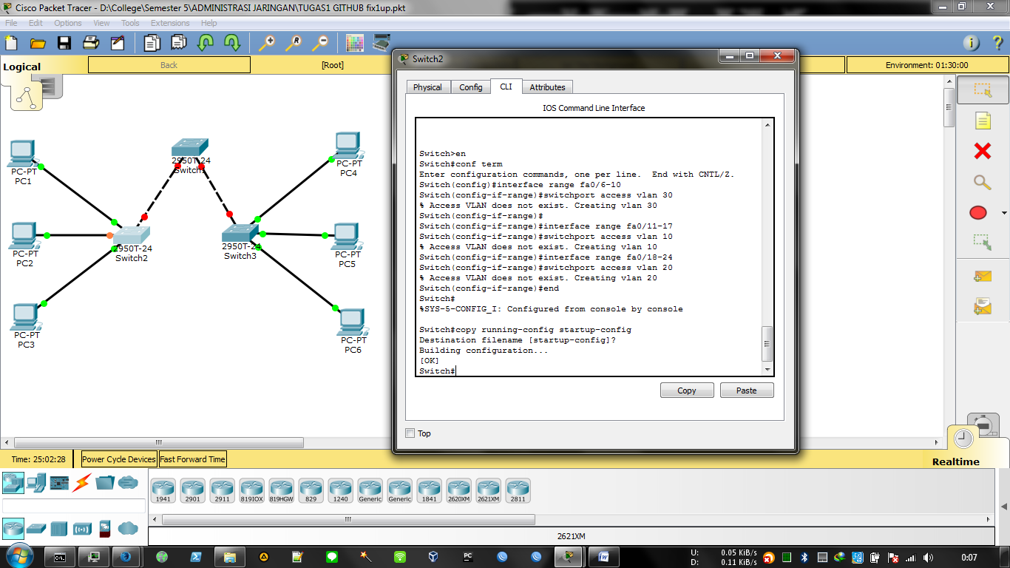

Switch 3

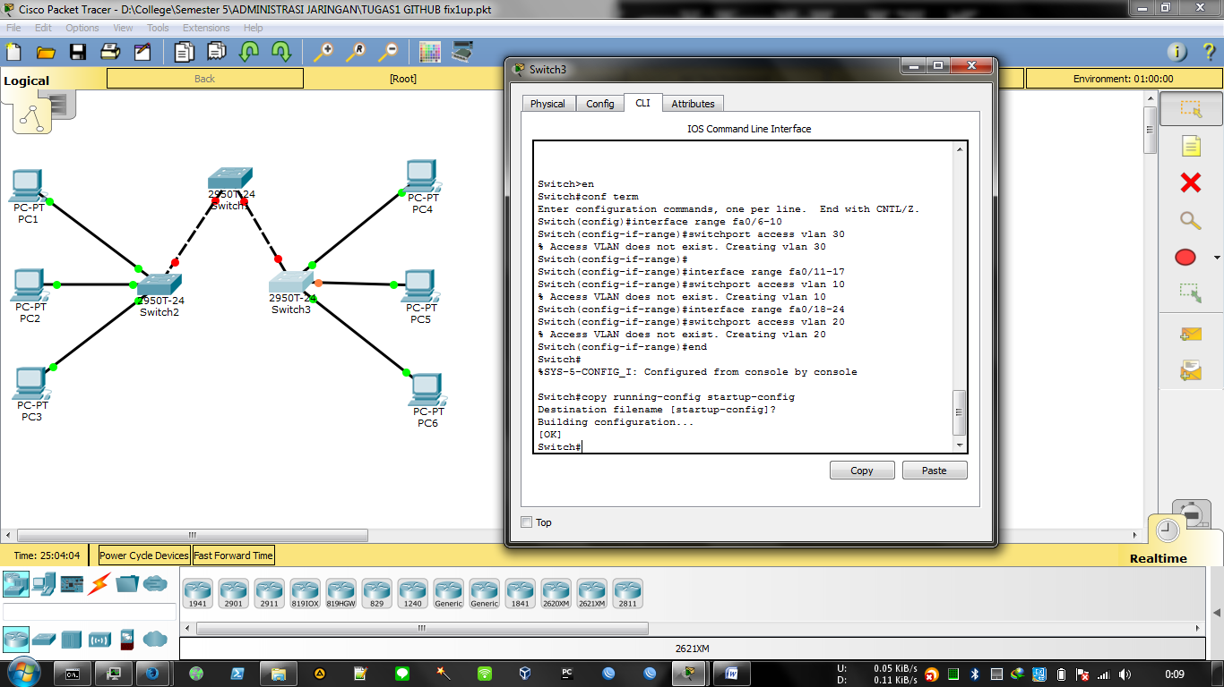

**Step 5: Determine which ports have been added.**

Use the show vlan id vlan-number command on S2 to see which ports are assigned to VLAN 10. Which ports are assigned to VLAN 10?

___________________________________________________

____

Fa0/11, Fa0/12, Fa0/13, Fa0/14,

Fa0/15, Fa0/16, Fa0/17

Note :The show vlan name vlan-namedisplays the same output. You can also view VLAN assignment information using the show interfaces interface switchport command

**Step 6: Assign the management VLAN.**

From interface configuration mode, use the ip address command to assign the management IP address to the switches.

S1(config)#interface vlan 99

S1(config-if)#ip address 172.17.99.11 255.255.255.0

S1(config-if)#no shutdown

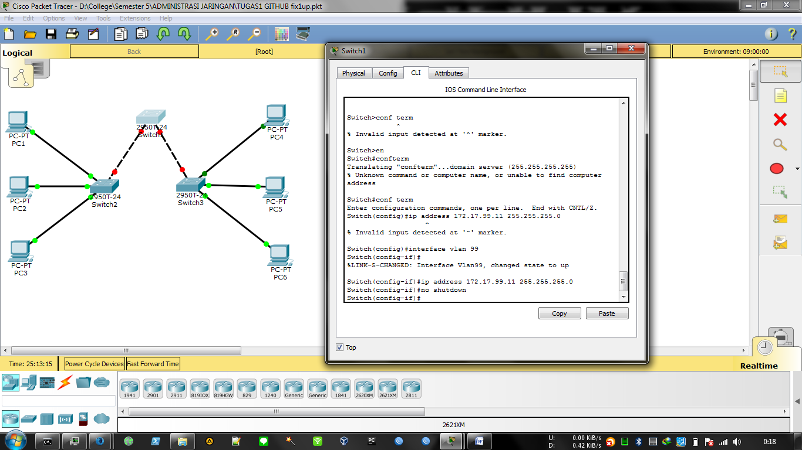

S2(config)#interface vlan 99

S2(config-if)#ip address 172.17.99.12 255.255.255.0

S2(config-if)#no shutdown

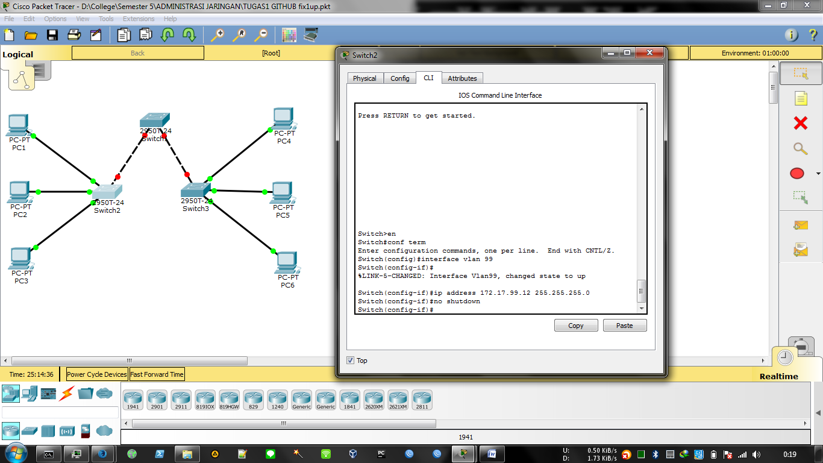

S3(config)#interface vlan 99

S3(config-if)#ip address 172.17.99.13 255.255.255.0

S3(config-if)#no shutdown

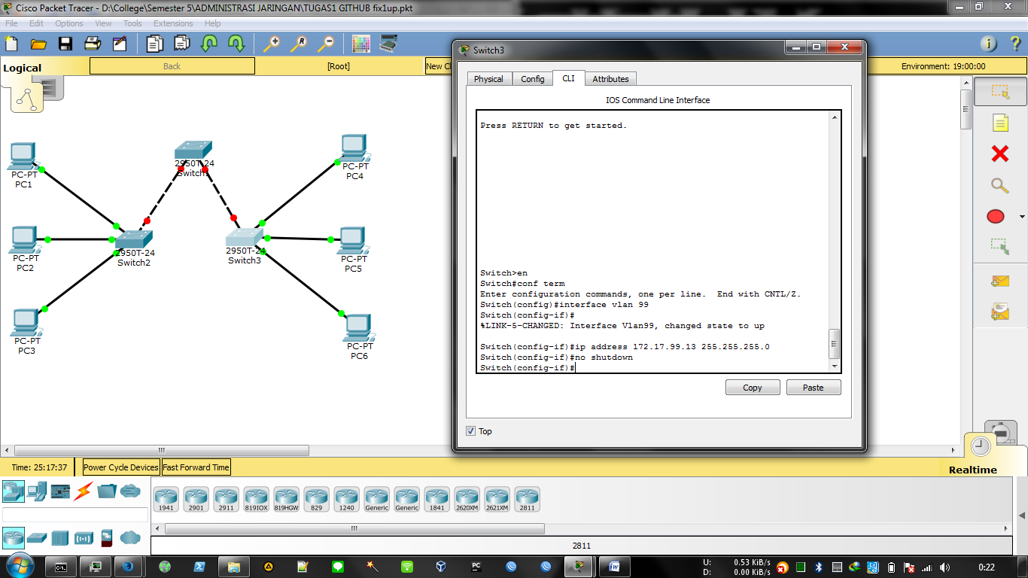

**Step 7: Configure trunking and the native VLAN for the trunking ports on all switches.**

Use the interface range command in global configuration mode to simplify configuring trunking.

S1(config)#interface range fa0/1-5

S1(config-if-range)#switchport mode trunk

S1(config-if-range)#switchport trunk native vlan 99

S1(config-if-range)#no shutdown

S1(config-if-range)#end

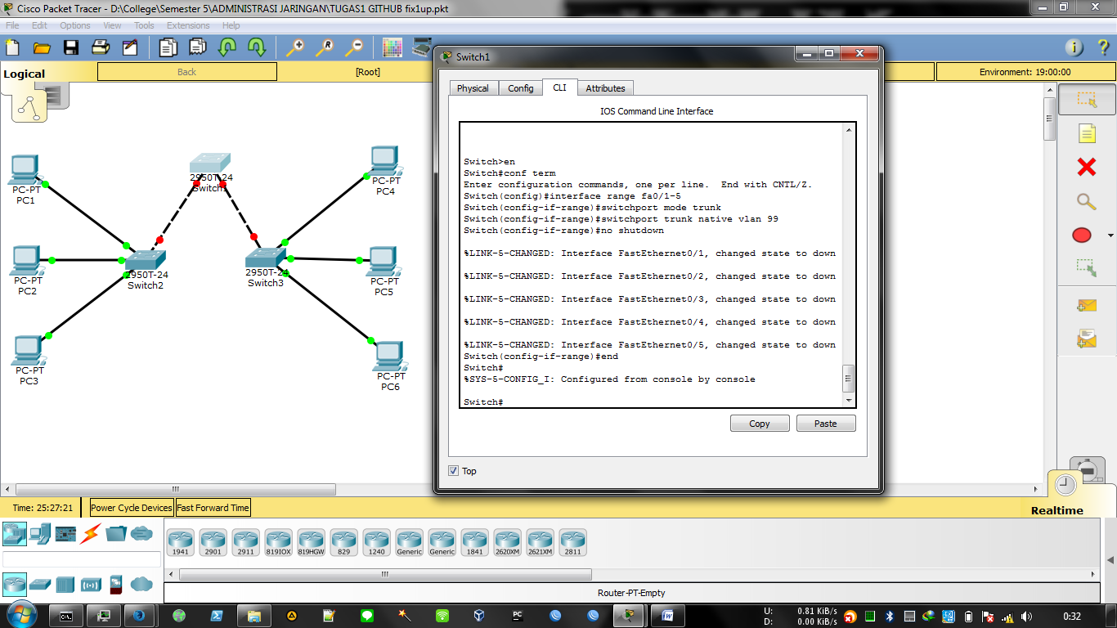

S2(config)# interface range fa0/1-5

S2(config-if-range)#switchport mode trunk

S2(config-if-range)#switchport trunk native vlan 99

S2(config-if-range)#no shutdown

S2(config-if-range)#end

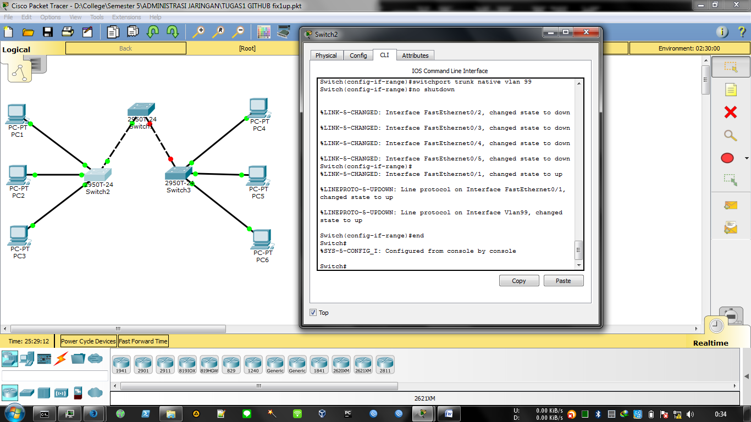

S3(config)# interface range fa0/1-5

S3(config-if-range)#switchport mode trunk

S3(config-if-range)#switchport trunk native vlan 99

S3(config-if-range)#no shutdown

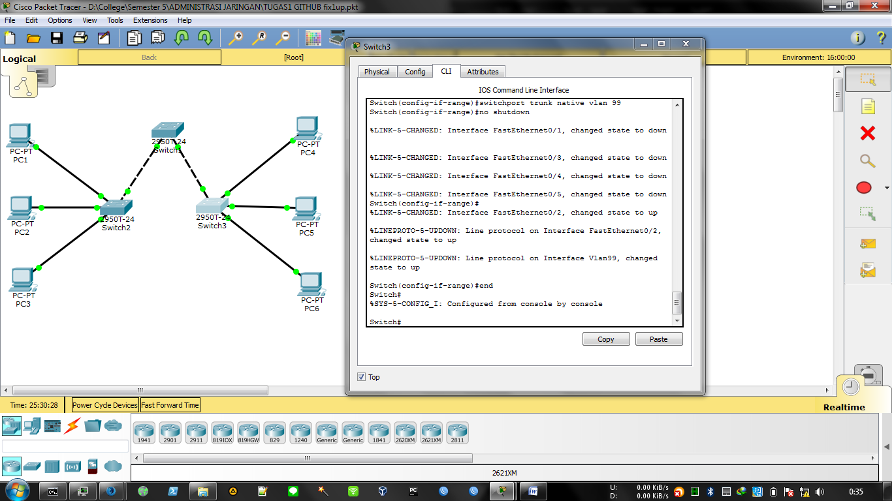

Verify that the trunks have been configured with the show interface trunk command.

S1#show interface trunk

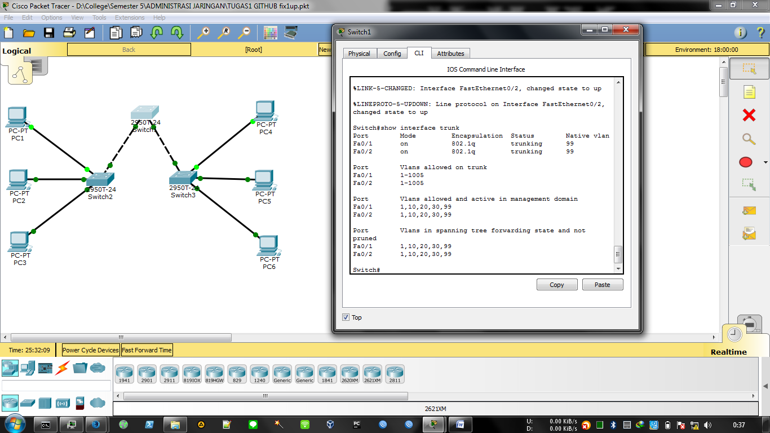

Step 8: Verify that the switches can communicate.

From S1, ping the management address on both S2 and S3.

S1#ping 172.17.99.12

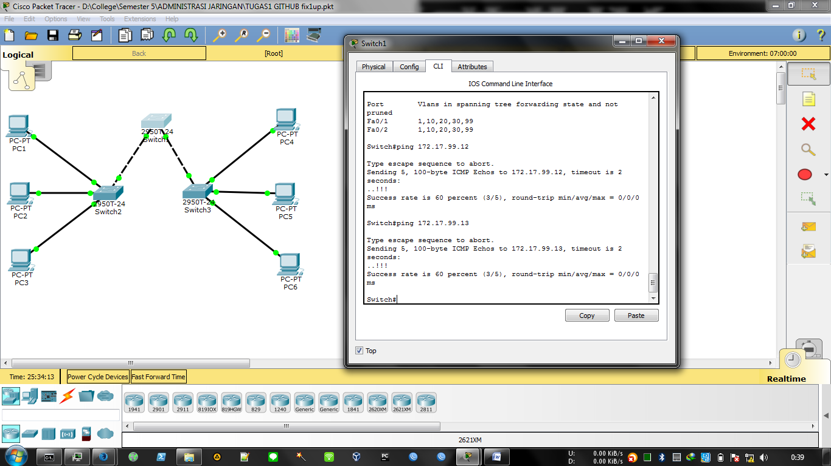

**Step 9: Ping several hosts from PC2.**

Ping from host PC2 to host PC1 (172.17.10.21). Is the ping attempt successful? _________ no

Ping from host PC2 to the switch VLAN 99 IP address 172.17.99.12. Is the ping attempt successful?

_________ no

Because these hosts are on different subnets and in different VLANs, they cannot communicate without a Layer 3 device to route between the separate subnet works.

Ping from host PC2 to host PC5. Is the ping attempt

successful? _________ yes

Because PC2 is in the same VLAN and the same subnet as PC5, the ping is successful

**Step 10: Move PC1 into the same VLAN as PC2.**

The port connected to PC2 (S2 Fa0/18) is assigned to VLAN 20, and the port connected to PC1 (S2 Fa0/11) is assigned to VLAN 10. Reassign the S2 Fa0/11 port to VLAN 20. You do not need to first remove a port from a VLAN to change its VLAN membership. After you reassign a port to a new VLAN, that port is automatically removed from its previous VLAN.

S2#configure terminal

Enter configuration commands, one per line. End with CNTL/Z.

S2(config)#interface fastethernet 0/11

S2(config-if)#switchport access vlan 20

S2(config-if)#end

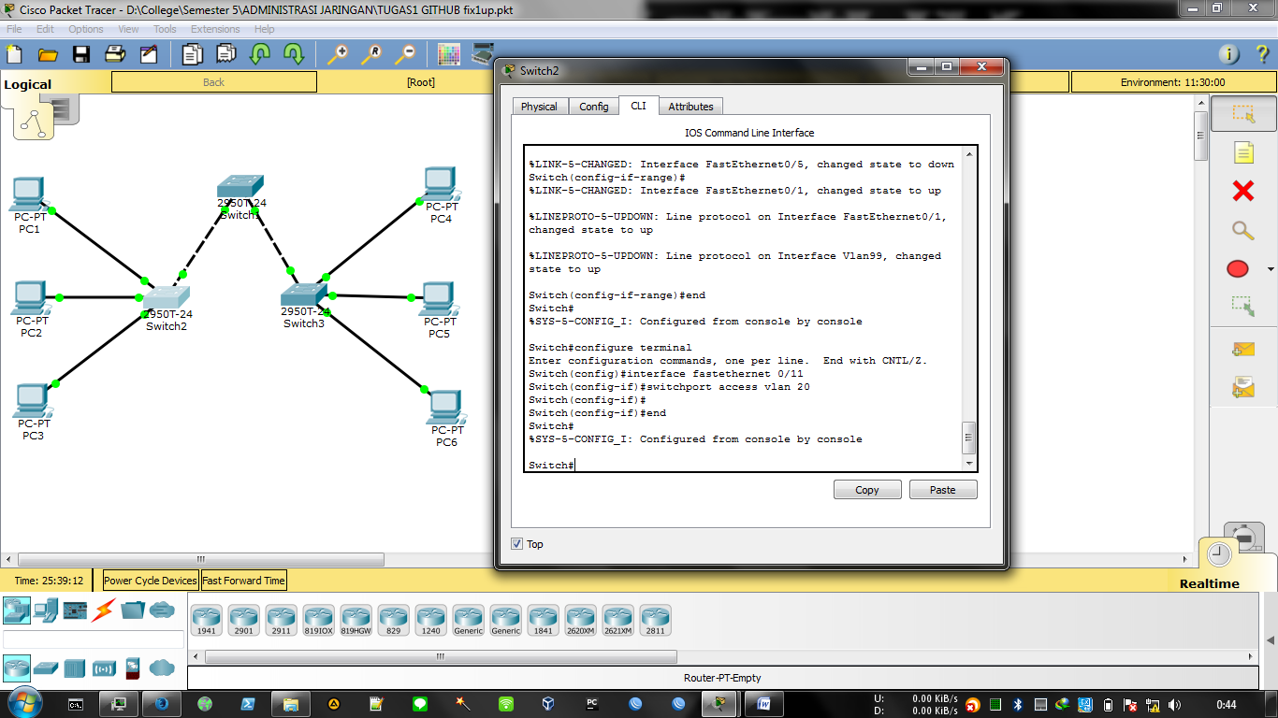

**Step 11: Change the IP address and network on PC1.**

Change the IP address on PC1 to 172.17.20.22. The subnet mask and default gateway can remain the same. Once again, ping from host PC2 to host PC1, using the newly assigned IP address.

**Task 5: Document the Switch Configurations**

On each switch, capture the running configuration to a text file and save it for future reference.

**Task 6: Clean Up**

Erase the configurations and reload the switches. Disconnect and store the cabling. For PC hosts that are normally connected to other networks (such as the s

chool LAN or to the Internet), reconnect the appropriate cabling and restore the TCP/IP settings