|  |  |  |
| --- | --- | --- |
| Nama | : | Desy Kartika Indahsari |
| NIM | : | L200150007 |
| Kelas | : | A |
|  |  |  |

TUGAS 2

Database Management System

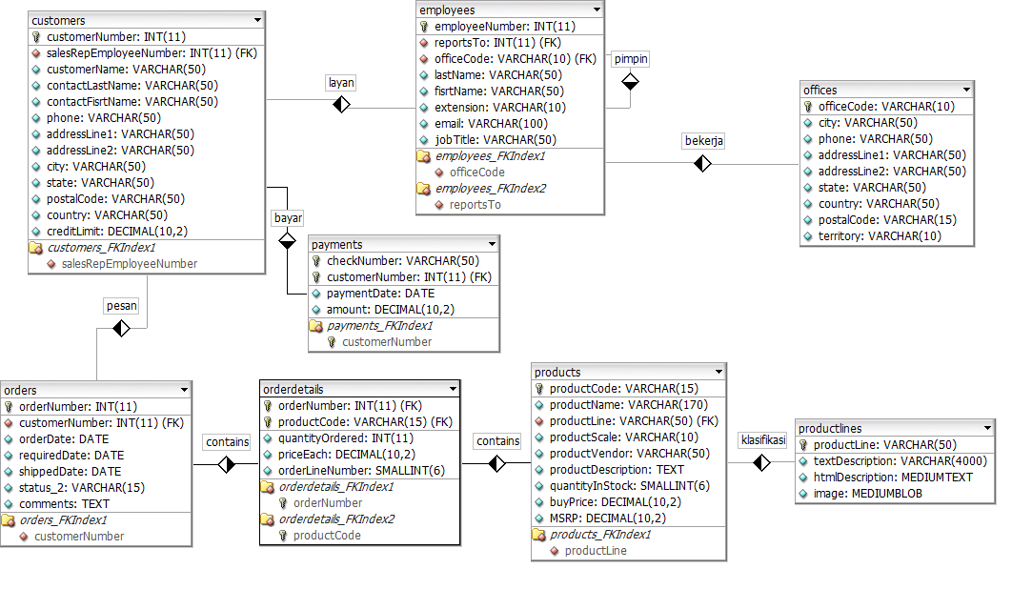

* Sebelum memberikan hak akses (GRANT) maka terlebih dahulu membuat usernya.
  + create user 'tugas2'@'localhost' identified by 'tugas';
* syntax dibawah adalah syntax yang digunakan untuk memberikan hak akses (GRANT).
  + grant select, update, delete on (nama_database).Employes to 'tugas2'@'localhost';
  + grant select, update, delete on (nama_database).Offices to 'tugas2'@'localhost';
  + grant select, update, delete on (nama_database).Paymentss to 'tugas2'@'localhost';