MENAMPILKAN KODE ASCII PADA PYTHON

Nama : Fitria Widya Astari
NIM : L200150027
Kelas : A

TUGAS-02:
Buatlah program untuk menampilkan daftar kode ASCII.
Buat catatan tentang berbagai macam fungsi matematik yang terdapat.

- Print ASCII Values in Python
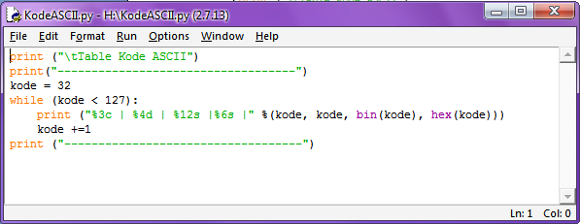

Program python ini akan mencetak semua karakter dengan nilai-nilai ASCII mereka. Program python akan mencetak dari kode ASCII 32 sampai dengan kode ASCII 126 bersama dengan karakter, nilai binary dan nilai hexadecimal dari kode ASCII .

Berikut adalah tampilan setelah program dijalankan (run/ menekan tombol F5) :
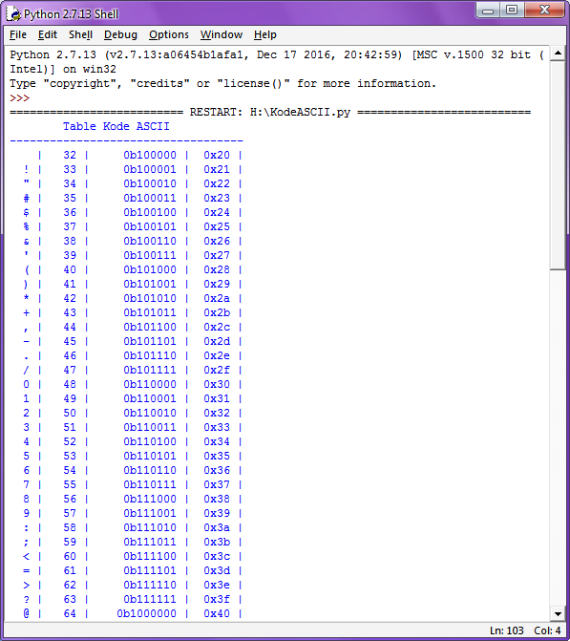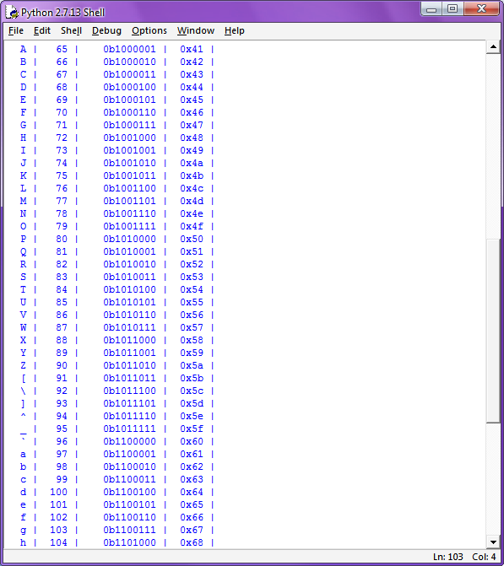
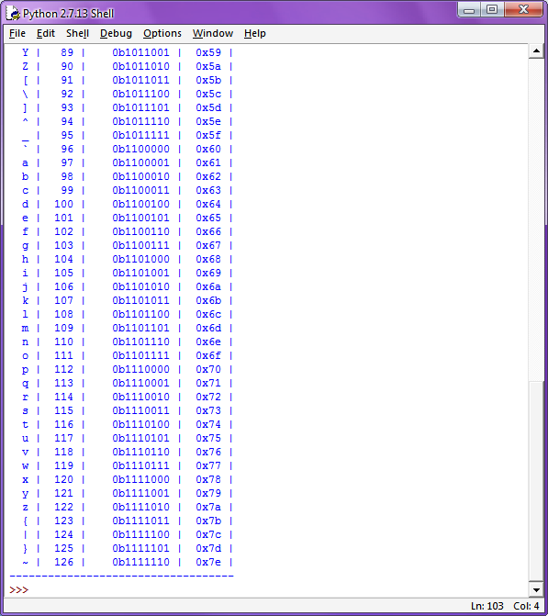

- Print ASCII Values in Python
Mengubah karakter menjadi nilai ASCII
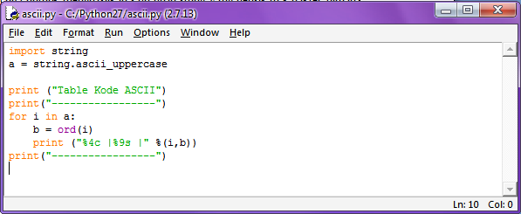

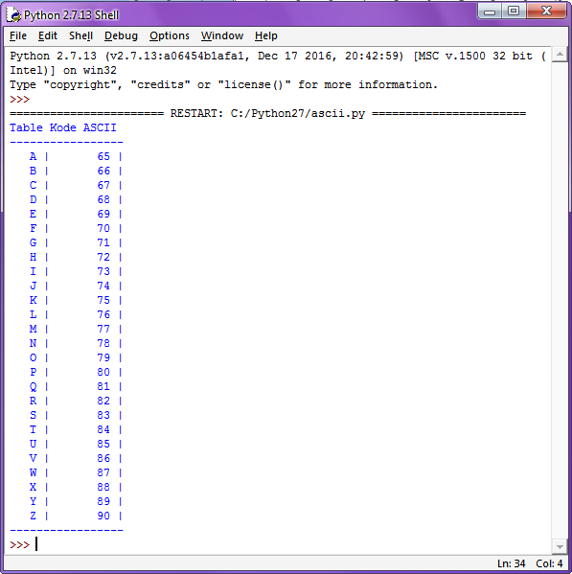

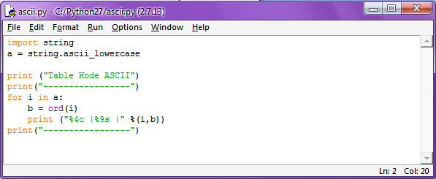

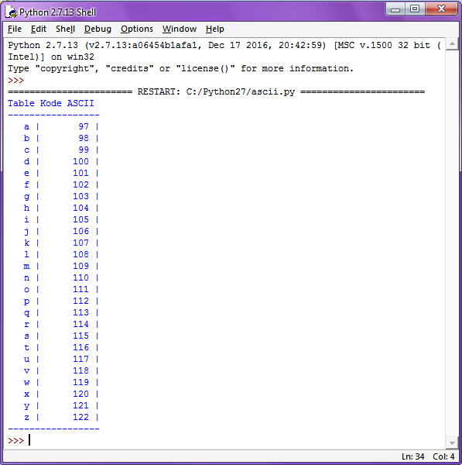

List of Functions in Python Math Module
Function | Description
ceil(x) | Returns the smallest integer greater than or equal to x.
copysign(x, y) | Returns x with the sign of y
fabs(x) | Returns the absolute value of x
factorial(x) | Returns the factorial of x
floor(x) | Returns the largest integer less than or equal to x
fmod(x, y) | Returns the remainder when x is divided by y
frexp(x) | Returns the mantissa and exponent of x as the pair (m, e)
fsum(iterable) | Returns an accurate floating point sum of values in the iterable
isfinite(x) | Returns True if x is neither an infinity nor a NaN (Not a Number)
isinf(x) | Returns True if x is a positive or negative infinity
isnan(x) | Returns True if x is a NaN
ldexp(x, i) | Returns x * (2**i)
modf(x) | Returns the fractional and integer parts of x
trunc(x) | Returns the truncated integer value of x
exp(x) | Returns e**x
expm1(x) | Returns e**x - 1
log(x[, base]) | Returns the logarithm of x to the base (defaults to e)
log1p(x) | Returns the natural logarithm of 1+x
log2(x) | Returns the base-2 logarithm of x
log10(x) | Returns the base-10 logarithm of x
pow(x, y) | Returns x raised to the power y
sqrt(x) | Returns the square root of x
acos(x) | Returns the arc cosine of x
asin(x) | Returns the arc sine of x
atan(x) | Returns the arc tangent of x
atan2(y, x) | Returns atan(y / x)
cos(x) | Returns the cosine of x
hypot(x, y) | Returns the Euclidean norm, sqrt(x*x + y*y)
sin(x) | Returns the sine of x
tan(x) | Returns the tangent of x
degrees(x) | Converts angle x from radians to degrees
radians(x) | Converts angle x from degrees to radians
acosh(x) | Returns the inverse hyperbolic cosine of x
asinh(x) | Returns the inverse hyperbolic sine of x
atanh(x) | Returns the inverse hyperbolic tangent of x
cosh(x) | Returns the hyperbolic cosine of x
sinh(x) | Returns the hyperbolic cosine of x
atanh(x) | Returns the hyperbolic tangent of x
erf(x) | Returns the error function at x
erfc(x) | Returns the complementary error function at x
gamma(x) | Returns the Gamma function at x
lgamma(x) | Returns the natural logarithm of the absolute value of the Gamma function at x
Pi | Mathematical constant, the ratio of circumference of a circle to it's diameter (3.14159...)
E | mathematical constant e (2.71828...)

