Nama :Rina Nuqisari

NIM :L200150037

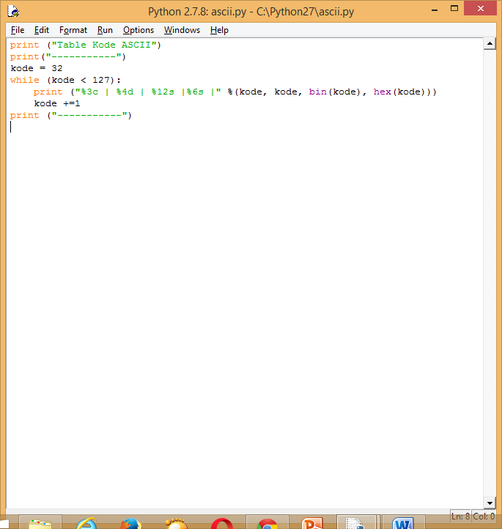

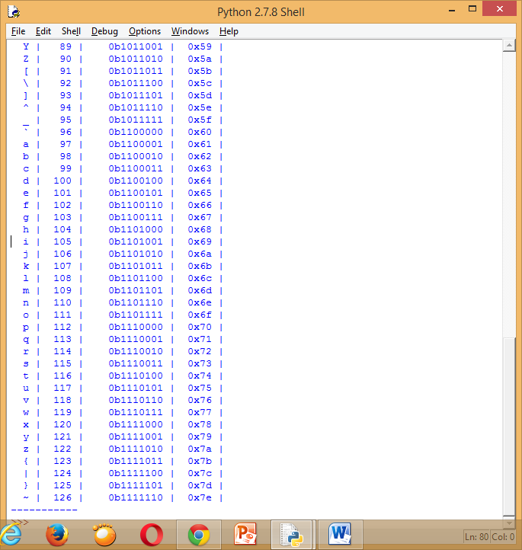

|  |  |
| --- | --- |
| Function | Description |
| ceil(x) | Returns the smallest integer greater than or equal to x. |
| copysign(x, y) | Returns x with the sign of y |
| fabs(x) | Returns the absolute value of x |
| factorial(x) | Returns the factorial of x |
| floor(x) | Returns the largest integer less than or equal to x |
| fmod(x, y) | Returns the remainder when x is divided by y |
| frexp(x) | Returns the mantissa and exponent of x as the pair (m, e) |
| fsum(iterable) | Returns an accurate floating point sum of values in the iterable |
| isfinite(x) | Returns True if x is neither an infinity nor a NaN (Not a Number) |
| isinf(x) | Returns True if x is a positive or negative infinity |
| isnan(x) | Returns True if x is a NaN |
| ldexp(x, i) | Returns x * (2**i) |
| modf(x) | Returns the fractional and integer parts of x |
| trunc(x) | Returns the truncated integer value of x |
| exp(x) | Returns e**x |
| expm1(x) | Returns e**x - 1 |
| log(x[, base]) | Returns the logarithm of x to the base (defaults to e) |
| log1p(x) | Returns the natural logarithm of 1+x |
| log2(x) | Returns the base-2 logarithm of x |
| log10(x) | Returns the base-10 logarithm of x |
| pow(x, y) | Returns x raised to the power y |
| sqrt(x) | Returns the square root of x |
| acos(x) | Returns the arc cosine of x |
| asin(x) | Returns the arc sine of x |
| atan(x) | Returns the arc tangent of x |
| atan2(y, x) | Returns atan(y / x) |
| cos(x) | Returns the cosine of x |
| hypot(x, y) | Returns the Euclidean norm, sqrt(x*x + y*y) |
| sin(x) | Returns the sine of x |
| tan(x) | Returns the tangent of x |
| degrees(x) | Converts angle x from radians to degrees |
| radians(x) | Converts angle x from degrees to radians |
| acosh(x) | Returns the inverse hyperbolic cosine of x |
| asinh(x) | Returns the inverse hyperbolic sine of x |
| atanh(x) | Returns the inverse hyperbolic tangent of x |
| cosh(x) | Returns the hyperbolic cosine of x |
| sinh(x) | Returns the hyperbolic cosine of x |
| atanh(x) | Returns the hyperbolic tangent of x |
| erf(x) | Returns the error function at x |
| erfc(x) | Returns the complementary error function at x |
| gamma(x) | Returns the Gamma function at x |
| lgamma(x) | Returns the natural logarithm of the absolute value of the Gamma function at x |
| pi | Mathematical constant, the ratio of circumference of a circle to it's diameter (3.14159...) |
| e | mathematical constant e (2.71828...) |