NAMA : ADITYA KHRSNA

NIM : L200150041

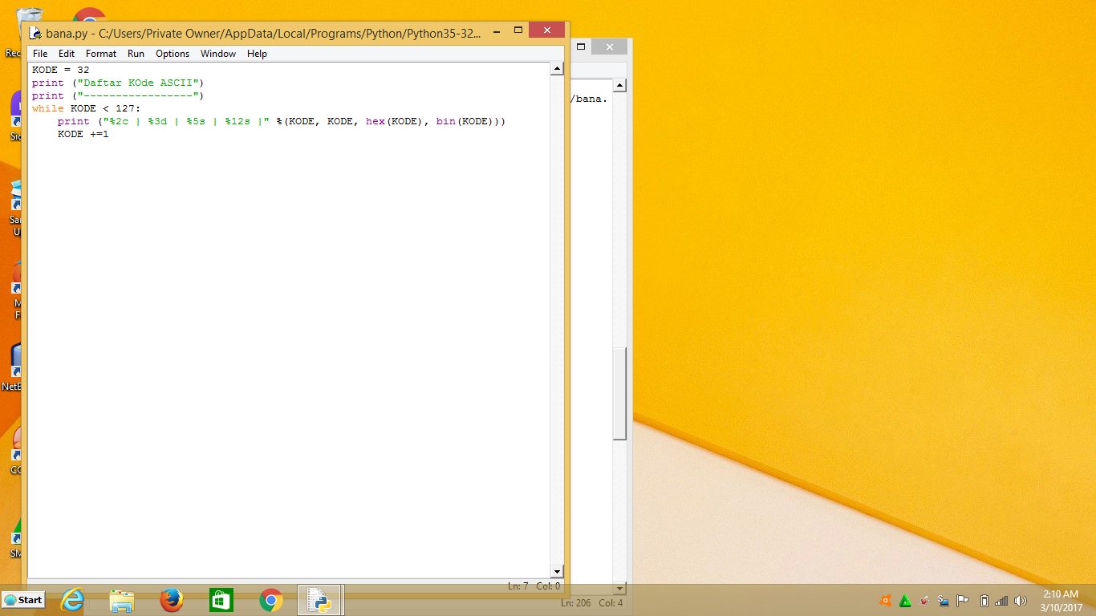

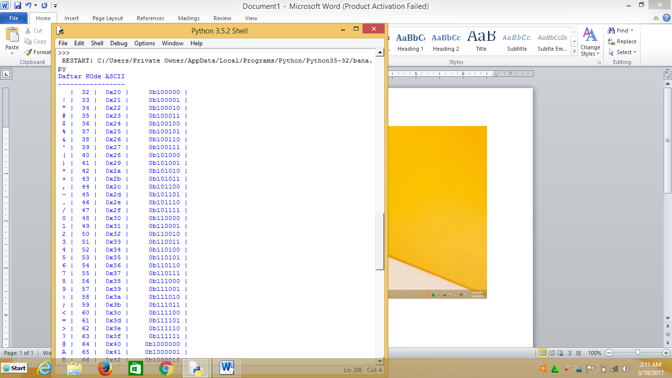

**Fungsi matematik yang terdapat dalam module "math" :**

Function Description

1. ceil(x) :Returns the smallest integer greater than or equal to x.
2. copysign(x, y) :Returns x with the sign of y
3. fabs(x) :Returns the absolute value of x
4. factorial(x) :Returns the factorial of x
5. floor(x) :Returns the largest integer less than or equal to x
6. fmod(x, y) :Returns the remainder when x is divided by y
7. frexp(x) :Returns the mantissa and exponent of x as the pair (m, e)
8. fsum(iterable) :Returns an accurate floating point sum of values in the iterable
9. isfinite(x) :Returns True if x is neither an infinity nor a NaN (Not a Number)
10. isinf(x) :Returns True if x is a positive or negative infinity
11. isnan(x) :Returns True if x is a NaN
12. ldexp(x, i) :Returns x * (2**i)
13. modf(x) :Returns the fractional and integer parts of x
14. trunc(x) :Returns the truncated integer value of x
15. exp(x) :Returns e**x
16. expm1(x) :Returns e**x - 1
17. log(x[, base]) :Returns the logarithm of x to the base (defaults to e)
18. log1p(x) :Returns the natural logarithm of 1+x
19. log2(x) :Returns the base-2 logarithm of x
20. log10(x) :Returns the base-10 logarithm of x
21. pow(x, y) :Returns x raised to the power y
22. sqrt(x) :Returns the square root of x
23. acos(x) :Returns the arc cosine of x
24. asin(x) :Returns the arc sine of x
25. atan(x) :Returns the arc tangent of x
26. atan2(y, x) :Returns atan(y / x)
27. cos(x) :Returns the cosine of x
28. hypot(x, y) :Returns the Euclidean norm, sqrt(xx + yy)
29. sin(x) :Returns the sine of x
30. tan(x) :Returns the tangent of x
31. degrees(x) :Converts angle x from radians to degrees
32. radians(x) :Converts angle x from degrees to radians
33. acosh(x) :Returns the inverse hyperbolic cosine of x
34. asinh(x) :Returns the inverse hyperbolic sine of x
35. atanh(x) :Returns the inverse hyperbolic tangent of x
36. cosh(x) :Returns the hyperbolic cosine of x
37. sinh(x) :Returns the hyperbolic cosine of x
38. atanh(x) :Returns the hyperbolic tangent of x
39. erf(x) :Returns the error function at x
40. erfc(x) :Returns the complementary error function at x
41. gamma(x) :Returns the Gamma function at x
42. lgamma(x) :Returns the natural logarithm of the absolute value of the Gamma function at x