Tugas-03

Nur Hasna’ Shofia

L200150056

#### **Verify that the VLANs have been created on S1.**

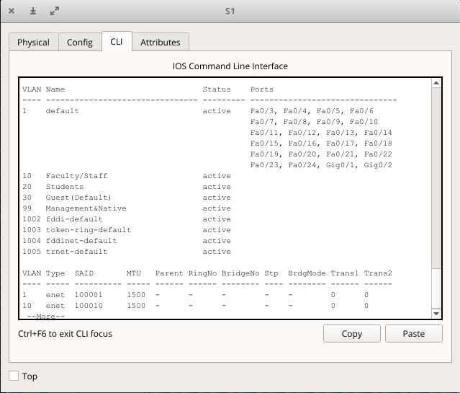

**show interface trunk**

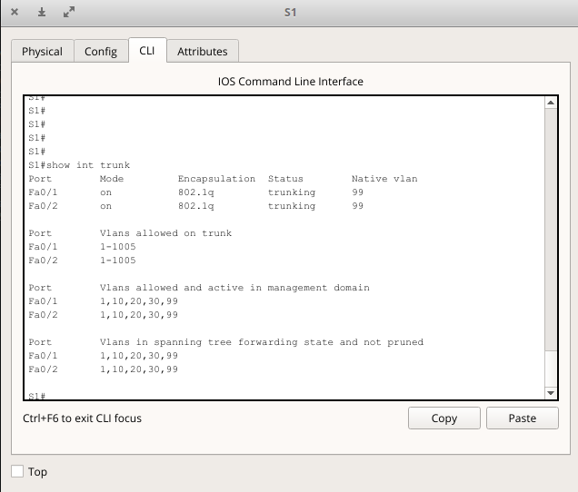

#### **Verify that the switches can communicate.**

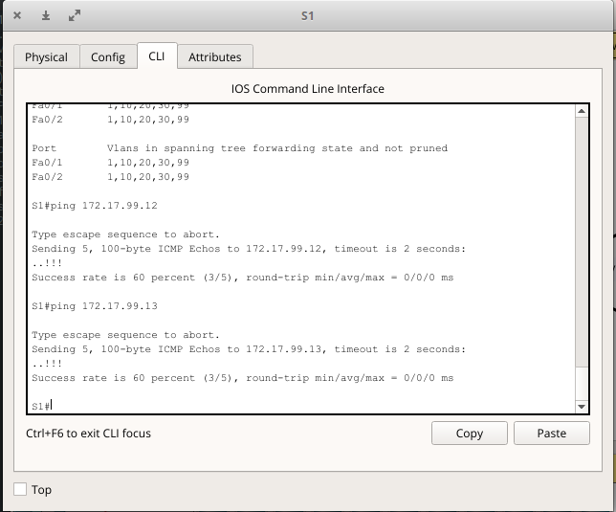

#### **Ping several hosts from PC2.**

Ping from host PC2 to host PC1 (172.17.10.21). Is the ping attempt successful?

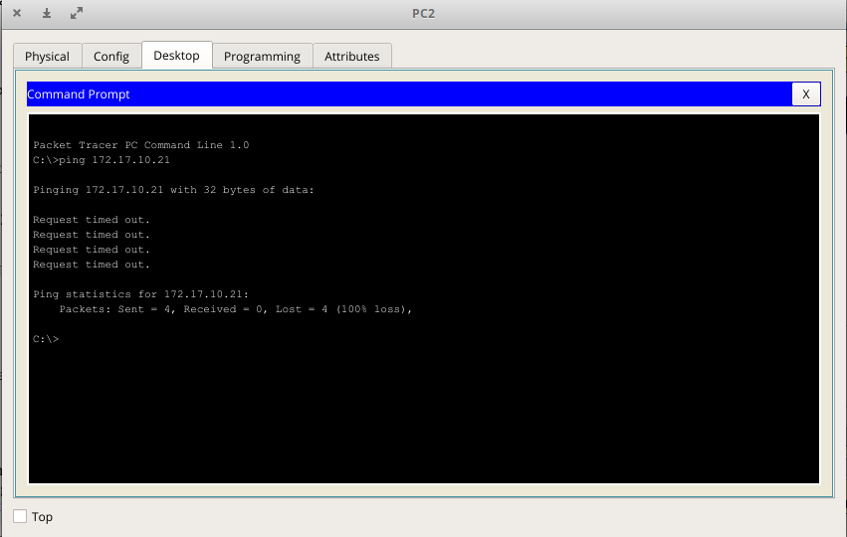

Ping from host PC2 to the switch VLAN 99 IP address 172.17.99.12. Is the ping attempt successful?

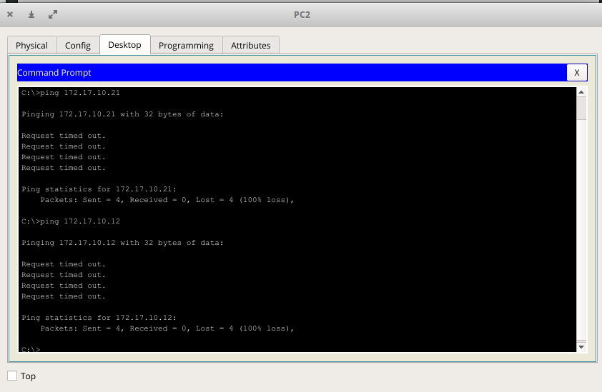

Ping from host PC2 to host PC5. Is the ping attempt successful?

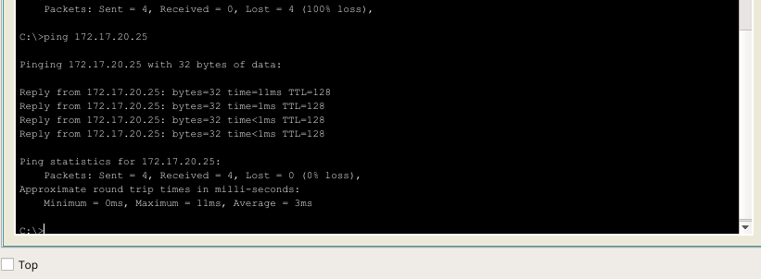

#### **Change the IP address and network on PC1.**

#### 

Is the ping attempt successful? successful

Why was this attempt successful? Change the ip address to 172.17.20.21