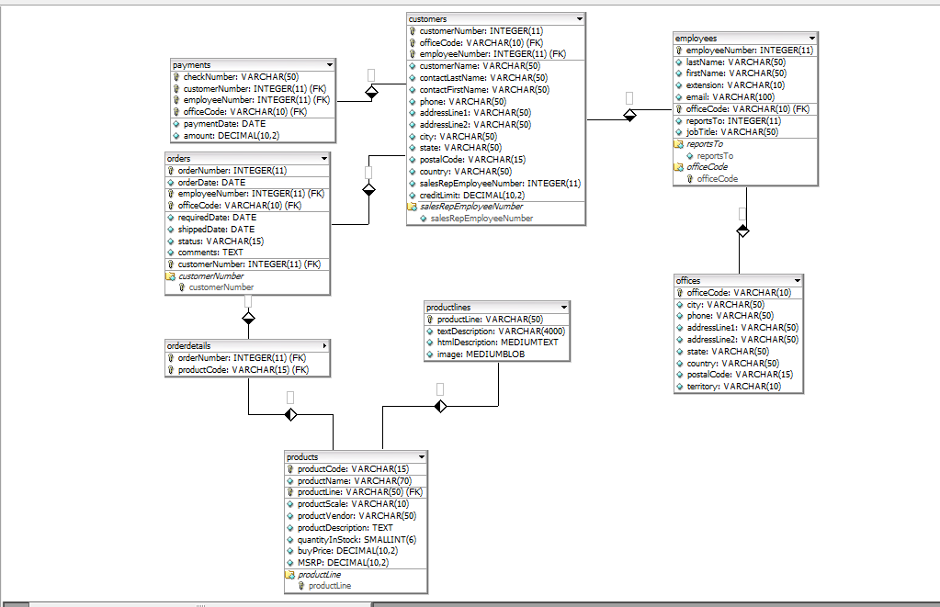

1

1

1

1

1

1

m

m

m

m

m

m

m