Nama : Akbar Aidhel Fatra

NIM : L200150092

Kelas : B

Matakuliah : Database Management System

Tugas 1

Identifikasi struktur table sesuai database yang di kasi di link dan tentukan relasinya.

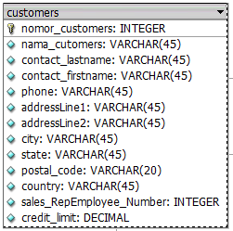

TABLE CUSTOMERS

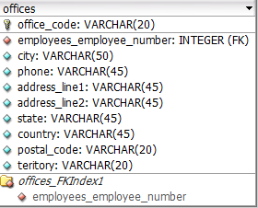

TABLE OFFICE

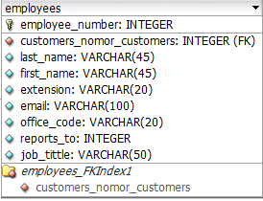

TABLE EMPLOYEE

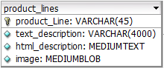

TABLE PRODUCT LINES

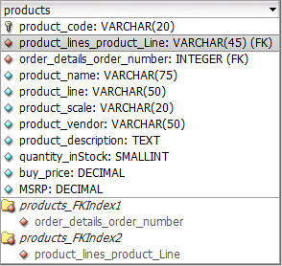

TABLE PRODUCTS

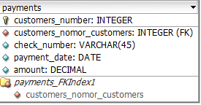

TABLE PAYMENTS

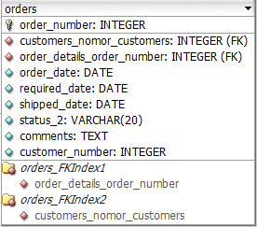

TABLE ORDERS

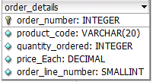

TABLE ORDER DETAILS

STRUKTUR RELASI-nya

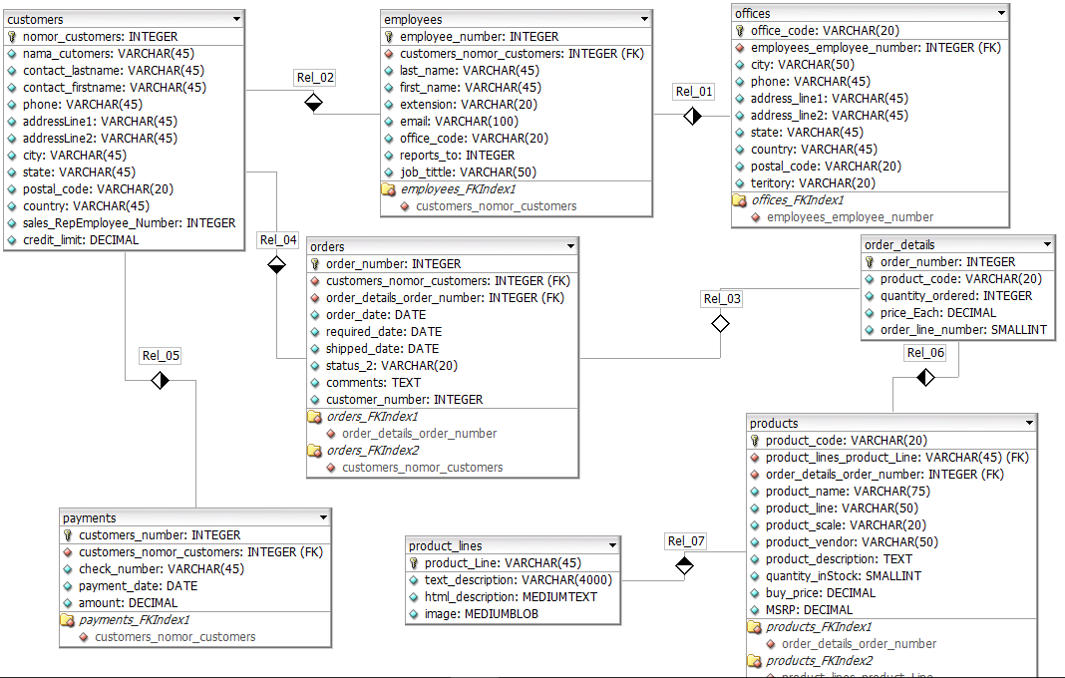

NB: Relationship many to one : E:\Kuliah Semester 5\Database Management System\1nnn.PNG

Relationship one to many : E:\Kuliah Semester 5\Database Management System\m1.PNG

Relationship one to one : E:\Kuliah Semester 5\Database Management System\11.PNG