MANAGEMENT BASIS DATA SYSTEM



Tri Utomo

L200154006

X class

UNIVERSITAS MUHAMMADIYAH SURAKARTA

Step to make view :

1.Enter into mariadb then use classicmodels database to make that view also check tables if there available any same view or not.

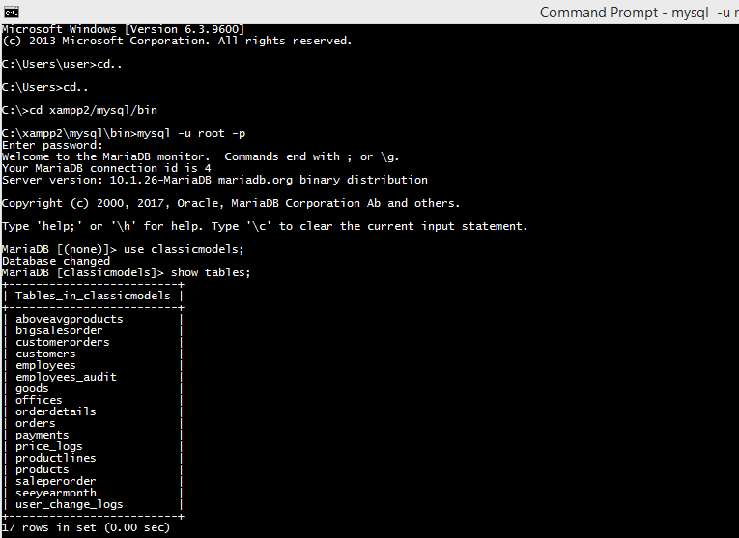

2.Create view to see year,month and total of selling goods in that time. Then,check tables to see that the view is got input inside database.

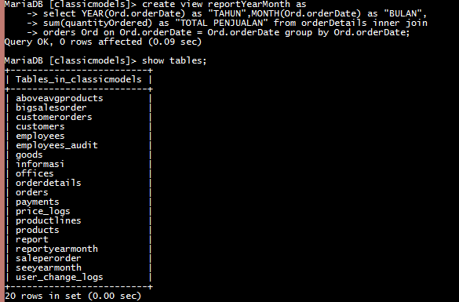

3.Result :

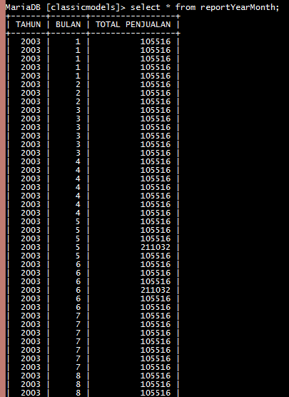

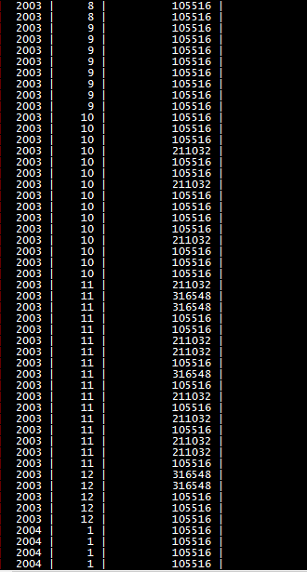

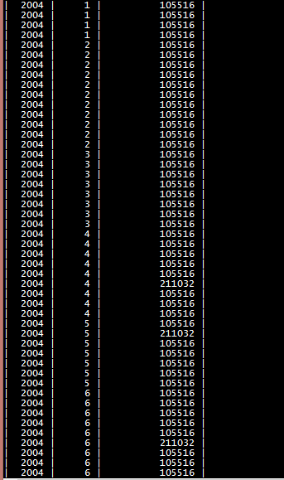

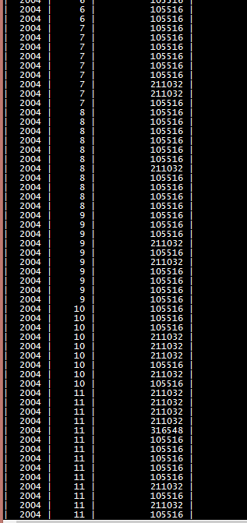

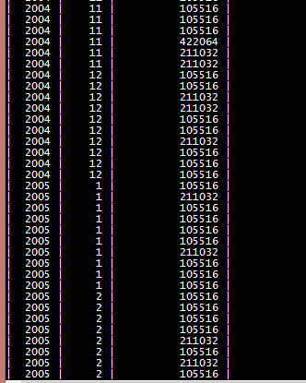

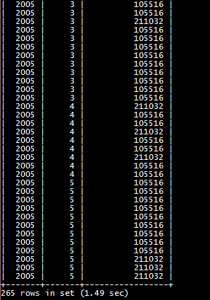

\*To make it simple we give command with limit command to see only a little part of view will be display.

