MANAGEMENT BASIS DATA SYSTEM



Tri Utomo

L200154006

X class

UNIVERSITAS MUHAMMADIYAH SURAKARTA

SCREENSHOT OF EXERCISE:

First is create role and grant.

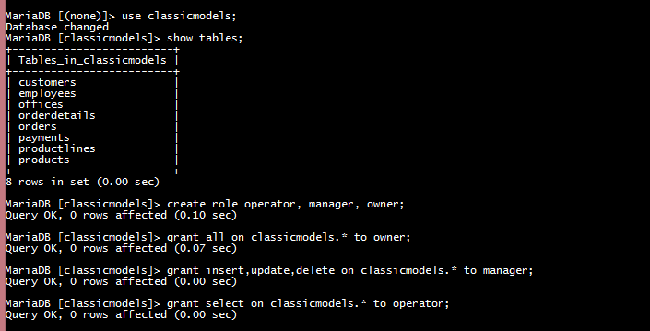

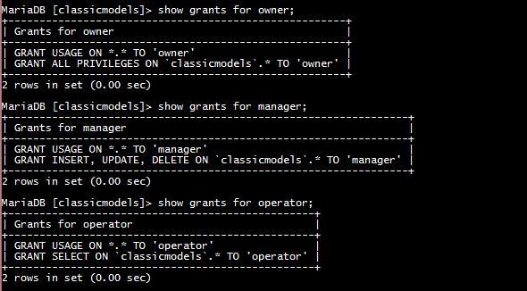

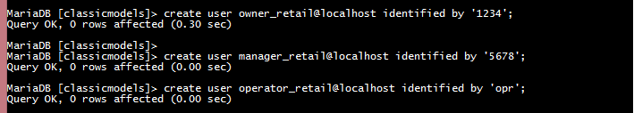

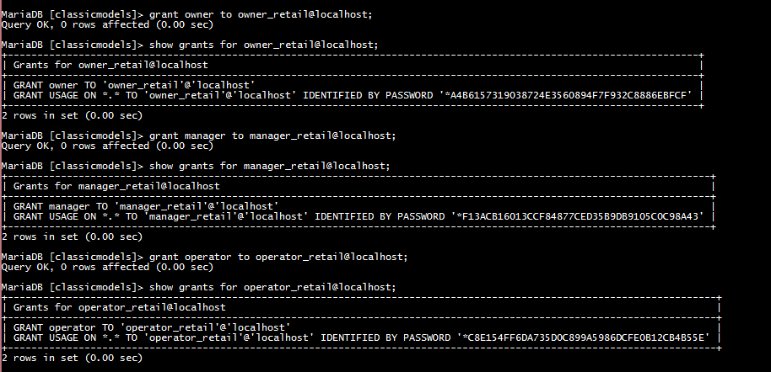

THE ROLE FOR OWNER, MANAGER, and OPERATOR

1.OWNER

Role for owner is he can give all command while using database classicmodels. Owner can see the information from tables by selecting any tables, create new tables, update it, and also delete that tables. Insert any new goods that correlated with retail and also modifying data from that goods like their prices. Using all command, owner freely to doing something that correlated with database in managing her retail overall.

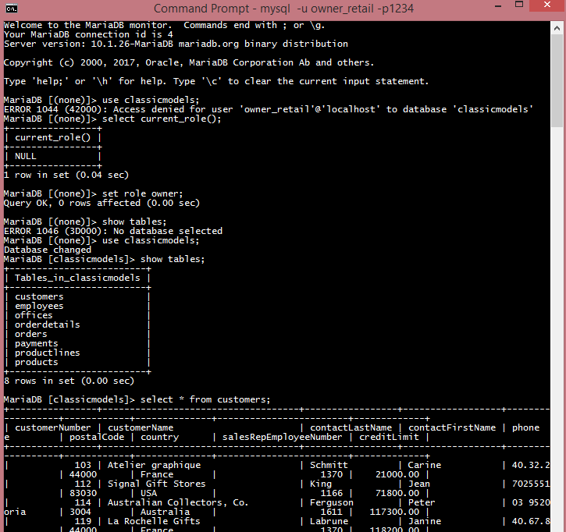

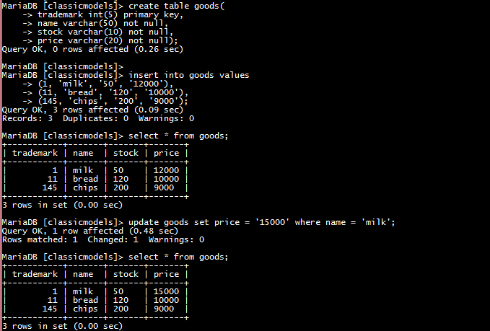

2.MANAGER

In here I make new role that is ‘manager2’ that can give permission to select, update, insert and delete command for manager. In using this role, manager only can give 4 commands that allow him to view the goods with select command, put in new goods for retail with insert command, then if situation is change in the market he can change the price from goods with update command, and last he can delete a table/ data that not used anymore in retail.



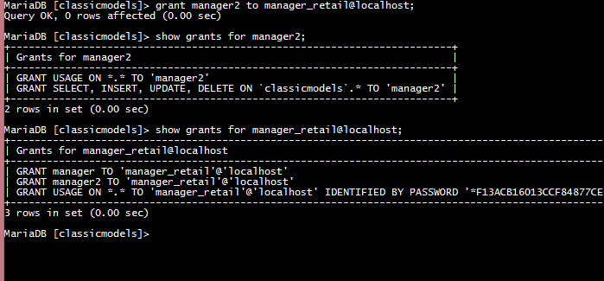

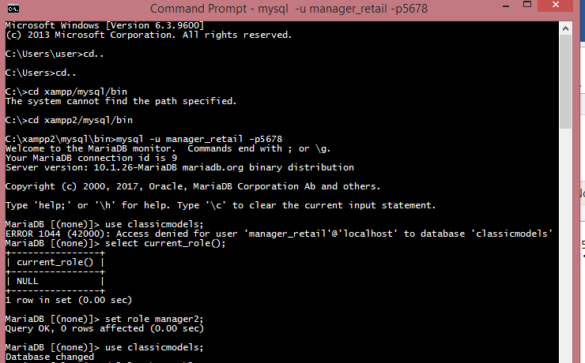

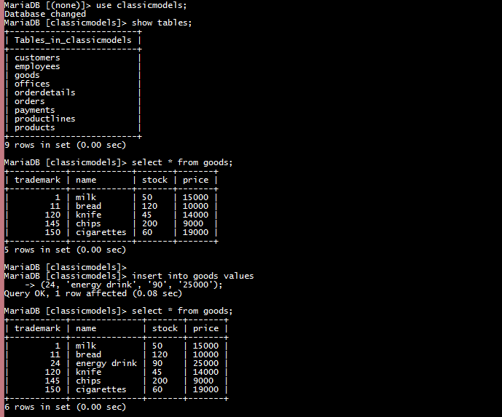

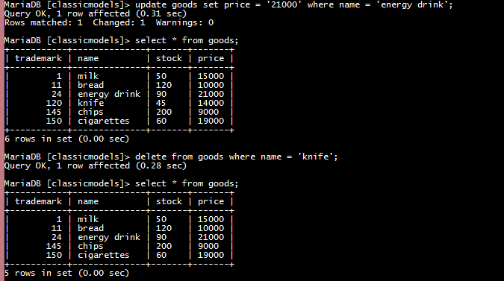

3.OPERATOR

In here I make new role that is ‘operator2’ because the first role that is ’operator’ is only have select commands then I make role ‘operator2’ that have 2 command that is select and update. Operator can see data from tables with select commands. In retail he can see the goods and keep an eye with the stock of product, quality of product, and expired date of product. Second, operator can update the data of goods like their price but he can’t insert anything & delete. For example, when stock of goods diminished operator should update the stock but he can’t insert new goods and delete anything.

