COMPUTER ORGANIZATION AND ARCHITECTURE

TASK 1 COMPARING MOTHERBOARD FOR i5 & i7



AJRINA ALIFIDA S.P

L200154012

INFORMATICS

FACULTY OF COMMUNICATION AND INFORMATICS

1. Motherboard H61M-E (ASUS)

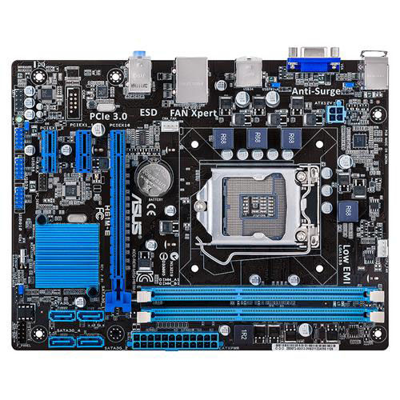

* CPU

Intel® Socket 1155 for 3rd/2nd Generation Core™ i7/Core™ i5/Core™ i3/Pentium®/Celeron® Processors   
Supports Intel® 22 nm CPU  
Supports Intel® 32 nm CPU  
Supports Intel® Turbo Boost Technology 2.0   
* The Intel® Turbo Boost Technology 2.0 support depends on the CPU types.

* Chipset

Intel® H61(B3)

* Memory

2 x DIMM, Max. 16GB, DDR3 2200(O.C.)/2133(O.C.)/2000(O.C.)/1866(O.C.)/1600/1333/1066 MHz Non-ECC, Un-buffered Memory   
Dual Channel Memory Architecture   
* 1600MHz and higher frequency is supported by Intel® 3rd generation processors.  
* Refer to [www.asus.com](http://www.asus.com) for the Memory QVL (Qualified Vendors Lists).  
* Due to OS limitation, when installing total memory of 4GB capacity or more, Windows® 32-bit operation system may only recognize less than 3GB. Install a 64-bit Windows® OS when you want to install 4GB or more memory on the motherboard.  
* Due to the CPU behavior, DDR3 2133/1866MHz memory module will run at DDR3 2000/1800MHz frequency as default.

* Graphic

Integrated Graphics Processor   
VGA output support : RGB port  
- Supports RGB with max. resolution 2048 x 1536 @ 75 Hz  
Maximum shared memory of 1024 MB

* Expansion Slots

1 x PCIe 3.0/2.0 x16   
2 x PCIe 2.0 x1

* Storage

**Intel® H61(B3) chipset :**   
4 x SATA 3Gb/s port(s), blue

* LAN

Realtek® 8111F, 1 x Gigabit LAN Controller(s)

* Audio

Realtek® ALC887 8-Channel High Definition Audio CODEC

* USB Ports

**Intel® H61(B3) chipset :**   
10 x USB 2.0 port(s) (4 at back panel, black, 6 at mid-board)

* Special Features

**ASUS Exclusive Features** :  
- AI Suite II  
- Ai Charger  
- Anti-Surge  
- ASUS UEFI BIOS EZ Mode featuring friendly graphics user interface   
- Network iControl  
**ASUS Quiet Thermal Solution** :  
- ASUS Fan Xpert   
**ASUS EZ DIY :**  
- ASUS CrashFree BIOS 3   
- ASUS EZ Flash 2   
- ASUS MyLogo 2   
**100% All High-quality Conductive Polymer Capacitors**

* Back I/O Ports

1 x PS/2 keyboard (purple)  
1 x PS/2 mouse (green)  
1 x D-Sub  
1 x LAN (RJ45) port(s)  
4 x USB 2.0   
3 x Audio jack(s)

* Internal I/O Ports

3 x USB 2.0 connector(s) support(s) additional 6 USB 2.0 port(s)  
4 x SATA 3Gb/s connector(s)  
1 x CPU Fan connector(s) (4 -pin)  
1 x Chassis Fan connector(s) (4 -pin)  
1 x 24-pin EATX Power connector(s)  
1 x 4-pin ATX 12V Power connector(s)  
1 x Front panel connector(s)   
1 x Front panel audio connector(s) (AAFP)  
1 x Internal speaker connector(s)  
1 x Clear CMOS jumper(s)

* Accessories

User's manual  
I/O Shield  
2 x SATA 3Gb/s cable(s)

* BIOS

64Mb Flash ROM, UEFI BIOS, PnP, DMI v2.0, WfM2.0, SMBIOS v2.7, ACPI v2.0a,SLP3.0, EUP-ready

* Manageability

WOL, PXE, PME Wake Up

* Support Disc

Drivers  
ASUS Utilities  
ASUS Update   
Anti-Virus Software (OEM Version)

* Form Factor

Micro ATX Form Factor   
8.9 inch x 6.9 inch ( 22.6 cm x 17.5 cm )

1. Motherboard GIGABYTE Z170X-GAMING 7

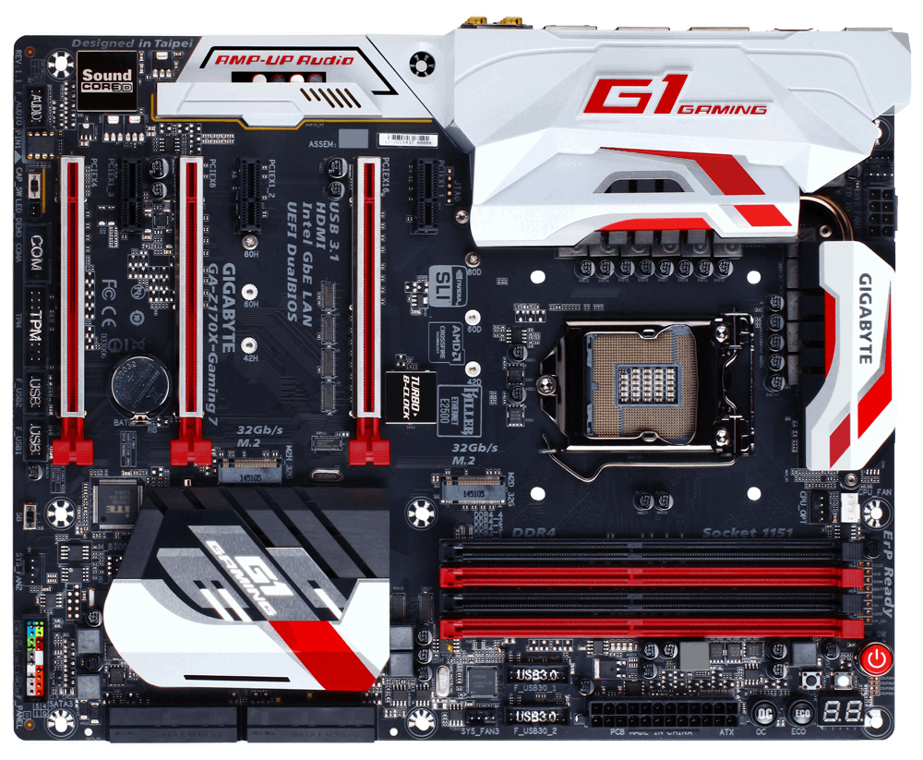

* CPU

1. Support for 7th/6th Generation Intel® Core™ i7 processors/Intel® Core™ i5 processors/ Intel® Core™ i3 processors/Intel® Pentium® processors/ Intel® Celeron® processors in the LGA1151 package  
   * For 7th Generation Intel® Core™ processors support need to update the latest BIOS.
2. L3 cache varies with CPU

* Chipset

1. Intel® Z170 Express Chipset

* Memory

1. 4 x DDR4 DIMM sockets supporting up to 64 GB of system memory  
   * Due to a Windows 32-bit operating system limitation, when more than 4 GB of physical memory is installed, the actual memory size displayed will be less than the size of the physical memory installed.
2. Dual channel memory architecture
3. Support for DDR4 3866(O.C)/3733(O.C)/3666(O.C) /3600(O.C.) /3466(O.C.) /3400(O.C.) /3333(O.C.) /3300(O.C.) /3200(O.C.) /3000(O.C.) /2800(O.C.) /2666(O.C.) /2400(O.C.) /2133 MHz memory modules
4. Support for ECC UDIMM 1Rx8/2Rx8 memory modules (operate in non-ECC mode)
5. Support for non-ECC UDIMM 1Rx8/2Rx8/1Rx16 memory modules
6. Support for Extreme Memory Profile (XMP) memory modules

* Onboard Graphics

Integrated Graphics Processor-Intel® HD Graphics support:

1 x DisplayPort, supporting a maximum resolution of 4096x2304@60 Hz  
* Support for DisplayPort 1.2 version.

 Integrated Graphics Processor+MegaChips MCDP2800 chip:

1. 1 x HDMI 2.0 port

Maximum shared memory of 1024 MB

* Audio

1. Creative® Sound Core 3D chip
2. Support for Sound Blaster Recon3Di
3. TI Burr Brown® OPA2134 operational amplifier
4. High Definition Audio
5. 2/5.1-channel
6. Support for S/PDIF Out

* LAN

1. 1 x Intel® GbE LAN chip (10/100/1000 Mbit)(LAN1)
2. 1 x Killer E2400 chip (10/100/1000 Mbit) (LAN2)  
   * Teaming is not supported.

* Expansion Slots

1. 1 x PCI Express x16 slot, running at x16 (PCIEX16)  
   * For optimum performance, if only one PCI Express graphics card is to be installed, be sure to install it in the PCIEX16 slot.
2. 1 x PCI Express x16 slot, running at x8 (PCIEX8)  
   * The PCIEX8 slot shares bandwidth with the PCIEX16 slot. When the PCIEX8 slot is populated, the PCIEX16 slot will operate at up to x8 mode.
3. 1 x PCI Express x16 slot, running at x4 (PCIEX4)  
   * The PCIEX4 slot shares bandwidth with the M2H_32G connector. The PCIEX4 slot will become unavailable when an SSD is installed in the M2H_32G connector.
4. 3 x PCI Express x1 slots  
   (All of the PCI Express slots conform to PCI Express 3.0 standard.)

* Storage Interface

· Chipset:

1. 2 x M.2 Socket 3 connectors (Socket 3, M key, type 2242/2260/2280 SATA & PCIe x4/x2/x1 SSD support)
2. 3 x SATA Express connectors
3. 6 x SATA 6Gb/s connectors (SATA3 0~5)
4. Support for RAID 0, RAID 1, RAID 5, and RAID 10  
   * Refer to "1-10 Internal Connectors," for the supported configurations with the M.2, SATA Express, and SATA connectors.

ASMedia® ASM1061 chip:

1. 2 x SATA 6Gb/s connectors (SATA3 6~7), supporting AHCI mode only

· Multi-Graphics Technology

1. · Support for NVIDIA® Quad-GPU SLI™ and 2-Way NVIDIA® SLI™ technologies
2. Support for AMD Quad-GPU CrossFireX™ and 3-Way/2-Way AMD CrossFire™ technologies

* USB

Chipset:

1. 5 x USB 3.0/2.0 ports on the back panel
2. 4 x USB 2.0/1.1 ports (available through the internal USB headers)

Chipset+Renesas® USB 3.0 Hub:

1. 4 x USB 3.0/2.0 ports (available through the internal USB headers)

Chipset+Intel® Thunderbolt™ 3 Controller:

1. 1 x USB Type-C™ port on the back panel, with USB 3.1 support
2. 1 x USB 3.1 Type-A port (red) on the back panel

* Internal I/O Connectors

1. 1 x 24-pin ATX main power connector
2. 1 x 8-pin ATX 12V power connector
3. 2 x M.2 Socket 3 connectors
4. 3 x SATA Express connectors
5. 8 x SATA 6Gb/s connectors
6. 1 x I/O shield audio LED power connector
7. 1 x CPU fan header
8. 1 x water cooling fan header (CPU_OPT)
9. 3 x system fan headers
10. 1 x front panel header
11. 1 x front panel audio header
12. 2 x USB 3.0/2.0 headers
13. 2 x USB 2.0/1.1 headers
14. 1 x Trusted Platform Module (TPM) header
15. 1 x serial port header
16. 1 x Clear CMOS jumper
17. 1 x power button
18. 1 x reset button
19. 1 x Clear CMOS button
20. 1 x ECO button
21. 1 x OC button
22. 1 x audio gain control switch
23. Voltage Measurement Points
24. 1 x BIOS switch

· Back Panel Connectors

1. 1 x PS/2 keyboard/mouse port
2. 1 x DisplayPort
3. 1 x HDMI port
4. 1 x USB Type-C™ port, with USB 3.1 support
5. 1 x USB 3.1 Type-A port (red)
6. 5 x USB 3.0/2.0 ports
7. 2 x RJ-45 ports
8. 1 x optical S/PDIF Out connector
9. 5 x audio jacks (Center/Subwoofer Speaker Out, Rear Speaker Out, Line In/Mic In, Line Out, Headphone)

* I/O Controller

1. iTE® I/O Controller Chip

* H/W Monitoring

1. System voltage detection
2. CPU/System/Chipset temperature detection
3. CPU/CPU OPT/System fan speed detection
4. CPU/System/Chipset overheating warning
5. CPU/CPU OPT/System fan fail warning
6. CPU/CPU OPT/System fan speed control  
   * Whether the fan speed control function is supported will depend on the cooler you install.

* BIOS

1. 2 x 128 Mbit flash
2. Use of licensed AMI UEFI BIOS
3. Support for DualBIOS™
4. PnP 1.0a, DMI 2.7, WfM 2.0, SM BIOS 2.7, ACPI 5.0

* Unique Features

1. Support for APP Center  
   * Available applications in APP Center may vary by motherboard model. Supported functions of each application may also vary depending on motherboard specifications.  
   3D OSD  
   @BIOS  
   Ambient LED  
   AutoGreen  
   Cloud Station  
   EasyTune  
   Easy RAID  
   Fast Boot  
   Smart TimeLock  
   Smart Keyboard  
   Smart Backup  
   System Information Viewer  
   USB Blocker
2. Support for Q-Flash
3. Support for Smart Switch
4. Support for Xpress Install

* Operating System

1. Windows® 10 64-bit (for 7th Generation Intel® Processors)
2. Windows® 10 64-bit / Windows® 8.1 64-bit / Windows® 7 32-bit / 64-bits (for 6th Generation Intel® Processors)  
   * Please download the "Windows USB Installation Tool" from GIGABYTE's website and install it before installing Windows 7.

* Form Factor

1. ATX Form Factor; 30.5cm x 24.4cm