BAB 3 MODUL PRAKTIKUM PWD

Nama : Hasna Azizah

NIM : L200160168

Kelas : D

1. Percobaan 1

* Variable.php

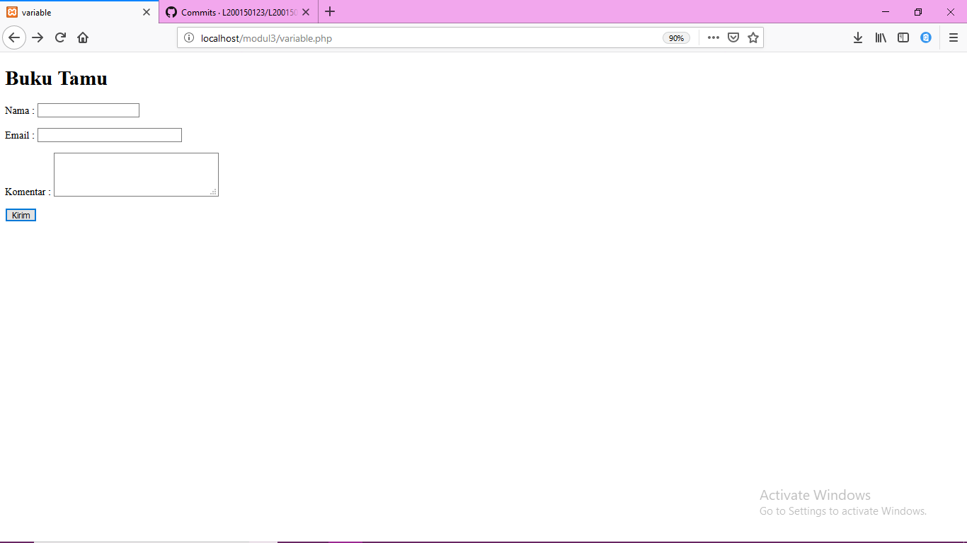

1. Kendali.php

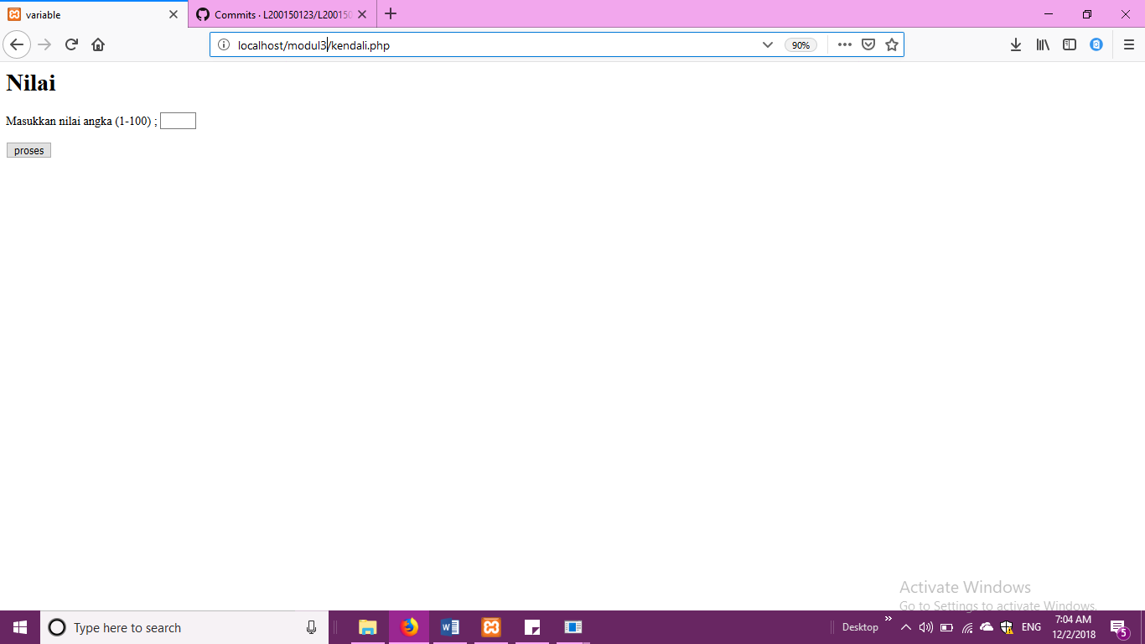

1. Upload.php

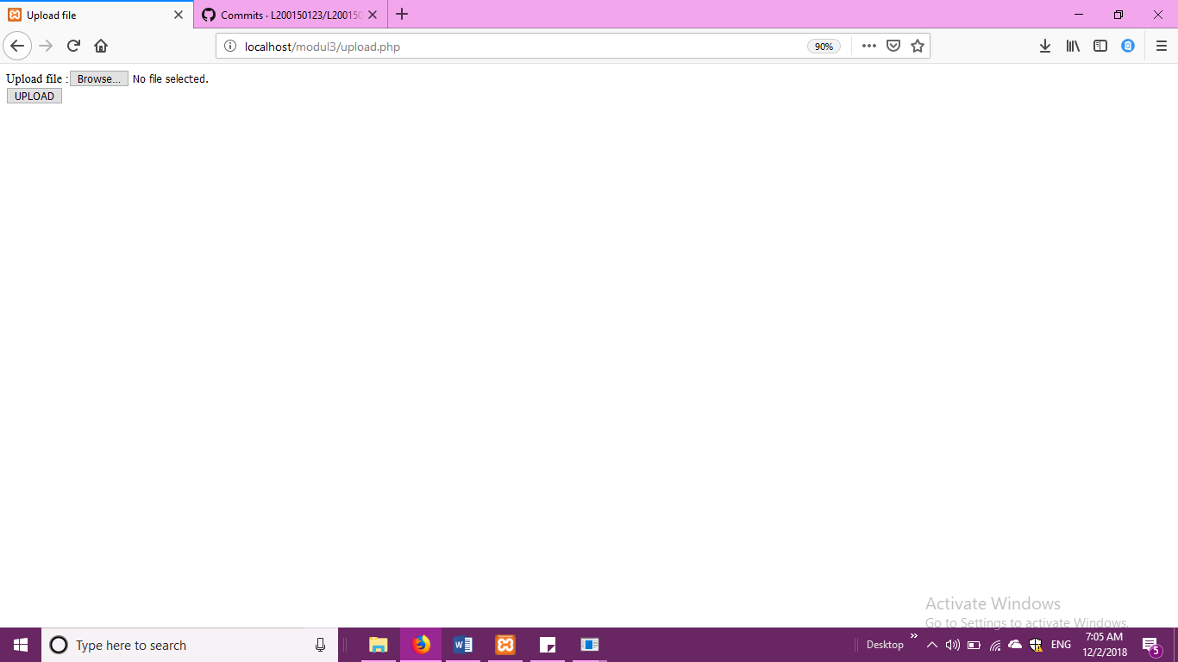

1. tanggal.php

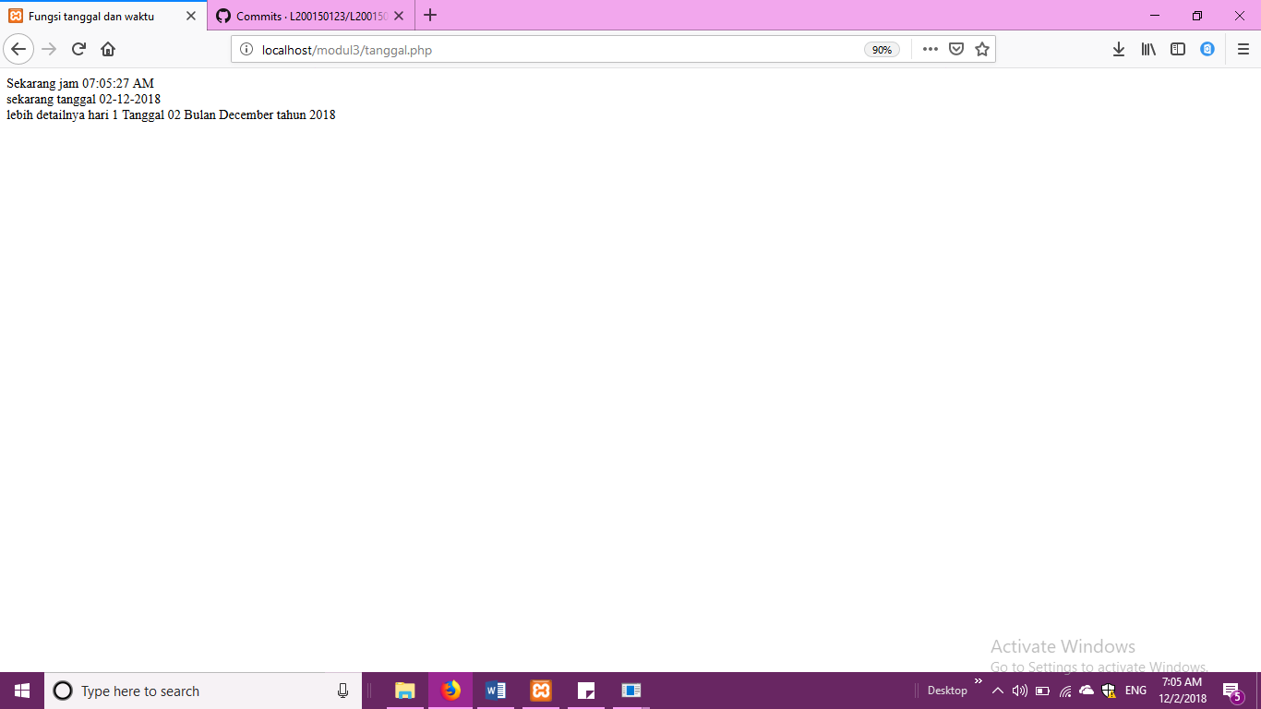

**TUGAS**

