Checksum!

WIDYASARI NUR FADHILAH L200164005.

1. 16 Bit
2. 8 Bit

HEXADECIMAL:

W = 57

I = 49

D = 44

Y = 59

A = 41

S = 53

A = 41

R = 52

I = 49

= 20

N = 4E

U = 55

R = 52

= 20

F = 46

A = 41

D = 44

H = 48

I = 49

L = 4C

A = 41

H = 48

= 20

L = 4C

2 = 32

0 = 30

0 = 30

1 = 31

6 = 36

4 = 34

0 = 30

0 = 30

5 = 30

. = 2E

A. 16 Bit

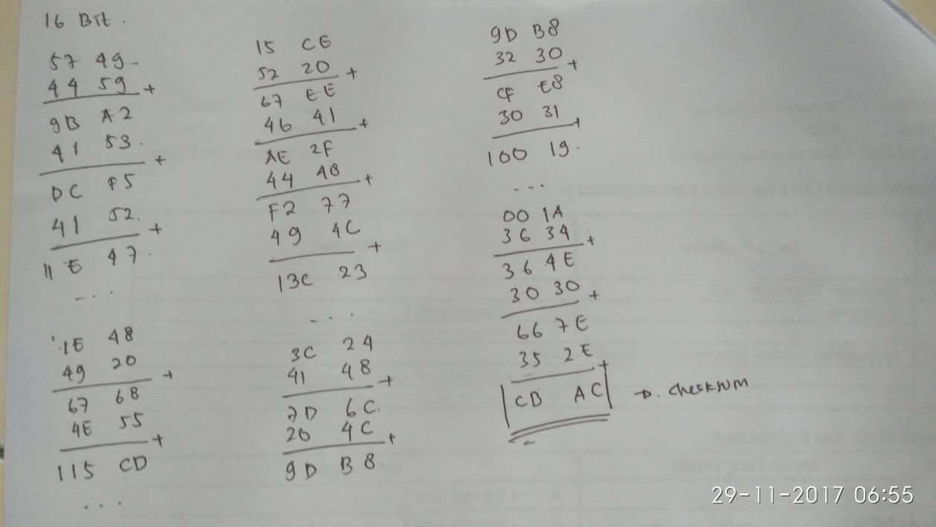

B. 8 Bit

