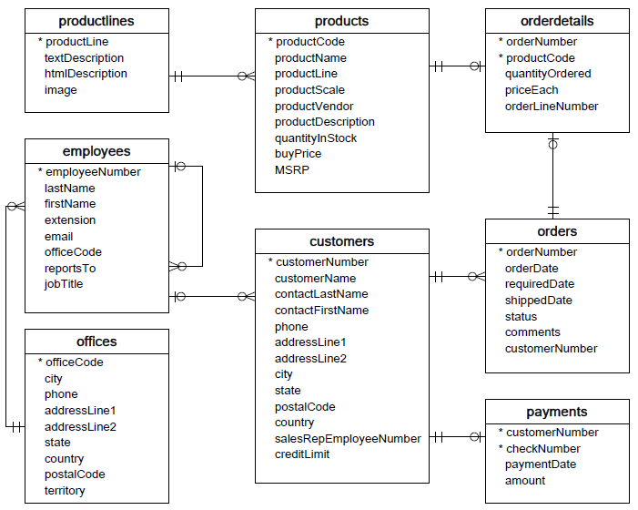

RELASI:

1. Productlines to Product (one to many)

* One Productline have many Pruduct
* many products are owned by the Product Line

1. Products to Orders (many to many)

* many products have many orders

1. Customers to Orders (one to many)

* one customer makes many orders
* lots of orders made by one buyer

1. Employees to Customers (one to many)

* one employee serves many customers
* many customers are served by one employee

1. Customers to payments (one to many)

* one customer has a lot of payment
* many payments made by one customer

1. Office to Employees (one to many)

* One office have many employees
* Many employees working in one office

1. Employees to employees (one to many)

* one employee knows many employees
* many employees know one worker