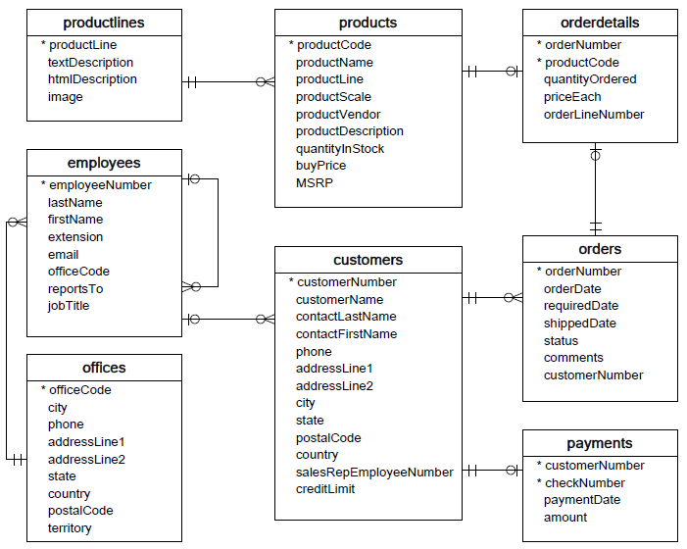

RELASI:

1. Productlines and Products
2. Products and Orderdetails (One to Many)
3. Orderdetails and Orders (Many to One)
4. Orders and Costumers (Many to One)
5. Costumers and Payments(One to Many)
6. Costumers and Employees(Many to One)
7. Employees and Employees(One to Many)
8. Employees and Offices(Many to One)