**RESUME OPERATING SYSTEM**

**INTRODUCTION OPERATING SYSTEM**

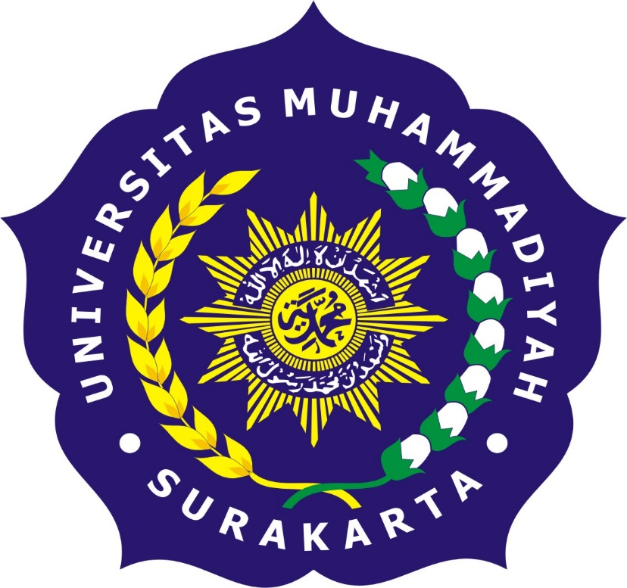

Arranged by:

Name : Widyasari Nur fadhilah (L200164005)  
Assyati Amadjida T M (L200164006)

Class : X

# JURUSAN INFORMATIKA

# FAKULTAS KOMUNIKASI DAN INFORMATIKA

# UNIVERSITAS MUHAMMADIYAH SURAKARTA

**What is Operating System**

**An Operating System** is a collection of system programs that control computer and any other peripherals connected to it. The program that hides the truth about the hardware from the programmer and present and a nice simple view a named file that can be read & written as “operating system”. Operating system shields the programmer from the interface, the abstraction offers by the operating system is slower & easier to use than the underlying hardware.  
Operating system is collection of software which is close to hardware. We can view operating system as a resource – hardware and software collector.  
The main functions of operating system are :  
1. Implementing using interface  
2. Sharing hardware among number of users.  
3. Allow user to share data  
4. Protecting user from each other  
5. Control the execution of programs

* **Operating System as extended machine or virtual machine**:. The operating system is design to maximize resource utilization.  
  The program that hides the truth about the hardware from the programmer and present and a nice simple view a named file that can be read & written as “operating system”. Operating system shields the programmer from the interface, the abstraction offers by the operating system is slower & easier to use than the underlying hardware.  
  The main function of operating system is to present the user with the equivalent of an extended machine or virtual machine that is easier to program than underlying hardware.
* **operating system as resource manager**:  
  Operating system is collection of software which is close to hardware. A system has many hardware and software that may b required to solve the problem, cpu time, memory space, file storage space, i/o device etc. the operating system acts as manager of these resources.

**History of Operating System**

1. **The First Generation (1945-1955) : Vacuum Tubes**

The first generation is the beginning of the development of electronic computing systems as a replacement for mechanical computing systems, that is what humans need to count is limited and humans are very easy to make carelessness, even mistakes. In this generation there is no operating system.

1. **The Second Generation (1955-1965) : Transistor and Batch System**

The second generation introduces the Batch Processing System, the Job that works in a series, then executed sequentially. In this generation the computer system is not equipped with the operating system, for example the function of the operating system FMS (Fortran Monitoring System) and IBSYS. So this second generation of computers is the first generation of Operating system.

1. **The Third Generation (1965-1980) : Ics and Multiprogramming**

In this generation the development of the operating system was developed to serve many users . at the same time, where interactive users communicate via the terminal on-line to the computer, the operating system becomes multi-user (multi user) and multi-programming (serving many programs at once).

1. **The Fourth Generation (1980-Present): Peronal Computers**

Today, the operating system is used for computer networks where the user is aware the existence of computers that are connected to each other. At this time of the users have also been secured with Graphical User Interface is a graphical interface computer that is very comfortable, at this time also begins the era of computing spread where computing is no longer centered in one point, but broken down in many computers so as to achieve better performance.

1. **The Fifth Generation(1990-Present)**

An imaginative example of a fifth generation computer is the HAL9000 fictional computer from the novel by Arthur C. Clarke entitled 2001: Space Odyssey. It displays all the desired functionality of a fifth generation computer. With artificial intelligence, HAL can be reason enough to engage with people, use visual input, and learn from their own experience. Although the realization of HAL9000 is still far from reality, many of its functions have already materialized. Some computers can receive oral instructions and be able to imitate human reasoning.

**Computer Hardware Review**

1. Processors

The central processing unit (CPU) is the computer component that's responsible for interpreting and executing most of the commands from the computer's other [hardware](https://www.lifewire.com/computer-hardware-2625895) and software.

1. Memory

is any physical device capable of storing information temporarily or permanently. For example, Random Access Memory ([RAM](https://www.computerhope.com/jargon/r/ram.htm)), is a volatile memory that stores information on an [integrated circuit](https://www.computerhope.com/jargon/i/ic.htm) used by the [operating system](https://www.computerhope.com/jargon/o/os.htm), [software](https://www.computerhope.com/jargon/s/software.htm), and [hardware](https://www.computerhope.com/jargon/h/hardware.htm).

1. Disks

disk is a a round plate on which [data](http://www.webopedia.com/TERM/D/data.html) can be encoded. There are two basic types of disks: magnetic disks and [optical disks](http://www.webopedia.com/TERM/O/optical_disk.html).

* On magnetic disks, data is encoded as microscopic magnetized needles on the disk's surface. You can record and erase data on a magnetic disk any number of times, just as you can with a cassette [tape](https://www.webopedia.com/TERM/T/tape.html). Magnetic disks come in a number of different forms:
* Floopy disk
* Hard disk
* [**removable cartridge**](http://www.webopedia.com/TERM/R/removable_hard_disk.html)
* Optical disks record data by burning microscopic holes in the surface of the disk with a laser.

1. I/O Devices

input/output device is any [hardware](https://www.computerhope.com/jargon/h/hardware.htm) used by a human operator or other systems to communicate with a computer. As the name suggests, input/output devices are capable of sending data (output) to a computer and receiving data from a computer (input).

1. Buses

is a communication system that transfers data between components inside a [computer](https://en.wikipedia.org/wiki/Computer), or between computers. This expression covers all related hardware components (wire, optical fiber, etc.) and software, including communication protocols.

1. Booting the Computer

Booting a computer refers to the process of powering on the computer and starting the operating system. The operating system is the program that makes all your software applications and hardware work together, so you can do the work you want to do. Once you hit the power button, it's all automatic from there. The boot process loads the operating system into main memory or the random access memory (RAM) installed on your computer. Now let's learn a little more about the boot process.

**The operating system zoo**

Operating System Zoo is a website that hosts disk images of free an open-source, operating systems for use in virtual machines and emulators

1. Mainframe Operating Systems
2. Server Operating Systems
3. Multiprocesor Operating Systems
4. Personal Computer Operating Systems
5. Handheld Computer Operating Systems
6. Embadded Operating Systems
7. Sensor-Node Operating Systems
8. Real-Time Operating Systems
9. Smart Card Operating Systems

**Operating System Concepts**

1. Processes

A process is basically a program in execution. The execution of a process must progress in a sequential fashion.A process is defined as an entity which represents the basic unit of work to be implemented in the system.

1. Address Spaces
2. Address space is the amount of [memory](http://searchmobilecomputing.techtarget.com/definition/memory) allocated for all possible [address](http://searchnetworking.techtarget.com/definition/address)es for a computational entity, such as a device, a file, a server, or a networked computer.
3. Files

Another key concept supported by virtually all operating systems is the file system. A major function of the operatig system is to hide the particularities of the disk and other I/O devises and present the programmer with a nice, clean abstract model of device-independent files

1. Input/Output

Every operating system has an I/O subsystem for managing its I/O devices. Some of the I/O software is device independent, that is, applies to many or all I/O device equally well

1. Protection
2. The Shell

The operating system is the code that carries out the system calls. Editors, compliers, assemblers, linkes, utility programs, and command interpeters definitionitely are not part of the operating system, even though they are important and usefull

1. Ontogency Recapitulates Phylogency

**System Calls**

System Calls provide the Interface between a process and the Operating System. • These calls are generally available as Assembly language instruction

1. System Calls for Process Management

A running program needs to be able to stop execution either normally or abnormally. When execution is stopped abnormally, often a dump of memory is taken and can be examined with a debugger.

1. System Calls for File Management

Some common system calls are create, delete, read, write, reposition, or close. Also, there is a need to determine the file attributes – get and set file attribute. Many times the OS provides an API to make these system calls.

1. System Calls for Divice Management

Process usually require several resources to execute, if these resources are available, they will be granted and control returned to the user process. These resources are also thought of as devices. Some are physical, such as a video card, and others are abstract, such as a file.

1. Information Management

Some system calls exist purely for transferring information between the user program and the operating system. An example of this is time, or date.The OS also keeps information about all its processes and provides system calls to report this information.

1. Communication

There are two models of interprocess communication, the message-passing model and the shared memory model. Message-passing uses a common mailbox to pass messages between processes.Shared memory use certain system calls to create and gain access to create and gain access to regions of memory owned by other processes. The two processes exchange information by reading and writing in the shared data.

**Operating System Structure**

Six design from Operating system structure are monolithic systems, layered systems, microkernels, client-server systems, virtual machines, and exokernels.

* + - 1. Monolithic system  
         Operating System The operating system is a set of procedures that the procedures in it can call each other when necessary. All services provided by the operating system contain a carnel. All operating system components are in one address space.  
         This organization suggests a basic structure for the operating system:  
         - A main program that invokes the requested service procedure.  
         - A set of service procedures that carry out the system calls.  
         - A set of utility procedures that help the service procedures.
      2. Layered system  
         Operating System The operating system is formed in a hierarchical manner based on layers, in which case the lower layers provide services for the upper layer. Each layer in a single address space.The layered system aims to reduce the implementation of the operating system and the complexity of the design. Each layer has an interface and functional input - output with 2 layers adjacent to a well-defined.
      3. Microkernels  
         Microkernel is the core (kernel) of the simplest operating system, no facilities whatsoever, making it a very small and usually very stable kernel (almost certainly no bugs).
      4. Client-Server models  
         The operating system is a set of processes, in which case processes are categorized into servers and clients. Servers and clients interact.
      5. Virtual Machines  
         Initially this structure makes it look as though all the users have all the computers alone. The technique used is the top processing process used. The operating system simulates many real machines. Virtual machine simulation results are used by users. This virtual machine is a hundred percent copy of a real machine. One user is given one virtual machine. All users are given the illusion of having a real (virtual) machine that is equally sophisticated.
      6. Exokernels  
         Exokernel is a kernel design developed by MIT parallel and distributed operating system group, and is also a similar operating system.

Most Operating Systems use the "C" language, sometimes using the "C ++" language. Focus on C, Python, and Java. The "C" language has much in common with the "Java" language although it also has something in common with "Python".  
Pointer is a very powerful construction, but also a source of error when used carelessly.  
 Some things that C does not have include built-in strings, threads, packages,  
class, object, type of safety, and garbage collection. The latter is the show stopper for the operating system All the storage in C static or allocated explicitly and released by the programmer, usually with malloc and free library functions.  
 The operating system is basically a real-time system to some extent, even a general purpose.

Computer hardware is useful to understand it. Computer consists of  
processor, memories, and I / O devices. This section is connected to the bus.  
 The basic concept in which all operating systems are built is the process, memory management, I / O management, file systems, and security.  
 The core of any operating system is a manageable set of systems. It tells what the actual operating system is. For UNIX, we've seen four groups of system calls. The first group of calling systems deals with the manufacturing and termination processes. The second group is reading and writing files. The three groups are for directory management. The fourth group contains various calls.