Name : Wahyu Purnama Widya Leksana

NIM : L200164012

Class : X

Course : Embedded Systems Programming

Showing that the application can work for measuring with Raspberry pi :

1. Picture of the Code :

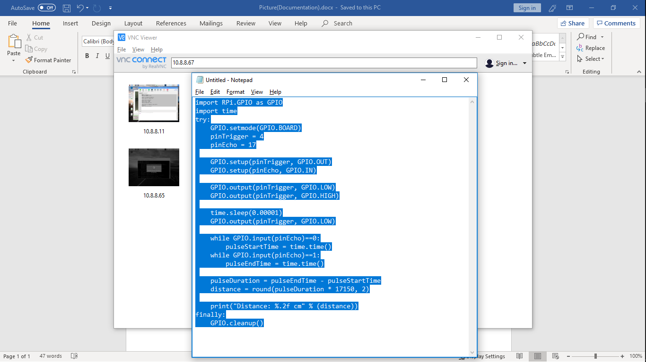

2. Picture of the Circuit :

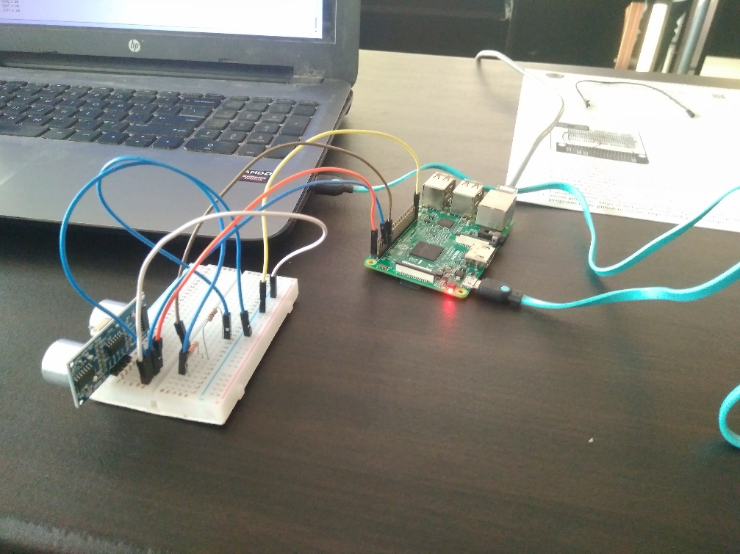

3. Picture of the Result :

