DATABASE MANAGEMENT SYSTEM



ARROTAMA HAFEDMAWAN L200164015

**Relationship ER-Diagram mysql sample database :**

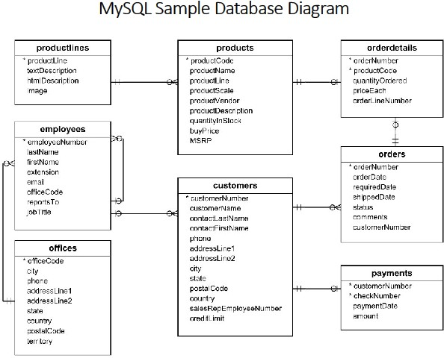

*\*Source :* [*http://www.mysqltutorial.org/mysql-sample-database.aspx*](http://www.mysqltutorial.org/mysql-sample-database.aspx)

## Productlines and Products ( 1 to many ) :

* + Minimum number of products that productlines could have : zero
  + Maximum number of products that productlines could have : many
  + A product could only have one and only one productlines.

## Productlines and Orders (many to many), which creates a new table : Orderdetails.

* 1. **Products and orderdetails ( 1 to 1 ) :**
     + An order details could have a zero or one product.
     + A products could only have one and only have 1 orderdetails.

## Orderdetails and order ( 1 to 1 ) :

* + - An order can only have one and only one orderdetails.
    - An orderdetails could only have zero or 1 orderdetails.

## Customer and order (1 to many) :

* + The amount orders that can be ordered by customer is zero or many
  + A specific order can only have one and only one customer.

## Employees and customers (1 to many ) :

* + An employees may serve zero or 1 customer only
  + A customer may be served by many employees or without employee.

## Customer and payments (1 to many ) :

* + A customer may pay or not pay the payments.
  + A specific payment can be only paid by only and only one customers.

## Office and employees ( 1 to many ) :

* + An office can be occupied by zero or many employees.
  + An employees can only have one and only one offices.

## Employees to employees ( 1 to many) :

* + An employee as a manager could lead many employees or none.
  + An employee could may have one leader or none