**Name : Arrotama Hafedmawan**

**NIM : L200164015**

Virtualization and the cloud

**Requirements for Virtualization**

Hypervisors should score well in three dimentions :

1. Safet : hypervisor should hava full control of virtualized resources.
2. Fidelity : behavior of a program on virtual machine should be identical to same program running on bare hardware.
3. Efficiency : much of code in virtual machine should run without intervention by hypervisor.

**Type of Hypervitors**

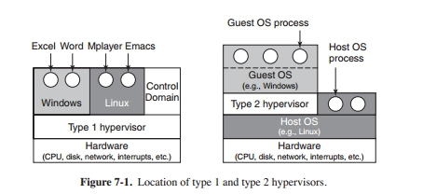

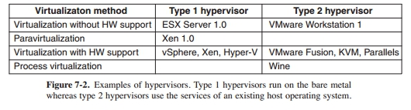

**I/O Virtualizaton**

Input/output (I/O) virtualization is a methodology to simplify management, lower costs and improve performance of servers in enterprise environments. I/O virtualization environments are created by abstracting the upper layer protocols from the physical connections.

In computing, an input–output memory management unit (IOMMU) is a memory management unit (MMU) that connects a direct-memory-access–capable (DMA-capable) I/O bus to the main memory.

**Virutalization Appliances**

A virtual appliance is a pre-configured virtual machine image, ready to run on a hypervisor; virtual appliances are a subset of the broader class of software appliances. Installation of a software appliance on a virtual machine and packaging that into an image creates a virtual appliance. Like software appliances, virtual appliances are intended to eliminate the installation, configuration and maintenance costs associated with running complex stacks of software.

A virtual appliance is not a complete virtual machine platform, but rather a software image containing a software stack designed to run on a virtual machine platform which may be a Type 1 or Type 2 hypervisor. Like a physical computer, a hypervisor is merely a platform for running an operating system environment and does not provide application software itself.

**Cloud**

Cloud computing is an information technology (IT) paradigm, a model for enabling ubiquitous access to shared pools of configurable resources (such as computer networks, servers, storage, applications and services),which can be rapidly provisioned with minimal management effort, often over the Internet. Cloud computing allows users and enterprises with various computing capabilities to store and process data either in a privately-owned cloud, or on a third-party server located in a data center - thus making data-accessing mechanisms more efficient and reliable. Cloud computing relies on sharing of resources to achieve coherence and economy of scale, similar to a utility.

five essential characteristics:

1. **On-demand self-service**. Users should be able to provision resources automatically, without requiring human interaction.
2. **Broad network access.** All these resources should be available over the network via standard mechanisms so that heterogeneous devices can make use of them.
3. **Resource pooling.** The computing resource owned by the provider should be pooled to serve multiple users and with the ability to assign and reassign resources dynamically. The users generally do not even know the exact location of ‘‘their’’ resources or even which country they are located in.
4. **Rapid elasticity.** It should be possible to acquire and release resources elastically, perhaps even automatically, to scale immediately with the users’ demands.
5. **Measured service.** The cloud provider meters the resources used in a way that matches the type of service agreed upon.

**VMWare Workstation**

VMware Workstation is a hosted hypervisor that runs on x64 versions of Windows and Linux operating systems (an x86 version of earlier releases was available); it enables users to set up virtual machines (VMs) on a single physical machine, and use them simultaneously along with the actual machine. Each virtual machine can execute its own operating system, including versions of Microsoft Windows, Linux, BSD, and MS-DOS. VMware Workstation is developed and sold by VMware, Inc.