Hesti Putri Utami

L200170009

Kelas A

Modul 3

Kegiatan Praktikum

Kegiatan 1. Desain dan Konfigurasi Subnetting

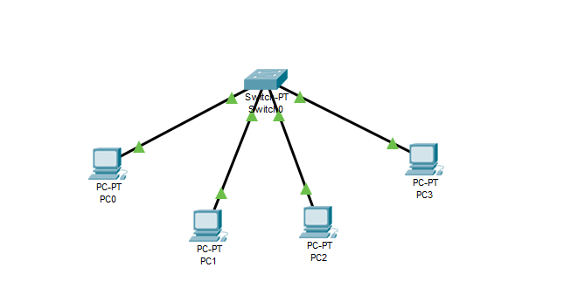

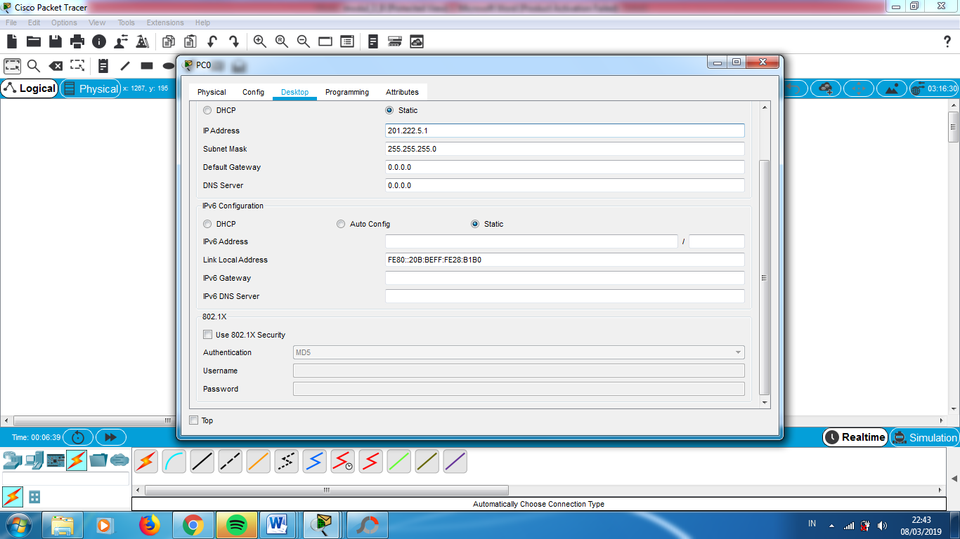

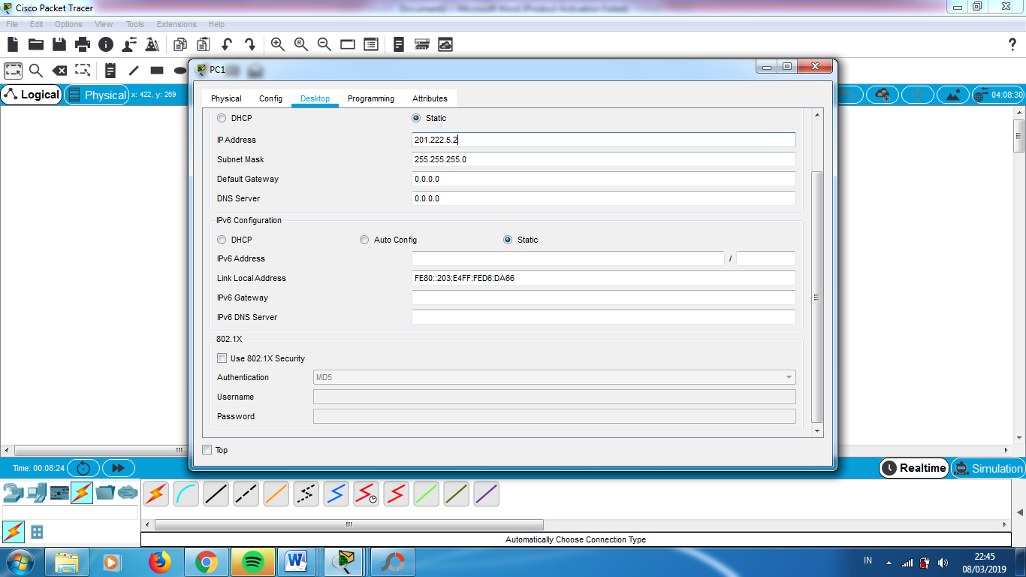

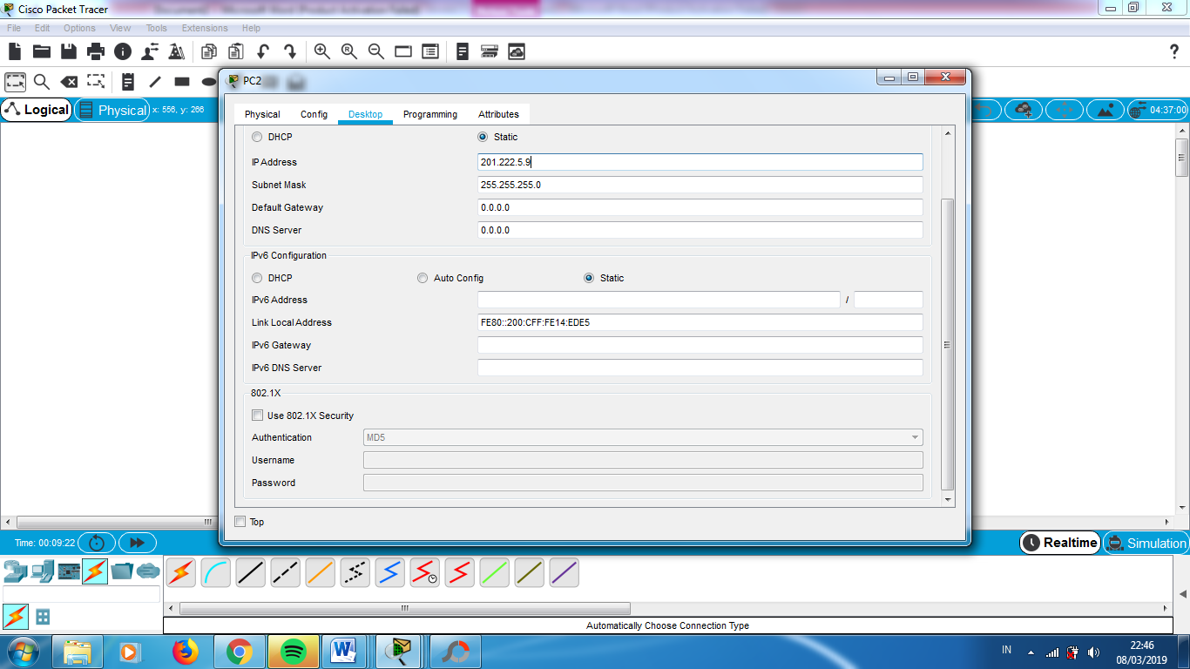

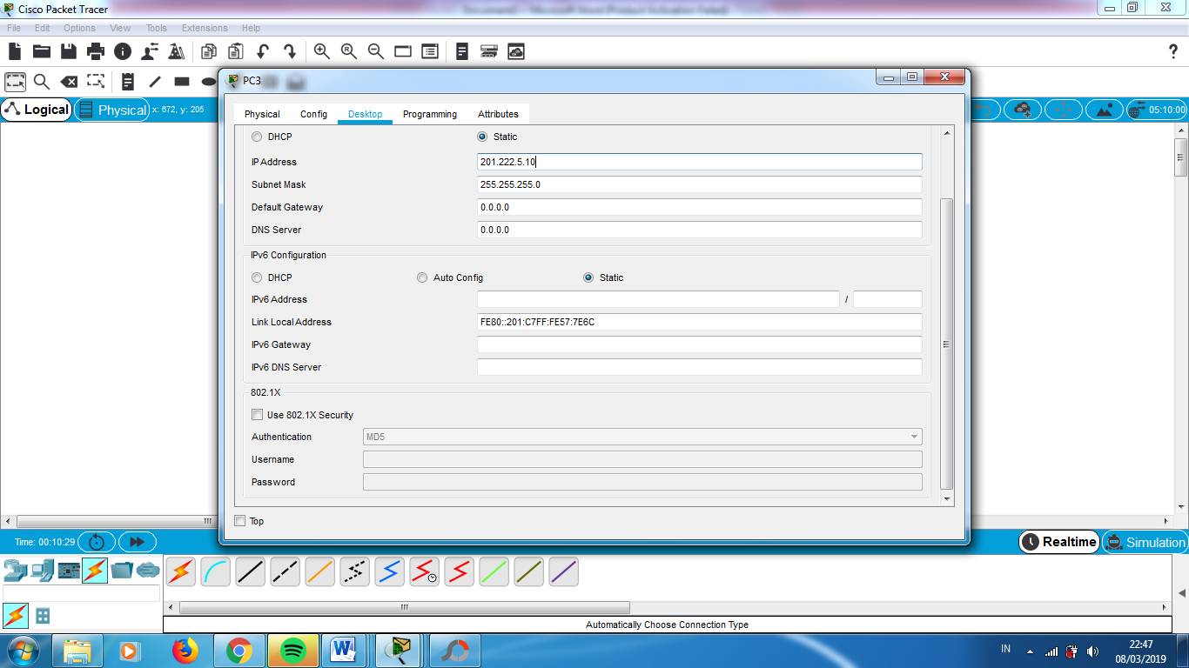

Tugas Modul

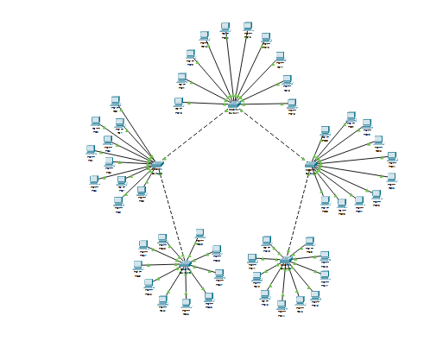

Menentukan Subnet Mask dan Subnet Address

IP Address : 202.155.19.0/27

11111111 11111111 11111111 11100000

Subnet Mask : 255.255.255.224

* Jumlah Subnet : 2x = 23 = 8
* Jumlah Host / Subnet : 2y – 2 = 25 – 2 = 32 – 2 = 30
* Block Subnet : 256 – 224 = 32
* Tabel Subnet

|  |  |  |  |  |  |  |  |  |
| --- | --- | --- | --- | --- | --- | --- | --- | --- |
| Network | 202.155.19.0 | 202.155.19.32 | 202.155.19.64 | 202.155.19.96 | 202.155.19.128 | 202.155.19.160 | 202.155.19.192 | 202.155.19.224 |
| Host Pertama | 202.155.19.1 | 202.155.19.33 | 202.155.19.65 | 202.155.19.97 | 202.155.19.129 | 202.155.19.161 | 202.155.19.193 | 202.155.19.225 |
| Host Terakhir | 202.155.19.30 | 202.155.19.62 | 202.155.19.94 | 202.155.19.126 | 202.155.19.158 | 202.155.19.190 | 202.155.19.222 | 202.155.19.254 |
| Broadcast | 202.155.19.31 | 202.155.19.63 | 202.155.19.95 | 202.155.19.127 | 202.155.19.159 | 202.155.19.191 | 202.155.19.223 | 202.155.19.255 |

