NAMA : Riyan Aldiansyah

NIM : L200170018

Kelas : A

Kegiatan 1

1. Membuat Topologi

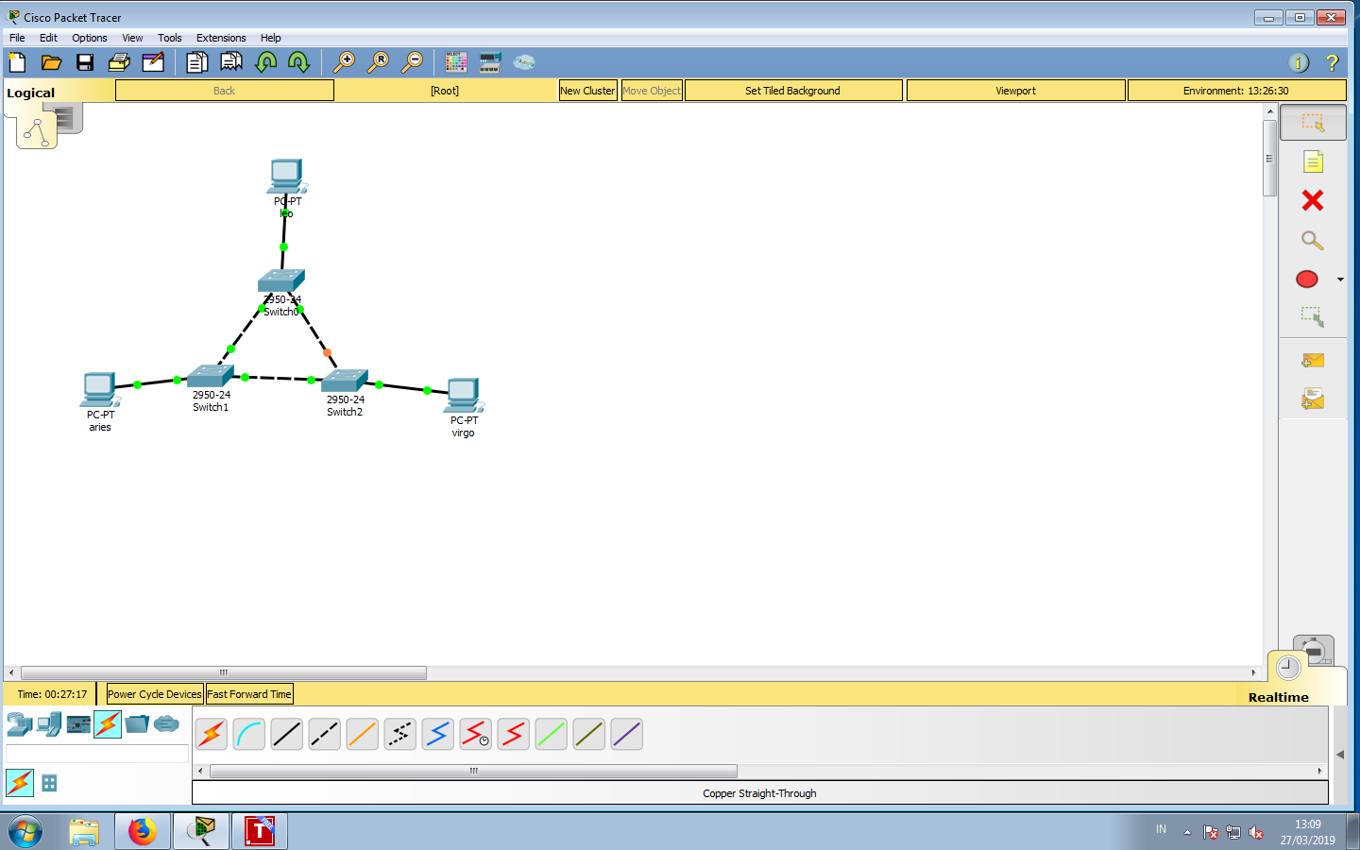

1. capture tampilan status masing2 switch

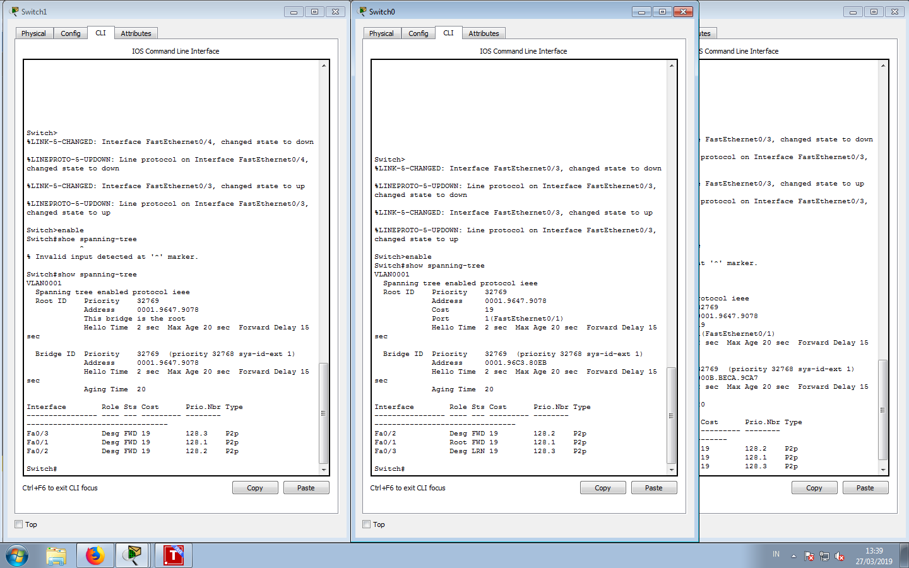

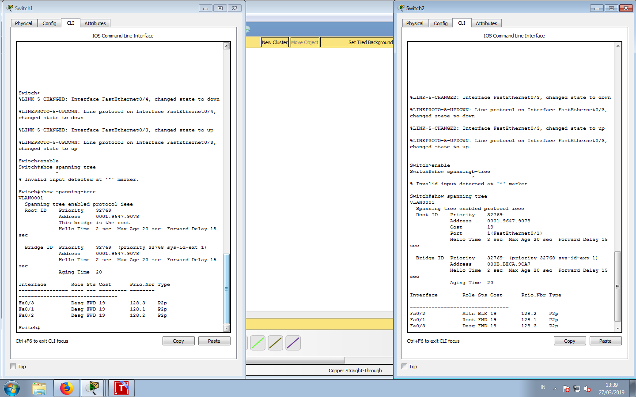

Lalu isi table tiap2 switch

-Swicth 1

|  |  |  |
| --- | --- | --- |
| no | Variable | Nilai |
| 1 | Root id | 32769, 0001.9647.9078 |
| 2 | Priotity | 32769 |
| 3 | MAC address | 0001.9647.9078 |
| 4 | Bridge id | 32769, 0001.96C3.80EB |
| 5 | Cost (0/1;0/2;0/3) | 19,19,19 |
| 6 | Hello time | 2 sec |
| 7 | Max Age | 20 sec |
| 8 | Forward Delay | 15 sec |

Swicth 2

|  |  |  |
| --- | --- | --- |
| no | Variable | Nilai |
| 1 | Root id | 32769, 0001.9647.9078 |
| 2 | Priotity | 32769 |
| 3 | MAC address | 0001.9647.9078 |
| 4 | Bridge id | 32769, 0001.9647.9078 |
| 5 | Cost (0/1;0/2;0/3) | 19,19,19 |

-Swicth 3

|  |  |  |
| --- | --- | --- |
| no | Variable | Nilai |
| 1 | Root id | 32769, 0001.9647.9078 |
| 2 | Priotity | 32769 |
| 3 | MAC address | 0001.9647.9078 |
| 4 | Bridge id | 32769,000B.BECA.9CA7 |
| 5 | Cost (0/1;0/2;0/3) | 19,19,19 |
| 6 | Hello time | 2 sec |
| 7 | Max Age | 20 sec |
| 8 | Forward Delay | 15 sec |

Tugas 4C pada kondisi default tersebut,switch dan port mana saja yang

-Menjadi root bridge : SW2,SW1

-Menjadi designated bridge :SW2,SW1

-Menjadi root port :SW3,SW1

-Menjadi designated port :SW3

Tugas 4D pada kondisi default tersebut,dan port mana saja yang

-Berada pada keadaan forwarding :SW2,SW1

-Berada pada keadaan blocking :SW3

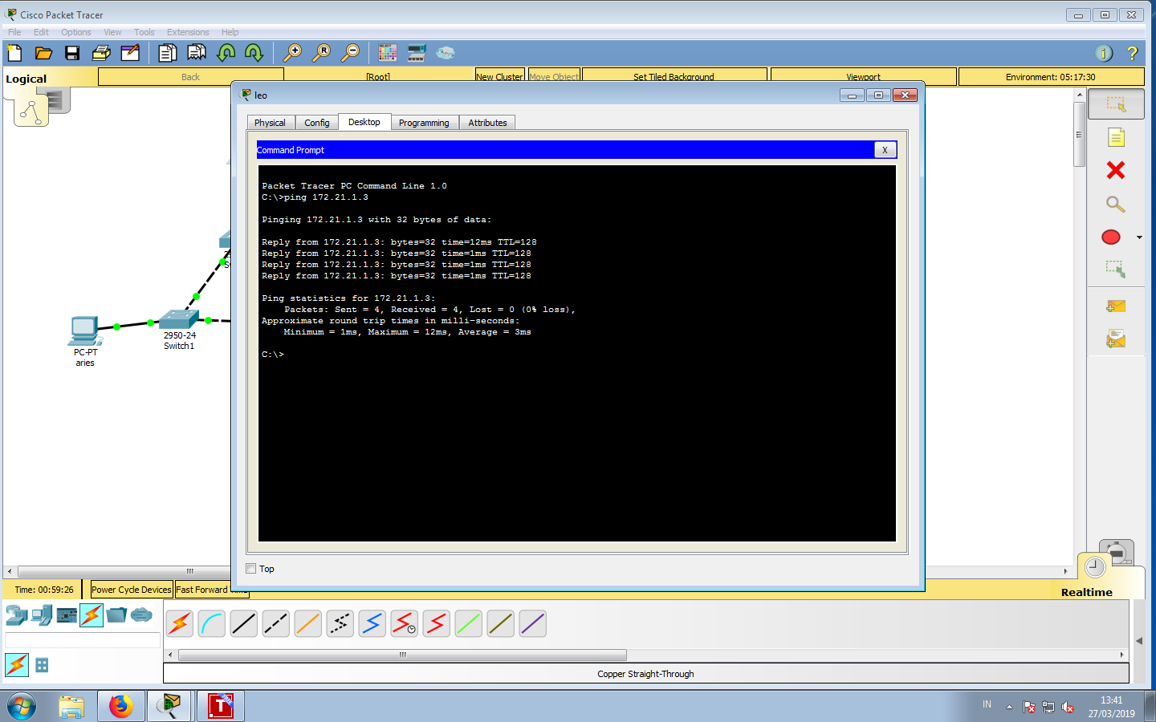

Kegiatan 2 Topologi 2

1. membuat topologi

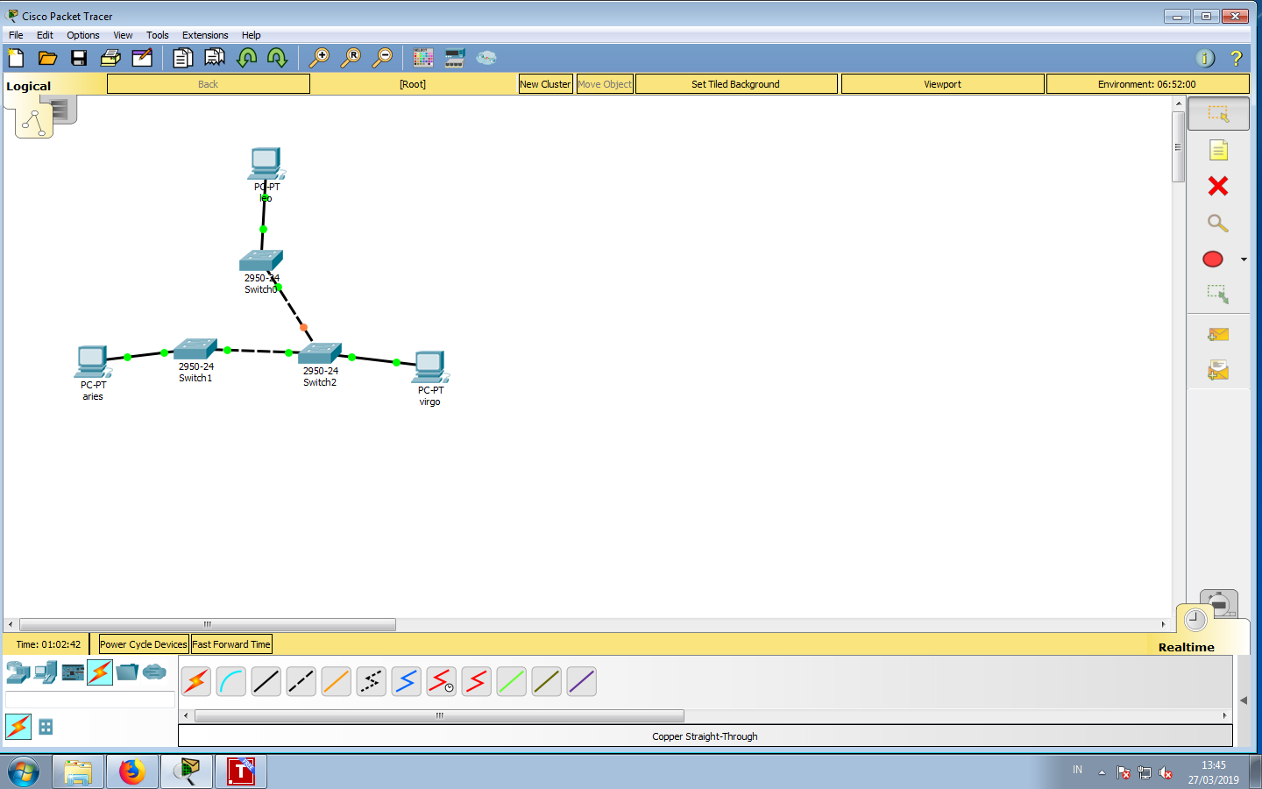

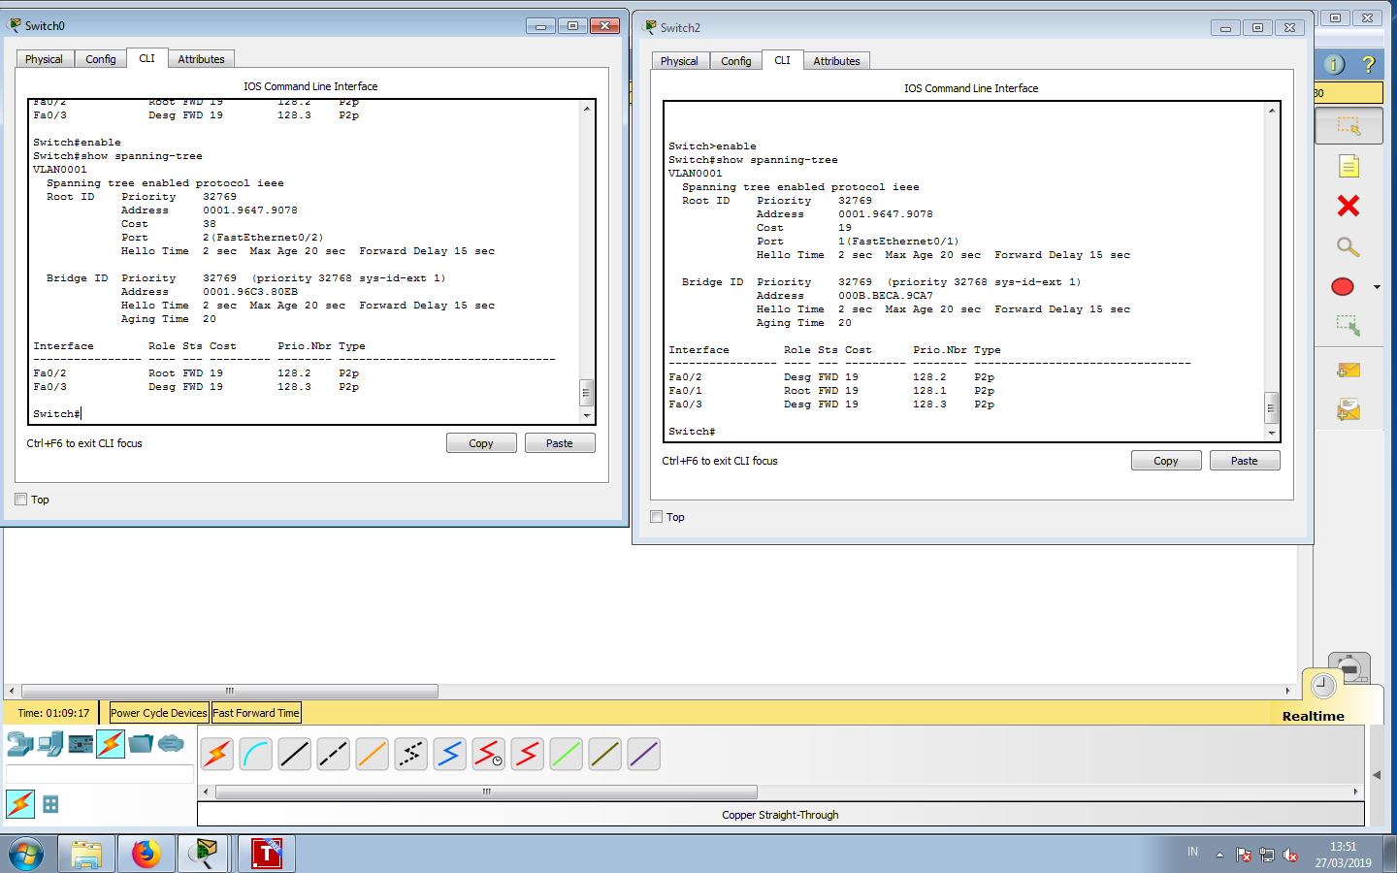

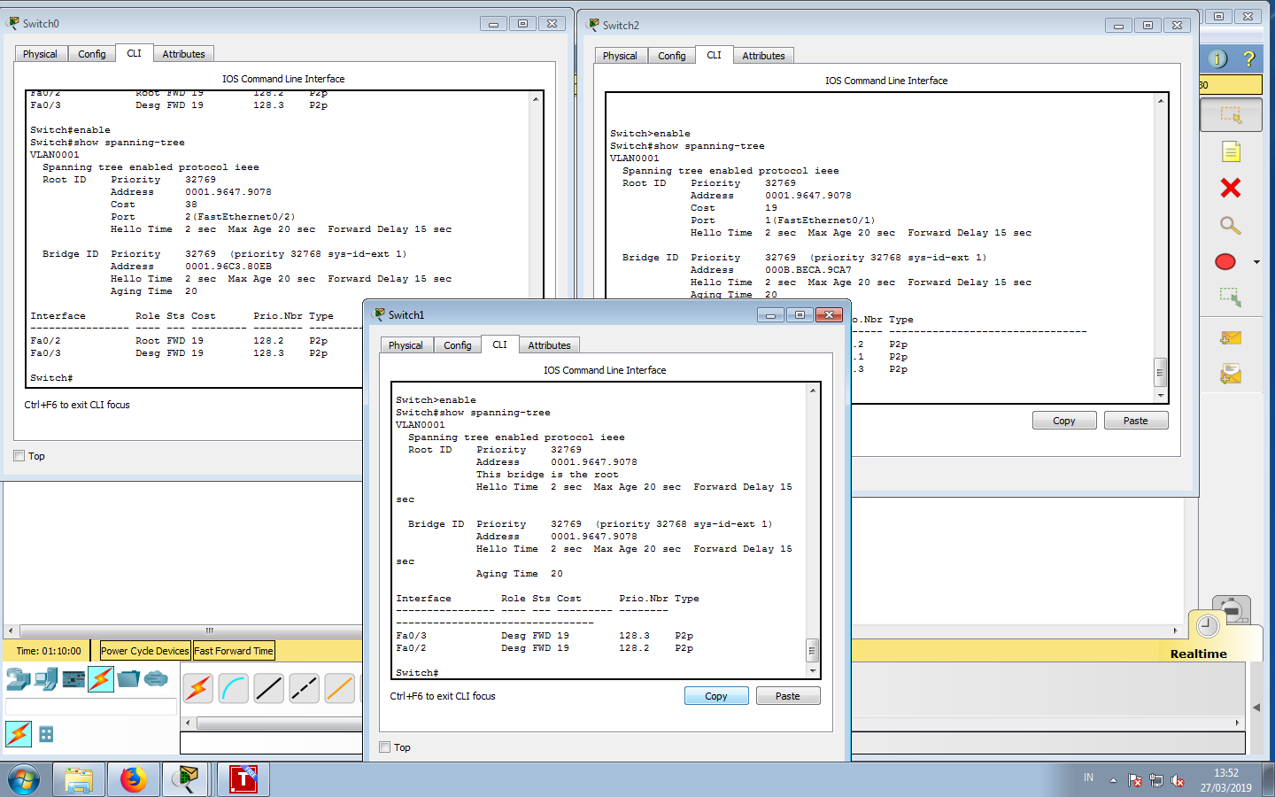

Lalu isi table tiap2 switch

-Swicth 1

|  |  |  |
| --- | --- | --- |
| no | Variable | Nilai |
| 1 | Root id | 32769, 0001.9647.9078 |
| 2 | Priotity | 32769 |
| 3 | MAC address | 0001.9647.9078 |
| 4 | Bridge id | 32769, 0001.96C3.80EB |
| 5 | Cost (0/2;0/3) | 19,19 |
| 6 | Hello time | 2 sec |
| 7 | Max Age | 20 sec |
| 8 | Forward Delay | 15 sec |

Swicth 2

|  |  |  |
| --- | --- | --- |
| no | Variable | Nilai |
| 1 | Root id | 32769, 0001.9647.9078 |
| 2 | Priotity | 32769 |
| 3 | MAC address | 0001.9647.9078 |
| 4 | Bridge id | 32769, 0001.9647.9078 |
| 5 | Cost (0/2;0/3) | 19,19 |
| 6 | Hello time | 2 sec |
| 7 | Max Age | 20 sec |
| 8 | Forward Delay | 15 sec |

-Swicth 3

|  |  |  |
| --- | --- | --- |
| no | Variable | Nilai |
| 1 | Root id | 32769, 0001.9647.9078 |
| 2 | Priotity | 32769 |
| 3 | MAC address | 0001.9647.9078 |
| 4 | Bridge id | 32769,000B.BECA.9CA7 |
| 5 | Cost (0/1;0/2;0/3) | 19,19,19 |
| 6 | Hello time | 2 sec |
| 7 | Max Age | 20 sec |
| 8 | Forward Delay | 15 sec |

Tugas 4C pada kondisi default tersebut,switch dan port mana saja yang

-Menjadi root bridge : SW2,SW1

-Menjadi designated bridge :SW2,SW1

-Menjadi root port :SW3,SW1

-Menjadi designated port :SW3

Tugas 4D pada kondisi default tersebut,dan port mana saja yang

-Berada pada keadaan forwarding :SW2,SW1

-Berada pada keadaan blocking :tidak ada

