**NAMA : JESSICA GUSTIN RAHAJENG**

**NIM / KELAS : L200170026/A**

**MODUL 6**

NO 2

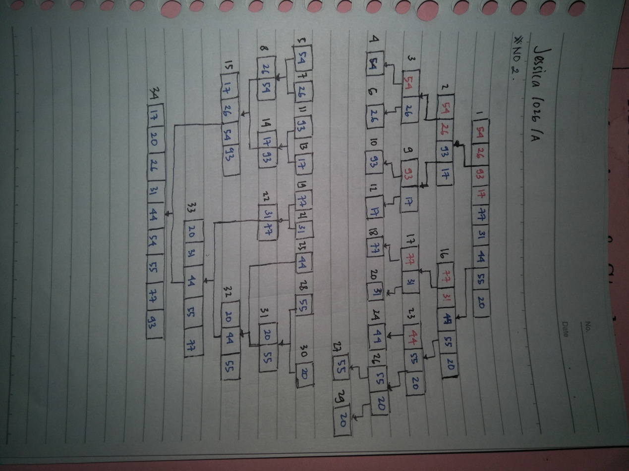

NO 4a

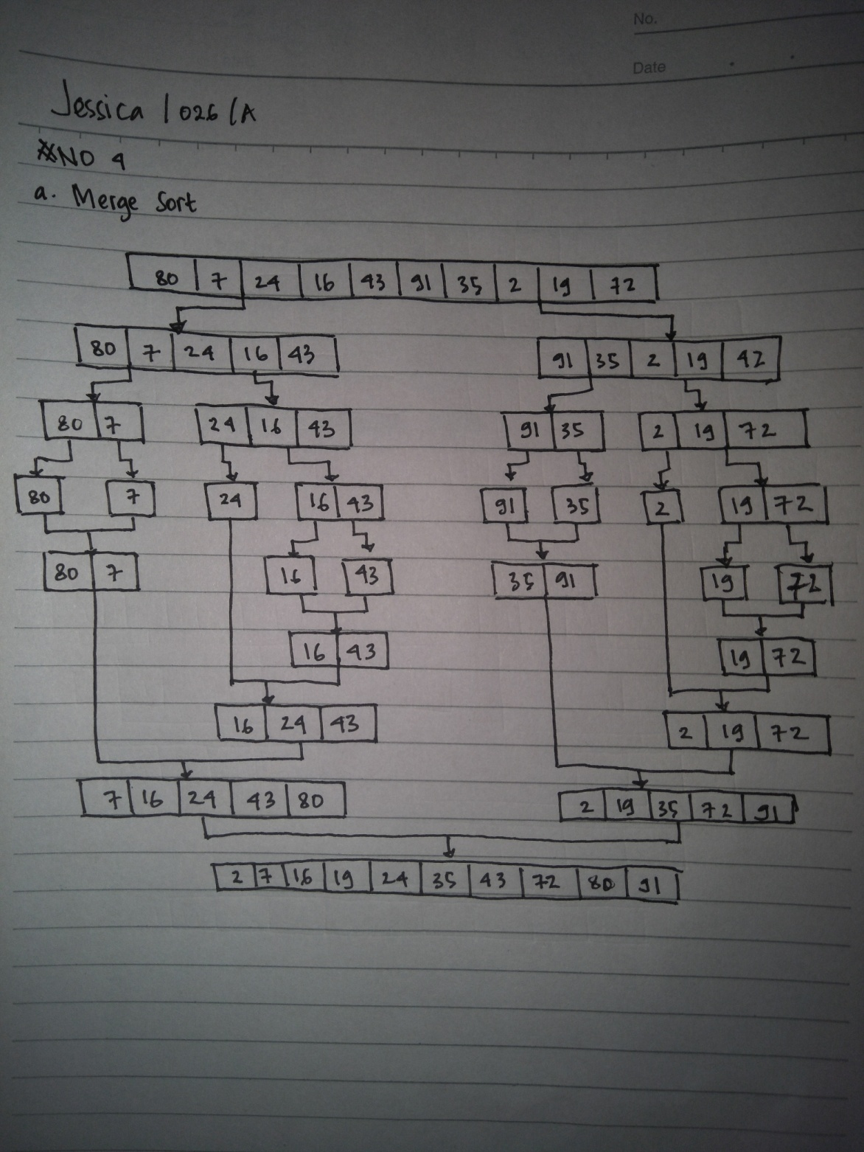

NO 4b

Quick sort

L = [80,7,24,16,43,91,35,2,19,72]

|  |  |  |  |  |  |  |  |  |  |
| --- | --- | --- | --- | --- | --- | --- | --- | --- | --- |
| 80 | 7 | 24 | 16 | 43 | 91 | 35 | 2 | 19 | 72 |

pivot

|  |  |  |  |  |  |  |  |  |  |
| --- | --- | --- | --- | --- | --- | --- | --- | --- | --- |
| 80 | 7 | 24 | 16 | 43 | 91 | 35 | 2 | 19 | 72 |

Low High

pivot

|  |  |  |  |  |  |  |  |  |  |
| --- | --- | --- | --- | --- | --- | --- | --- | --- | --- |
| 72 | 7 | 24 | 16 | 43 | 91 | 35 | 2 | 19 | 80 |

Low High

pivot

|  |  |  |  |  |  |  |  |  |  |
| --- | --- | --- | --- | --- | --- | --- | --- | --- | --- |
| 72 | 7 | 24 | 16 | 43 | 91 | 35 | 2 | 19 | 80 |

Low High

pivot

|  |  |  |  |  |  |  |  |  |  |
| --- | --- | --- | --- | --- | --- | --- | --- | --- | --- |
| 72 | 7 | 24 | 16 | 43 | 80 | 35 | 2 | 19 | 91 |

Low High

pivot

|  |  |  |  |  |  |  |  |  |  |
| --- | --- | --- | --- | --- | --- | --- | --- | --- | --- |
| 72 | 7 | 24 | 16 | 43 | 19 | 35 | 2 | 80 | 91 |

Low High

pivot

|  |  |  |  |  |  |  |  |  |  |
| --- | --- | --- | --- | --- | --- | --- | --- | --- | --- |
| 72 | 7 | 24 | 16 | 43 | 19 | 35 | 2 | 80 | 91 |

Low High

pivot

|  |  |  |  |  |  |  |  |  |  |
| --- | --- | --- | --- | --- | --- | --- | --- | --- | --- |
| 2 | 7 | 24 | 16 | 43 | 19 | 35 | 72 | 80 | 91 |

Low High

pivot

|  |  |  |  |  |  |  |  |  |  |
| --- | --- | --- | --- | --- | --- | --- | --- | --- | --- |
| 2 | 7 | 24 | 16 | 43 | 19 | 35 | 72 | 80 | 91 |

Low High

pivot

|  |  |  |  |  |  |  |  |  |  |
| --- | --- | --- | --- | --- | --- | --- | --- | --- | --- |
| 2 | 7 | 24 | 16 | 43 | 19 | 35 | 72 | 80 | 91 |

Low High

pivot

|  |  |  |  |  |  |  |  |  |  |
| --- | --- | --- | --- | --- | --- | --- | --- | --- | --- |
| 2 | 7 | 24 | 16 | 43 | 19 | 35 | 72 | 80 | 91 |

Low High

pivot

|  |  |  |  |  |  |  |  |  |  |
| --- | --- | --- | --- | --- | --- | --- | --- | --- | --- |
| 2 | 7 | 24 | 16 | 43 | 19 | 35 | 72 | 80 | 91 |

Low High

pivot

|  |  |  |  |  |  |  |  |  |  |
| --- | --- | --- | --- | --- | --- | --- | --- | --- | --- |
| 2 | 7 | 24 | 16 | 43 | 19 | 35 | 72 | 80 | 91 |

Low High

pivot

|  |  |  |  |  |  |  |  |  |  |
| --- | --- | --- | --- | --- | --- | --- | --- | --- | --- |
| 2 | 7 | 19 | 16 | 43 | 24 | 35 | 72 | 80 | 91 |

Low High

pivot

|  |  |  |  |  |  |  |  |  |  |
| --- | --- | --- | --- | --- | --- | --- | --- | --- | --- |
| 2 | 7 | 19 | 16 | 43 | 24 | 35 | 72 | 80 | 91 |

Low High

pivot

|  |  |  |  |  |  |  |  |  |  |
| --- | --- | --- | --- | --- | --- | --- | --- | --- | --- |
| 2 | 7 | 19 | 16 | 24 | 43 | 35 | 72 | 80 | 91 |

Low High

pivot

|  |  |  |  |  |  |  |  |  |  |
| --- | --- | --- | --- | --- | --- | --- | --- | --- | --- |
| 2 | 7 | 19 | 16 | 24 | 43 | 35 | 72 | 80 | 91 |

Low High

pivot

|  |  |  |  |  |  |  |  |  |  |
| --- | --- | --- | --- | --- | --- | --- | --- | --- | --- |
| 2 | 7 | 16 | 19 | 24 | 35 | 43 | 72 | 80 | 91 |

Low High

|  |  |  |  |  |  |  |  |  |  |
| --- | --- | --- | --- | --- | --- | --- | --- | --- | --- |
| 2 | 7 | 16 | 19 | 24 | 35 | 43 | 72 | 80 | 91 |