**Nama : Rendra Rizki Kurniawan**

**NIM : L200170027**

**Kelas : A**

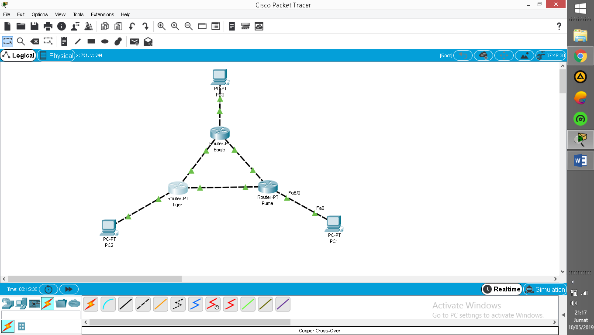

**Konfigurasi Router Eagle**

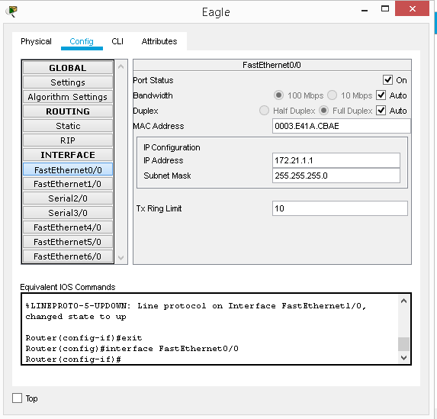

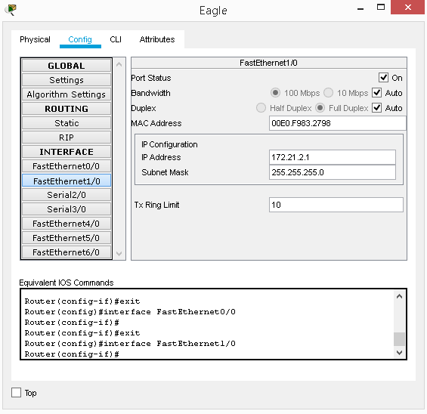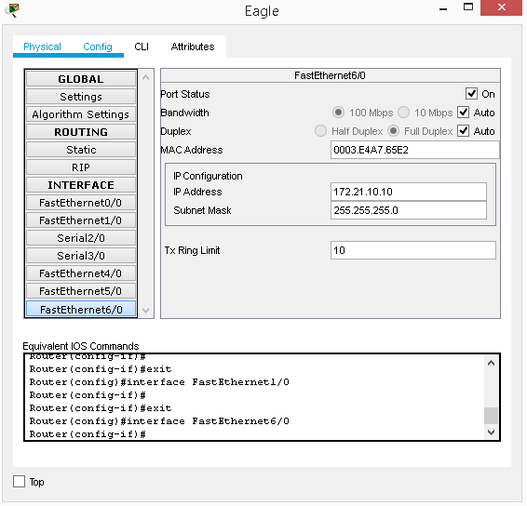

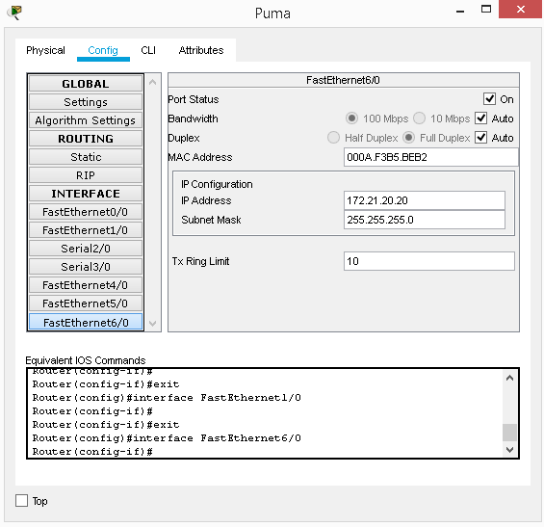**Konfigurasi Router Puma**

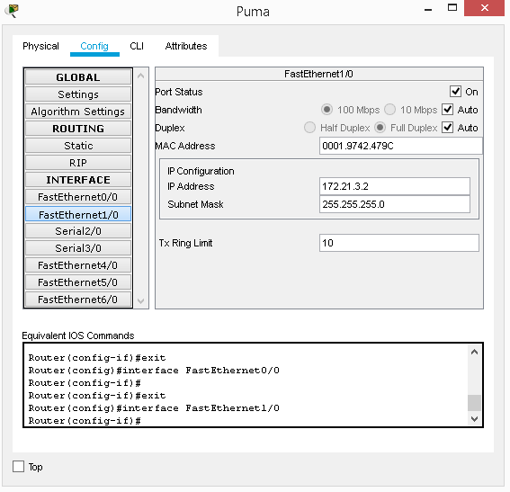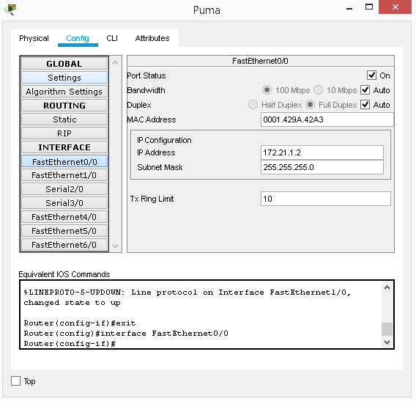

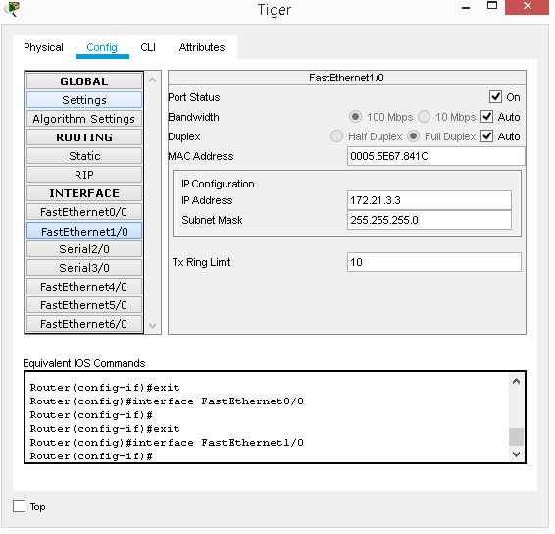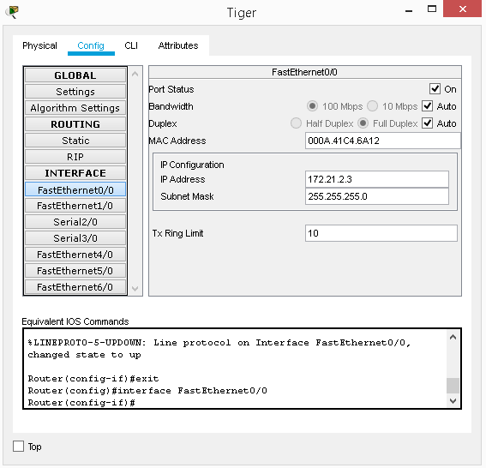 **Konfigurasi Router Tiger**

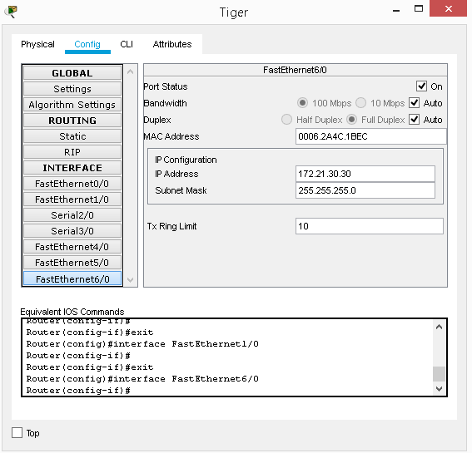

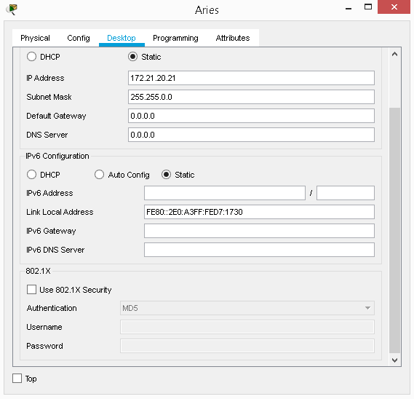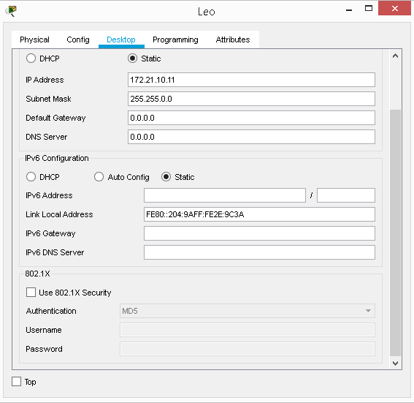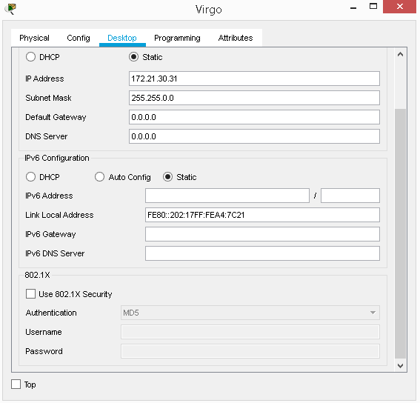**Konfigurasi IP di PC**

**Ping PC Leo ke Router Eagle (172.21.1.1)**

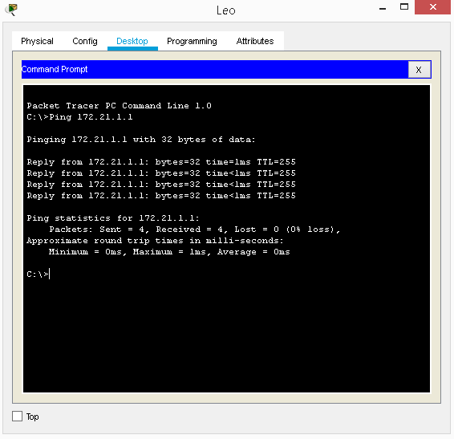

* **Ping PC Aries ke Router Puma (172.21.1.2)**

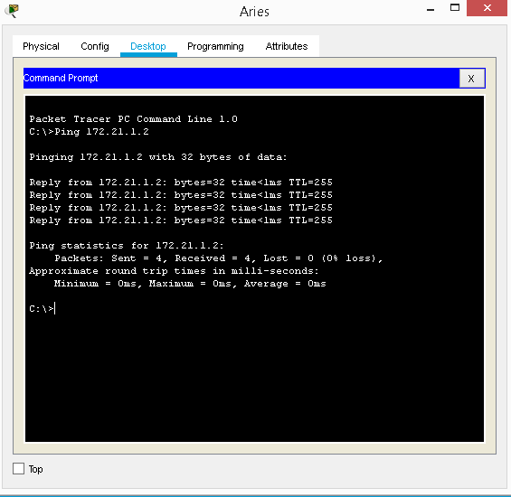

* **Ping PC Virgo ke Router Tiger (172.21.3.3)**

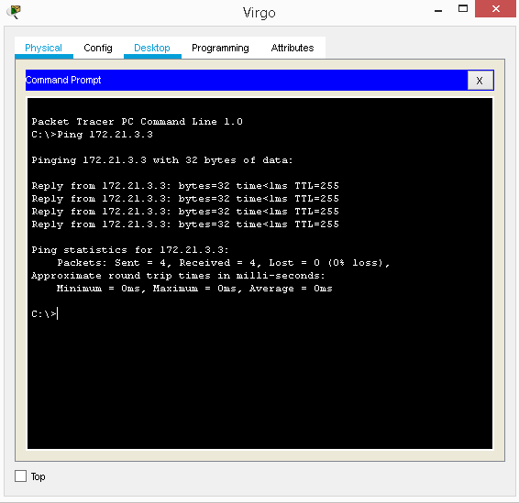

* **Ping Router Eagle ke Router Puma**

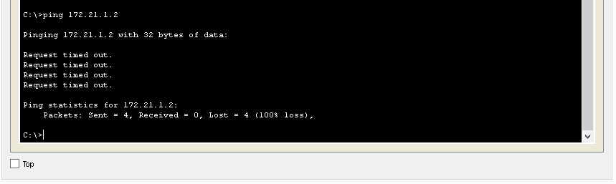

* **Ping Router Eagle ke Router Tiger**

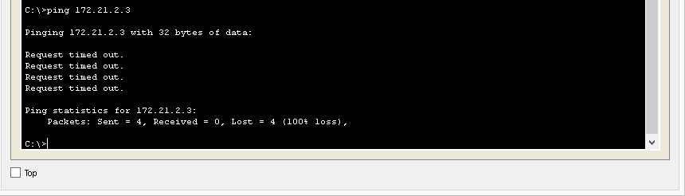

* **Ping Router Puma ke Router Tiger**