M. Salman Alfarisi

L200170031 / Kelas : B

**MODUL09**

**Percobaan 1 (Session)**

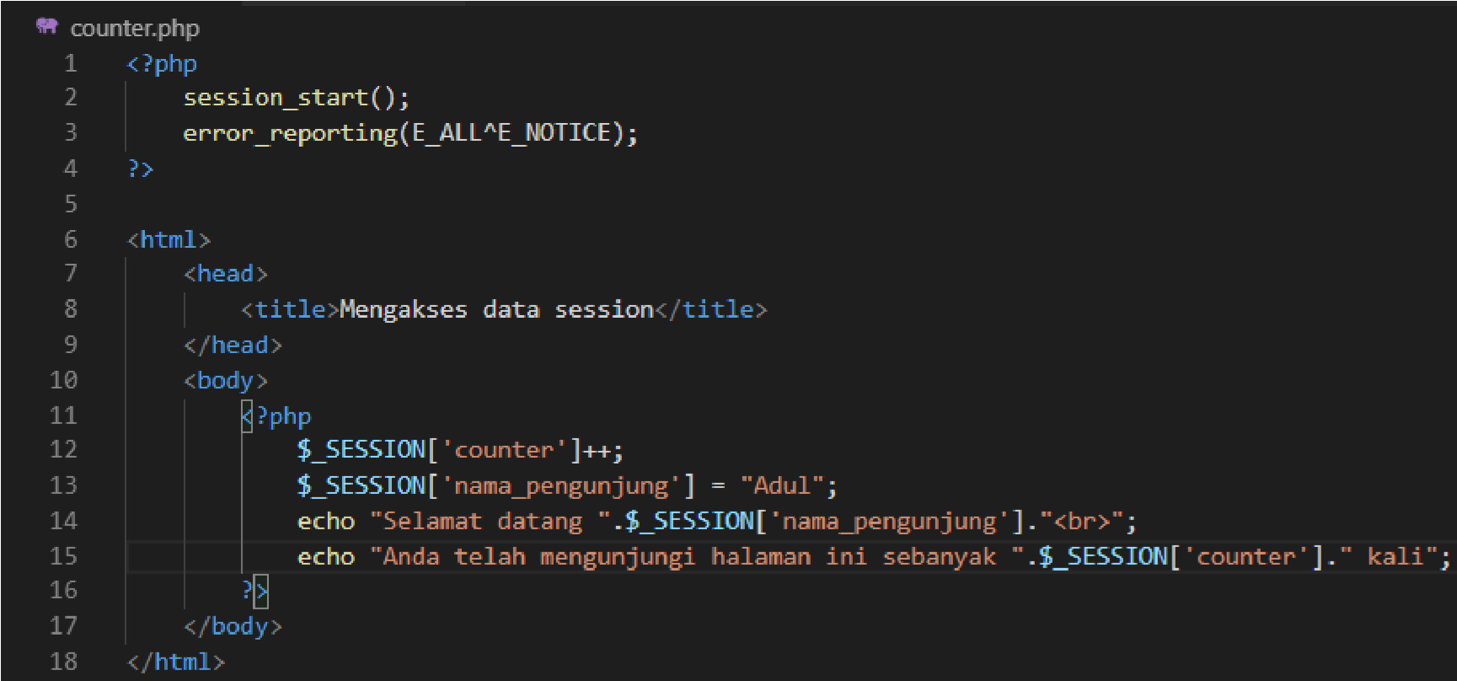

**Percobaa 2 (Session Destroy)**

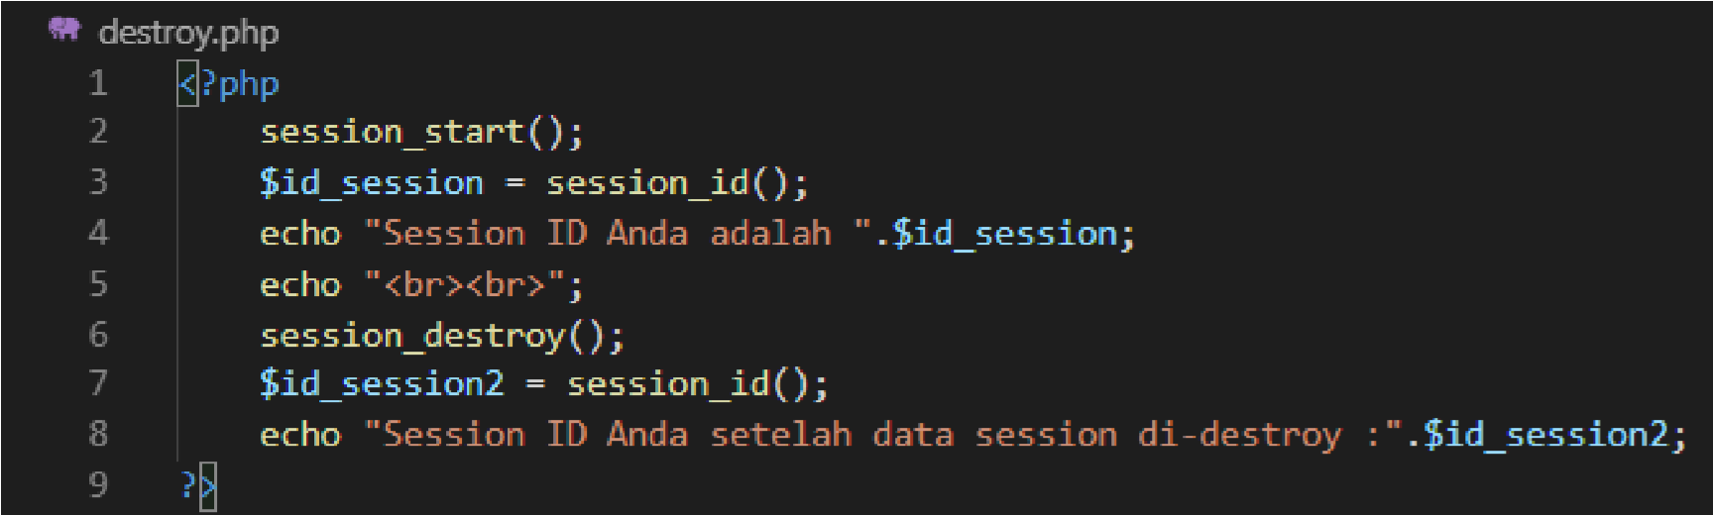

**Percobaan 3 (Login)**

.

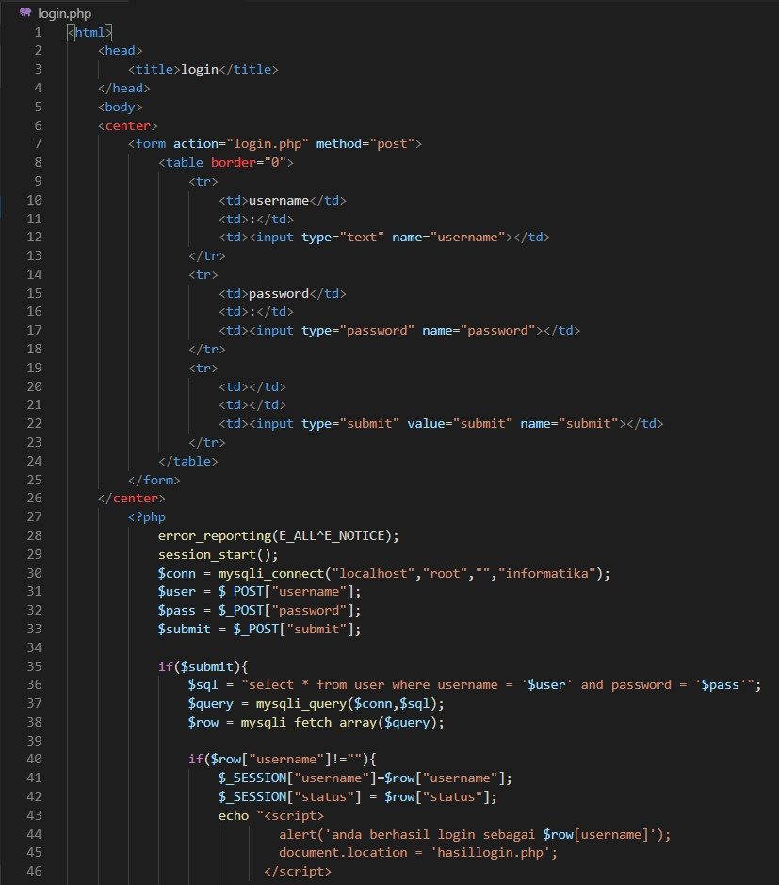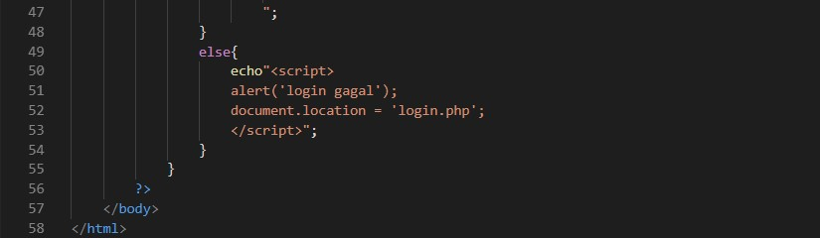

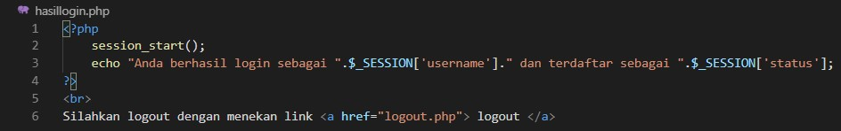

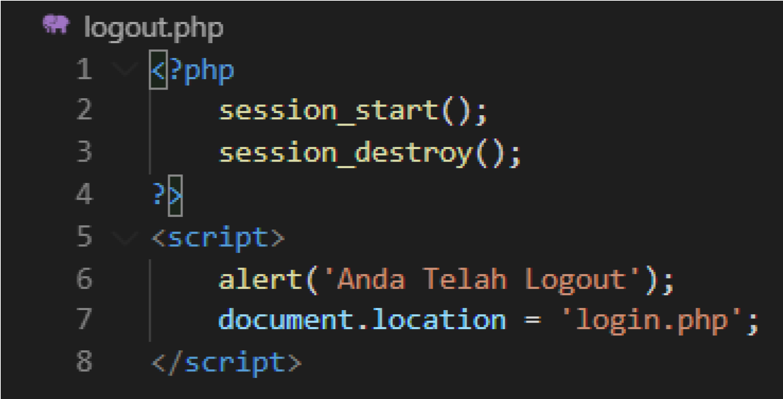

Laman login

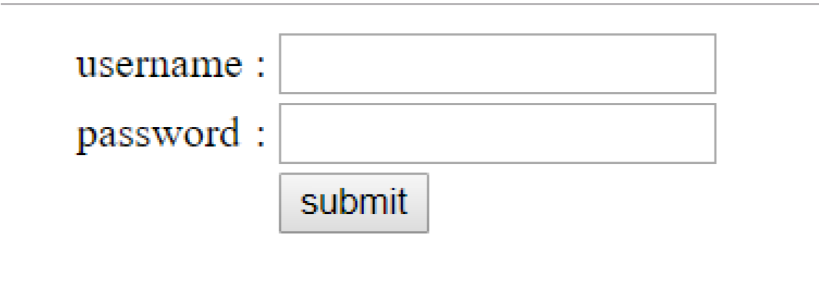

* + Laman hasil login

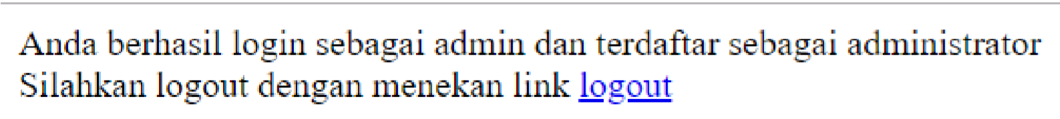

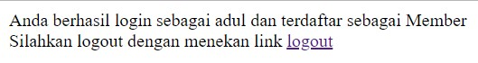

* + Logout

