M. Salman Alfarisi

L200170031

MODUL 10

1. SVD
2. Nilai Eigenvalue

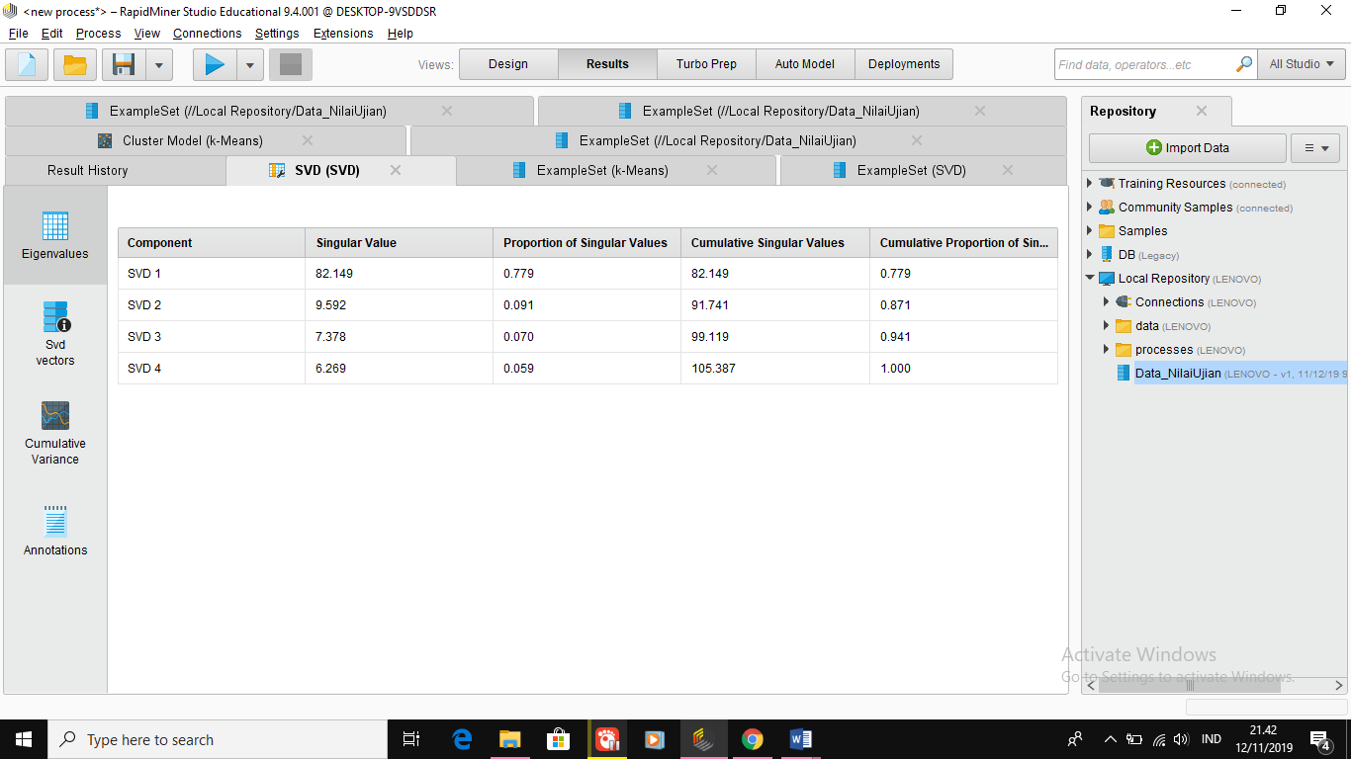

ii. Nilai SVD Vectors

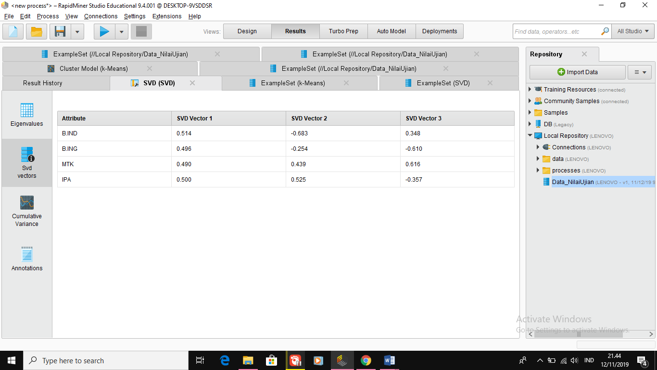

iii. Nilai Cumulative variance

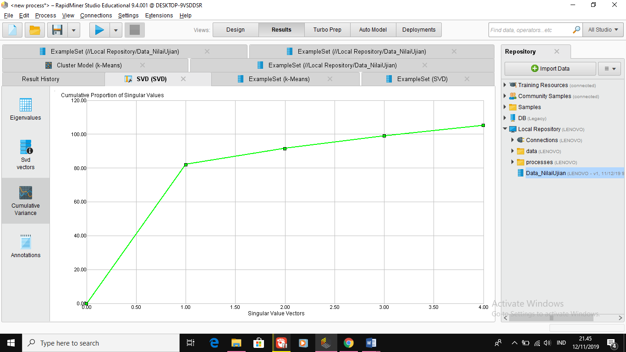

Plotter = Scatter

x-Axis = cluster

y-Axis = B.IND, B.ING, MTK, IPA

color Column = cluster

Jitter = bias di ubah-ubah untuk melihat distribusi data secara lebih detil

1. ExampleSet (SVD)

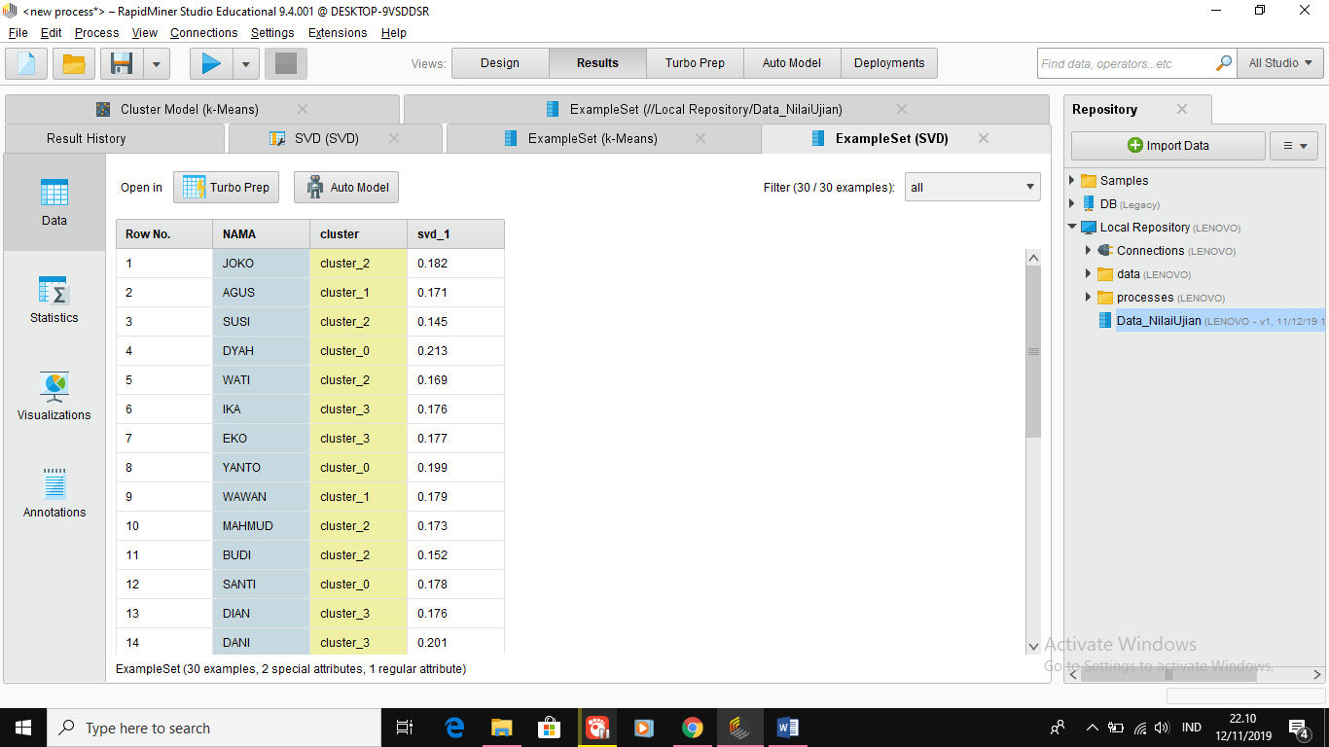

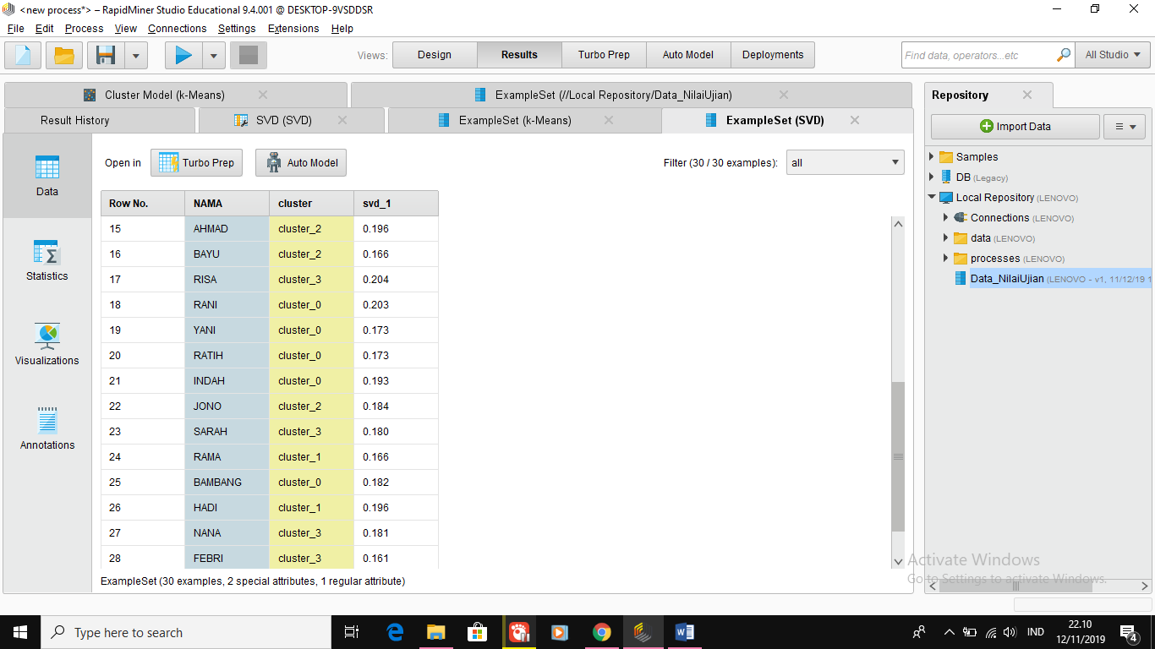

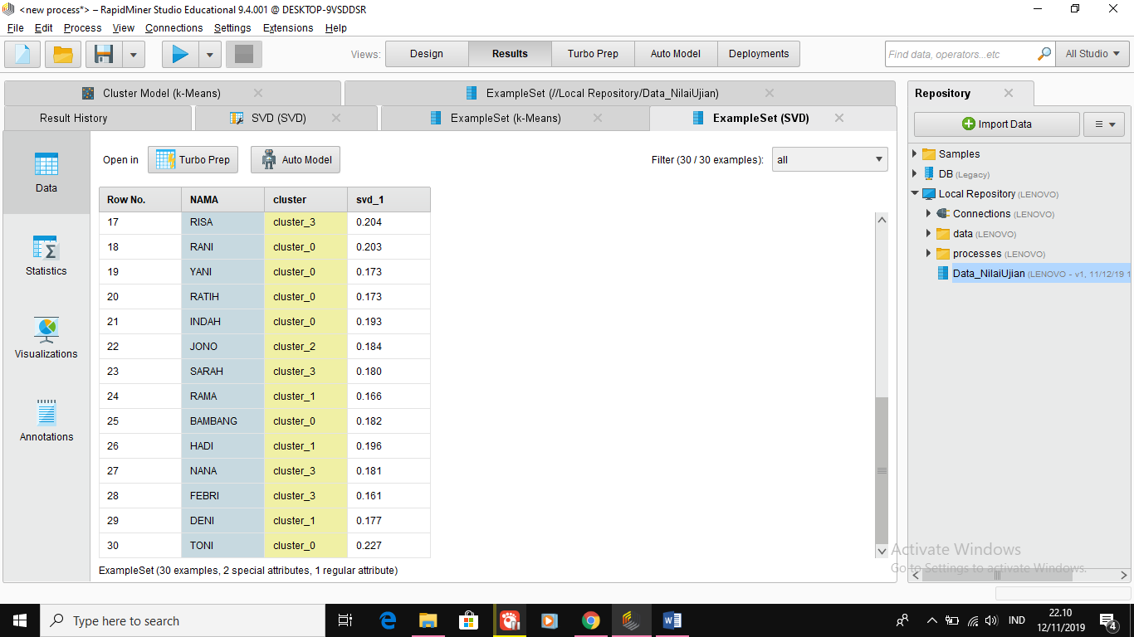

1. Cluster Model (Clustering)

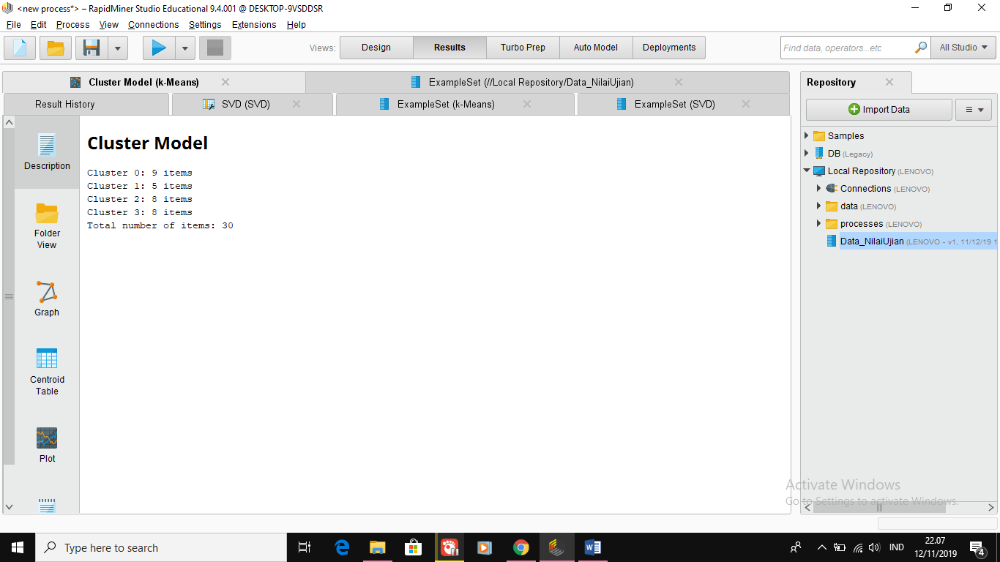

3.

Cluster 0

-Dyah

-Yanto

-Santi

-Rani

-Yani

-Ratih

-Indah

-Bambang

-Toni

Cluster 1

-Agus

-Wawan

-Rama

-Hadi

-Deni

Cluster 2

-Joko

-Susi

-Wati

-Mahmud

-Budi

-Ahmad

-Bayu

-Jono

Cluster 3

-Eka

-Eko

-Dian

-Dani

-Risa

-Sarah

-Nana