UAS PRAKTIKUM JARINGAN KOMPUTER

Nama : Malvin Iqbal Firdaus  
NIM : L200170035  
Kelas : A

No.1

*Membuat topologi jaringan sebagai berikut:*

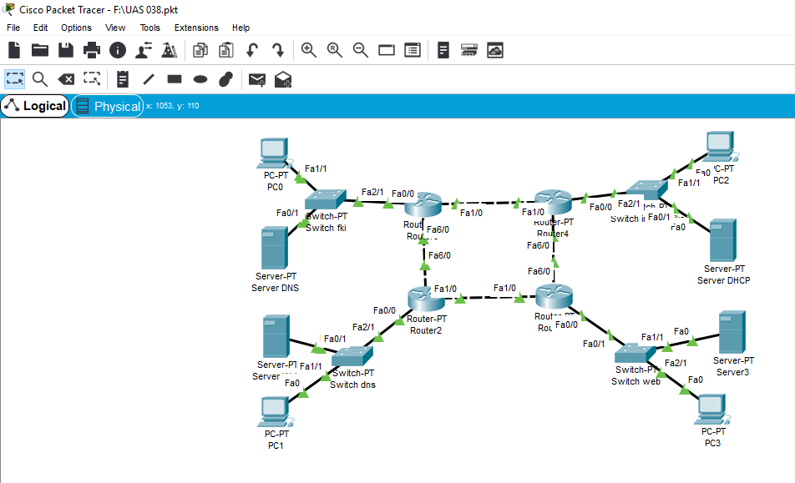

No.2

*Konfigursi pengalamatan ip(sesuai gambar diatas(no.1))*

a)

|  |  |  |  |  |
| --- | --- | --- | --- | --- |
| Router 0 | Server DNS |  | PC 0 |  |
| SE 2/0 (ip add 192.168.5.1) | Ip add 192.168.1.2 |  | Ip add 192.168.1.3 |  |
| SE 3/0 (ip add 192.168.8.2) |  |  |  |  |
| Fa 0/0 (ip add 192.168.1.1) |  |  |  |  |
| b) |  |  |  |  |
| Router 1 | Server DHCP |  | PC 2 |  |
| SE 2/0 (ip add 192.168.6.1) | Ip add 192.168.2.2 |  | Otomatis sesuai pengaturan |  |
| SE 3/0 (ip add 192.168.5.2) |  |  | dhcp yang dibuat |  |
| Fa 0/0 (ip add 192.168.2.1) |  |  | (ip add 192.168.2.3) |  |
| c) |  |  |  |  |
| Router 2 | Server3 |  | PC 3 |  |
| SE 2/0 (ip add 192.168.7.1) | Ip add 192.168.3.2 |  | Ip add 192.168.3.3 |  |
| SE 3/0 (ip add 192.168.6.2) |  |  |  |  |
| Fa 0/0 (ip add 192.168.3.1) |  |  |  |  |
| d) |  |  |  |  |
| Router 3 | Server Web |  | PC 1 |  |
| SE 2/0 (ip add 192.168.8.1) | Ip add 192.168.4.2 |  | Ip add 192.168.4.3 |  |
| SE 3/0 (ip add 192.168.7.2) |  |  |  |  |
| Fa 0/0 (ip add 192.168.4.1) |  |  |  |  |

Test no.2

* DNS server

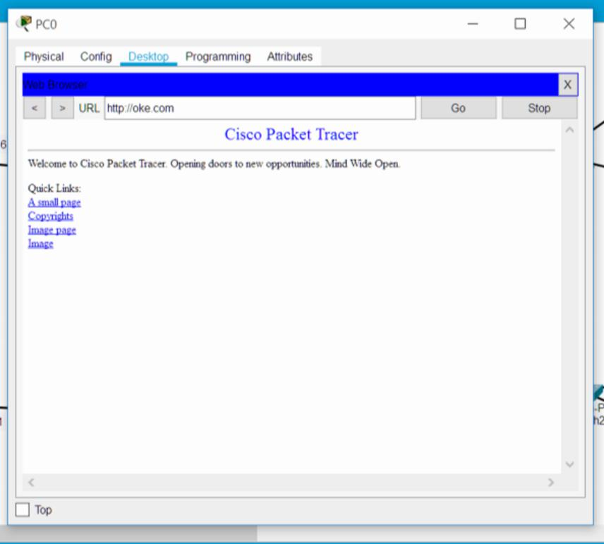

* DHCP Server

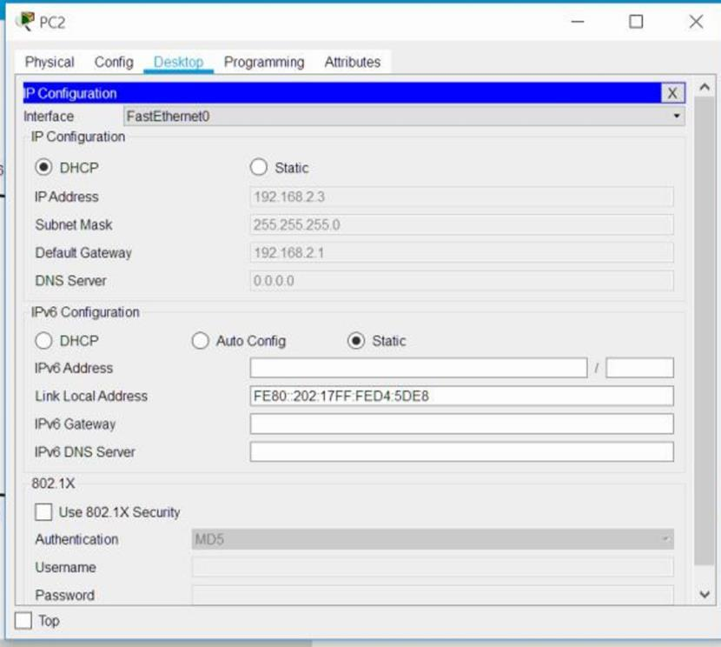

* Server3

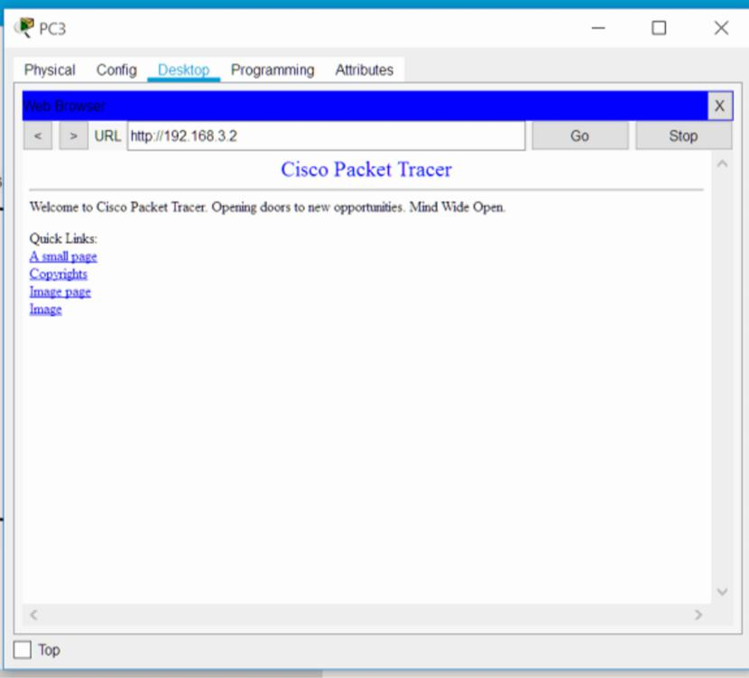

* Server Web

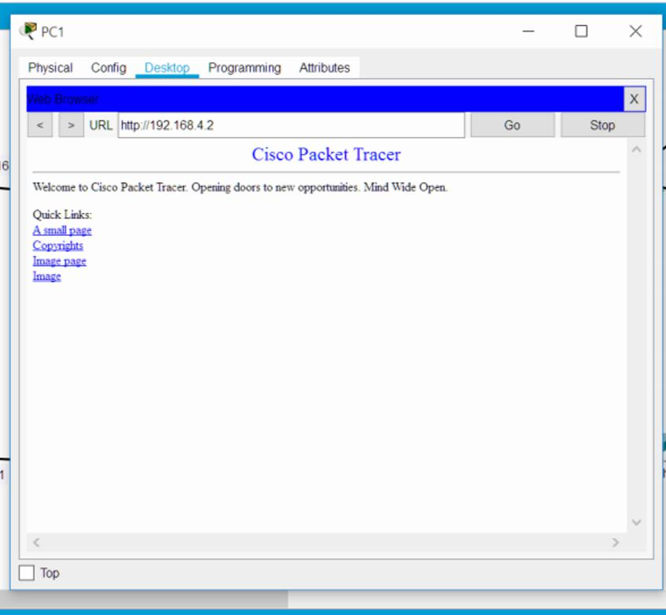

No.3

Konfigurasi routing dinamis

a)router 0

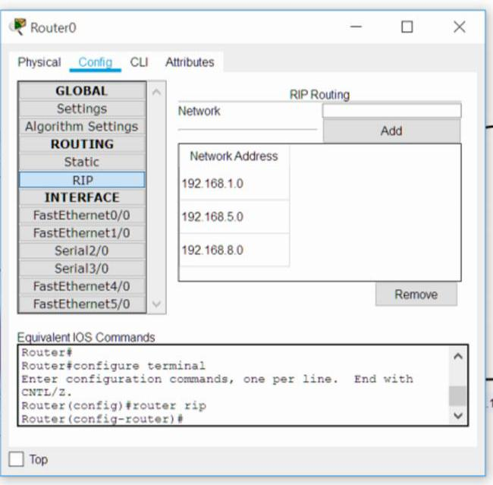

b)router 1

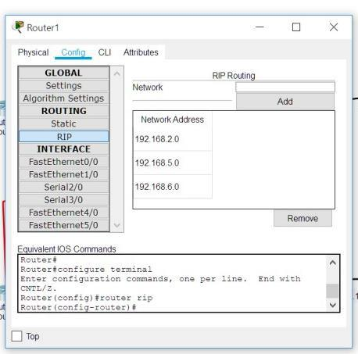

c)router 2

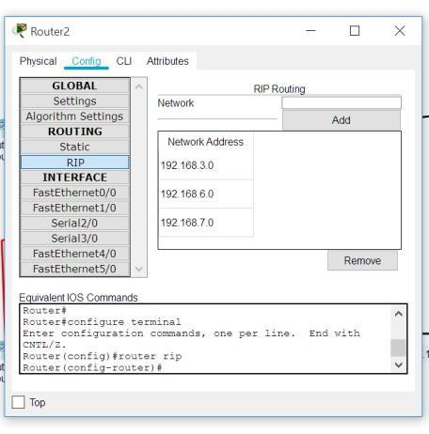

d)router 3

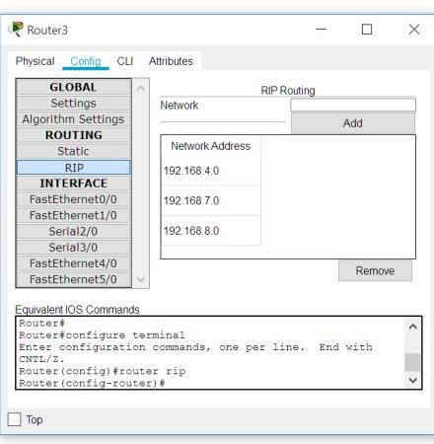

* Test no.3 router dinamis (uji konektivitas antar PC)

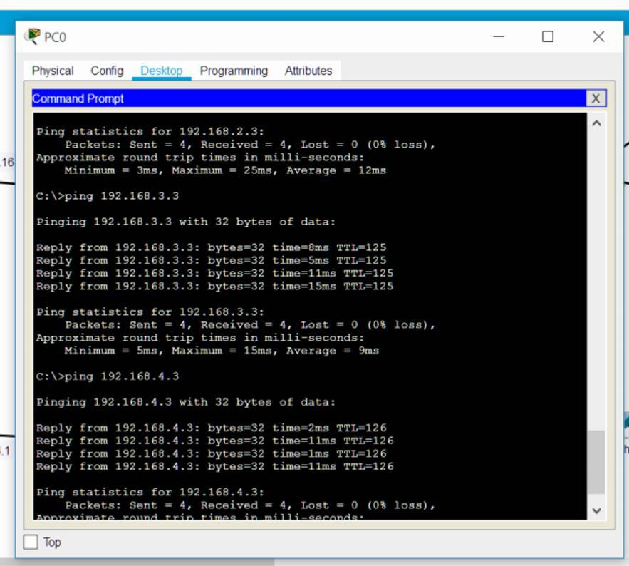

* Test no.3 router dinamis (uji konektivitas PC ke server antar router)

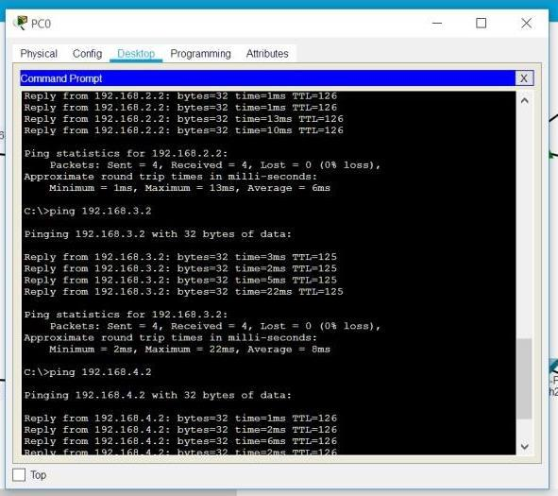

No.4

Konfigurasi router statis

a)router 0

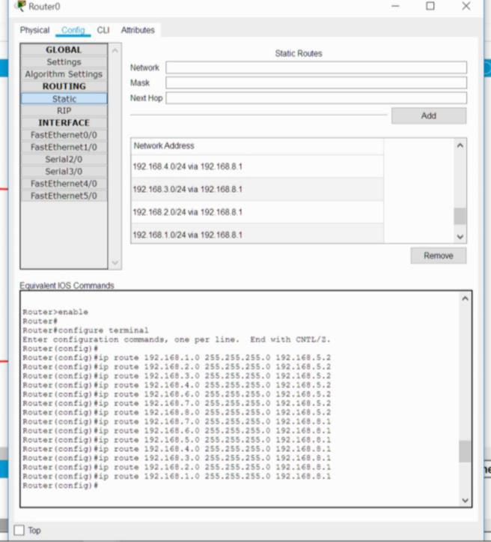

b)router 1

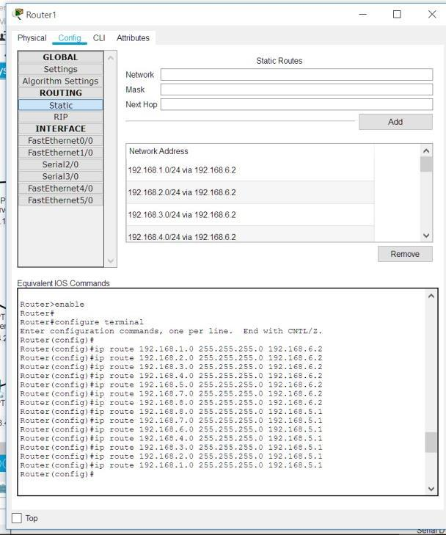

c)router 2

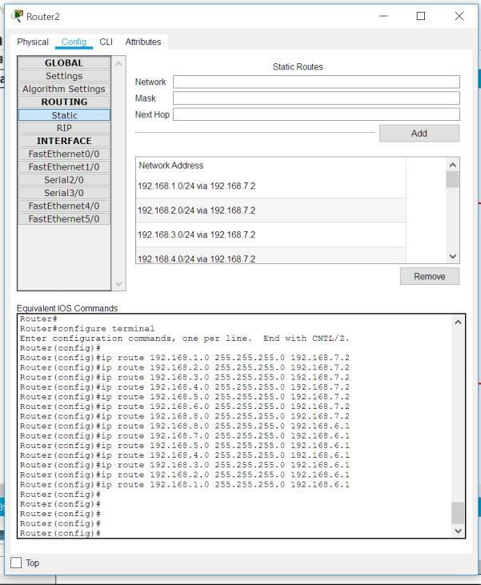

c)router 3

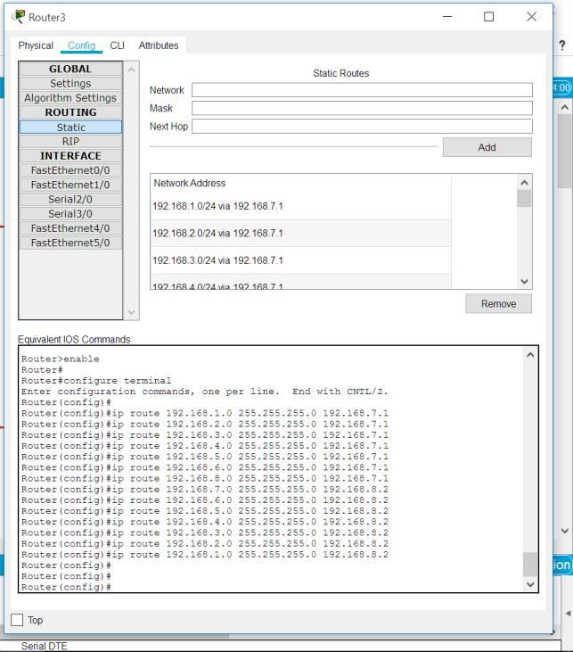

* Test no.4 router statis(uji konektivitas antar PC)

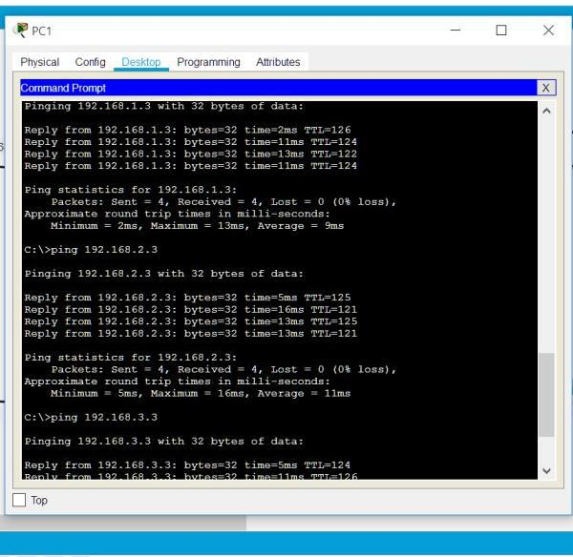

* *Test no.4 router statis (uji konektivitas PC ke server antar router)*

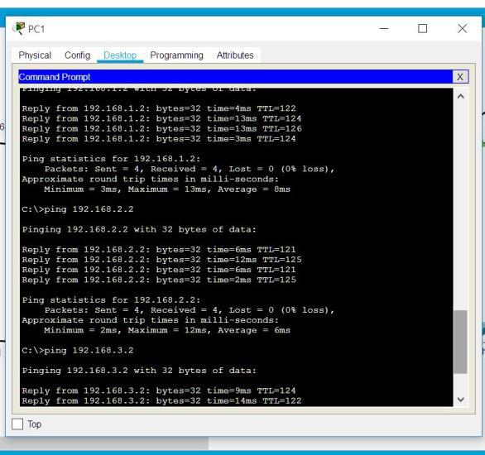

No.5

*Menggunkan access list untuk membatasi 1 PC saja yang dapat mengakses server web*

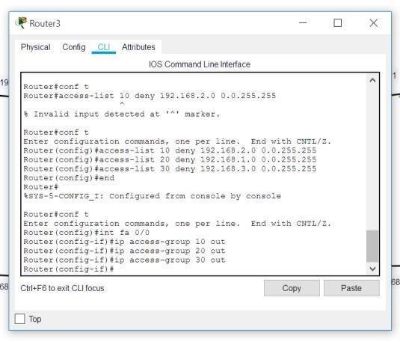

a)Test akses dengan PC 0

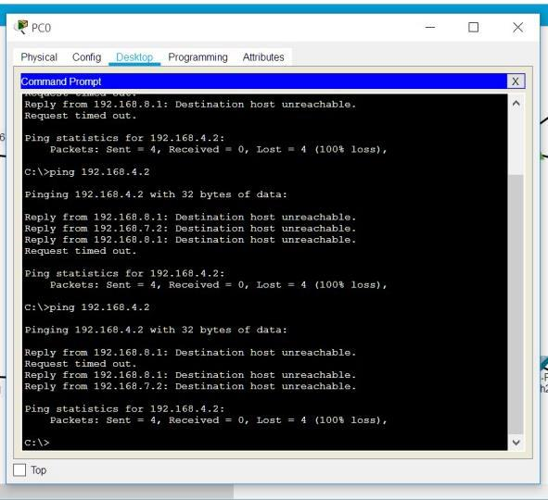

b) Test akses dengan PC 2

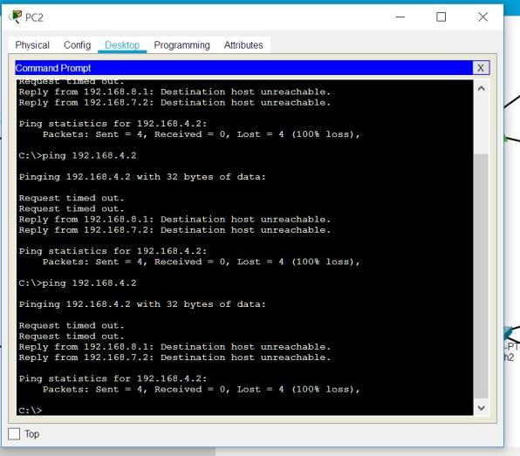

c) Test akses dengan PC 3

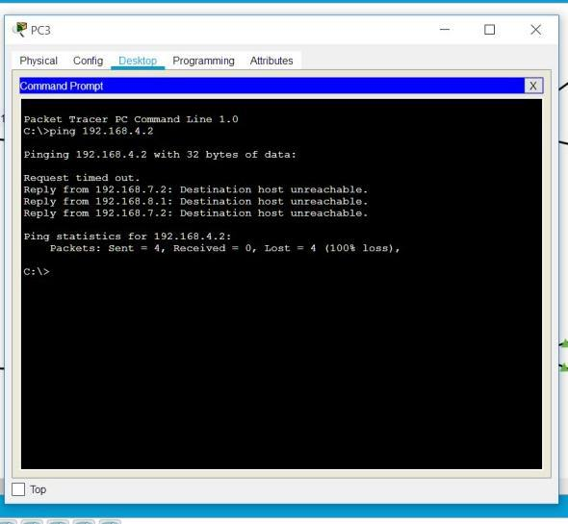

d) Test akses dengan PC 1

