**UAS PRAKTIKUM JARINGAN KOMPUTER**

**NAMA : AL ADIAT RUSSETYA TAMORA**

**NIM : L200170037**

**KELAS : A**

# No.1

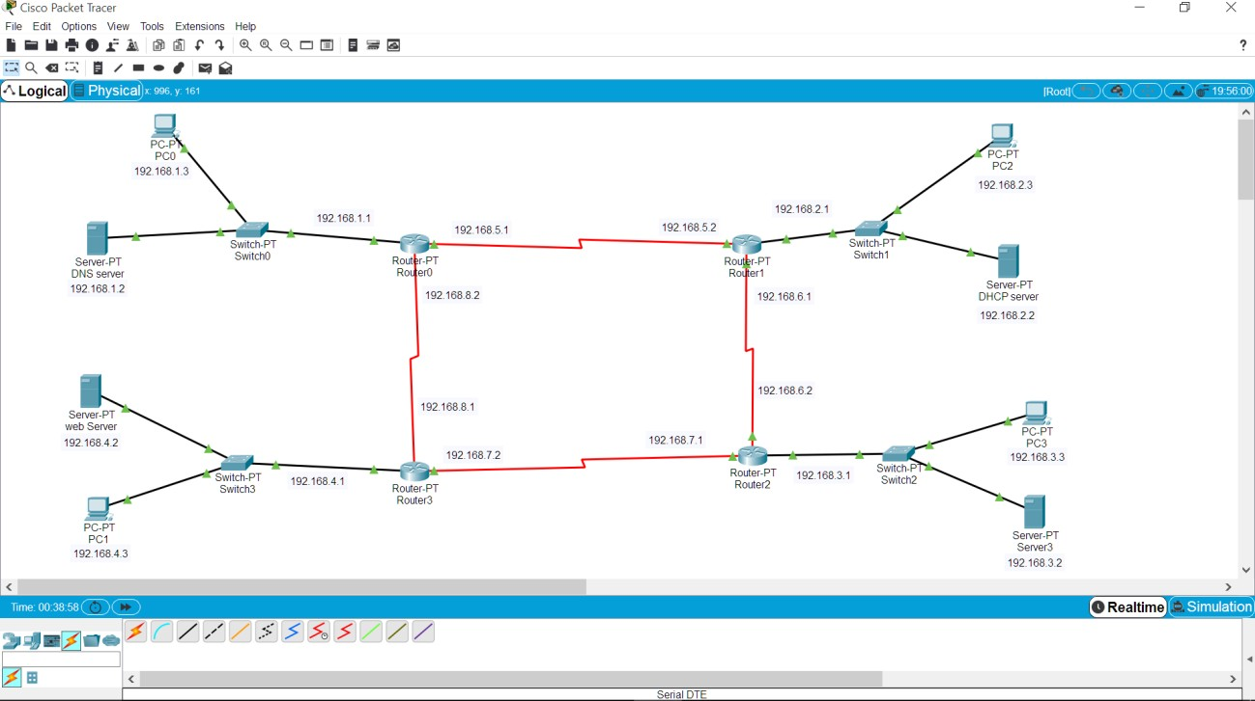Membuat topologi jaringan sebagai berikut:

# No.2

Konfigursi pengalamatan ip(sesuai gambar diatas(no.1))

# a)

|  |  |  |
| --- | --- | --- |
| Router 0 | Server DNS | PC 0 |
| SE 2/0 (ip add 192.168.5.1) | Ip add 192.168.1.2 | Ip add 192.168.1.3 |
| SE 3/0 (ip add 192.168.8.2) |
| Fa 0/0 (ip add 192.168.1.1) |

b)

|  |  |  |
| --- | --- | --- |
| Router 1 | Server DHCP | PC 2 |
| SE 2/0 (ip add 192.168.6.1) | Ip add 192.168.2.2 | Otomatis sesuai pengaturan dhcp yang dibuat  (ip add 192.168.2.3) |
| SE 3/0 (ip add 192.168.5.2) |
| Fa 0/0 (ip add 192.168.2.1) |

c)

|  |  |  |
| --- | --- | --- |
| Router 2 | Server3 | PC 3 |
| SE 2/0 (ip add 192.168.7.1) | Ip add 192.168.3.2 | Ip add 192.168.3.3 |
| SE 3/0 (ip add 192.168.6.2) |
| Fa 0/0 (ip add 192.168.3.1) |

d)

|  |  |  |
| --- | --- | --- |
| Router 3 | Server Web | PC 1 |
| SE 2/0 (ip add 192.168.8.1) | Ip add 192.168.4.2 | Ip add 192.168.4.3 |
| SE 3/0 (ip add 192.168.7.2) |
| Fa 0/0 (ip add 192.168.4.1) |

Test no.2

# DNS server

* DHCP Server

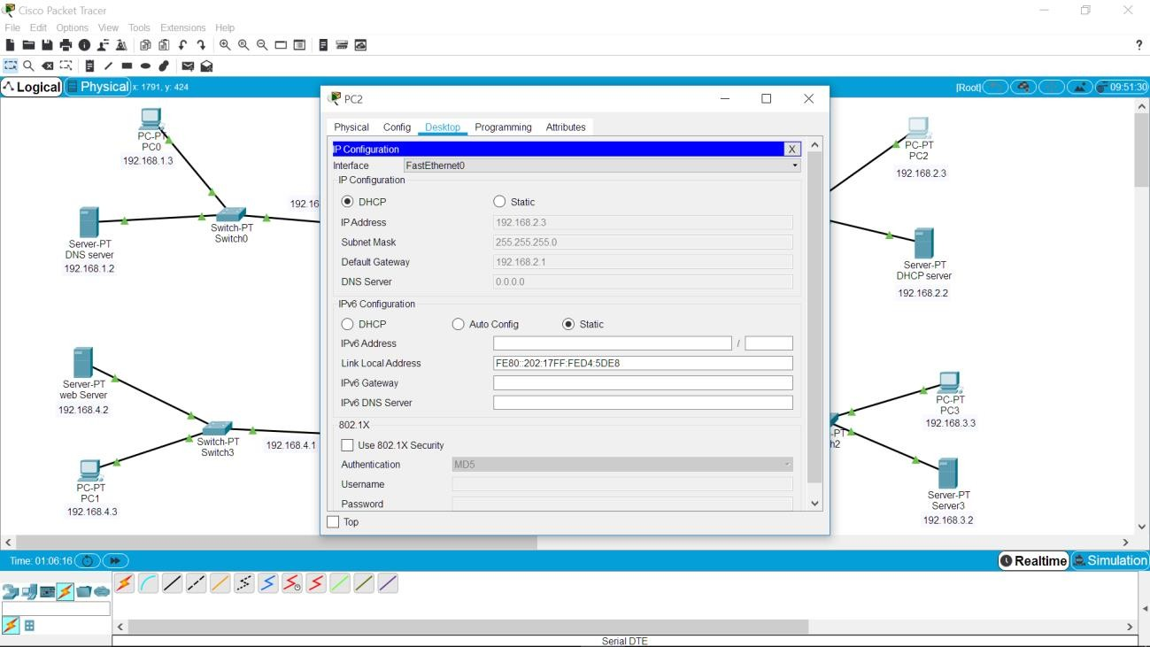

* 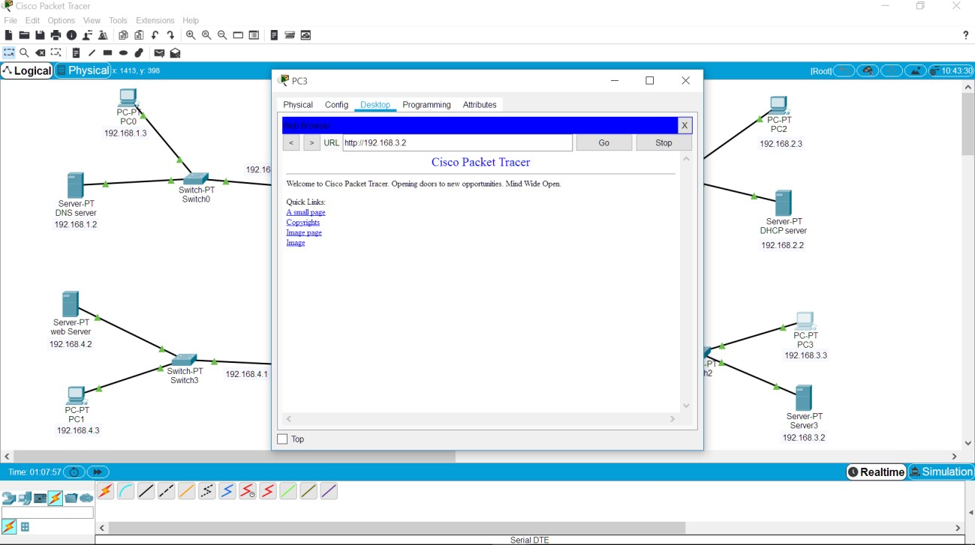Server3
* Server Web

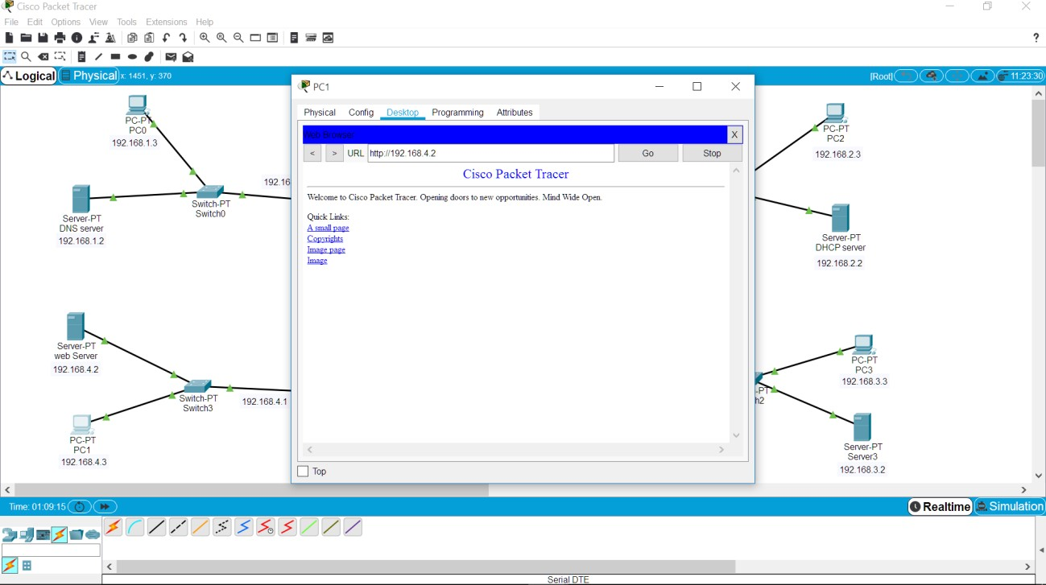

No.3

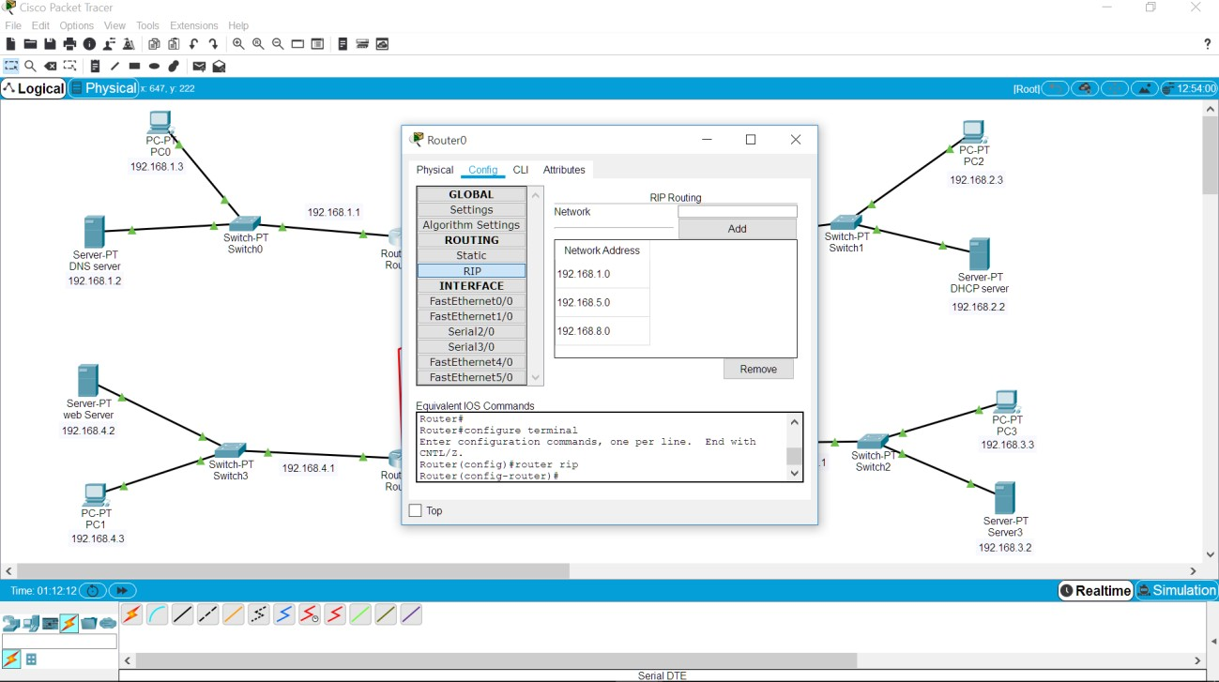Konfigurasi routing dinamis a)router 0

1. router 1

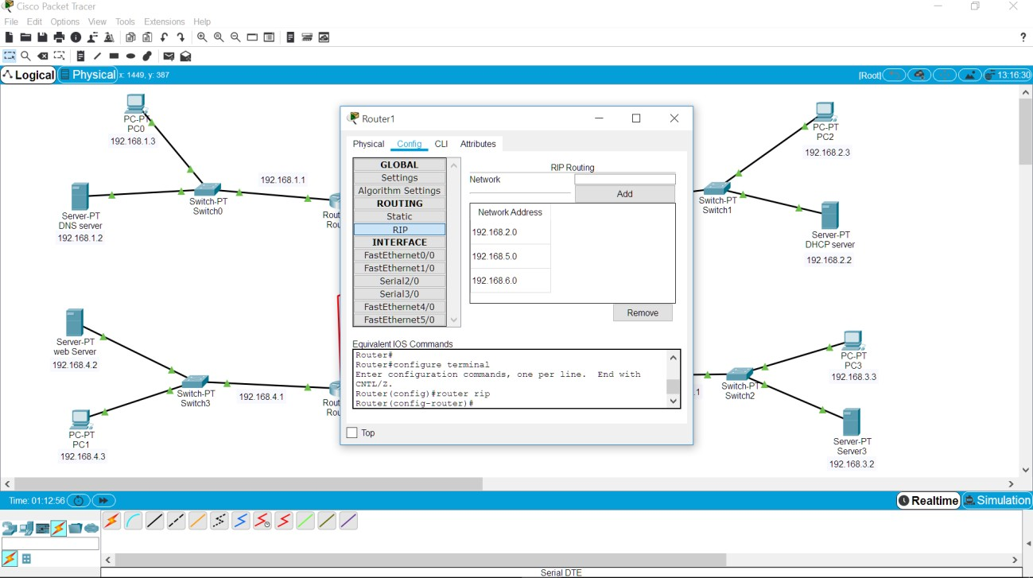

1. 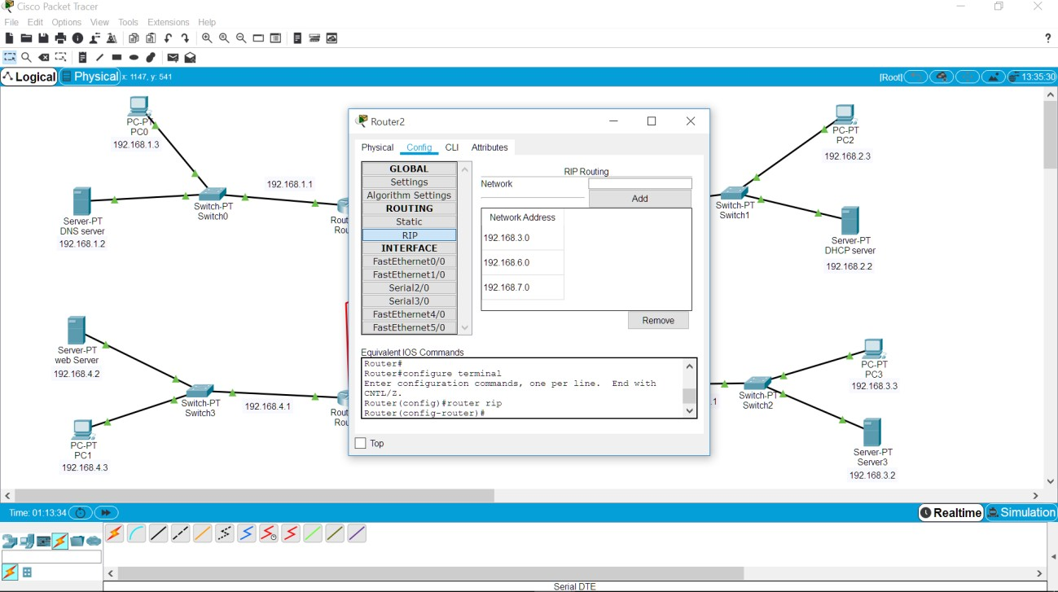router 2
2. 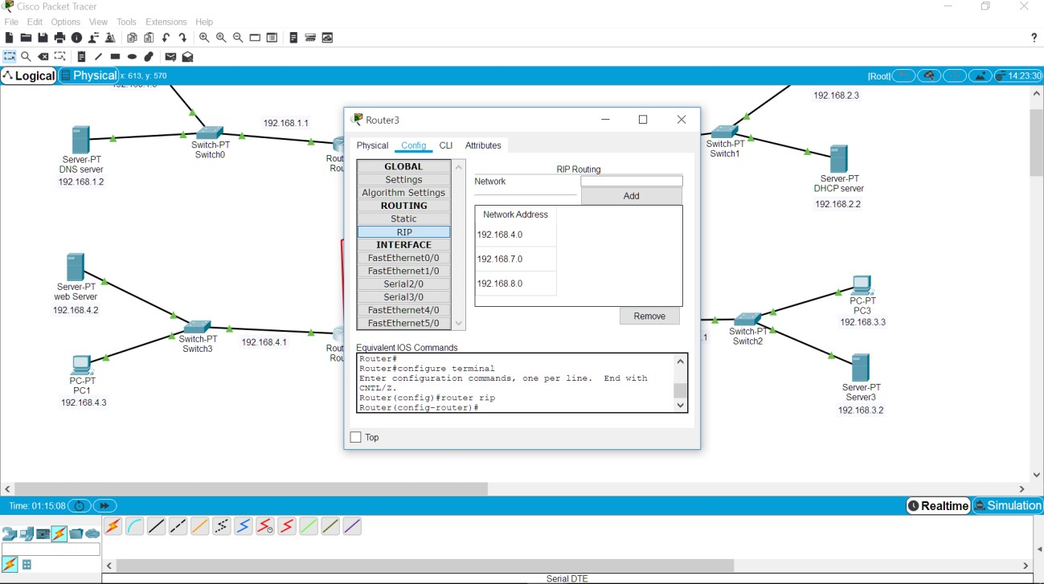router 3
   * 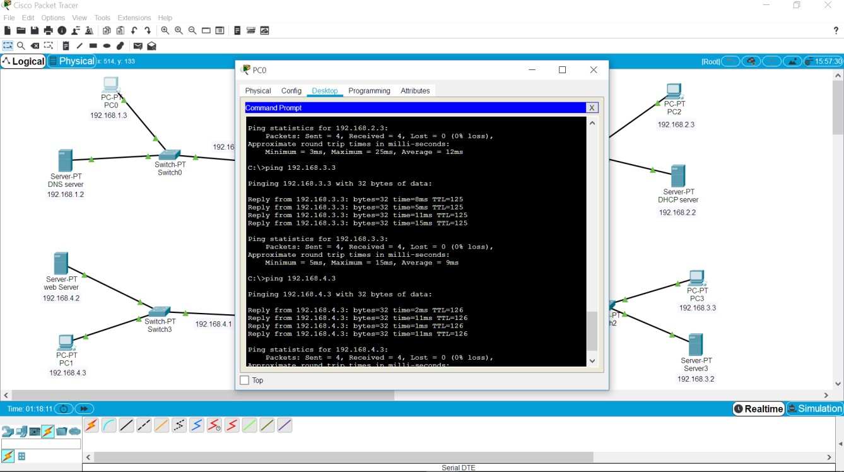*Test no.3 router dinamis (uji konektivitas antar PC)*
   * *Test no.3 router dinamis (uji konektivitas PC ke server antar router)*

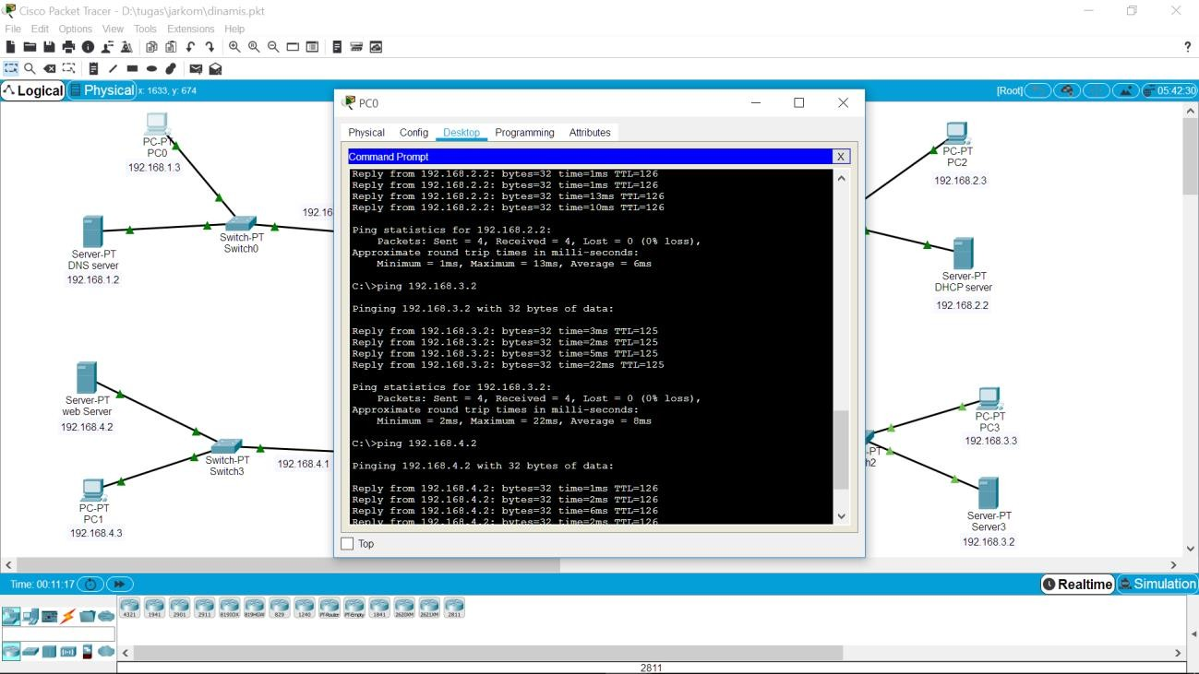

# No.4

Konfigurasi router statis

# router 0

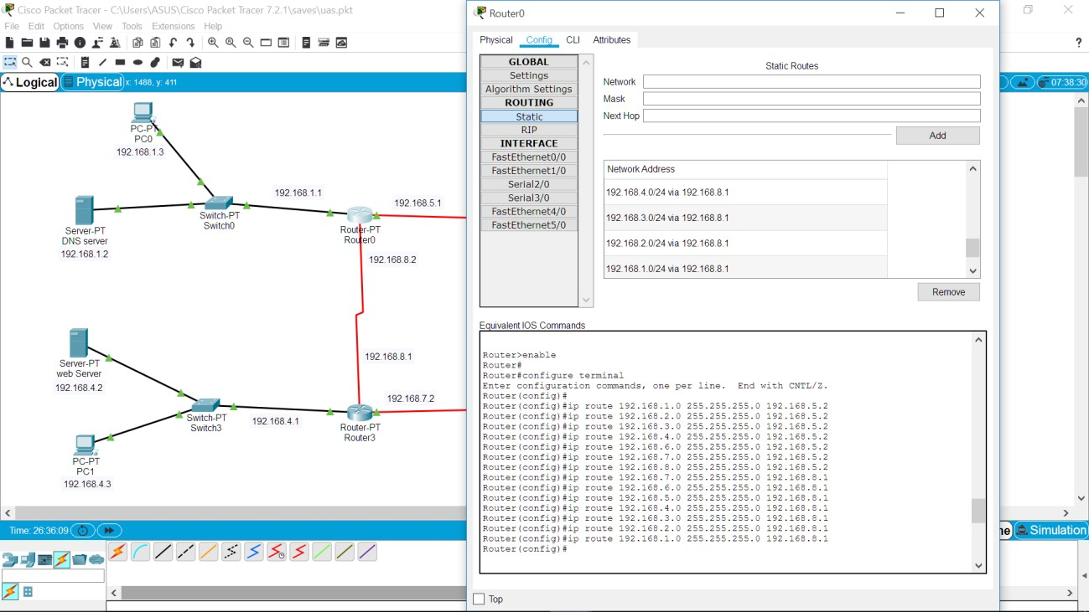

1. router 1

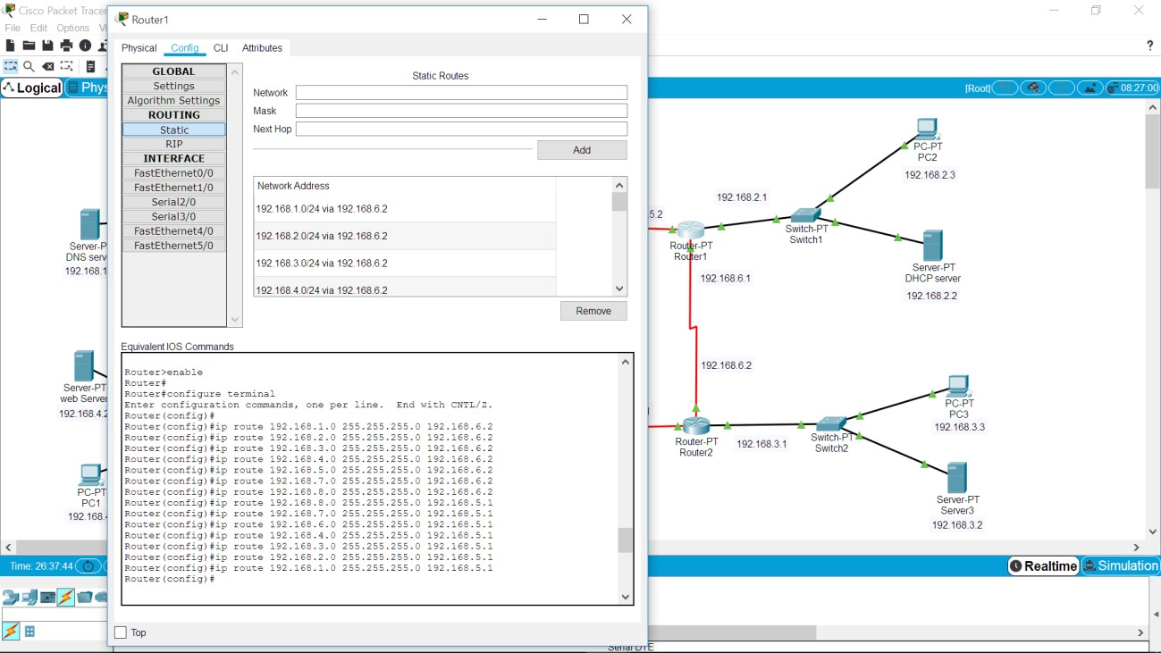

1. router 2

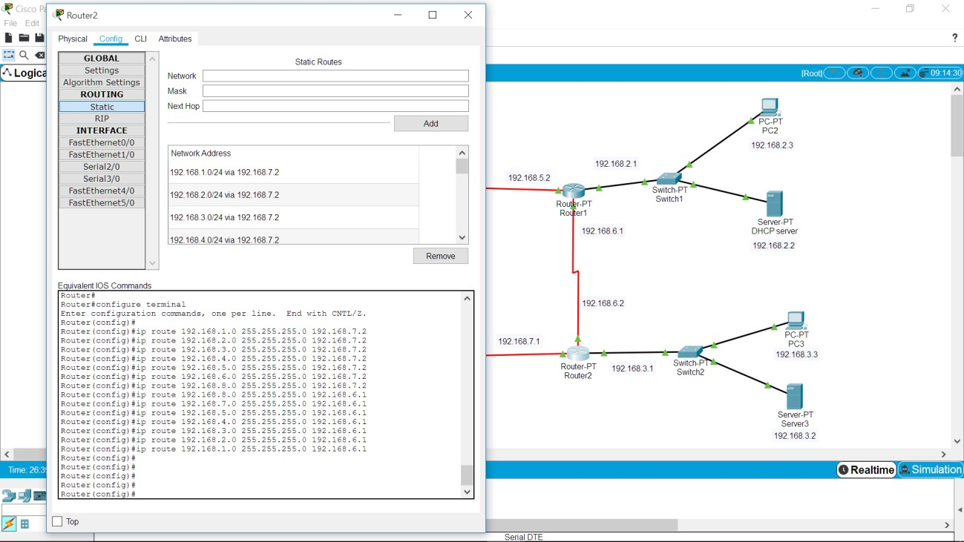

1. router 3

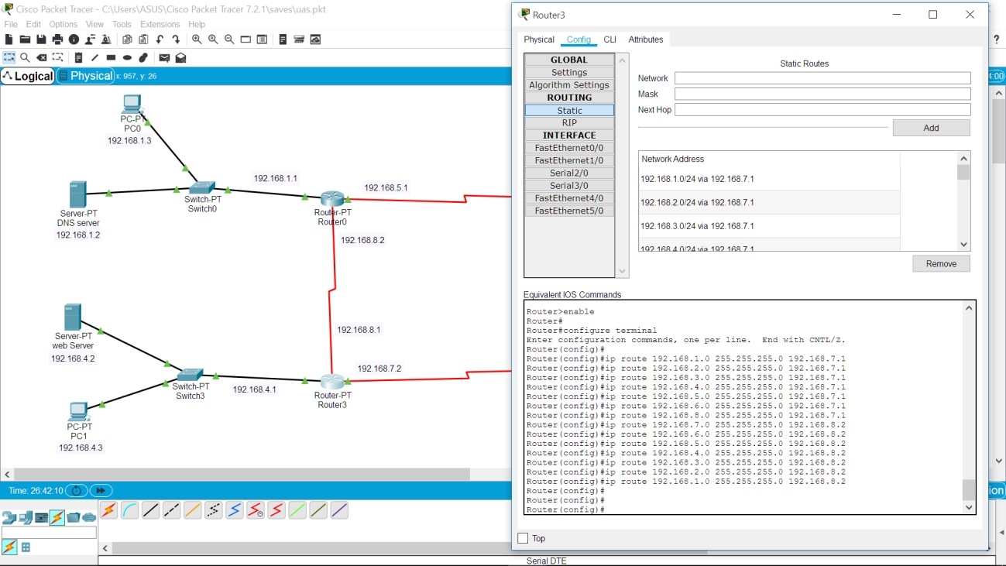

* + 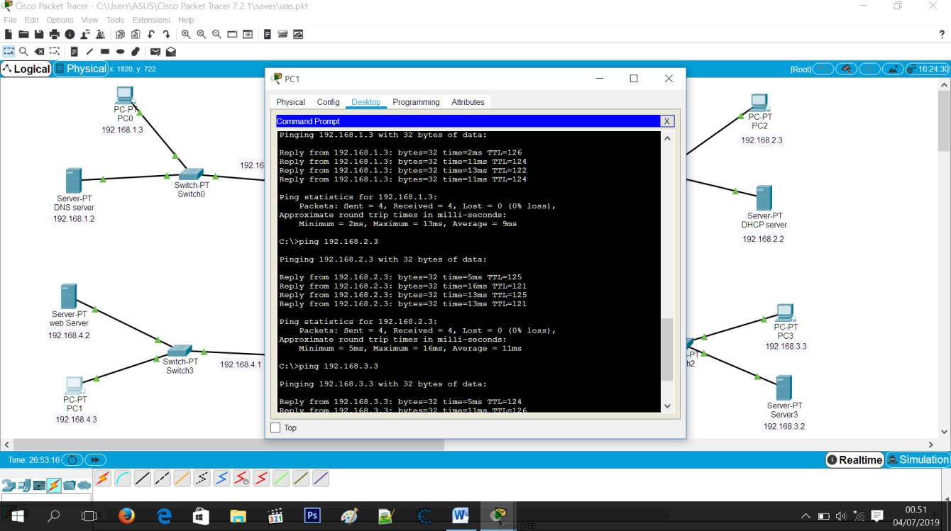*Test no.4 router statis(uji konektivitas antar PC)*
  + 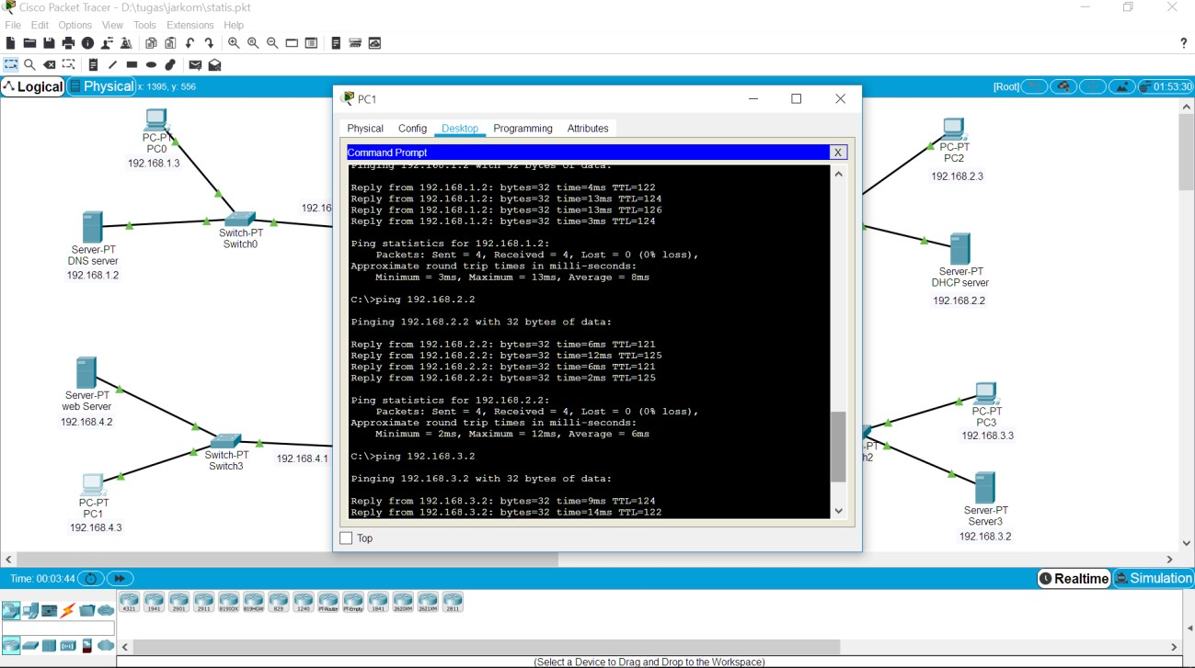*Test no.4 router statis (uji konektivitas PC ke server antar router)*

# No.5

Menggunkan access list untuk membatasi 1 PC saja yang dapat mengakses server web

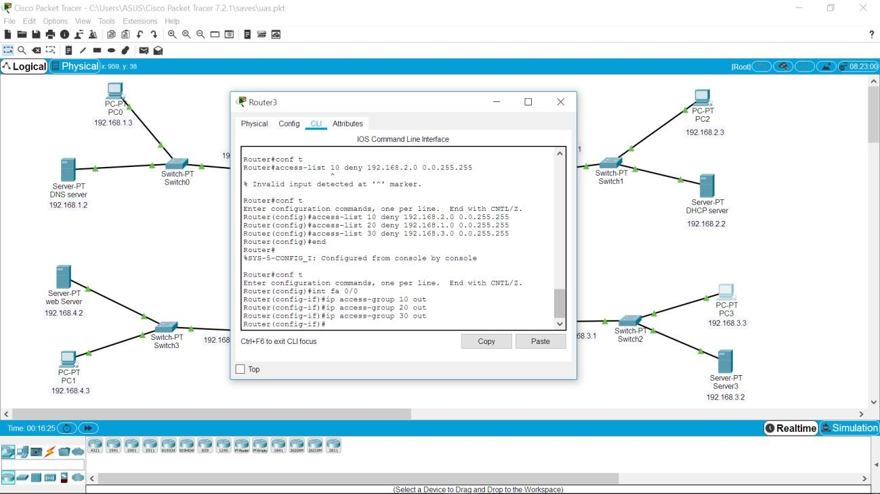

# Test akses dengan PC 0

1. 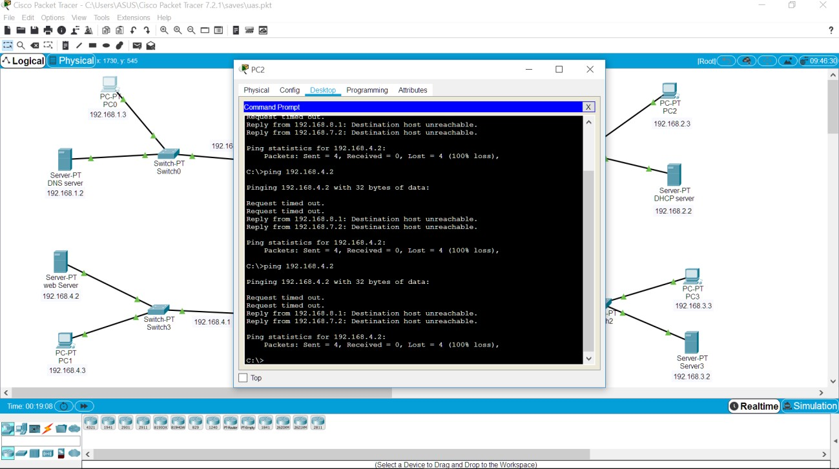Test akses dengan PC 2
2. 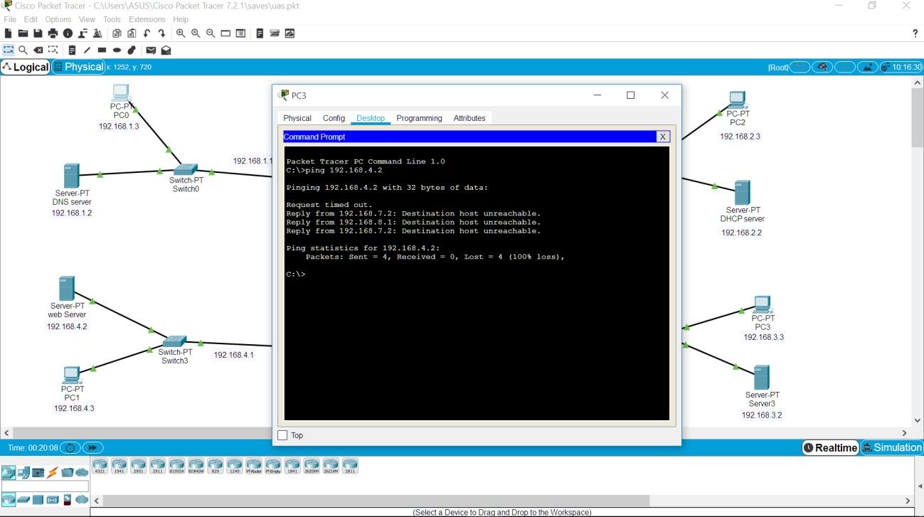Test akses dengan PC 3
3. 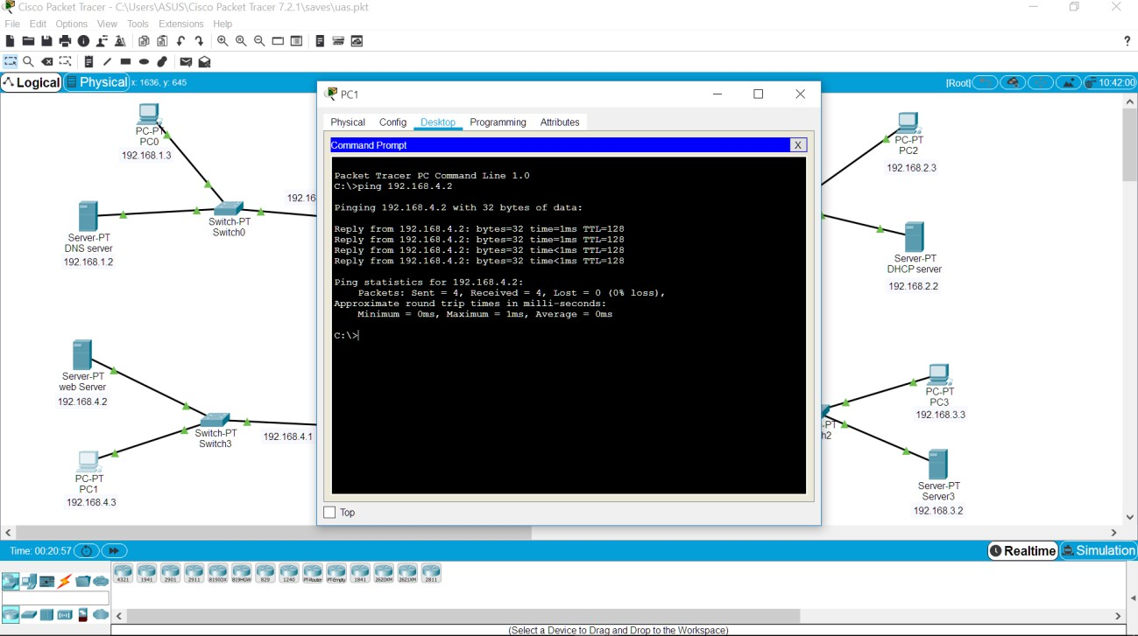Test akses dengan PC 1