MODUL 10

Nama : Fachrul Rinaldi

NIM : L200170042

Kelas : C

1. List

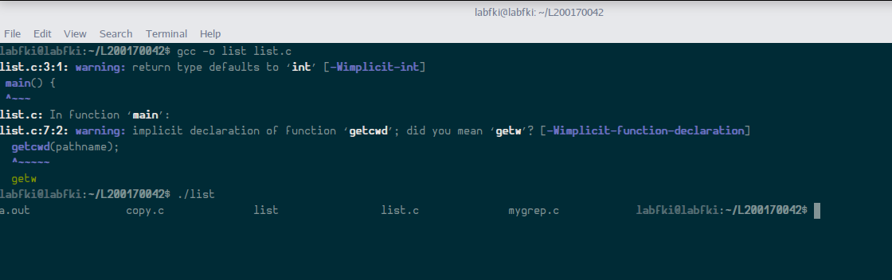

1. Mygrep

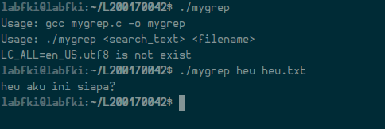

1. Copy

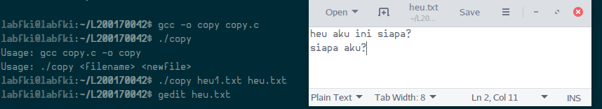

1. Delete

