Nama : Helmi Lutfian NIM : L200170055

Kelas : C

**Modul 11** TUGAS

1.)

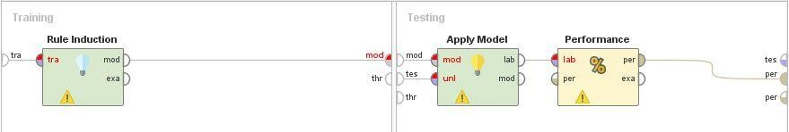

Rule model

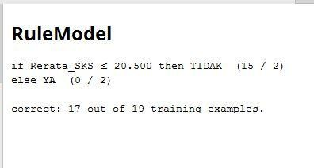

Vector

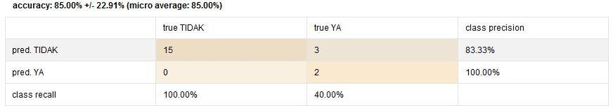

2.)

1. Number of bin 2

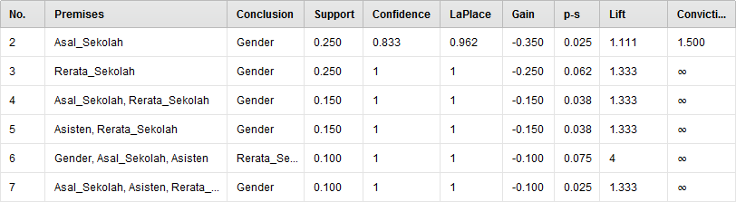

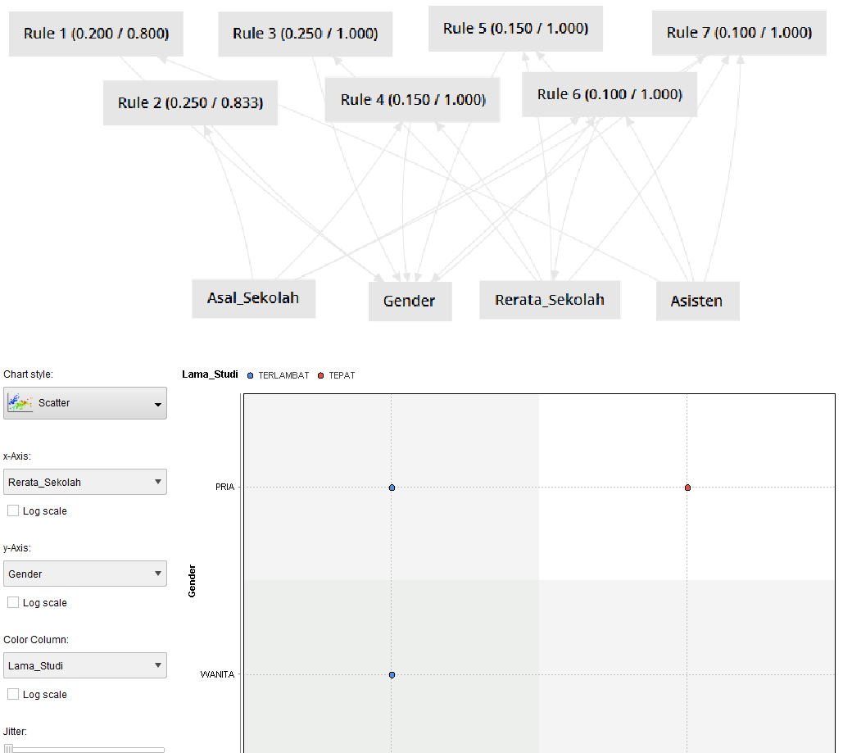

1. Number of bin 3

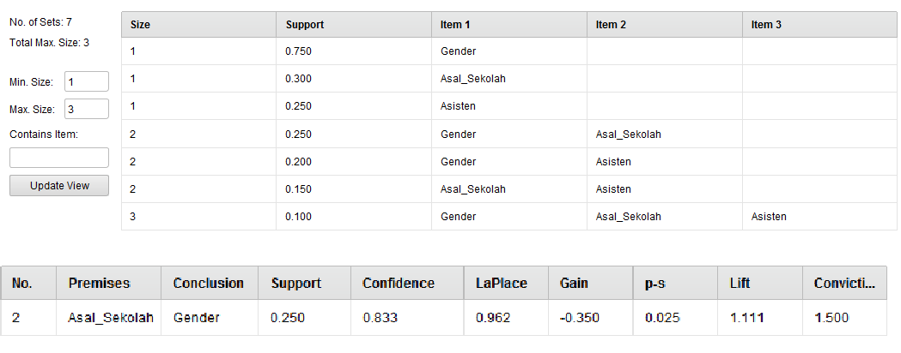

Ch art stdIe

Rule 1 [0.200 / 0.800)

Asisten

Lama_5tudi o T6RL<ide<T • TEPAT

Rule 2 (0.250 / 0.833)

Gender Asal_Sekolah



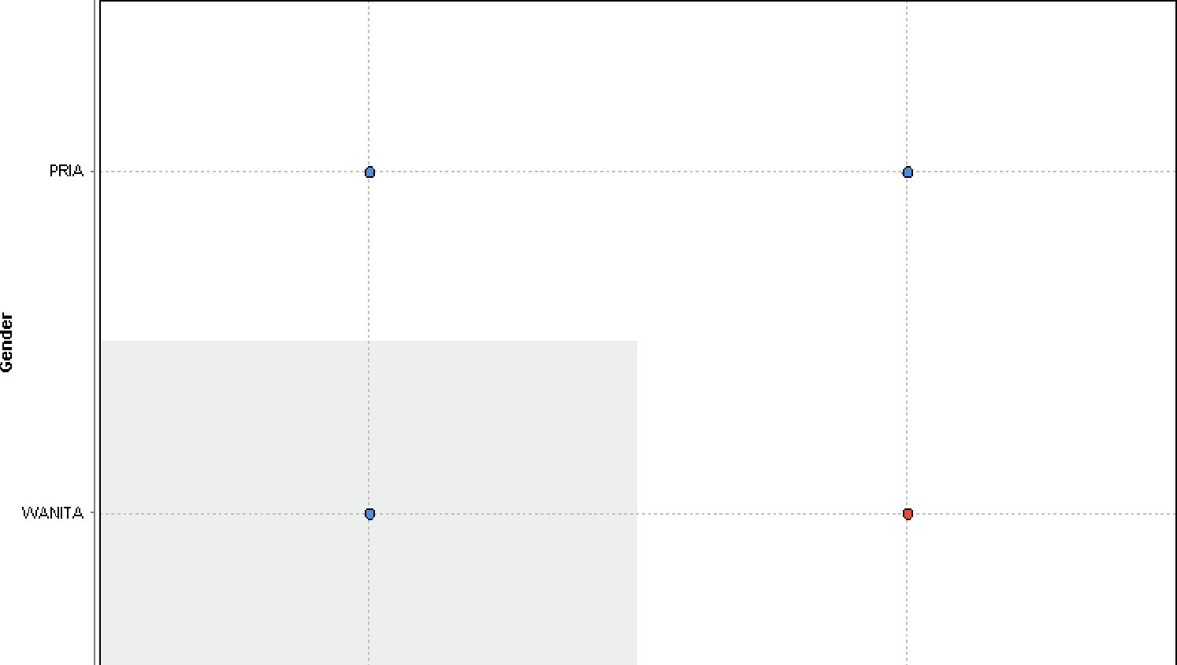Rerata_S e kol ah

Log scale

Lo g s cale

*C 0 i 0 I* G 0 I UMFi

Lama_Studi •

Log scale

Jiter: