*Nama : Naufal Alip Pratama*

*NIM : L2001700456*

*Kelas : B*

**Modul:6**

Latihan1

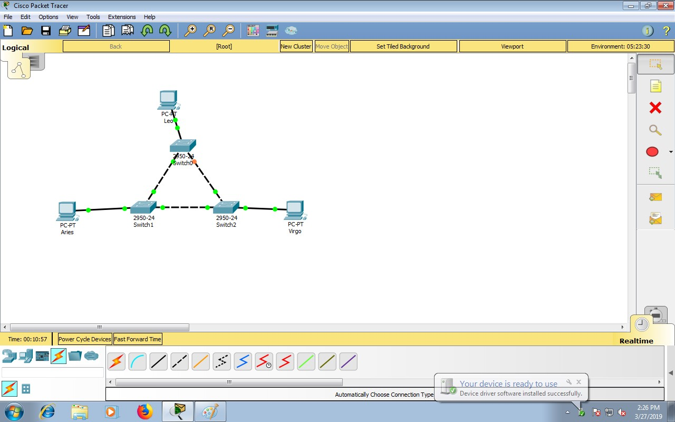

Gambar diatas merupakan suatu topologi yang menggunakan switch Catalyst 2950-24

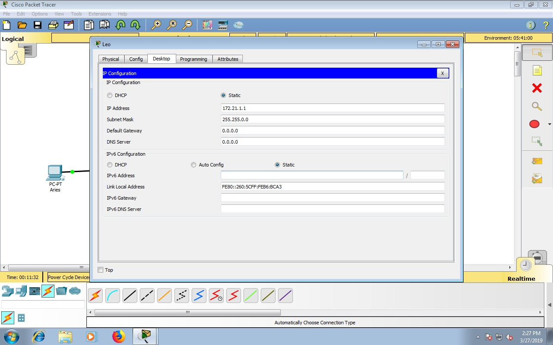

Memasukan IP Address pada PC0 atau Leo “172.21.1.1”

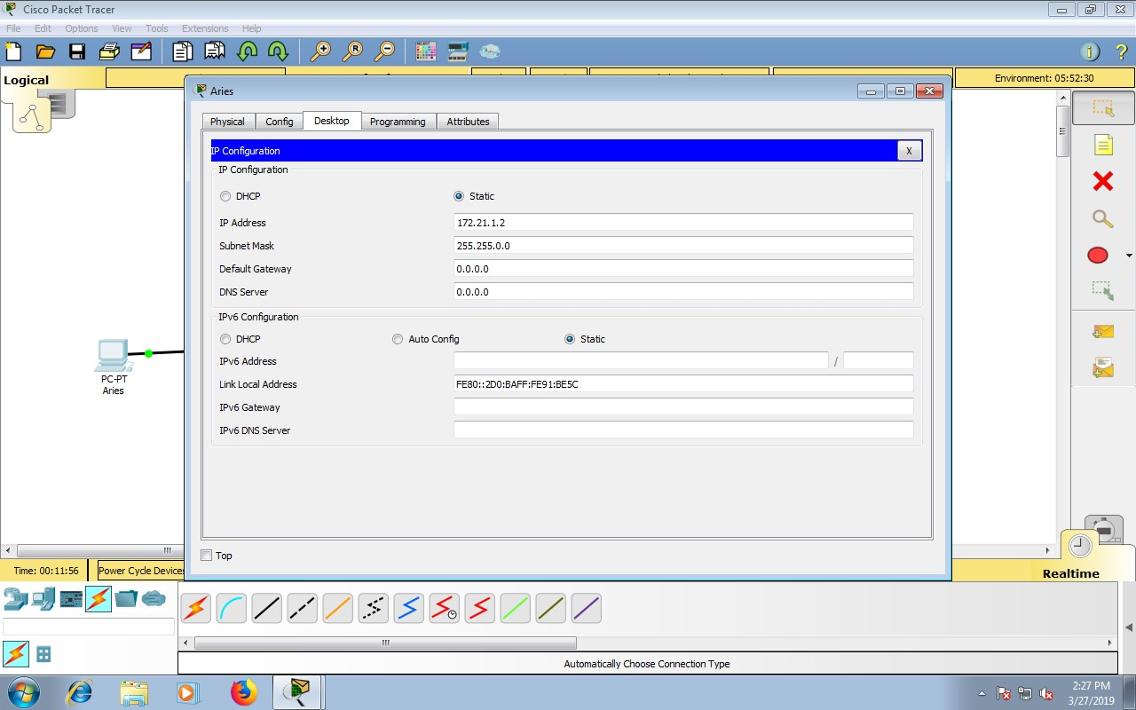

Memasukan IP Address pada PC1 atau Aries ”172.21.1.2”

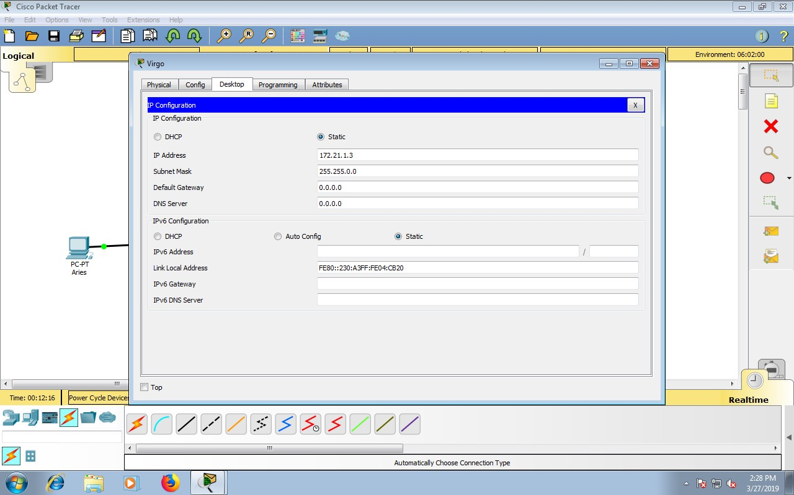

Memasukkan IP Address pada PC2 atau Virgo “172.21.1.3”

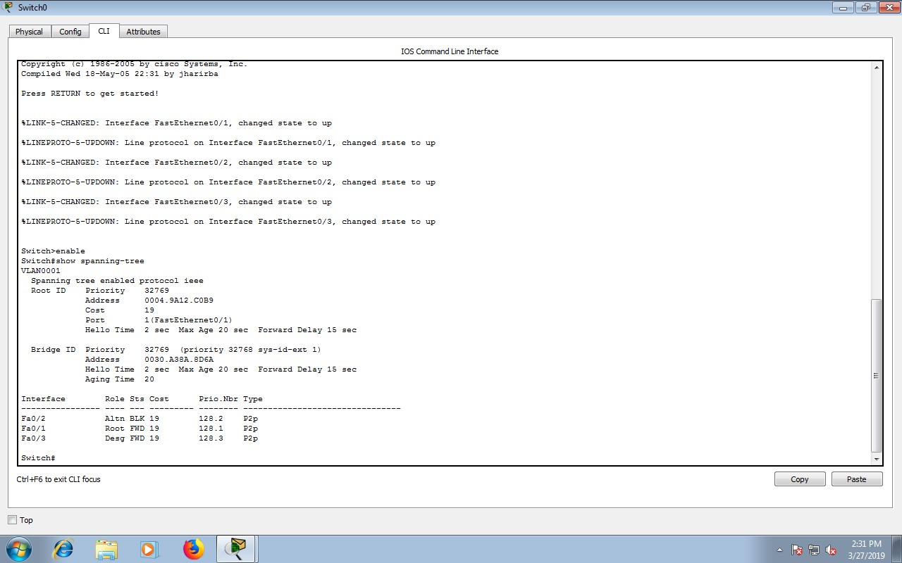

Pada mode user atau mode privileged,lihat status STP pada masing-masing switch.Langkahpengoperasian:

a.BukaCLIpadamasing-masingswitch

b.Tekan enter

c.Masukkan mode privileged(optional) yaitu dengan ketikkan enable

d.Ketik show spanning-tree

PadaSwitch0

|  |  |  |  |  |  |
| --- | --- | --- | --- | --- | --- |
| No | Variabel | | Nilai | | |
| 1 | RootID | | 32769.004.9A12.C0B9 | | |
| 2 | Priority | | 32769 | | |
| 3 | MACAdrress | | 0030.A38A.8D6A | | |
| 4 | BridgeID | | 32769.0030.A38A.8D6A | | |
| 5 | Cost(0/1;0/2;0/3) | | 19 | | |
| 6 | HelloTime | | 2sec | | |
| 7 | MaxAge | | 20sec | | |
| 8 | ForwardDelay | | 15sec | | |
| Interface | | Role | | Sts |
| Fa0/2 | | Altn | | BLK |
| Fa0/1 | | Root | | FWD |
| Fa0/3 | | Desg | | FWD |

PadaSwitch1

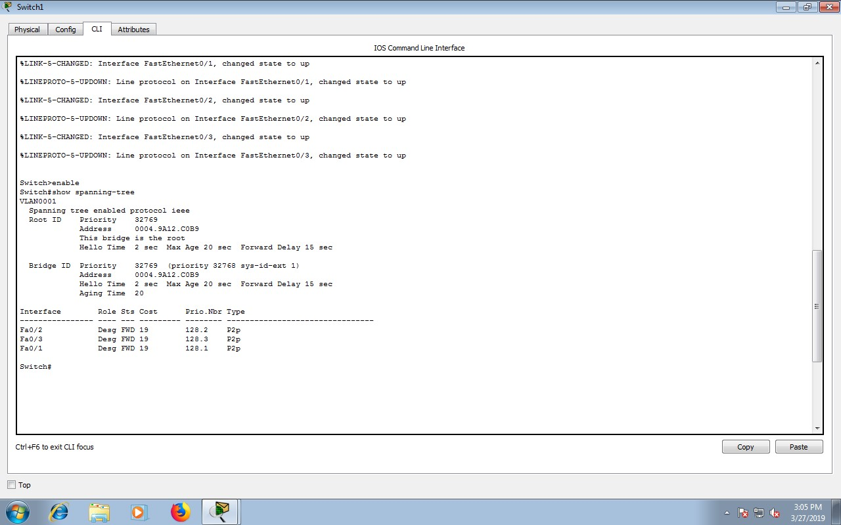

|  |  |  |  |  |  |
| --- | --- | --- | --- | --- | --- |
| No | Variabel | | Nilai | | |
| 1 | RootID | | 32769.004.9A12.C0B9 | | |
| 2 | Priority | | 32769 | | |
| 3 | MACAdrress | | 004.9A12.C0B9 | | |
| 4 | BridgeID | | 32769.0030.A38A.8D6A | | |
| 5 | Cost(0/1;0/2;0/3) | | 19 | | |
| 6 | HelloTime | | 2sec | | |
| 7 | MaxAge | | 20sec | | |
| 8 | ForwardDelay | | 15sec | | |
| Interface | | Role | | Sts |
| Fa0/2 | | Desg | | FWD |
| Fa0/3 | | Desg | | FWD |
| Fa0/1 | | Desg | | FWD |

PadaSwicth2

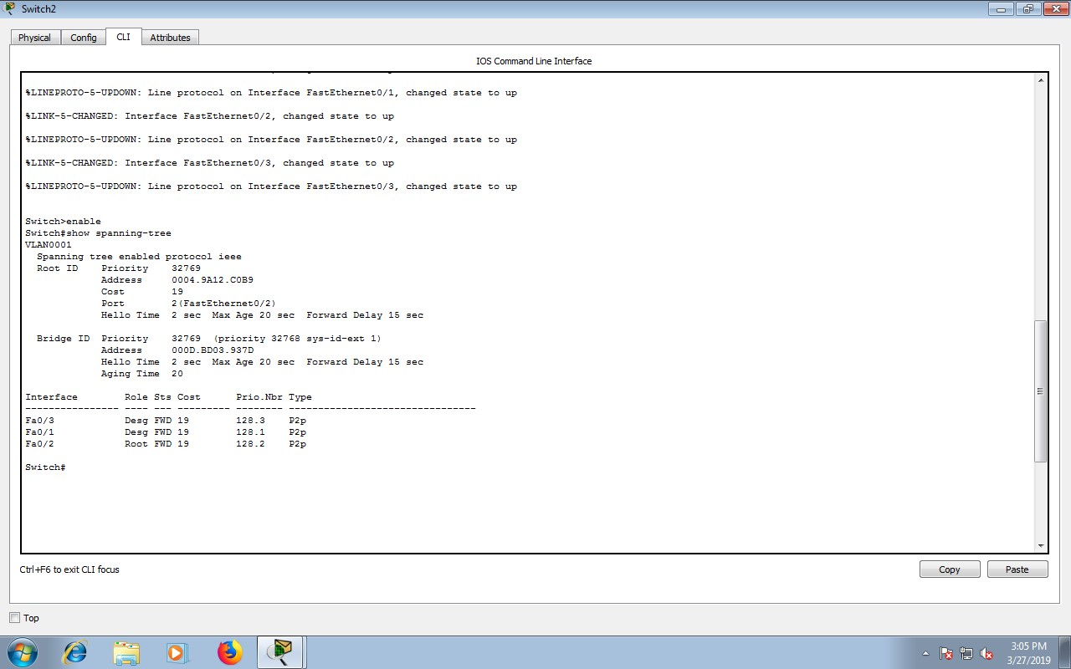

|  |  |  |  |  |  |
| --- | --- | --- | --- | --- | --- |
| No | Variabel | | Nilai | | |
| 1 | RootID | | 32769.004.9A12.C0B9 | | |
| 2 | Priority | | 32769 | | |
| 3 | MACAdrress | | 000D.BD03.937D | | |
| 4 | BridgeID | | 32769. 000D.BD03.937D | | |
| 5 | Cost(0/1;0/2;0/3) | | 19 | | |
| 6 | HelloTime | | 2sec | | |
| 7 | MaxAge | | 20sec | | |
| 8 | ForwardDelay | | 15sec | | |
| Interface | | Role | | Sts |
| Fa0/3 | | Desg | | FWD |
| Fa0/2 | | Desg | | FWD |
| Fa0/1 | | Root | | FWD |

•Padakondisidefaulttersebut,switchdanportmanasajayang

a.Menjadirootbridge:SW1

b.Menja didesignatedbridge:SW0danSW2

c.Menjadi rootport:SW0danSW2

d.Menjadi designatedport:SW0danSW2

•Pada kondisi default tersebut,danportmanasajayang

a.Beradapadakeadaanforwarding:SW1

b.Beradapadakeadaanblocking:SW0padaFa0/2

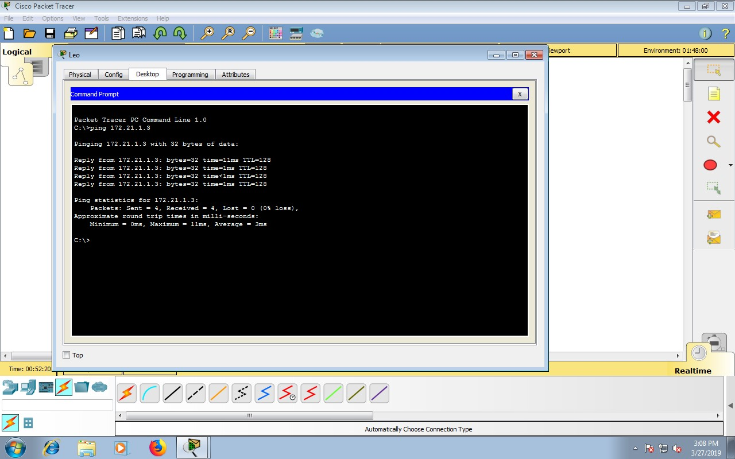

HasilpingantaraPCLeokePCVirgo

Latihan2

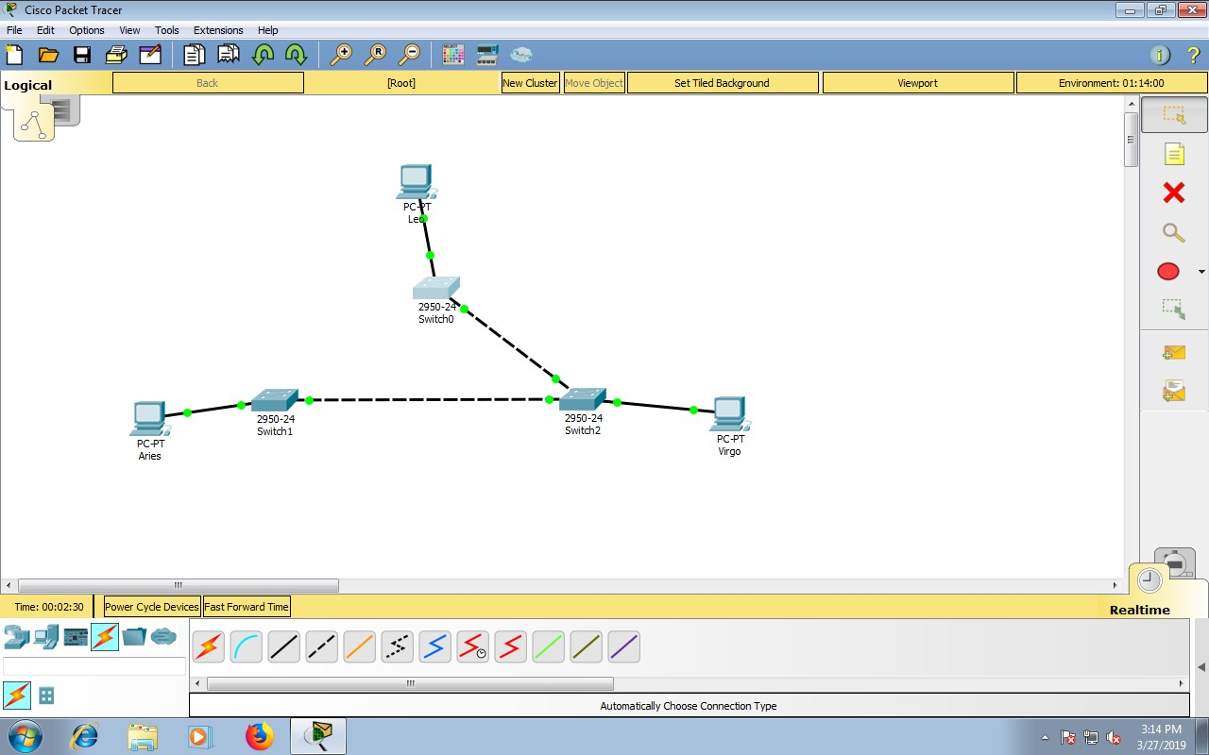

GambardiatasmerupakansuatutopologiyangmenggunakanswitchCatalyst 2950-24

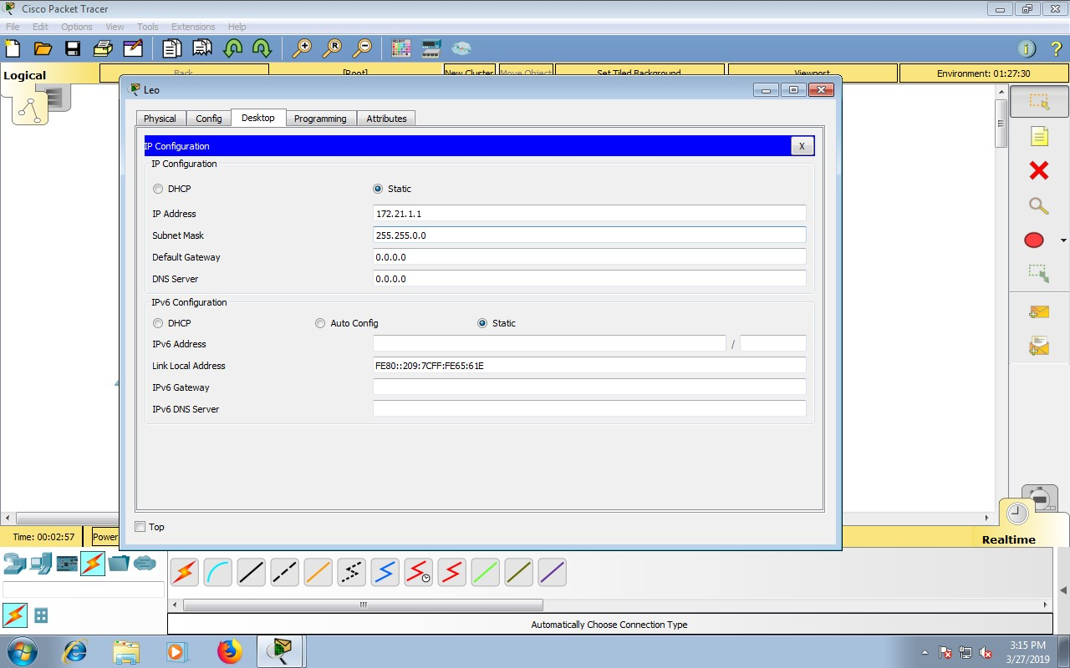

MemasukanIPAddresspadaPC0atauLeo“172.21.1.1”

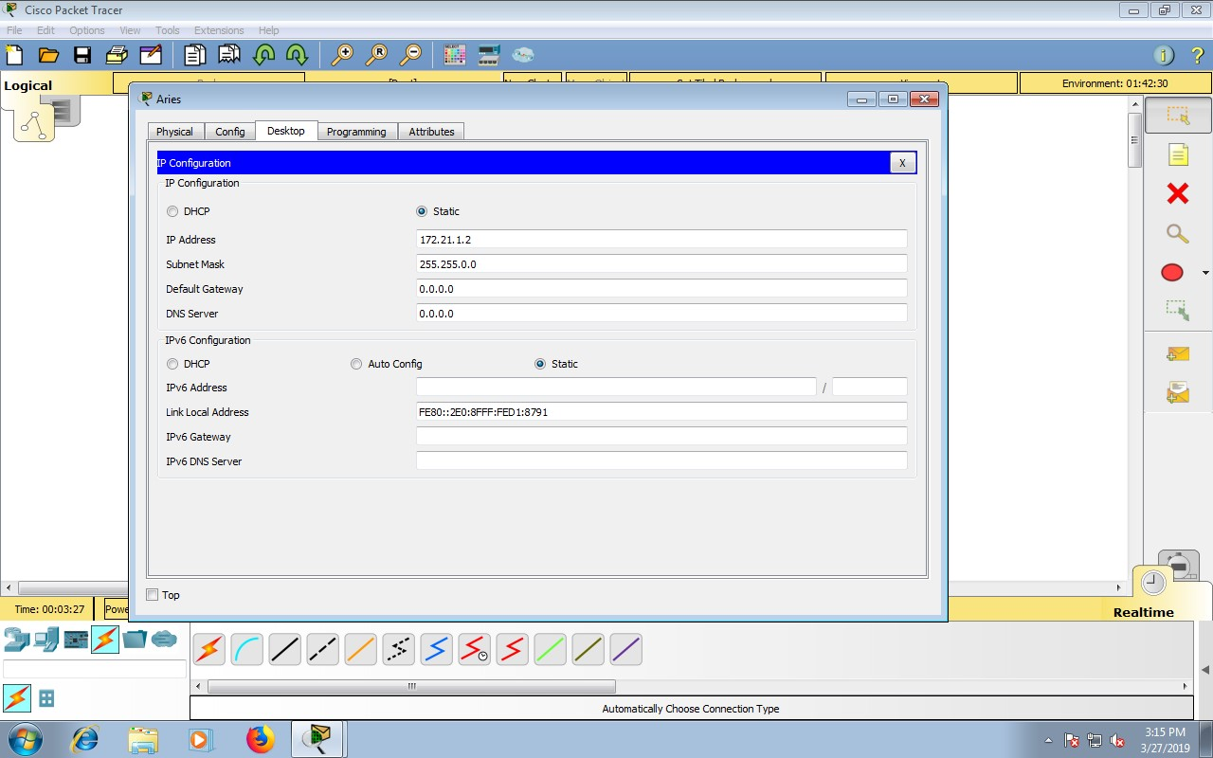

MemasukanIPAddresspadaPC1atauAries“172.21.1.2”

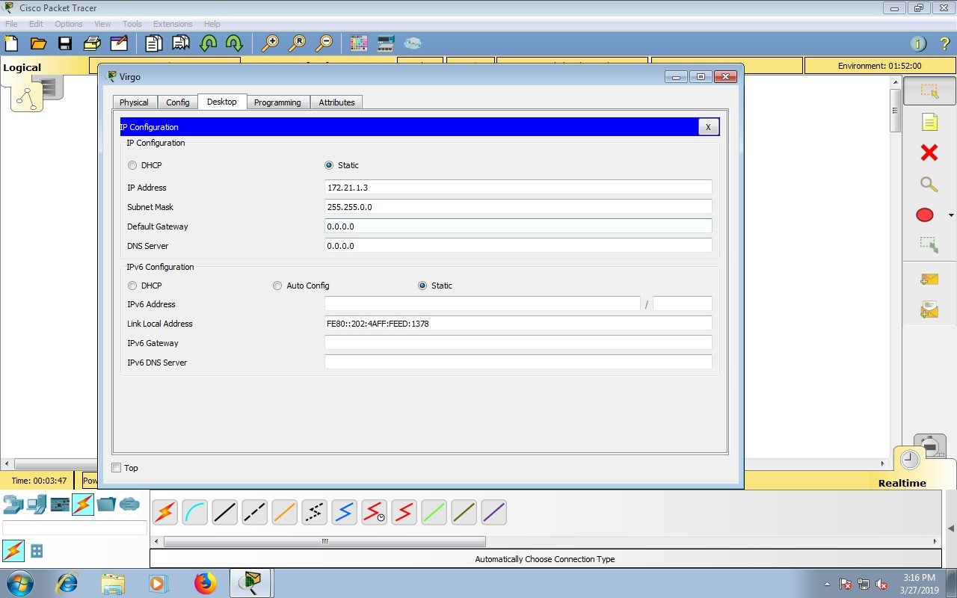

MemasukanIPAddresspadaPC2atauVirgo“172.21.1.3”

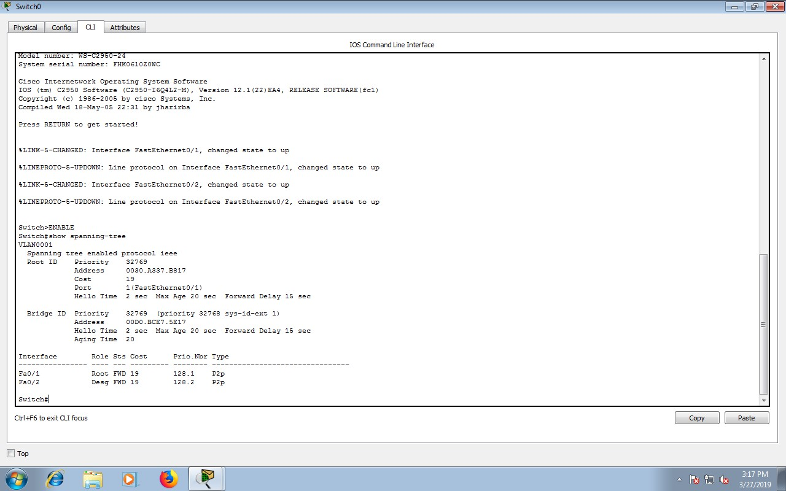

Padamodeuserataumodeprivileged,lihatstatusSTPpadamasing-masing switch.Langkahpengoperasian:

a.BukaCLIpadamasing-masingswitch

b.Tekanenter

c.Masukkanmodeprivileged(optional)yaitudenganketikkanenable

d.Ketikshowspanning-tree

PadaSwitch0

|  |  |  |  |  |  |
| --- | --- | --- | --- | --- | --- |
| No | Variabel | | Nilai | | |
| 1 | RootID | | 32769.0030.A337.B817 | | |
| 2 | Priority | | 32769 | | |
| 3 | MACAdrress | | 00D0.BCE7.5E17 | | |
| 4 | BridgeID | | 32769.00D0.BCE7.5E17 | | |
| 5 | Cost(0/1;0/2;0/3) | | 19 | | |
| 6 | HelloTime | | 2sec | | |
| 7 | MaxAge | | 20sec | | |
| 8 | ForwardDelay | | 15sec | | |
| Interface | | Role | | Sts |
| Fa0/2 | | Root | | FWD |
| Fa0/1 | | Desg | | FWD |

PadaSwitch1

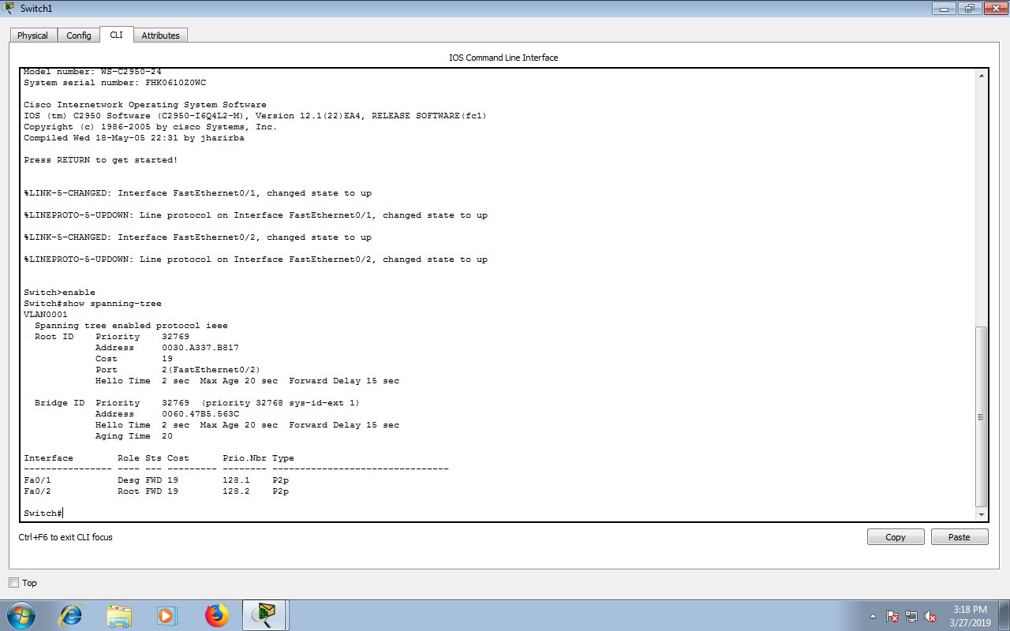

|  |  |  |  |  |  |
| --- | --- | --- | --- | --- | --- |
| No | Variabel | | Nilai | | |
| 1 | RootID | | 32769.0030.A337.B817 | | |
| 2 | Priority | | 32769 | | |
| 3 | MACAdrress | | 0060.47B5.563C | | |
| 4 | BridgeID | | 32769.0060.47B5.563C | | |
| 5 | Cost(0/1;0/2;0/3) | | 19 | | |
| 6 | HelloTime | | 2sec | | |
| 7 | MaxAge | | 20sec | | |
| 8 | ForwardDelay | | 15sec | | |
| Interface | | Role | | Sts |
| Fa0/1 | | Desg | | FWD |
| Fa0/2 | | Root | | FWD |

PadaSwitch2

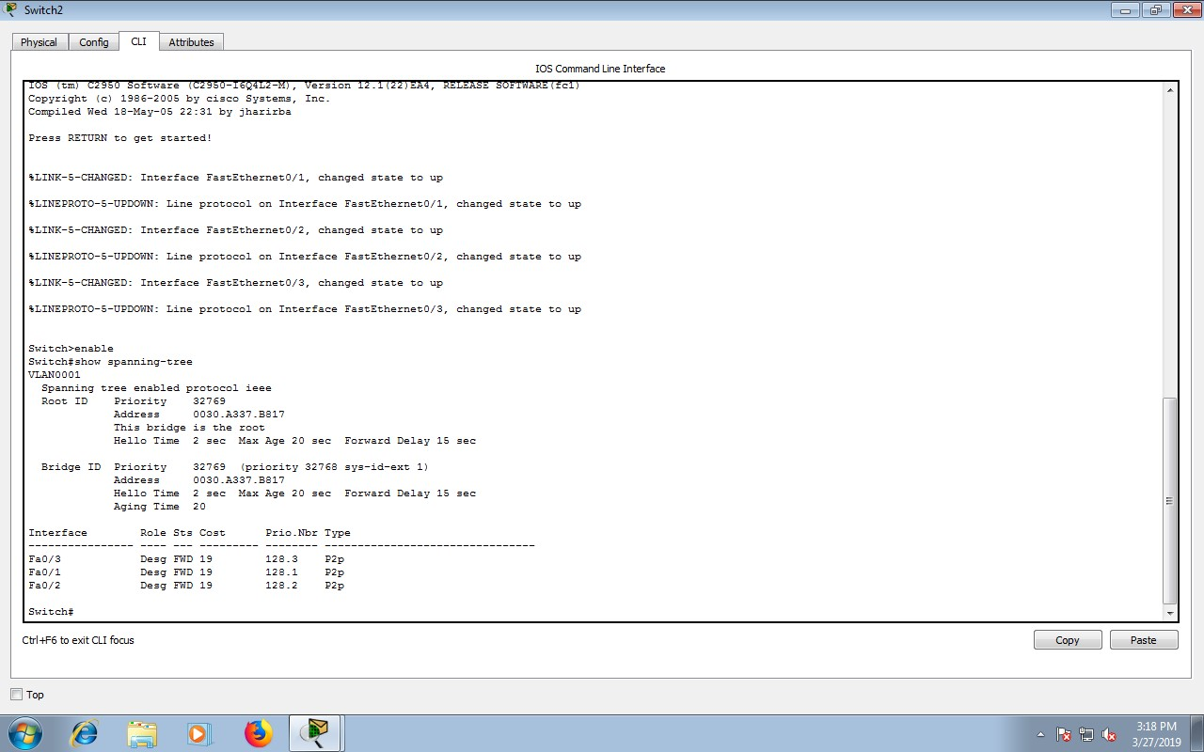

|  |  |  |  |  |  |
| --- | --- | --- | --- | --- | --- |
| 1 | RootID | | 32769.0030.A337.B817 | | |
| 2 | Priority | | 32769 | | |
| 3 | MACAdrress | | 0060.47B5.563C | | |
| 4 | BridgeID | | 32769.0060.47B5.563C | | |
| 5 | Cost(0/1;0/2;0/3) | | 19 | | |
| 6 | HelloTime | | 2sec | | |
| 7 | MaxAge | | 20sec | | |
| 8 | ForwardDelay | | 15sec | | |
| Interface | | Role | | Sts |
| Fa0/3 | | Desg | | FWD |
| Fa0/2 | | Desg | | FWD |
| Fa0/3 | | Desg | | FWD |

•Padakondisidefaulttersebut,switchdanportmanasajayang

e.Menjadirootbridge:SW2

f.Menjadidesignatedbridge:SW0danSW1

g.Menjadirootport:SW0danSW1

h.Menjadidesignatedport:SW0danSW1

•Padakondisidefaulttersebut,danportmanasajayang

c.Beradapadakeadaanforwarding:SW2

d.Beradapadakeadaanblocking:-

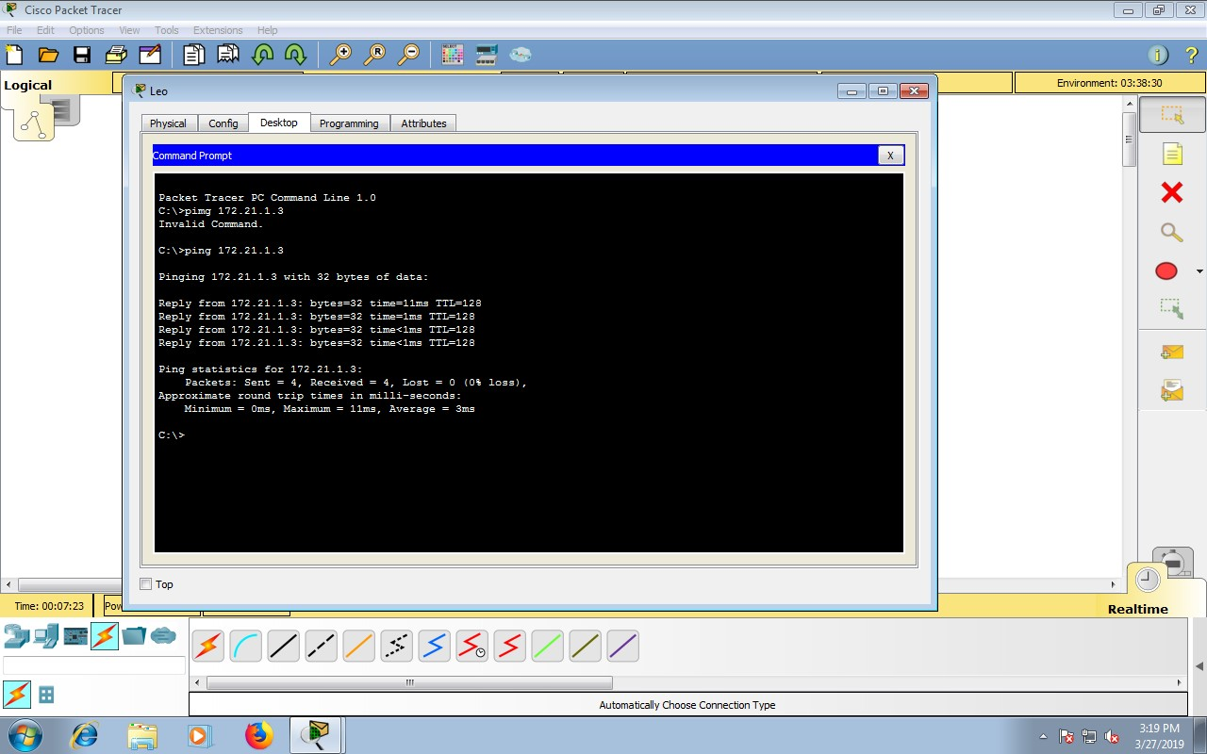

HasilpingantaraLeokeVirgo